Deliverable 3: Design & Delivery Specifications
Describe logical progression of ideas / story
My idea started off with wanting to make a vinyl collection website where it just displays my collection so other music lovers can see and talk about similar interests when I share it. I had a vision in my mind of it being colourful, something inspired by Tyler, The Creator’s album colours but mixed. Here would be an example;
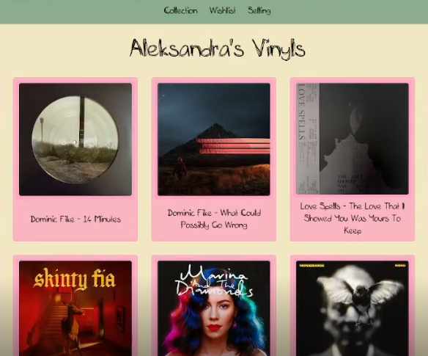
I also wanted the fonts to look like it was written freehand and have it in a fun scribbly type of text. As I continued working, I started to dislike how it visually looked, the colours didn’t really match, and the fonts didn’t seem to be fit for perfect readability. I changed the colours and the fonts, so it’s now a simpler modern-like kind of style, but not too serious in tone (in my opinion). The layout of the website still stayed the same, spanning the vinyls in a grid like format. So here would be the updated look of the website since what it originally started out as;
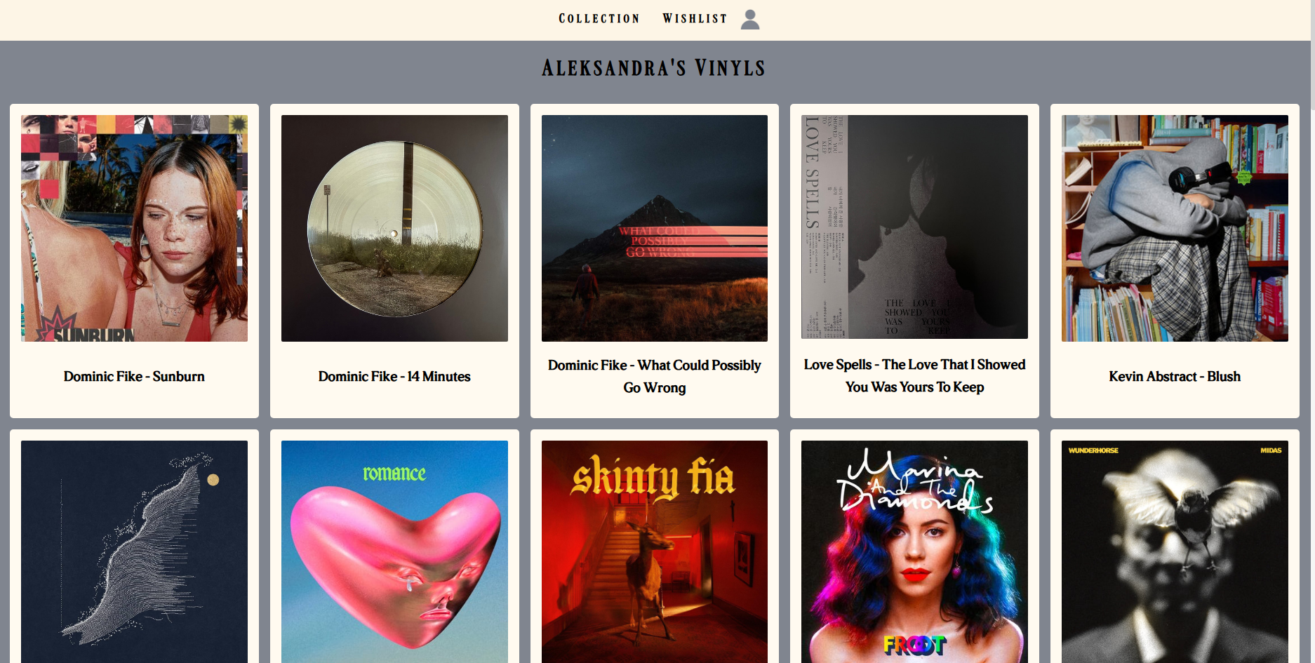
Describe tone and style (formal/ informal, technical, simple, visual, text heavy) and consistency across all content
It is very simple and visually pleasing to look at. Images accompany each vinyl with the same dimensions, along with text that displays the artist’s name and title of the album all using the same font and size to keep it simple. When clicking into each modal, each written thought section on the right uses the same font and size as well to keep it consistent. They are also accompanied with images inside that stick to the left side with the same size so it’s not different every time you click into different vinyl. The Spotify embed that is linked to each sit under the thoughts section, which you can scroll down to and fully look at. In the wishlist section, the modals only consist of the images on the left, title to the right, and the Spotify embed that takes up the rest of the modal space. The colours inside the modal also stay the same, so it’s not a surprise of colour when clicked into.
What content Formats are you using -text, images, video, animation, audio, interactive elements
Content formats I am using throughout the website are text, images, audio, and interactive elements. The text and images are used to display each vinyl album with its artist and title, along with written thoughts inside the modal. Audio is used inside the modals through Spotify embeds so users can listen to snippets of songs that are in each album. And the interactive elements are the modal itself. When you hover your mouse over each vinyl it slightly gets bigger, with a small transition animation when clicking on the modal to open it. The written thoughts inside are also scrollable depending on size of paragraph.
User journey mapping (how do users access the content and what are the key interaction points?
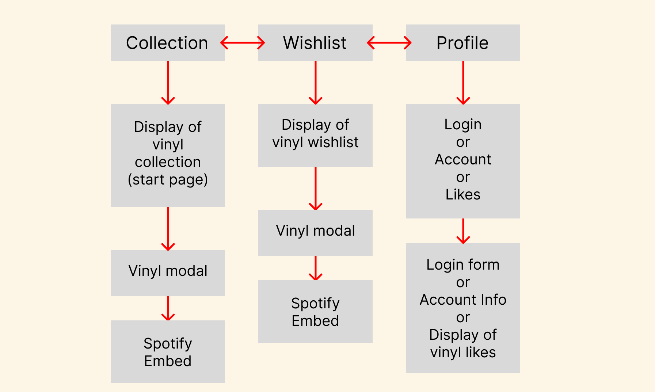
Key interaction points would be Collection, Wishlist, Profile, the vinyl modals, Spotify embeds, login form, account, and likes.
Description of Accessibility consideration (readability, captions, alt text, inclusive language, keyboard navigation)
I made sure when using text to use a clear and readable font and have it at a decent size so it is not too small to read but also not too big. Each picture is accompanied by alt text that says what it is, and keyboard navigation is yet to be fully implemented so users can get into the vinyl modals.
Visual Identity (colour palette, typography, iconography and imagery style)
The colour palette consists of colours that compliment each other well and are not too intense, they are used throughout the whole website. The way the images are displayed with each vinyl is also consistent throughout the website, so it stays neat and doesn’t overwhelm the user.
Layout and composition (responsive / adaptive design considerations)
The layout includes a banner at the top of the website to navigate around the main areas of the website, as well as a footer at the bottom of the page. The display of vinyl is in a grid-like structure, keeping it neat and consistent without overwhelming the user with different elements all over the place.
Brand consistency (alignment with brand guidelines - logos, tones, visuals)
My website does not have a set logo, but the visuals of how the modals are laid out throughout the website are consistent, as well as the tone.
UI/ UX considerations e.g. navigation structure, usability and intuitiveness, interaction design (buttons, transitions, feedback)
Navigating through the website is simple, it is straightforward to get to each section (collection, Wishlist, profile etc.), there are no extra steps needed to click into. When looking through the collection and wanting to interact with a specific vinyl, you click onto any and then a small smooth transition animation happens when the modal opens to show the inside information. There is a button top right of the modal to close it, but you can also click anywhere around the modal, and it will close it too.
Technical Specifications (resolution, dimensions, file formats, platform requirements)
To display the album covers nicely, the images displayed are sized 100% but are capped to how big the cards are set, so they will adapt to those if they change size. To support high resolution screens, images would be displayed 2x their size wherever possible.
When dimensions change, the website adapts and the vinyl displays moves to fit. They are displayed in a grid, then using display columns to span them across the website consistently of same size and spacing.
File formats used for images are PNG, JPEG, and WebP. For text ttf.
For platform requirements, the latest versions of Chrome, Edge, FireFox, Safari, OperaGX etc. is needed. My site depends on HTML, CSS, JavaScript frontend-wise.
Performance considerations e.g. file size optimization, load times and rendering performance
Each image is uploaded and stored on the database that I display the vinyl from, so load time and rendering as well as file sizes are optimized.
Delivery method (cloud storage, LMS, client platform)
The project will be delivered as a live website hosted on Netlify, and then accessed through a public URL.
Testing across devices/ platforms
The website functions as intended on other platforms; other devices are yet to be tested as I am more desktop focused with this project.

