


B.Sc. in Interactive Digital Art and Design

Academic Year 2025 / 2026

Project Diary & Notebook

Name: Aleksandra Skarzycka

Student ID: C00294397

Supervisor: David Hearne

Project Title: Vinyl Collections

This is an important Document – Do not lose it!

Schedule of Dates and Project Deliverables

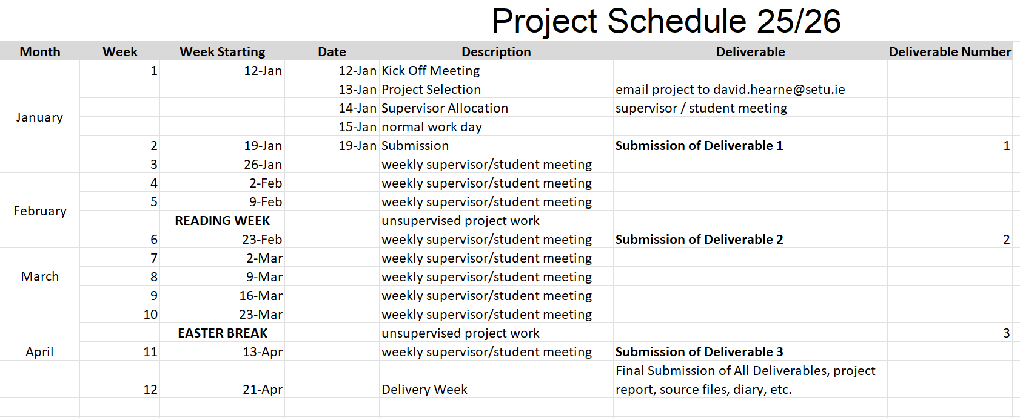

IDAD Project Documents

Proposal: 1 page
Specification of the type of web presence to be modelled. Background of the proposed Business environment / application.
Proposal should include a description of the entity intended to model as well as a reason (or reasons) for how the entity would benefit from having a web presence.

Planning & Research document: (5 marks)
Project plan & timeline
Platform choice, software stack choice, description existing system, similar existing sites,
Proposed outline site map (basic)

Project Requirements & Specification: (10 marks)
Overview of Business
Project Objectives, User roles,
Functional requirements of each user:
Features & functional specification for each user: List features & purpose of features

Design & Storyboard: (10 marks)
Content plan and flow, design specifications, Storyboard

Progress Presentation: (10 marks)
Brief Description of Project, work done so far, work you still have to do, Technology Options/Discussion, Potential Issues/Challenges

Project Final Report: (15 marks)
Description of Submitted Project, Description of Conformance to Specification and Design,
Description of Learning, Scrum experience; Full Review of Project

Technical document: Admin & Setup Guide (10 marks)
Detailed instructions on how to install, set-up, configure and use the system.

Project Management: Stand Up Meetings and Diary (10 marks)
Evidence that the project process was executed effectively and effeciently through all the stages through to final production.

Full rubric will be available in a separate document.

PROJECT DOCUMENTATION STANDARDS

All documents submitted as part of the project are to be word processed and submitted on-line. Upload links will be provided at the relevant deliverable dates.

The format of each document must conform to this specification:

- Title Page: including your project title, name, login-id, supervisor's name, and date of submission.
- Table of Contents.
- Introduction to the report
- Page numbering (in a footer) is required on all pages except the title page.
- References and a bibliography are required for all material sourced from elsewhere (including printed works and material from the Internet). The format of references is to conform to the published standards for the Department of Computing.

Be sure to spell-check your documents before submission.

________________________________________________________________________

Work submitted for assessment which does not include this declaration will not be assessed.

DECLARATION

*I declare that all material in this submission e.g. thesis/essay/project/assignment is entirely my/our own work except where duly acknowledged.

*I have cited the sources of all quotations, paraphrases, summaries of information, tables, diagrams or other material; including software and other electronic media in which intellectual property rights may reside.

*I have provided a complete bibliography of all works and sources used in the preparation of this submission.

* I have not used Artificial Intelligence to create any of my work, where AI has been used and been cited and all prompts used have been added to an appendix in my final deliverable.

*I understand that failure to comply with the Institute’s regulations governing plagiarism constitutes a serious offence.

Student Name: (Printed) ALEKSANDRA SKARZYCKA

Student Number: C00294397

Signature: Aleksandra Skarzycka

Date: 12/01/2026

Please note:
The Institute regulations on plagiarism are set out in Section 13.3 Examination and Assessment Regulations published each year in the Student Handbook.

Week 1 Beginning: 12/01/2026

Description of Work Completed:

Created my project proposal and submit it. Supervisors assigned next week.

Notes (and things to remember):

________________________________________________________________________________
________________________________________________________________________________
________________________________________________________________________________
________________________________________________________________________________
________________________________________________________________________________
________________________________________________________________________________
________________________________________________________________________________

Signed (and dated):

Aleksandra Skarzycka 20/01/26
Student Supervisor
Week 2 Beginning: 19/01/2026

Description of Work Completed:

Created and submit Deliverable 1; made a project plan and timeline, identified available time and resources, identified personal skill level, described my target audience and intended platform and proposed a basic outline site map with a moodboard.
Started on the concept of what the pages would look like. Layout is finished, might be changing around the colour scheme.
Created a concept idea for what the preview of a vinyl looks like.

Notes (and things to remember):

Create a small preview of what the Spotify Web API will look like on the web, as well as 1 preview of what it looks like to click on a vinyl.
________________________________________________________________________________
________________________________________________________________________________
________________________________________________________________________________
________________________________________________________________________________

Signed (and dated):

Aleksandra Skarzycka 26/01/2026
Student Supervisor
Week 3 Beginning: 26/01/2026

Description of Work Completed:

Finished off the quick previews of what the web pages will look like.
Started the coding for the website, currently just got the basics like the top menu.
Coded in the grid view of each vinyl, added the pictures and titles for each vinyl album.
Started adding in the database, looking to make a log in feature next

Notes (and things to remember):

Have users be able to register and log in
Made the popouts for each vinyl
________________________________________________________________________________
________________________________________________________________________________
________________________________________________________________________________
________________________________________________________________________________
________________________________________________________________________________

Signed (and dated):

Aleksandra Skarzycka 02/02/2026
Student Supervisor
Week 4 Beginning: 02/02/2026

Description of Work Completed:

Had the progress report submitted.
Other than that, I was away in Dublin for a concert and didn’t really work on anything for the week.
Also very terrible at remembering to fill this diary out, apologies.

Notes (and things to remember):

________________________________________________________________________________
________________________________________________________________________________
________________________________________________________________________________
________________________________________________________________________________
________________________________________________________________________________
________________________________________________________________________________
________________________________________________________________________________

Signed (and dated):

Aleksandra Skarzycka 25/02/26
Student Supervisor
Week 5 Beginning: 09/02/26

Description of Work Completed:

Worked on getting modal pop ups to work for each vinyl so when you click on them it opens up to my personal thoughts on each, with a vinyl picture and Spotify album embed so people can listen to snippets (only for first 2 I believe).
Once I got that working, I placed in placeholder images and text so I can work out the layout inside the modals.
During reading week on the 19th I believe, I reworked the code after the meeting with my supervisor as I was told there was an easier way with the database after I worked it out, so there is much less code and it’s so much neater and understandable. I then also just made colour changes, font changes, and had to rework the modals so it could work through the database too.

Notes (and things to remember):

Get registration done after all thoughts are filled out on each vinyl
________________________________________________________________________________
________________________________________________________________________________
________________________________________________________________________________
________________________________________________________________________________
________________________________________________________________________________
________________________________________________________________________________

Signed (and dated):

Aleksandra Skarzycka 25/02/26
Student Supervisor
Week 6 Beginning: 23/02/26

Description of Work Completed:

Set up the new modal layouts and tweaked the fonts for inside the modals. Also changed the fonts for the titles again as well at the banners, I grew to dislike the scribble-like font as I didn’t think it would suit as well as the old colours. I will be removing the unused fonts after I finally decide which ones are definitely staying.
Placed in each album embed for each vinyl, and up until Gemini Rights all thoughts have been placed in so far. Still working with the same images as the cover, not a priority to switch them to my own vinyl until I get the important features done.

Notes (and things to remember):

REGISTRATION FOR USERS!!!
________________________________________________________________________________
________________________________________________________________________________
________________________________________________________________________________
________________________________________________________________________________
________________________________________________________________________________
________________________________________________________________________________

Signed (and dated):

Aleksandra Skarzycka 03/03/26
Student Supervisor
Week 7 Beginning: 02/03/26

Description of Work Completed:

Finished off the thoughts section on each vinyl.
________________________________________________________________________________
________________________________________________________________________________
________________________________________________________________________________
________________________________________________________________________________
________________________________________________________________________________
________________________________________________________________________________
________________________________________________________________________________
________________________________________________________________________________
________________________________________________________________________________

Notes (and things to remember):

________________________________________________________________________________
________________________________________________________________________________
________________________________________________________________________________
________________________________________________________________________________
________________________________________________________________________________
________________________________________________________________________________
________________________________________________________________________________

Signed (and dated):

_______________________________________ _______________________________________
Student Supervisor
Week 8 Beginning: ______________________________

Description of Work Completed:

________________________________________________________________________________
________________________________________________________________________________
________________________________________________________________________________
________________________________________________________________________________
________________________________________________________________________________
________________________________________________________________________________
________________________________________________________________________________
________________________________________________________________________________
________________________________________________________________________________
________________________________________________________________________________

Notes (and things to remember):

________________________________________________________________________________
________________________________________________________________________________
________________________________________________________________________________
________________________________________________________________________________
________________________________________________________________________________
________________________________________________________________________________
________________________________________________________________________________

Signed (and dated):

_______________________________________ _______________________________________
Student Supervisor
Week 9 Beginning: ______________________________

Description of Work Completed:

________________________________________________________________________________
________________________________________________________________________________
________________________________________________________________________________
________________________________________________________________________________
________________________________________________________________________________
________________________________________________________________________________
________________________________________________________________________________
________________________________________________________________________________
________________________________________________________________________________
________________________________________________________________________________

Notes (and things to remember):

________________________________________________________________________________
________________________________________________________________________________
________________________________________________________________________________
________________________________________________________________________________
________________________________________________________________________________
________________________________________________________________________________
________________________________________________________________________________

Signed (and dated):

_______________________________________ _______________________________________
Student Supervisor

Week 10 Beginning: ______________________________

Description of Work Completed:

________________________________________________________________________________
________________________________________________________________________________
________________________________________________________________________________
________________________________________________________________________________
________________________________________________________________________________
________________________________________________________________________________
________________________________________________________________________________
________________________________________________________________________________
________________________________________________________________________________
________________________________________________________________________________

Notes (and things to remember):

________________________________________________________________________________
________________________________________________________________________________
________________________________________________________________________________
________________________________________________________________________________
________________________________________________________________________________
________________________________________________________________________________
________________________________________________________________________________

Signed (and dated):

_______________________________________ _______________________________________
Student Supervisor

Week 11 Beginning: ______________________________

Description of Work Completed:

________________________________________________________________________________
________________________________________________________________________________
________________________________________________________________________________
________________________________________________________________________________
________________________________________________________________________________
________________________________________________________________________________
________________________________________________________________________________
________________________________________________________________________________
________________________________________________________________________________
________________________________________________________________________________

Notes (and things to remember):

________________________________________________________________________________
________________________________________________________________________________
________________________________________________________________________________
________________________________________________________________________________
________________________________________________________________________________
________________________________________________________________________________
________________________________________________________________________________

Signed (and dated):

_______________________________________ _______________________________________
Student Supervisor

Week 12 Beginning: ______________________________

Description of Work Completed:

________________________________________________________________________________
________________________________________________________________________________
________________________________________________________________________________
________________________________________________________________________________
________________________________________________________________________________
________________________________________________________________________________
________________________________________________________________________________
________________________________________________________________________________
________________________________________________________________________________
________________________________________________________________________________

Notes (and things to remember):

________________________________________________________________________________
________________________________________________________________________________
________________________________________________________________________________
________________________________________________________________________________
________________________________________________________________________________
________________________________________________________________________________
________________________________________________________________________________

Signed (and dated):

_______________________________________ _______________________________________
Student Supervisor

Extra Notes : ______________________________

________________________________________________________________________________
________________________________________________________________________________
________________________________________________________________________________
________________________________________________________________________________
________________________________________________________________________________
________________________________________________________________________________
________________________________________________________________________________
________________________________________________________________________________
________________________________________________________________________________
________________________________________________________________________________
________________________________________________________________________________
________________________________________________________________________________
________________________________________________________________________________
________________________________________________________________________________
________________________________________________________________________________
________________________________________________________________________________
________________________________________________________________________________
________________________________________________________________________________
________________________________________________________________________________
________________________________________________________________________________
________________________________________________________________________________
________________________________________________________________________________
________________________________________________________________________________
________________________________________________________________________________

