Version 1

1. Features being developed:

* Basic grid printing
* Ability to choose a cell and place a cross/circle with coordinates

1. Code:

*Main.py*

**from** Core.Game **import** Game # Import game class from 'Core' folder  
  
game = Game() # Create new game instance  
  
**while True**: # Loop infinitely  
 game.run() # Play one game round

*Core/Game.py*

**from** .Matrix **import** Matrix # Import Matrix class from current folder  
**import** re # Import regular expressions module  
  
  
**class Game**: # Define Game class  
 **def** __init__(self): # Define class constructor with empty parameters  
 self.matrix = Matrix(3, 3) # Initialise 3x3 member instance of Matrix class  
 self.turn_index = 0 # Initialise an integer member instance indicating who's turn it is  
  
 **def run**(self): # Define run method (one game round)  
 self.compose_frame() # Print game state  
 self.update_model() # Update game state  
  
 **def compose_frame**(self): # Define method which prints the game state  
 self.matrix.print()  
  
 **def update_model**(self): # Define update_model method (update game state)  
 **while True**: # Loop while user input is invalid  
 match = re.match(r"^\(?(?P<x>[1-3]),? ?(?P<y>[1-3])\)?$", input("Enter coordinate: ")) # Check whether user input matches conditions  
  
 **if** match: # Exit loop if input is valid (the match class defines a __bool__ method for implicit type casting); helps to avoid having to define the variable outside of the loop with a dummy value (bad code design)  
 **break** print("Invalid input. Please try again.") # Indicate to user that their input is invalid  
  
 self.matrix[int(match.group("x")) - 1, int(match.group("y")) - 1] = ["X", "O"][self.turn_index % 2] # Put the player's symbol at the appropriate spot on the grid  
 self.turn_index += 1 # Increment the user's turn

*Core/Matrix.py*

**class Matrix**: # Define Matrix class  
 **def** __init__(self, height, width): # Define constructor accepting a width and height  
 self.height = height # Initialise height member  
 self.width = width # Initialise width member  
 self.matrix = ["-" **for** _ **in** range(height * width)] # Initialise empty grid  
  
 **def** __getitem__(self, item): # Define get indexer accessor to retrieve any symbol on the grid  
 **return** self.matrix[self.map_index(item)]  
  
 **def** __setitem__(self, key, value): # Define set indexer accessor to set any symbol on the grid  
 self.matrix[self.map_index(key)] = value  
  
 **def map_index**(self, coordinate): # Define method which maps the coordinate to the appropriate 1D index  
 x, y = coordinate  
 **return** x + y * self.width  
  
 **def print**(self): # Define method which outputs the grid to the screen  
 print("\n".join(" ".join(self[column, row] **for** column **in** range(self.width)) **for** row **in** range(self.height)))

1. Testing and Debugging

Debugging:

One of the first problems I had with the code was that the game was updating the grid after each game with the user’s input, however on the next round, the game grid was empty again. It turns out that I was creating a new instance of the game class on every round, which was subsequently creating a new instance of the matrix, therefore resetting the grid.

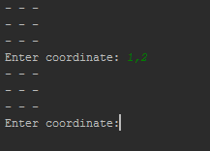Here is the debugging process:

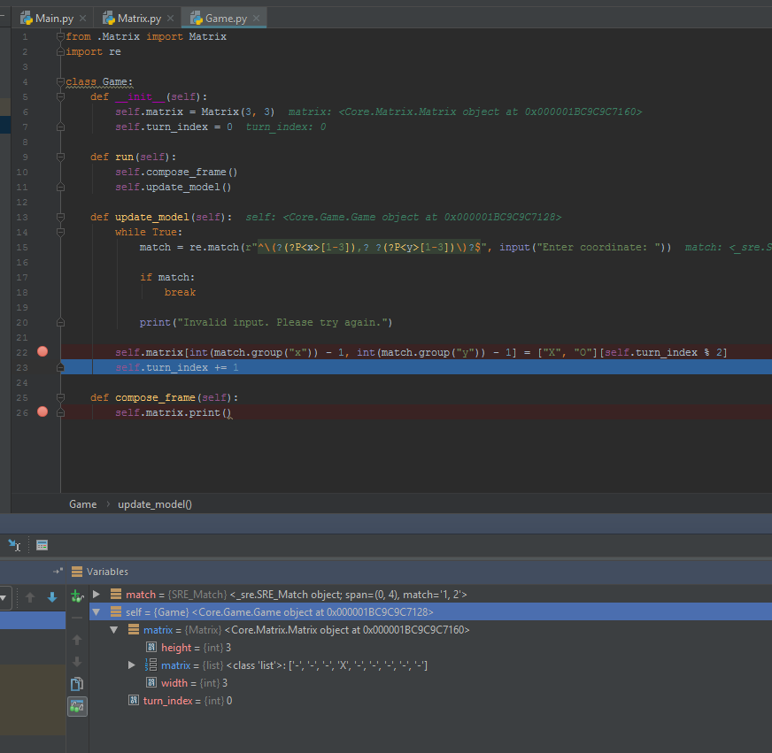As you can see, even though a coordinate was being input, the grid was not modified at all.

I ran the debugger, and noticed that the matrix was in fact being filled correctly.

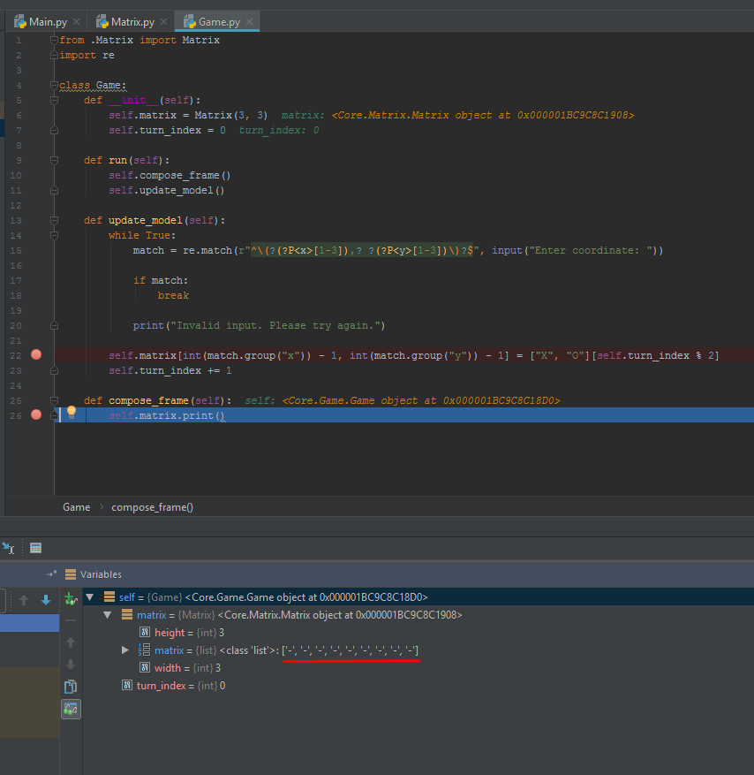However, as soon as the next round occurs (composing the game frame), the matrix is reset to the defaults.

I looked in *Main.py* to check what the problem was, and realised that a new instance of Game was being created on every iteration.

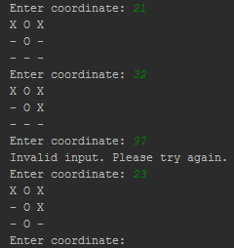After fixing the problem, the game printed correctly.

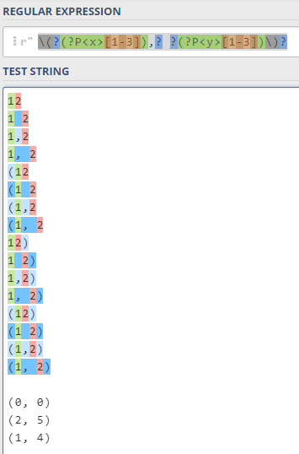In addition, in order to test and debug the regular expression which I used to validate user input, I used [regex101.com](http://www.regex101.com) and provided a variety of valid and invalid entries, to see which ones should fit and which ones should not, and built the regular expression around this.

Version 2:

1. Features being developed:

* The ability to enter an index instead of a 2D coordinate

1. Code:

Main.py is practically set in stone, so there have been no changes to that code file. Only changes since version 1 will be displayed.

Changes in *Game.py*:

**def update_model**(self): # Define update_model method (update game state)  
 **def set_symbol**(coordinate): # Define local function which places the player's symbol at the appropriate spot on the grid  
 self.matrix[coordinate] = ["X", "O"][self.turn_index % 2]  
  
 **while True**: # Loop while user input is invalid  
 input_string = input("Enter coordinate: ") # Store input for use in two places  
  
 match = re.match(r"^\(?(?P<x>[1-3]),? ?(?P<y>[1-3])\)?$", input_string) # Check whether user input matches 2D coordinate  
  
 **if** match:  
 set_symbol((int(match.group("x")) - 1, int(match.group("y")) - 1)) # Get 2D index and place user symbol in matrix  
 **break** match = re.match("^(?P<index>[1-9])$", input_string) # Check whether user input matches 1D coordinate  
  
 **if** match:  
 set_symbol(int(match.group("index")) - 1) # Get index and place user symbol in matrix  
 **break** print("Invalid input. Please try again.") # Indicate to user that their input is invalid  
  
 self.turn_index += 1 # Increment the user's turn

Changes in *Matrix.py*:

**def map_index**(self, coordinate): # Define method which maps the coordinate to the appropriate 1D index  
 **if** type(coordinate) **is** tuple: # If a 2D coordinate is given, map this coordinate  
 x, y = coordinate  
 **return** x + y * self.width  
 **elif** type(coordinate) **is** int: # If a 1D coordinate is given, it is already mapped, so just return it  
 **return** coordinate  
  
 # Prevent logic errors by asserting the type of the input variable  
 **assert** type(coordinate) **is** tuple **or** type(coordinate) **is** int # This line can only execute if a logic error has been encountered

1. Testing and Debugging

Initially I thought of using the same regex to match both types of input. This isn’t a difficult task, as the or operator (‘|’) can be used for conditional operation. However, this would be problematic to my program, as a method needs to be identified whereby the input choice can be gathered.

To solve this, I decided to use two regexes, and branch the code with appropriate flow control to provide different logic for each case.

First, I defined a regular expression to match the input:

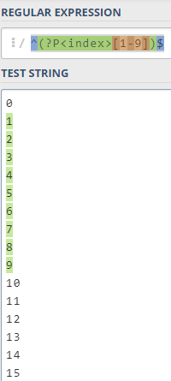

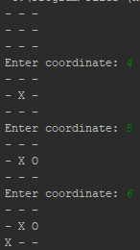After implementing the initial program, I noticed a small error: the user-entered coordinates were being zero-indexed. In other words, entering coordinate ‘5’ would fill cell #6, which has an index of 5. This is also problematic for the regular expression, as users can’t physically enter a coordinate which fills the first cell, and the regular expression would validate coordinates which are out of bounds.

This was a fairly simple fix, by taking away 1 from the user input.

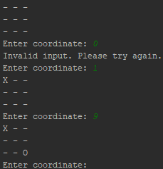

Once this was complete, this version was also complete.

Version 3:

1. Features being developed:

* Inability to place symbols at a filled coordinate
* Ability to win or draw the game

1. Code:

*Main.py*:

**from** Core.Game **import** Game # Import game class from 'Core' folder  
  
game = Game() # Create new instance  
  
**while** game.run(): # Loop until game has finished  
 **pass**

Changes in *Game.py*:

**def run**(self): # Define run method (one game round)  
 self.compose_frame() # Print game state  
  
 **if** self.process_game_state(): # Check whether game has finished  
 **return True** self.update_model() # Update game state  
  
 **return False** # Return that the game is still ongoing  
  
**def process_game_state**(self):  
 **def process_succession**(iterable, generator): # Local function which uses meta-programming principles to perform row, column, and diagonal checks  
 **for** item **in** iterable: # For each diagonal, row, or column  
 # Applies generator function to each item, and converts the collection into a set to check whether all  
 # symbols are the same  
 symbols = "".join(set(generator(index, item) **for** index **in** range(3)))  
  
 **if** len(symbols) == 1 **and** symbols != "-": # If all of the symbols are the same (but not '-')  
 print(f"{symbols} wins!") # The only symbol in the set wins  
 **return True** # Indicate win  
  
 **if** any(  
 [  
 process_succession(range(3), **lambda** column, _: self.matrix[column, 0]), # Check columns for win  
 process_succession(range(3), **lambda** row, _: self.matrix[0, row]), # Check rows for win  
 process_succession([0, 2], **lambda** index, diagonal: self.matrix[index + [diagonal, 0, -diagonal][index], index]) # Check diagonals for win  
 ]  
 ): # Check whether any row, column, or diagonal has a win state  
 **return True** # Return game end state  
  
 **if** all(map(**lambda** symbol: symbol != "-", self.matrix)): # Check if no empty cells are left  
 **return True** # Return game end state  
  
 **return False** # Return game continuing state

# compose_frame omitted  
  
**def update_model**(self): # Define update_model method (update game state)  
 **def set_symbol**(coordinate): # Define local function which places the player's symbol at the appropriate spot on the grid  
 self.matrix[coordinate] = ["X", "O"][self.turn_index % 2]  
  
 **def is_bad_coordinate**(coordinate):  
 **return** self.matrix[coordinate] != "-"  
  
 **while True**: # Loop while user input is invalid  
 input_string = input("Enter coordinate: ") # Store input for use in two places  
  
 match = re.match(r"^\(?(?P<x>[1-3]),? ?(?P<y>[1-3])\)?$",  
 input_string) # Check whether user input matches 2D coordinate  
  
 **if** match:  
 coordinate = (int(match.group("x")) - 1, int(match.group("y")) - 1)  
  
 **if** is_bad_coordinate(coordinate):  
 print("Bad coordinate. Please try again.")  
 **continue** set_symbol(coordinate) # Get 2D index and place user symbol in matrix  
 **break** match = re.match("^(?P<index>[1-9])$", input_string) # Check whether user input matches 1D coordinate  
  
 **if** match:  
 coordinate = int(match.group("index")) - 1  
  
 **if** is_bad_coordinate(coordinate):  
 print("Bad coordinate. Please try again.")  
 **continue** set_symbol(coordinate) # Get index and place user symbol in matrix  
 **break** print("Invalid input. Please try again.") # Indicate to user that their input is invalid  
  
 self.turn_index += 1 # Increment the user's turn

1. Testing and Debugging

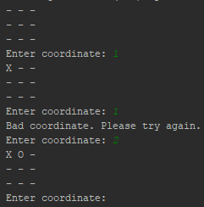The first feature I started developing was the inability to place symbols at a filled coordinate. Due to the simplicity of the code, this was an immediate success:

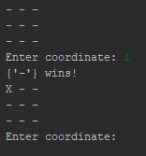However, for the game winning feature, the story was different. On the first test, this was the result:

My program was detecting that the ‘-‘ player was winning, as it had columns, rows, or diagonals which were the same. Again, this was a simple fix. I added a secondary condition (using the ‘and’ operator) which makes sure that all symbols are not dashes.

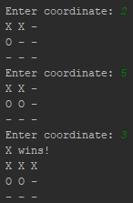Following this, the game was perfectly playable:

The only problem was that the game would not end when the player would win. To fix this, main just had to loop until game.run() returns false.

I also made sure that the game board was printed first, before displaying the win state, to allow the user to see the boards state at the end of the game, instead of exiting immediately.

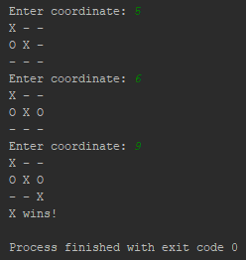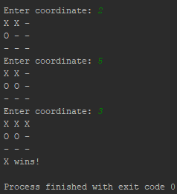Following this, the game was complete: