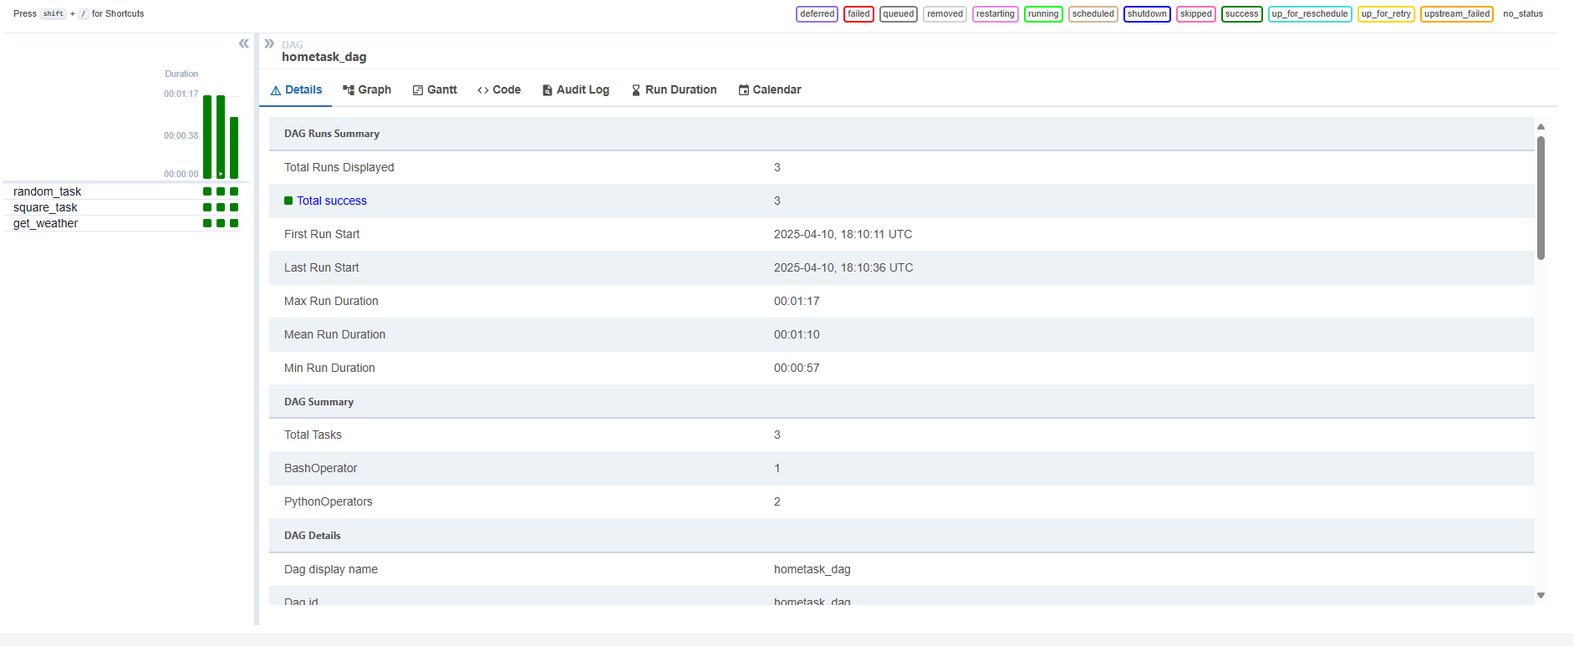

Сам даг:

from airflow import DAG

*2*from airflow.operators.python import PythonOperator, BranchPythonOperator

*3*from airflow.operators.bash import BashOperator

*4*from datetime import datetime

*5*from random import randint

*6*import requests

*7*

*8*dag = DAG("hometask_dag",

*9* start_date=datetime(2021, 1 ,1),

*10* schedule_interval='@daily',

*11* catchup=False)

*12*

*13*def square_random_num():

*14* num = randint (1, 1000)

*15* square_num = num ** 2

*16* print(f"Number is {num}, it's square is {square_num}")

*17*

*18*random_num_operator = BashOperator(

*19* task_id="random_task",

*20* bash_command="echo $[(RANDOM %100)]",

*21* dag = dag

*22* )

*23*

*24*square_num_operator = PythonOperator(

*25* task_id="square_task",

*26* python_callable=square_random_num,

*27* dag = dag

*28* )

*29*

*30*def get_weather():

*31* url = "https://goweather.herokuapp.com/weather/minsk"

*32* headers = {"Content-Type": "application/json"}

*33* response = requests.get(url, headers = headers)

*34* if response.status_code == 200:

*35* weather_data = response.json()

*36* return weather_data

*37* else:

*38* return "Error"

*39*

*40*weather_operator = PythonOperator(

*41* task_id = "get_weather",

*42* python_callable=get_weather,

*43* provide_context=True,

*44* dag=dag)

*45*

*46*random_num_operator >> square_num_operator >> weather_operator

