Introduction to A/B tests
What is an A/B test?
An A/B test (experiment) is an analytical technique whose goal is to compare several configurations/mechanics in processes using a control and a test group.
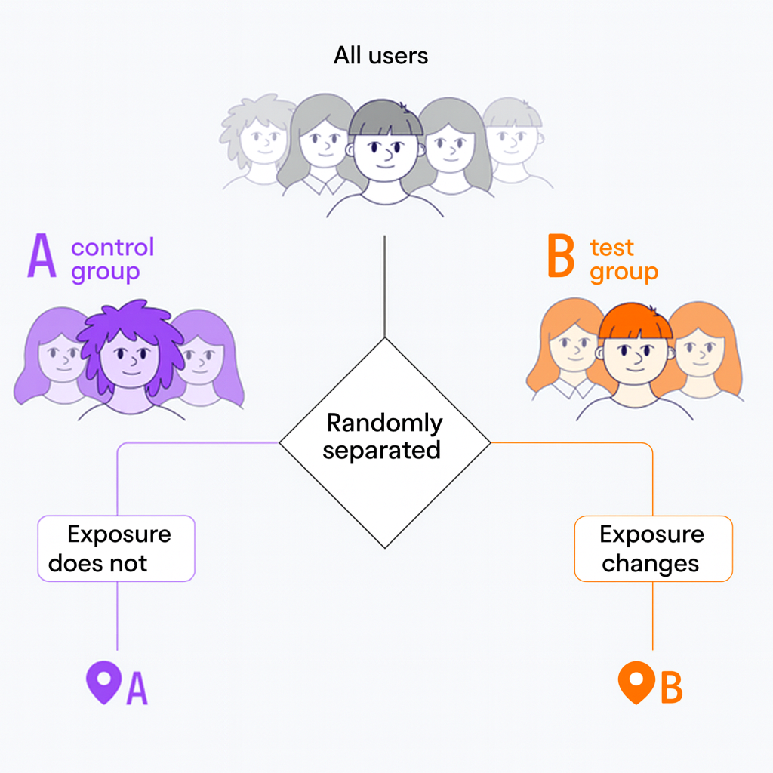
Given: our store's website has a reddish tint.
Business hypothesis: there is a proposal to repaint the site in other tones (for example, blue); this may potentially increase the conversion from visit to purchase.

Stages of A/B test design
- Define the statistical unit (order, customer, partner, point of sale, etc.).
- Define the target metric (and also guard metrics).
- Define the problems that may arise when splitting statistical units into groups.

Calculation of an A/B test
Task: draw conclusions from the A/B test based on the data.
Step 1. Calculation on the full sample.
Step 2. Calculation by segment:
- If pitfalls prevent evaluating A/B test results on the full sample.
- If we are interested in studying the difference of the treatment on a particular segment.

Example of an A/B test in a taxi aggregator
Given: In our taxi aggregator it was decided to provide special offers to customers — to place an order within 24 hours with a discount. The discount was always 25%.
Task: Evaluate how increasing the discount to 35% affects conversion.
[Scheme/flow retained — caption translated: “Example: evaluating the effect of increasing discount from 25% to 35% on conversion (taxi aggregator)”]

Random splitting of users

Hashing
A hash function is a function that transforms an arbitrary input array into a string of a specific type and fixed length.
Hashing represents a transformation of any amount of information into a unique set of characters that is inherent only to that particular input array.
Consider the Python function crc32.
Hashing is applied to unique identifiers (IDs) to ensure that:
- The split is random.
- A single unit belongs to only one group.

Experiment salt
An experiment salt is some string of characters (associated specifically with the given experiment) that is appended to the customer's identifier before hashing, in order to ensure random redistribution within each new experiment.

Splitting without salt
Problem: if you do not introduce a “salt”, then the same customer across any experiment will fall into the same group (depending on their id).

Splitting with salt
Solution: now each customer in every new experiment will be randomly assigned to a group again.
Thus, we solved the problem of a customer being permanently fixed to the same group.

Python code
(The code below is left unchanged — original Python preserved.)
import binascii

your_id = 3125678545

hash_your_id = binascii.crc32(bytes(str(your_id),
'utf-8'))

print(hash_your_id)

hash_your_id % 10

##################################################
#########

your_salted_id = str(your_id) + 'SaltySalty'

hash_your_salted_id =
binascii.crc32(bytes(your_salted_id, 'utf-8'))

print(hash_your_salted_id)

hash_your_salted_id % 10

