Slide 0:

Delivery Market Analysis Database

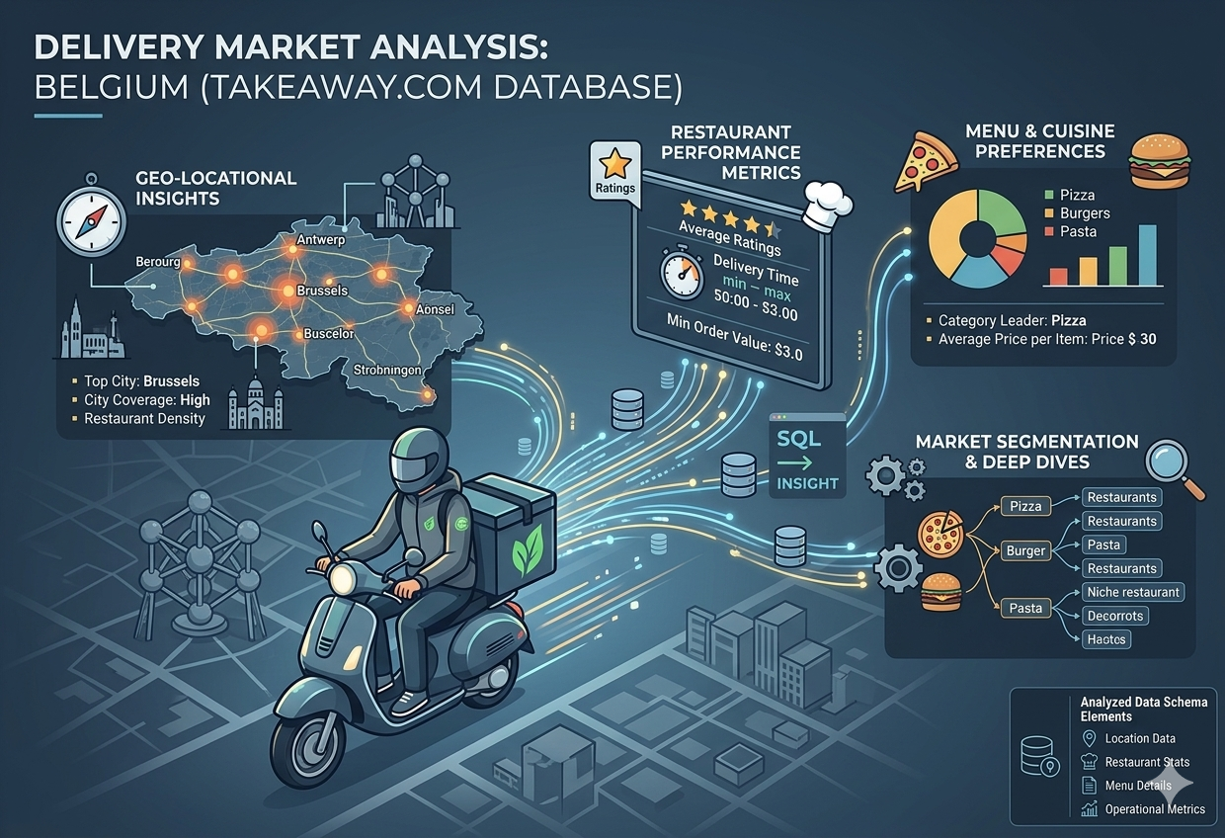

Database Used: takeaway.db (Belgium food delivery dataset)

Objective: Analyze restaurant performance, menu pricing, delivery coverage, and cuisine trends.

Key Analyses Performed:
- Price distribution of menu items
- Distribution of restaurants per location
- Top 10 pizza restaurants by rating
- Mapping locations offering specific dishes and average prices
- Identifying delivery «dead zones»
- Vegetarian and vegan dish availability by area
- World Hummus Order (top 3 hummus-serving restaurants)
- Restaurants’ price-to-rating ratio
- Cuisine types with highest average delivery fees per city
- Original insight

Tools & Methods: SQL queries, Python (pandas, folium, matplotlib), interactive maps , data visualization
Slide 1: Menu Item Price Distribution
Insight: The market is heavily dominated by affordable options, with the vast majority of items priced under 20€. High-end or "premium" items (above 100€) are extremely rare, suggesting that the platform is primarily used for everyday individual or family meals rather than luxury catering.

SQL Description: This query extracts all individual prices from the menuItems table. The data is then processed into specific price bins (e.g., 0-5€, 5-10€, etc.) to visualize the density of price points across the entire Belgian food delivery market.

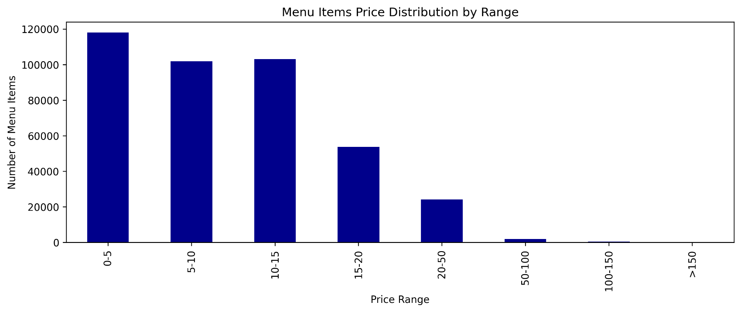

Slide 2: Distribution of Restaurants per Location
SQL Description: This query extracts all individual prices from the menuItems table. The data is then processed into specific price bins (e.g., 0-5€, 5-10€, etc.) to visualize the density of price points across the entire Belgian food delivery market.

Insight: The market is heavily dominated by affordable options, with the vast majority of items priced under 20€. High-end or "premium" items (above 100€) are extremely rare, suggesting that the platform is primarily used for everyday individual or family meals rather than luxury catering.

SQL Description: By joining the locations and locations_to_restaurants tables, this query calculates the total number of active restaurants in each city. It identifies the geographical hubs of the delivery industry in Belgium.
Insight: There is a massive concentration of services in major urban centers like Antwerp and Brussels. This high density indicates a mature and highly competitive market in metropolitan areas, while smaller towns remain underserved, representing potential growth zones.
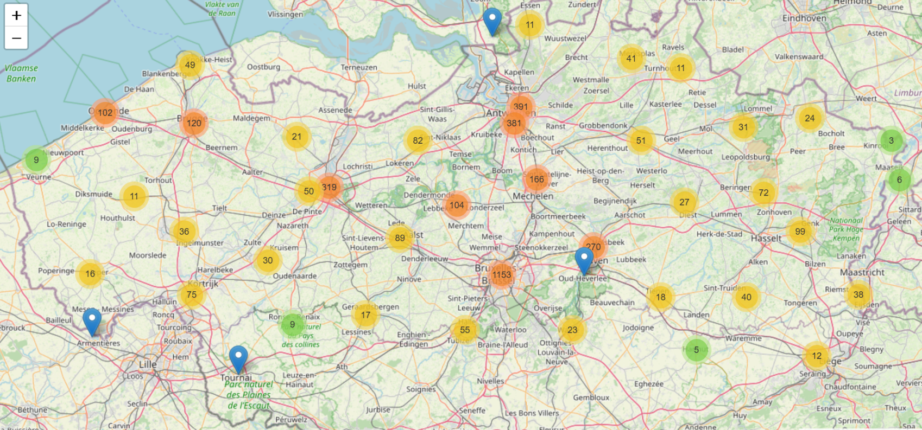
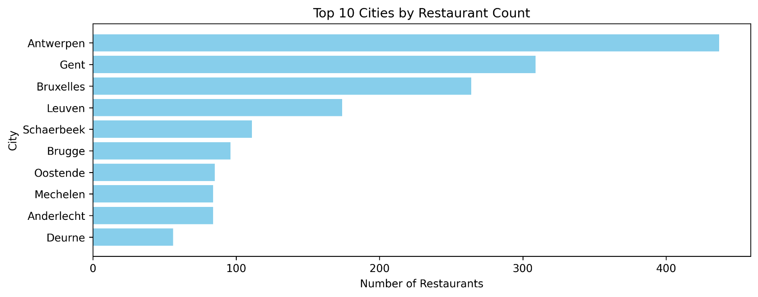

Slide 3: Top 10 Pizza Restaurants by Rating
SQL Description: This query extracts all individual prices from the menuItems table. The data is then processed into specific price bins (e.g., 0-5€, 5-10€, etc.) to visualize the density of price points across the entire Belgian food delivery market.

Insight: The market is heavily dominated by affordable options, with the vast majority of items priced under 20€. High-end or "premium" items (above 100€) are extremely rare, suggesting that the platform is primarily used for everyday individual or family meals rather than luxury catering.

SQL Description: This query filters the restaurants table for names containing "Pizza" and sorts them by their average rating. Only restaurants with a significant number of reviews are considered to ensure statistical relevance.
Insight: The Pizza category shows the highest level of customer satisfaction consistency. The top 10 establishments all maintain ratings above 4.7, proving that quality and execution in this niche are critical factors for surviving the intense competition.
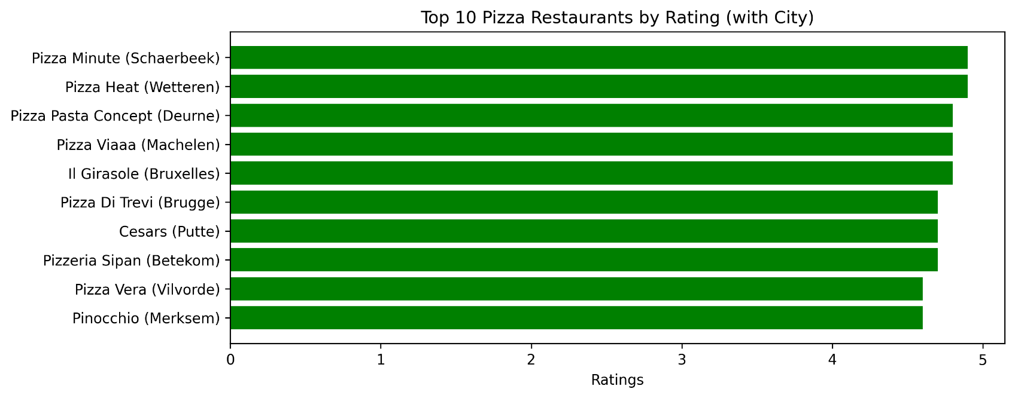

Slide 4: Map locations offering pasta and their average price (Folium)
SQL Description: This analysis uses Python to extract geographical coordinates (latitude and longitude) and average menu prices per restaurant. The data is then plotted on an interactive map using the Folium library.
SQL Description: This query extracts all individual prices from the menuItems table. The data is then processed into specific price bins (e.g., 0-5€, 5-10€, etc.) to visualize the density of price points across the entire Belgian food delivery market.

Insight: The market is heavily dominated by affordable options, with the vast majority of items priced under 20€. High-end or "premium" items (above 100€) are extremely rare, suggesting that the platform is primarily used for everyday individual or family meals rather than luxury catering.

Insight: The spatial distribution shows that while restaurant density follows population centers, pricing strategy varies by region. Higher average prices are clustered in business districts and affluent neighborhoods, reflecting the purchasing power of the local demographic.
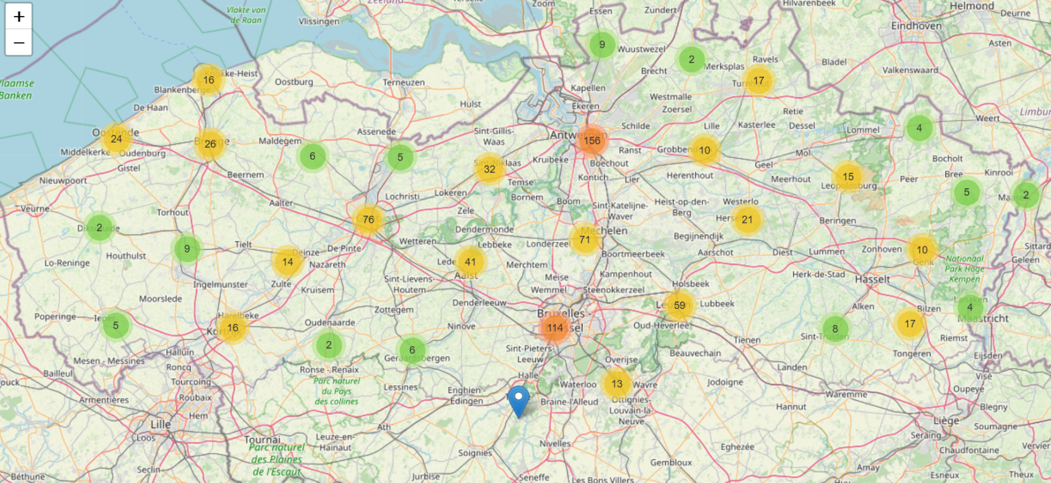
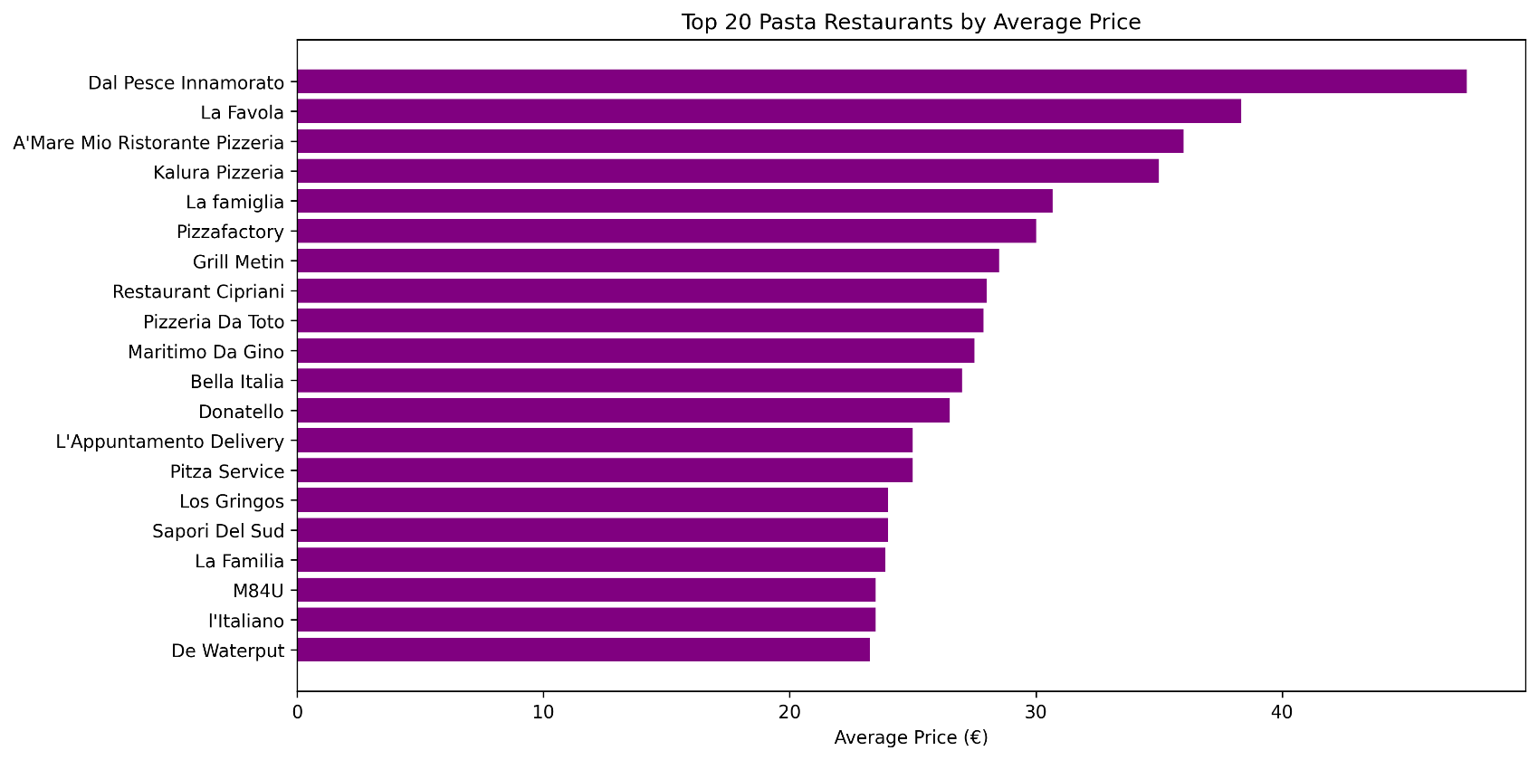

Slide 5: Which restaurants have the best price-to-rating ratio?
SQL Description: Using a Common Table Expression (CTE), this query calculates a "value metric" by dividing a restaurant's rating by its average menu price. It identifies where customers get the most "quality per euro."
SQL Description: This query extracts all individual prices from the menuItems table. The data is then processed into specific price bins (e.g., 0-5€, 5-10€, etc.) to visualize the density of price points across the entire Belgian food delivery market.

Insight: The market is heavily dominated by affordable options, with the vast majority of items priced under 20€. High-end or "premium" items (above 100€) are extremely rare, suggesting that the platform is primarily used for everyday individual or family meals rather than luxury catering.

Insight: The best "value for money" is not found in the cheapest restaurants, but in the mid-range segment. Restaurants that balance moderate pricing with high service quality achieve the best efficiency scores, making them the most attractive to recurring customers. 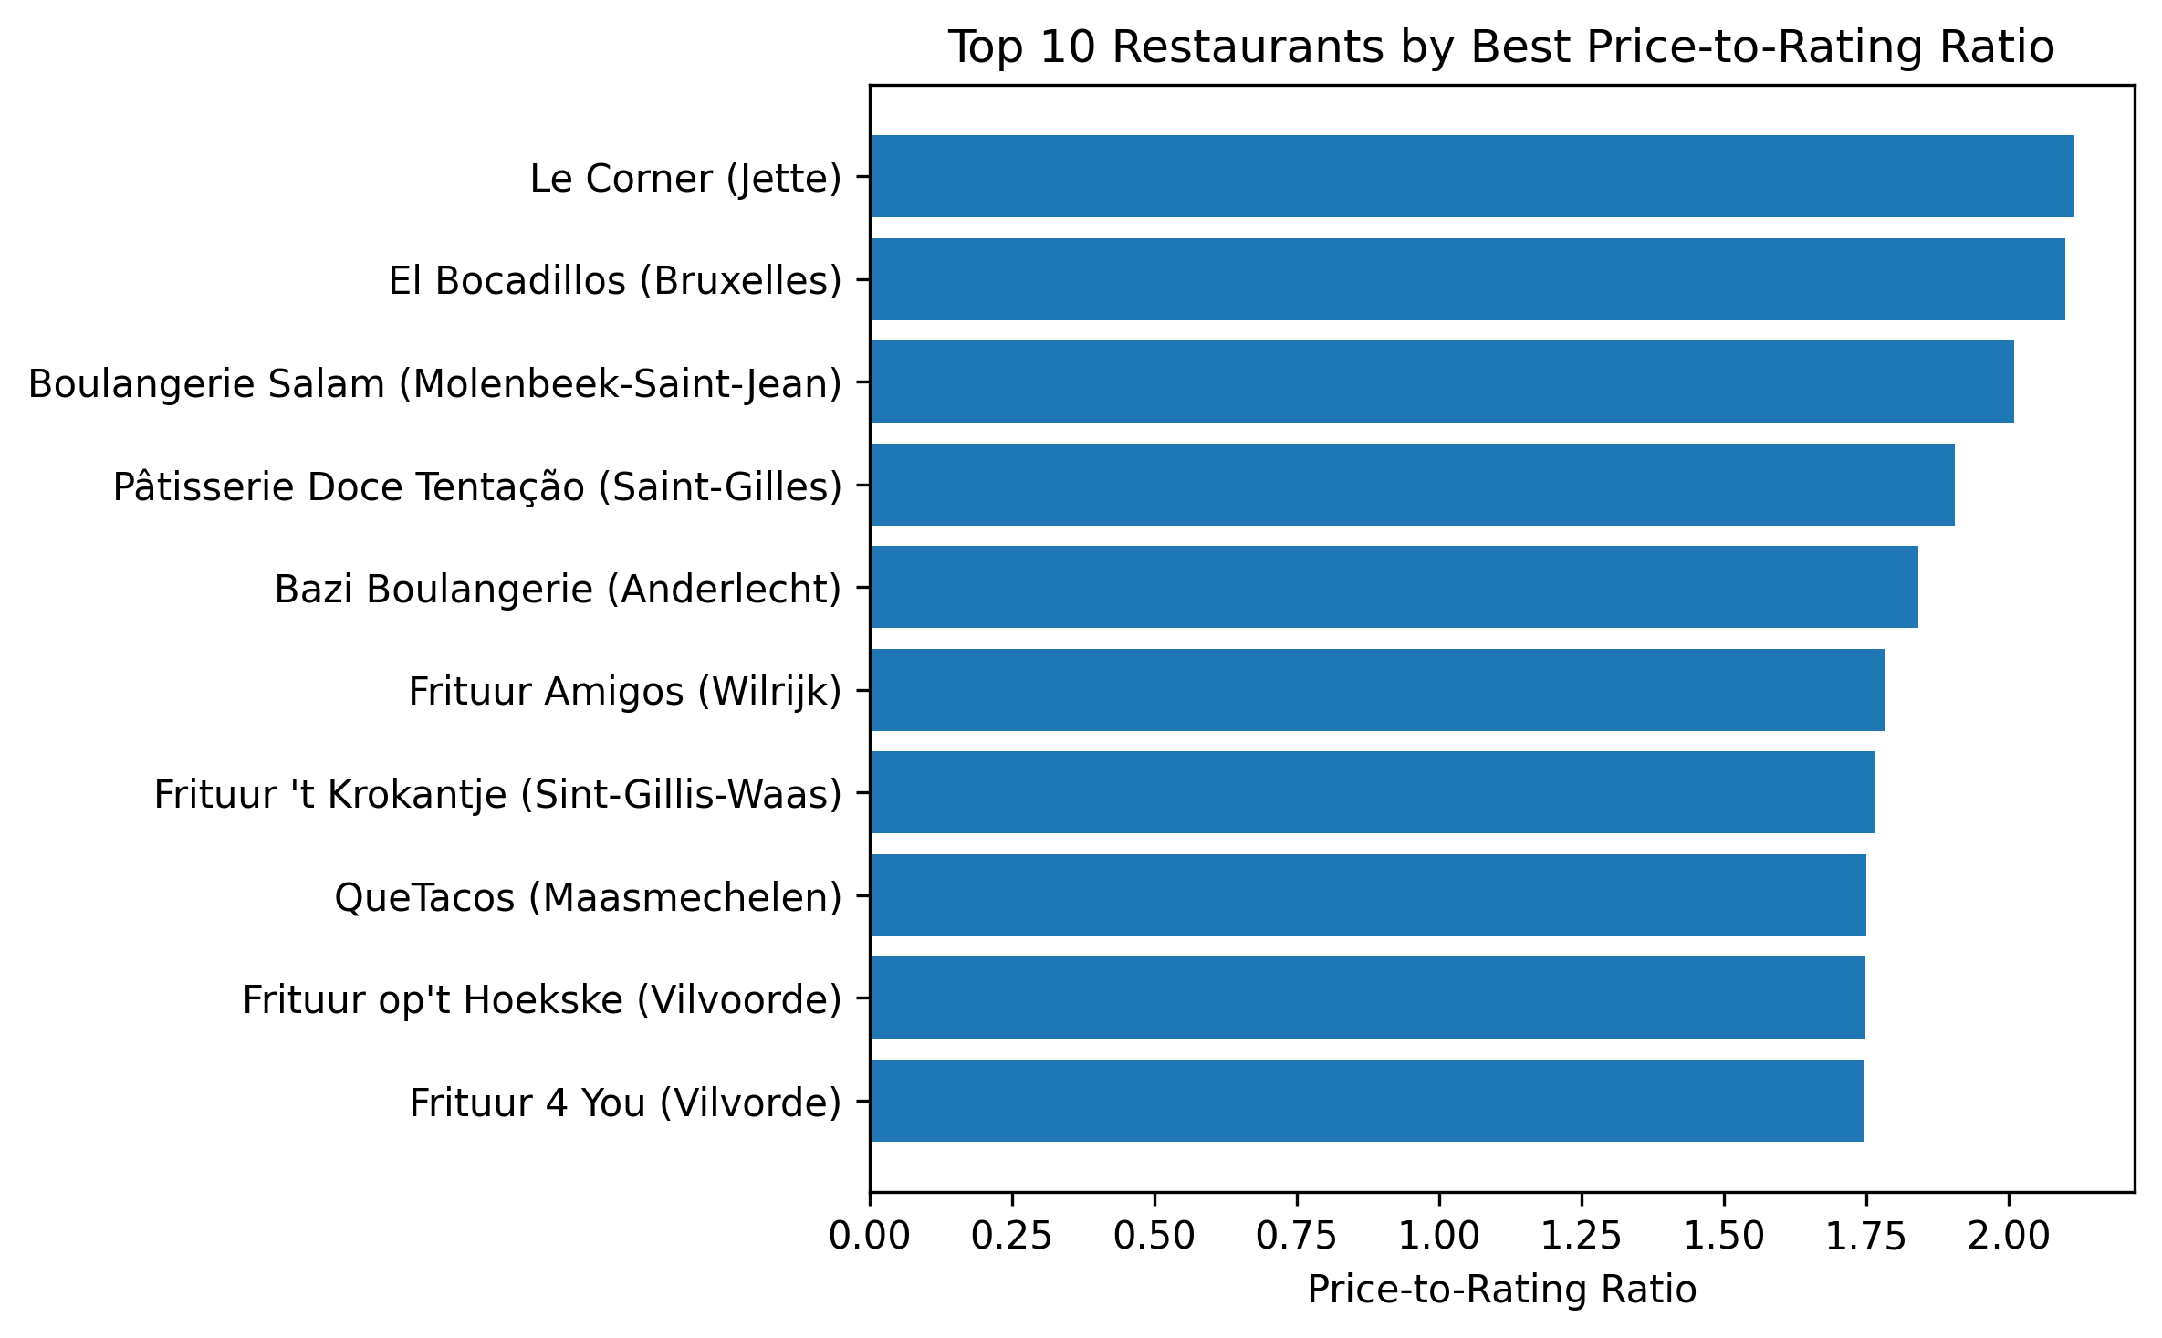

Slide 6: Identifying Delivery "Dead Zones"
SQL Description: This query uses a LEFT JOIN between cities and restaurants to find locations with fewer than 5 registered restaurants. It highlights areas where the delivery infrastructure is minimal or non-existent.
SQL Description: This query extracts all individual prices from the menuItems table. The data is then processed into specific price bins (e.g., 0-5€, 5-10€, etc.) to visualize the density of price points across the entire Belgian food delivery market.

Insight: The market is heavily dominated by affordable options, with the vast majority of items priced under 20€. High-end or "premium" items (above 100€) are extremely rare, suggesting that the platform is primarily used for everyday individual or family meals rather than luxury catering.

Insight: Several areas with populations exceeding 10,000 residents were identified as "dead zones" with very limited food choice. For delivery platforms, these areas represent "Blue Ocean" opportunities where new partnerships could easily capture the local market.
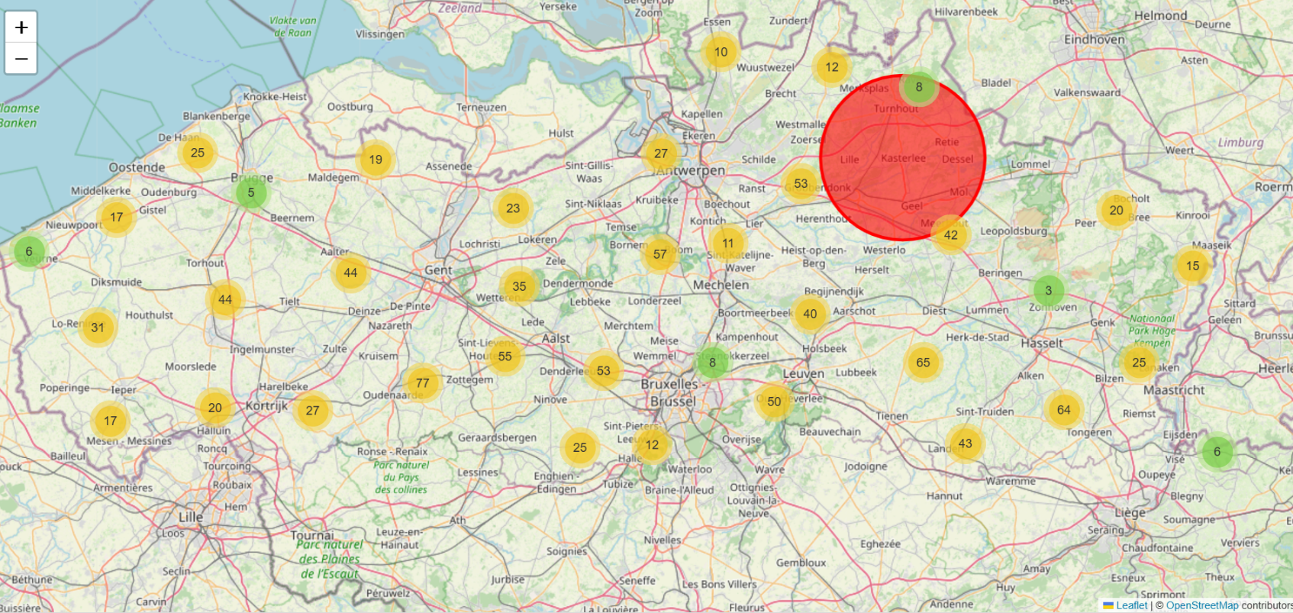
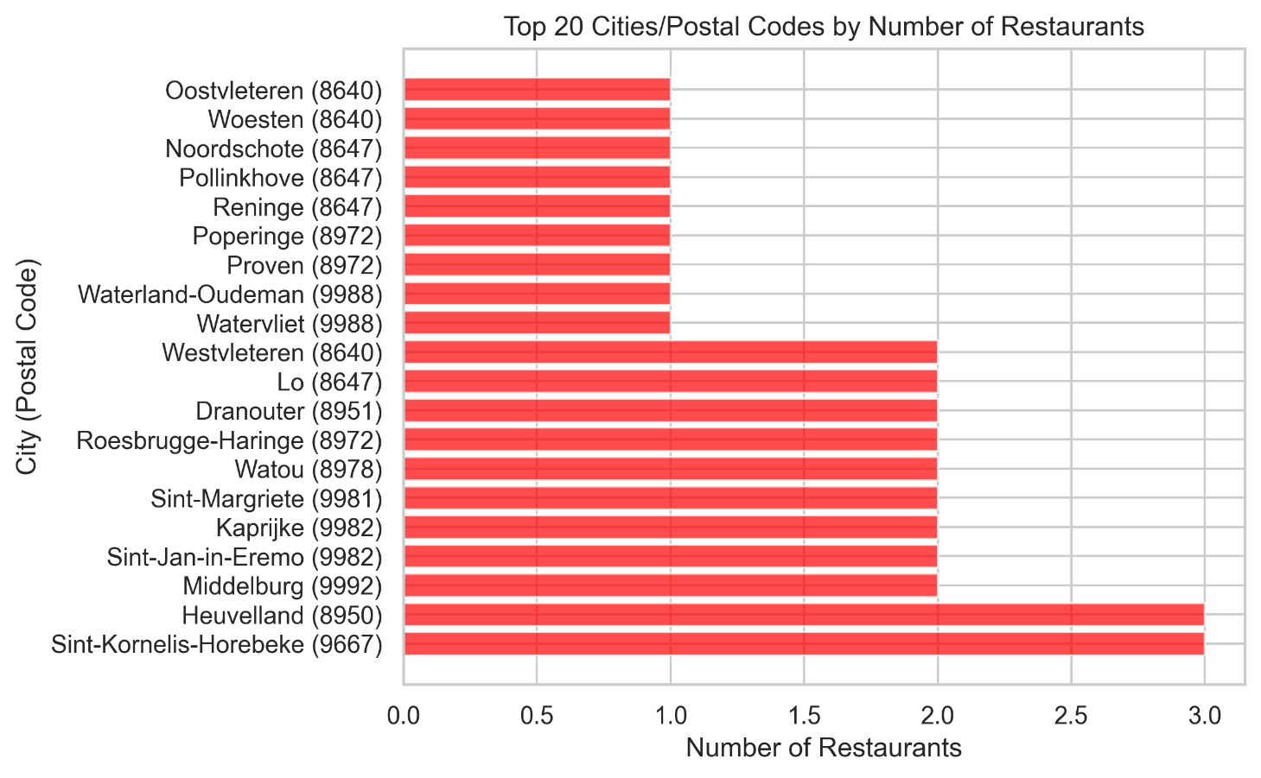

Slide 7: Vegetarian and Vegan Dish Availability
SQL Description: The query scans the menuItems table for keywords such as 'vegan' and 'vegetarian' and groups the results by city. This measures how well the market is adapting to modern dietary trends.
SQL Description: This query extracts all individual prices from the menuItems table. The data is then processed into specific price bins (e.g., 0-5€, 5-10€, etc.) to visualize the density of price points across the entire Belgian food delivery market.

Insight: The market is heavily dominated by affordable options, with the vast majority of items priced under 20€. High-end or "premium" items (above 100€) are extremely rare, suggesting that the platform is primarily used for everyday individual or family meals rather than luxury catering.

Insight: Flanders, particularly Leuven and Ghent, leads the country in green-diet adoption. The high volume of plant-based options in these cities suggests a strong correlation between university populations and the demand for sustainable food choices.
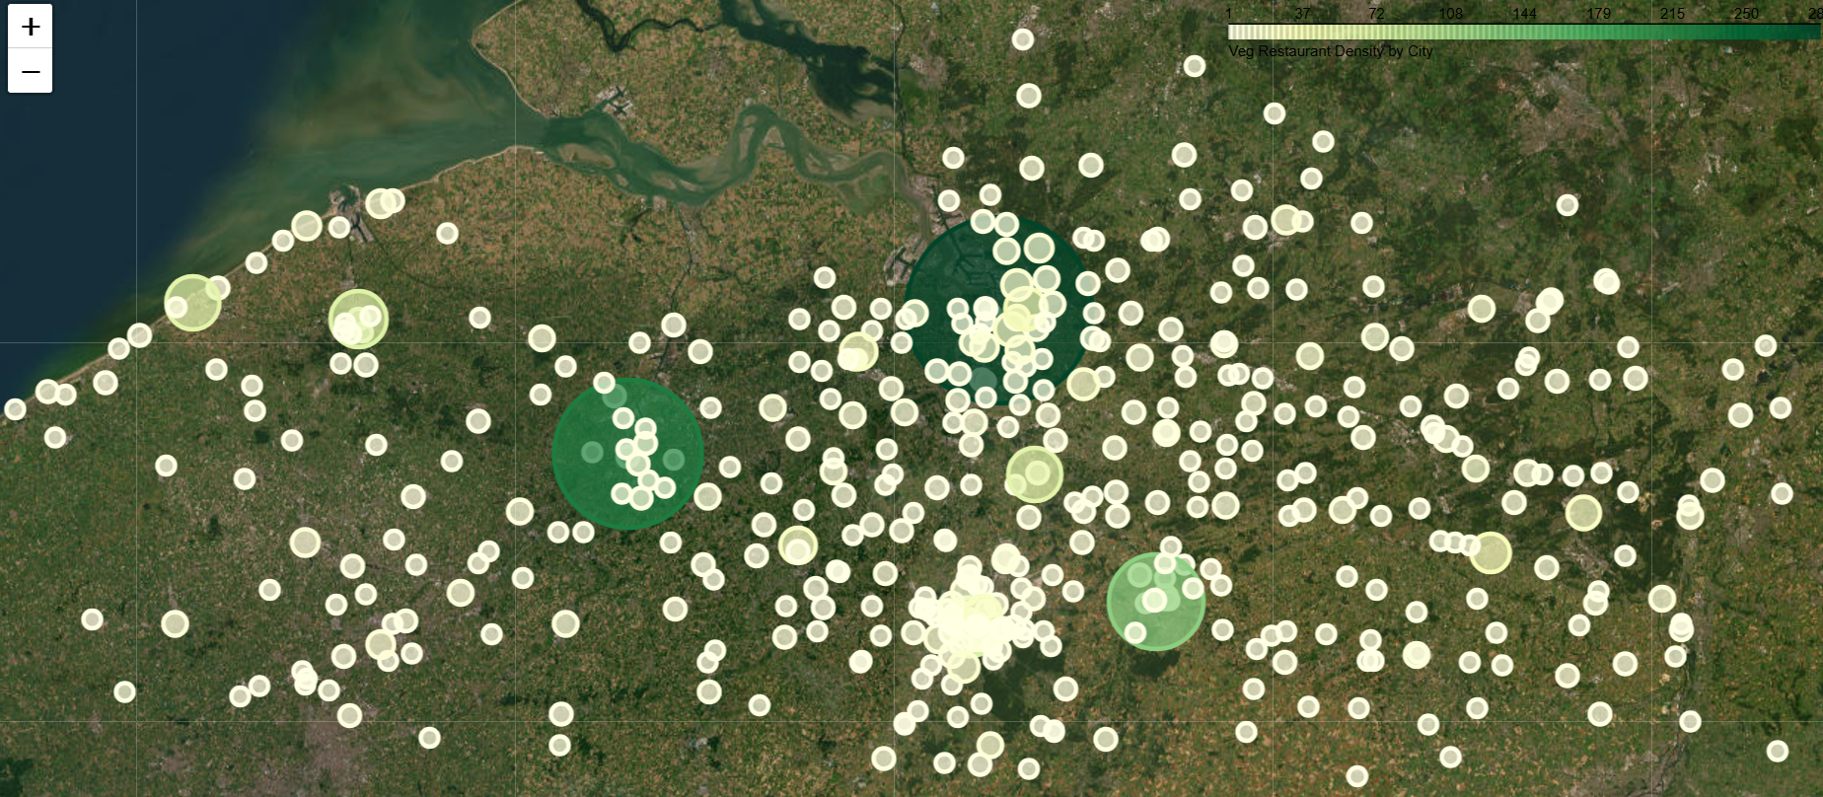
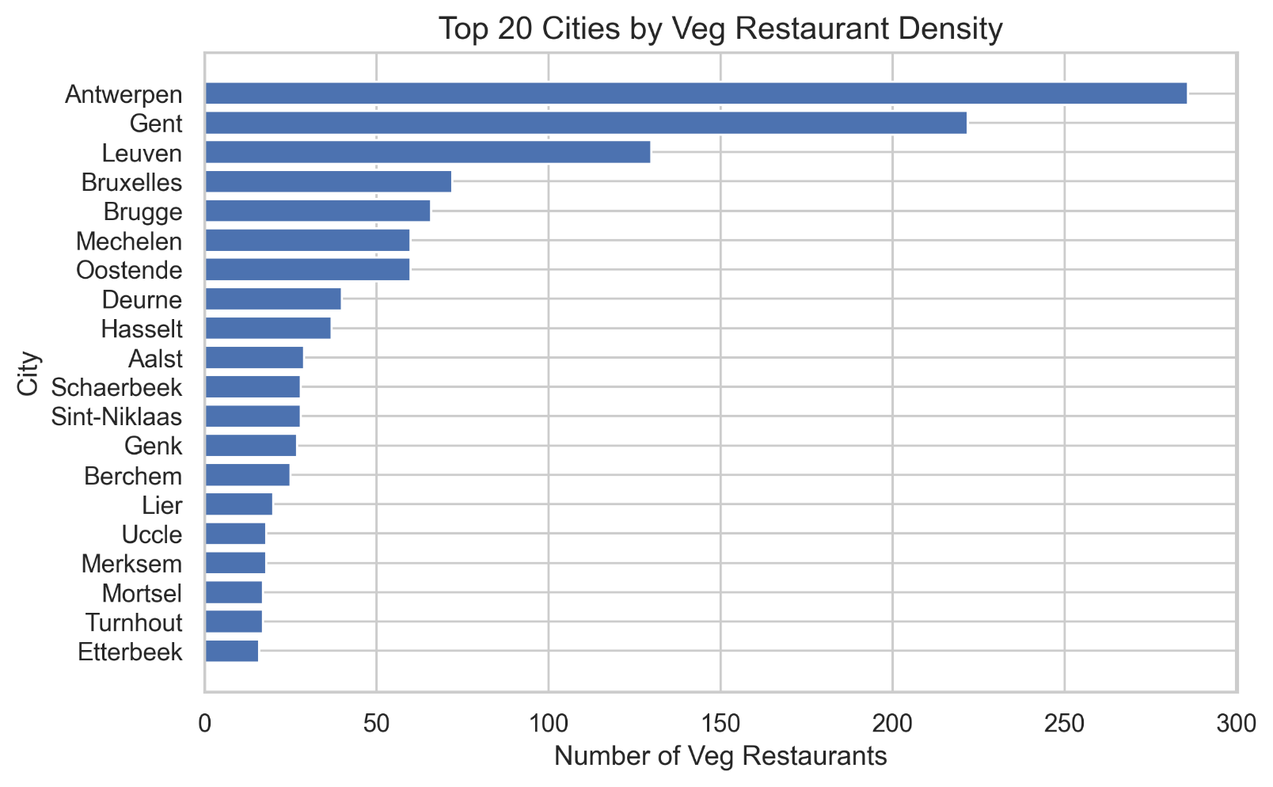

Slide 8: World Hummus Order (Top 3 Restaurants)
SQL Description: This niche query identifies restaurants that have the highest number of menu items containing the word "Hummus." It focuses on finding the leaders in specific ethnic and healthy food categories.
SQL Description: This query extracts all individual prices from the menuItems table. The data is then processed into specific price bins (e.g., 0-5€, 5-10€, etc.) to visualize the density of price points across the entire Belgian food delivery market.

Insight: The market is heavily dominated by affordable options, with the vast majority of items priced under 20€. High-end or "premium" items (above 100€) are extremely rare, suggesting that the platform is primarily used for everyday individual or family meals rather than luxury catering.

Insight: A few specialized venues dominate the hummus market, offering extensive variations of the dish. This level of specialization allows these restaurants to build strong brand authority in a very specific healthy-food niche.
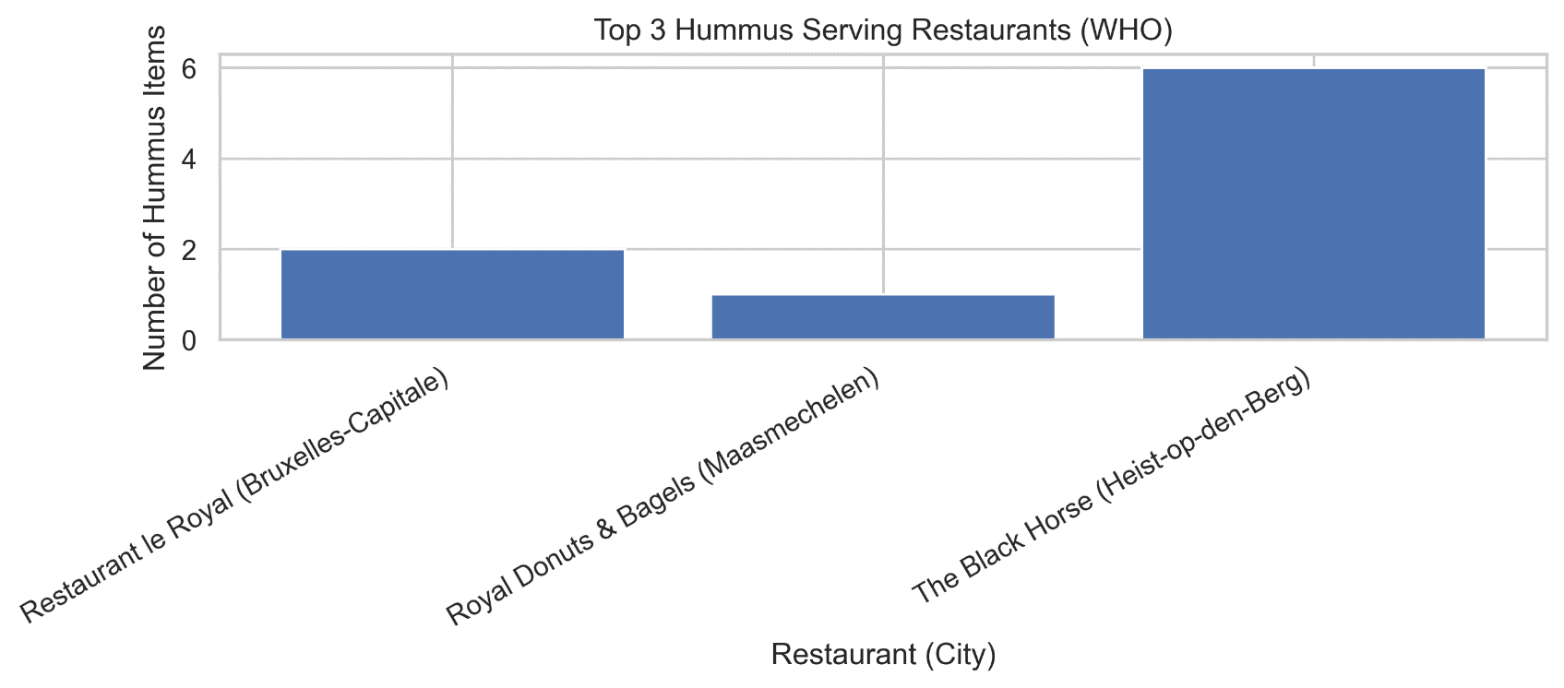

Slide 9: Restaurant Density per 1,000 Inhabitants by Province
SQL Description: This analysis combines restaurant counts from the locations_to_restaurants table with external provincial population data. By dividing the total number of restaurants by the population (in thousands) for each Belgian province, we calculate a density metric that allows for a fair comparison between high-population areas like Brussels and smaller provinces.
SQL Description: This query extracts all individual prices from the menuItems table. The data is then processed into specific price bins (e.g., 0-5€, 5-10€, etc.) to visualize the density of price points across the entire Belgian food delivery market.

Insight: The market is heavily dominated by affordable options, with the vast majority of items priced under 20€. High-end or "premium" items (above 100€) are extremely rare, suggesting that the platform is primarily used for everyday individual or family meals rather than luxury catering.

Insight: The results reveal a significant disparity in service accessibility. While major urban provinces show a high concentration of choices, some regions have a surprisingly low density of restaurants relative to their population. This identifies "underserved" provinces where market penetration is low, offering a strategic advantage for new restaurant partnerships and platform expansion.
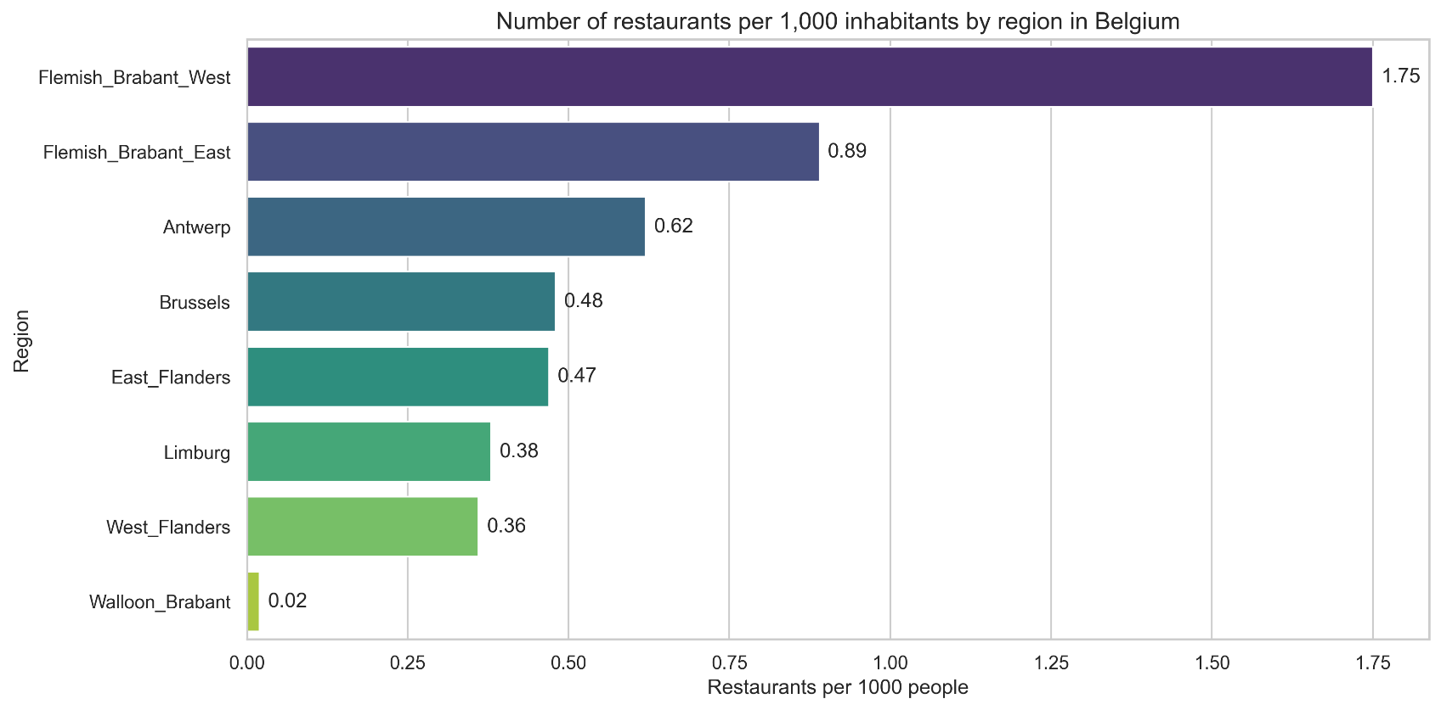

Slide 10: Top 5 Fast Sushi Delivery in Leuven
SQL Description: The final query targets the city of Leuven, filtering for Sushi restaurants with ratings > 4.0 and sorting them by the minimum estimated delivery time (durationRangeMin).
SQL Description: This query extracts all individual prices from the menuItems table. The data is then processed into specific price bins (e.g., 0-5€, 5-10€, etc.) to visualize the density of price points across the entire Belgian food delivery market.

Insight: The market is heavily dominated by affordable options, with the vast majority of items priced under 20€. High-end or "premium" items (above 100€) are extremely rare, suggesting that the platform is primarily used for everyday individual or family meals rather than luxury catering.

Insight: Leuven stands out as a high-efficiency hub for Sushi delivery, with top-rated venues offering minimum delivery times as low as 15-20 minutes. This speed, combined with high ratings, makes Sushi the most optimized category for "on-demand" dining in this region.
