F91 Mini-module Interrupt Demo Application

Introduction:
This sample application lets you use the interrupt generation for TEST button placed on the F91 mini module board and how to write an interrupt routine and to install the interrupt handler.

Operation:
The application creates a thread which will install the interrupt handler for the TEST button (PB3 port) and creates a thread that handles when the PB3 interrupt is generated. Whenever the PB3 interrupt is generated, the Interrupt handling thread is invoked and displays the message which contains the number of times the TEST button is pressed. This program will run till a RESET button is pressed.

The application output can be viewed in the HyperTerminal window just after program is executed as shown below.

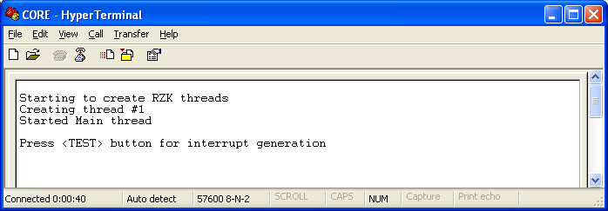
Figure#1:- HyperTerminal display for interrupt demo

Pressing TEST button twice the below output is displayed (Sample output shown contain the TEST button pressed twice.

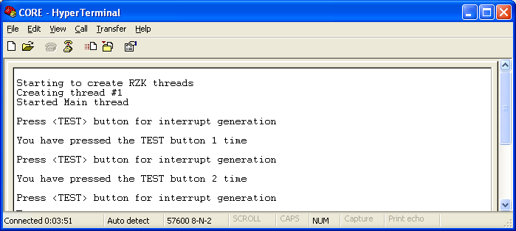
Figure#2:- HyperTerminal display for interrupt demo after the test button is pressed

