File System Shell Application

Introduction:
This ZiLOG File System shell application provides a user-interactive shell that accepts a number of commands and executes a corresponding operation. The shell application provides many commands that are in use in the DOS operating system, such as copy, move, ren, dir, etc.

This application can be used for determining the operations that the ZiLOG File System supports. Please note that the application uses only a few of the APIs present in ZiLOG File System; many more commands can be implemented at the application level.

Operation:
When the application is downloaded onto the target, the system will check for the existence of a valid file system on the configured target device. If a valid file system is present, then the shell command is displayed; otherwise, it will display the name of an invalid volume on the console. The user can issue any commands through the shell prompt to perform an operation. Operation on an invalid volume will result in an error condition, and an error message will be displayed. To make an invalid volume valid, the volume must be formatted. After entering a command and its required arguments, press the ENTER key to execute the command. The application will accept any characters until the ENTER key is pressed. Enter the “?” or “help” command to display all commands available in the application.

Where files and directories are stored in different configurations:
The table below lists where the files and directories will be stored when the FileSystem shell application is executed for different targets that reflect different configurations, such as RAM, FLASH, or COPY_TO_RAM.

Configuration/  Platform | RAM | FLASH | COPY_TO_RAM
eZ80F91 | External Flash | External Flash | External Flash
eZ80F92 | External Flash | External Flash | External Flash
eZ80F93 | External Flash | Platform RAM | Platform RAM
eZ80L92 | External Flash | Platform RAM | Platform RAM

User Interface commands:
The File System shell application provides many commands, each of which have a specific format. These commands are described in the following table.

Command | Description
? | Displays the help screen.
cd <directory name> | Changes the current working directory to a specified directory.
copy <file name> <directory name> | Copies a specified file into a specified directory.
create <file name> | Creates a new file in a specified path.
cwd | Displays the current working directory.
del <file name> | Deletes a specified file present in the current working directory or in a specified path.
deldir <directory name> | Deletes a specified empty directory (the root directory cannot be deleted).
deltree <directory name> | Deletes all subdirectories and files present within a specified directory, as well as the directory itself.
dir <directory name> | Displays directory and file information present in a specified directory.
format <volume name> | Formats a specified volume.
help | Displays the help screen.
gettime | Displays the system time.
md <directory name> | Creates a directory in the current working directory or in a specified directory.
move <file name> <directory name> | Moves a specified file to the a specified directory.
ren <file name> <new file name> | Renames a file to a specified name.
render <directory name> <new directory name> | Renames a directory to a specified name.
settime <year> <month> <day of month> <day of week> <hrs> <mins> <secs> | Sets the time to a specified value.
type <file name> | Displays the contents of a file on the console device.
vol | Displays different volume information present in the system.

How to execute in a ZDSII-based environment:
Requirements:
The following hardware and software items are required for the sample application using the ZiLOG File System.
Hardware:
eZ80® Development Platform with eZ80® module installed
ZPAKII/ USB smart cabel
One RS232 cable
Ethernet cable
Two COM ports on the PC
Software:
Windows operating system
ZDSII_eZ80Acclaim! v5.0.0
HyperTerminal application
Hardware Setup:
1. Set the jumper pin connections on the eZ80® Development Platform to their defaults.
2. Connect the power supply cables to the eZ80® Development Platforms (9V) and to the ZPAKII unit (5V, required if debugging with ZDSII).
3. Connect the ZDI target interface module to the ZDI J4 port on the eZ80® Development Platform (required if debugging with ZDSII).
4. Connect one end of the RJ-45 cable to the Ethernet port on the ZPAKII unit and the other end to the LAN (required if debugging with ZDSII).
5. Connect one end of the FRC cable to the ZPAKII unit and the other end to P1 on the ZDI target interface module (required if debugging with ZDSII).
6. Connect the RS-232 cable to the eZ80® Development Platform and to the COM1 port of the Development PC.

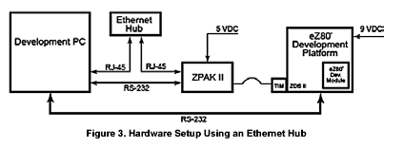

Note: Before using the ZiLOG File System, ensure that all of the host and target sys-tem requirements are met and the software installation is successful.

Setting up HyperTerminal:
1. Open the HyperTerminal program from Windows by navigating to Start→Programs → Accessories→Communications→HyperTerminal. The HyperTerminal application is launched and the Connection Description dialog box is displayed.
2. Enter a name for a new connection and click OK. The Connect To dialog box is displayed.
3. In the Connect using text field, select the port to which you have connected the serial cable (COM1 or COM2). Click OK.
4. In the <Port> Properties dialog box, enter the following port settings:
Bits per second: 57600 bps
Data bits 8
Parity None
Stop Bits 2
Flow control None
Click OK. A connection is established to the eZ80® Development Platform via a serial port.
5. Push the button labeled RESET on the eZ80® Development Platform.
Building the sample application project:
1. Launch ZDSII by navigating from the Start menu to Programs → ZiLOG ZDSII–eZ80Acclaim !_<Version> → ZDSII–eZ80Acclaim!_<Version>.
2. From the File menu in ZDSII, choose Open Project, and navigate to the following filepath:
<RZK Installed directory>\RZK_X.Y.Z_Lib_<TOOL>\SamplePrograms\FS\FSShell
3. Select the FSShell_XXX.zdsproj project (where XXX indicates the platform) within the above filepath and click Open. A list of source files appears in the Workspace panel.
4. Choose the configuration appropriate to your project (RAM, FLASH, COPY_TO_RAM) from Build → Set Active Configuration.
5. From the Project menu in ZDSII, select Settings. The Settings dialog box appears.
6. In the Settings window, select the Debugger tab. In the Debugger tab, click the Communication button. The Setup TCPIP communication dialog box appears.
7. In the IP Address field, a default IP address, 192.168.1.50, is displayed and highlighted. This IP address tells ZDSII where to find ZPAKII on a network. Enter an IP address that corresponds to your subnet settings. Do not change the other parameters. Click OK to return to the Settings dialog box. Click Rebuild All.
8. After the build is complete, push the button labeled RESET on the eZ80® Development Platform.
9. If the chosen configuration is RAM, download the application code by selecting Build → Debug → Download Code. To run application, select Build → Debug → Go.
10. If the chosen configuration is FLASH or COPY_TO_RAM, burn the FSShell_XXX_Flash.hex image or the FSShell_XXX_Copy_To_Ram.hex image into Flash memory using the ZDSII integrated Flash Loader, as follows:
a. Select Tools → Flash Loader to open the Flash Loader dialog box.
b. Select the FSShell_XXX_Flash.hex or FSShell_XXX_Copy_To_Ram.hex file located in the following path:
<RZKInstalled Directory>\RZK_X.Y.Z_Lib_<TOOL>\SamplePrograms\FS\FSShell
c. Click Erase, then click Fast Burn to write the application image into Flash memory.
d. Click Close to close the Flash Loader dialog box.
e. Push the button labeled RESET on the eZ80® Development Platform.
11. The application output can be viewed in the HyperTerminal window. An example of this output is shown in the screen shot below.

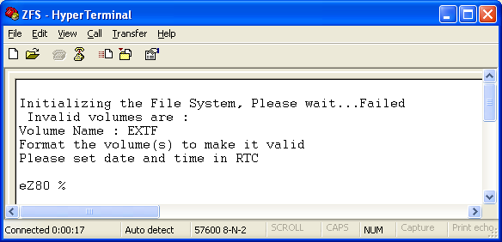

Sample commands to demonstrate the usage:
- Setting the date and time:
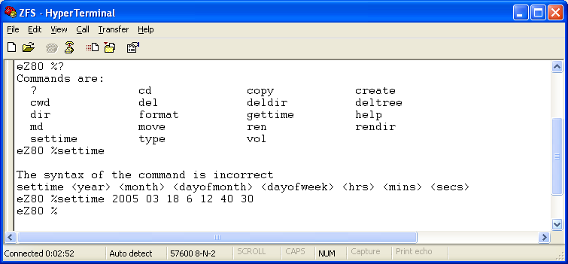

- As soon as File System shell is started, if any invalid volumes are present, those need to be formatted. So, Formatting the volume EXTF:
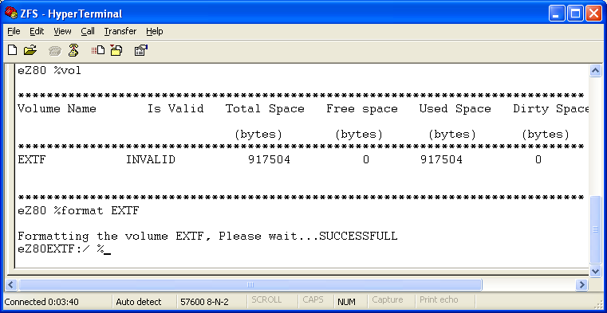

- Creating a directory called “MyDir”.
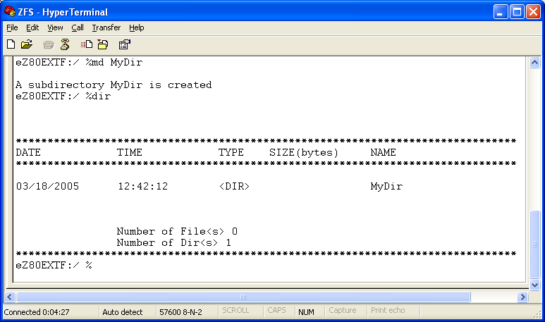

- Creating a file named “MyFile.txt”. A primitive editor is present in standalone shell which will accept maximum of 128 characters and <CR> or <Enter> key will store the typed data into the file.
