RTC Demo Application

Introduction:
This sample application lets you use RTC to change the date and time and also lets you to setup an alarm. Whenever the alarm times-out, a message will be displayed on the screen. Then it keeps on displaying the current time on the screen.

Operation:
The application creates three threads. Thread for continuously displaying the date and time, thread for accepting the time and modifying the date and time in RTC, other thread to setup an alarm. The date and time setup thread is invoked by pressing the PB0 button present on the development board, and alarm time set thread is invoked by pressing the PB1 button present on the development board. Whenever these threads finish their work, they will be suspended to give control to the date-time display thread that displays the date and time. Please note that the setting up of alarm should be within a week as it is a characteristic of RTC present in the eZ80 devices.

The application output can be viewed in the HyperTerminal window as shown in the figures below.

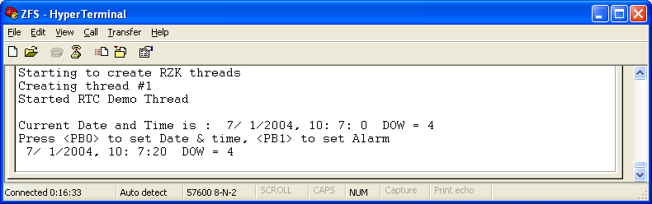

Figure#1: A snapshot of HyperTerminal screen showing Initial Time and date info on
HyperTerminal

Setting the new time and date:
Press PB0 button present on the development board and enter the date and time which need to be set. Example as below:
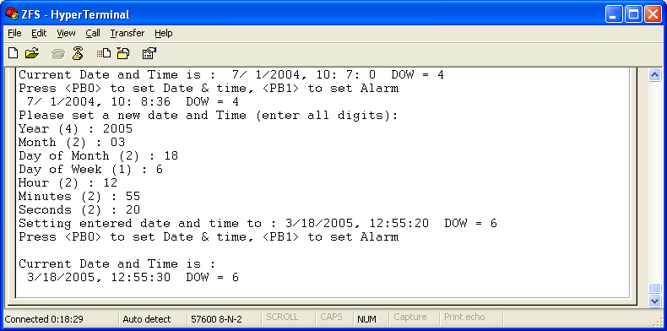
Figure #2: A snapshot of HyperTerminal screen showing setting of new Time and Date

Setting an Alarm:
Press PB1 button present on the development board and enter the time for which alarm is needed

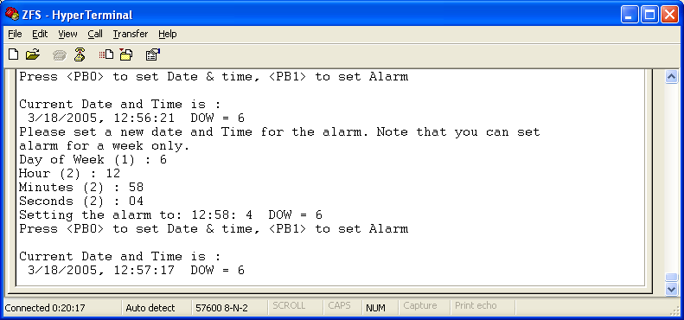
Figure#3: A snapshot of HyperTerminal screen showing an Alarm Setting

Once the Alarm triggers, the system gives an indication as shown in Figure#4, below
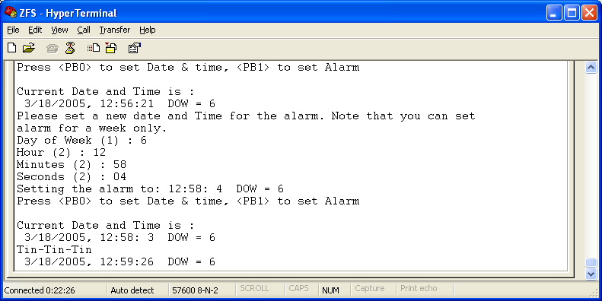
Figure#4: A snapshot of HyperTerminal screen showing a message once the Alarm triggers

