Serial Device Driver Sample Application

Introduction:
The sample program demonstrates the usage of serial driver. It basically shows how the different APIs provided by the serial driver could be used for serial communication over the UART.

What this application does:

The demo program opens a serial device (UART0) for communication. It accepts the input through the HyperTerminal on the host system and reads the input into the application buffer. It then echoes back all the bytes read back to the HyperTerminal.

Operation/Design:
The design of the sample program is very simple. In the main () function, a single auto start thread is created and UART0 is opened. In the thread body of UARTPeek () a function is called to get the number of bytes available in the UART Rx buffer. These many bytes are read into the application buffer by calling RZKDevRead () function with the handle for UART0 device. The contents of the same buffer are transmitted back over UART0 by calling RZKDevWrite () function. This happens in a continuously and any data sent UART is echoed back on the HyperTerminal

Below is the HyperTerminal Snapshot showing the UART demo application

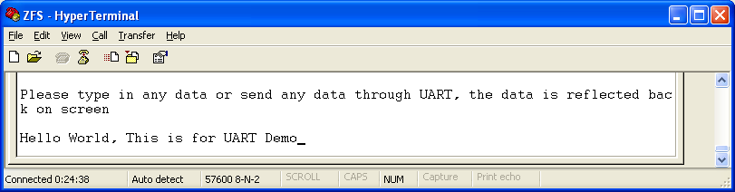
Figure#1: Data sent through UART displayed on HyperTerminal

