Intrmsgq Sample Application

Introduction:
This sample application sends messages from an interrupt thread to a normal thread and unblocks the normal thread. Normal thread here is blocked on a message queue.

Operation:
The application uses several APIs present in the RZK (Real-Time Zilog kernel) to create a message queue, then a thread blocks on the message queue using a message queue API and then interrupt thread sends message using a send API thereby unblocking the thread.

The display on the HyperTerminal Window is captured to a notepad and is depicted below

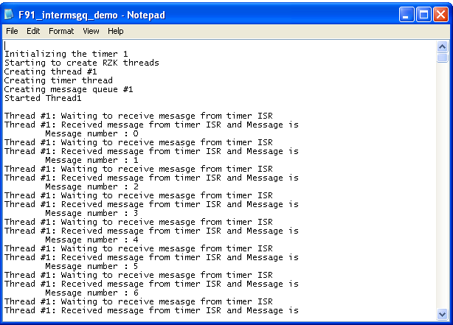

Figure #1: Interrupt message queue demo.

