Data Transfer between a Serial Link and a TCP/IP Link

This document describes an eZ80®-based serial-to-TCP and TCP-to-serial communicator that transfers data between a serial RS-232 link and a TCP/IP link. The communicator application, powered by the eZ80F91 MCU and running the ZiLOG TCP/IP Software Suite (ZTP), accepts incoming data from the Internet (or LAN), and sends it to a serial port. This communicator application is also capable of uploading serial data to the Internet (or LAN).

The serial-to-TCP and TCP-to-serial communicator application provides an excellent interface for controlling web-enabled devices. Web-enabling a device that serves as a source of data to an external processing device is convenient via the internet. This method of communication provides connectivity between serial devices and the Internet. Often, web-enabled devices output data through a serial UART-compatible channel. This data output can be a continuous stream, or it can be a series of data packets offering greater reliability in terms of communication. However, a remote device featuring a UART communications port can contain information that can be processed by another external processing device, such as a CPU. Sending information to this external processing device can be accomplished by using a web-enabling device such as a serial-to-TCP interface. This method of information transfer results in a throughput performance that offers a significant improvement over current communication methods, such as modems or low-end ISDN.
Theory of Operation
Figure 1 illustrates a serial-to-TCP interface. This serial-to-TCP interface functions as a serial-to-TCP and TCP-to-serial converter. The eZ80® device acts as a web server to provide an interface between the serial link and the TCP link. One end of the eZ80® device is connected to a HTML (web) page using the CGI function interface, and the other end is connected to a serial device using the UART driver interface. One end of the eZ80F91 web server transmits/receives data from the HTML (web) page using the CGI function interface. The other end of this web-server is connected to the serial device (HyperTerminal) to transmit and receive data from this end, using the UART driver interface.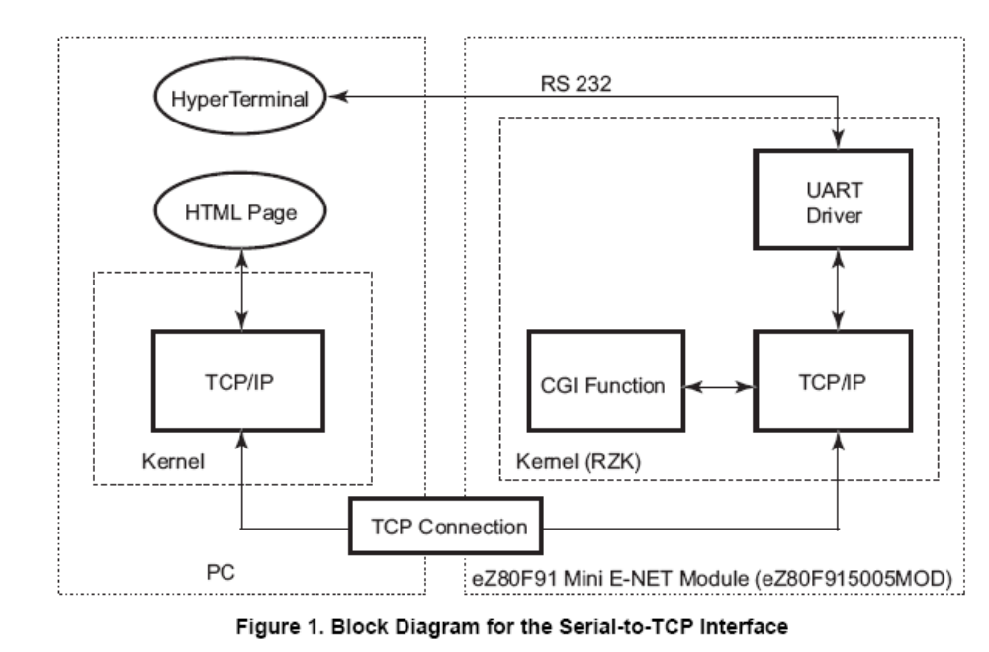

Developing the Communicator Application
This section discusses the software implementation for the serial-to-TCP and TCP-to-serial communicator application.
Software Implementation
Figure 2 is a software flow control diagram illustrating the main function block for the serial-to-TCP interface. The serial-to-TCP and TCP-to-serial communicator application is implemented in two software modules: the serial interface module and the TCP interface module.
Serial Interface Module The serial interface module uses the HyperTerminal application as a serial input/ output device. Whenever the user hits a key, the Serial Read thread continuously reads the data from the UART driver and stores this data in the Current buffer. If the Current buffer is full or if the user hits the Enter key, this data is transferred from the Current buffer to the TCP buffer. The TCP window reads the data from the TCP buffer and updates the Serial Read window. The data-upload CGI function uploads the data to the HTML page after receiving repeated requests from the browser.

TCP Interface Module The TCP interface module uses the TCP window (HTML web page) which contains two separate windows for writing and reading data. After the user clicks the Submit button, the TCP Write window transfers the data to the buffer using the CGI function interface. The TCP Read window is updated automatically and continuously. The TCP-to-serial CGI function interface reads the data from the HTML page on receiving a request from the browser. This browser request is generated after the user clicks the Submit button at the TCP Write window. The browser request updates the serial buffer with the current received data, and uploads the data to the serial driver for transmission over the serial link (HyperTerminal in this case).
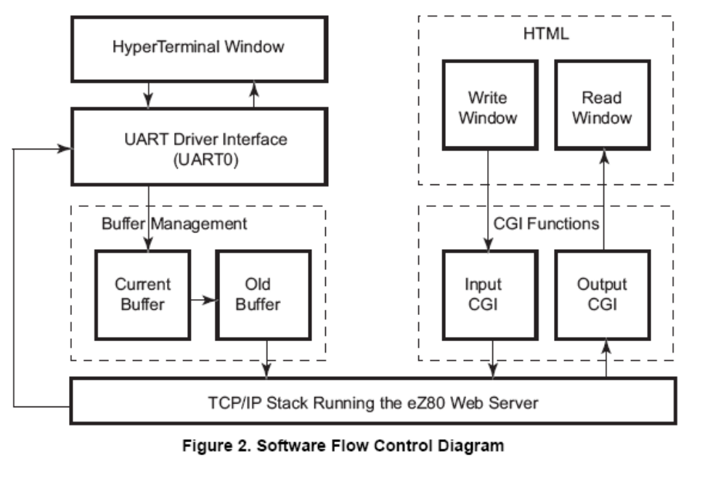

Following are the steps to execute the application at eZ80 side:

- Open the demo project S2TCPDemo_F91_Mini.zdsproj which is located in the following file path:
..\ ZTP\SamplePrograms\ Serial2TCPDemo
- Open ZTPConfig_mini.c file. For this application, DHCP (Dynamic Host Configuration Protocol) is disabled; therefore, ensure the following: b_use_dhcp = FALSE
- In the ZTPConfig_mini.c file, locate the following commonServers structure definition:
struct commonServers csTbl=
{ "172.16.6.28", // Default Timer Server.
"", // Default Network Timer Server( NTP )
"", // Default rfs server.
"", // Default File Server - Not currently. // used.
"172.16.6.194" // Default Name Server.
};

struct If ifTbl[MAX_NO_IF]=
{
// Interface 0 -> Ethernet Configuration.
{ &usrDevBlk[0], // Control block for this device.
ETH, // Interface type.
ETH_MTU, // MTU.
ETH_100, // Speed can be ETH_10,AUTOSENCE.
"172.16.6.198", // Default IP address.
"172.16.6.1", // Default Gateway.
0xffff0000UL // Default Subnet Mask.
}

The ifTbl variable contains the network parameters and settings (in the four-octet dotted decimal format) that are specific to the local area net-work at ZiLOG by default. Modify the above structure definition with appropriate IP addresses within your local area network.
- Rebuild the project and generate the code to be downloaded.
- Flash the hex file to the F91 Mini module.

Following are the files provided along with this demo.

Serail2TCPDemo
|---- main.Mini.c -- Entry point function for the application
|---- S2TCP_cgi.c -- Serial To TCP Demo application
|---- S2TCPDemo_F91_Mini.zdsproj – The project workspace
|---- S2TCP_website_Mini
|--- serial_to_tcp.htm
|--- S2TCP.htm
|--- main.htm
|--- call_cgi.htm
|--- S2TCP_website
|--- S2TCP_website.zdsproj

S2TCP_website.zdsproj is used to generate the Serial 2 TCP webpage.
In case there is any need to change the web page, please regenerate the library S2TCPMini_Website.lib by opening S2TCP_website.zdsproj file and copy the generated .lib file to the ../ZTP/Lib folder.

