TCP and UDP Demo Applications

The TCP and UDP Demo applications are simple user interactive applications that use the ZTP native socket interface to showcase socket programming for network data transfer.

This demo application has two parts – the eZ80 side application and the host side application. The host side application can either act as an UDP/TCP server or an UDP/TCP client. The same is applicable to the eZ80 side applications. For example, if a UDP Client application program is run on the host side, then the eZ80 should act as a corresponding UDP Server. The host side application must be explicitly started. On the eZ80 side, running a command triggers the TCP or UDP client demo application. In any case, the server should always be started first. These demo applications run in the full duplex mode means, in case of eZ80 running as a TCP/UDP server, the amount of data that is received, is sent back to the client. Where as in the case of eZ80 running as a TCP/UDP client, the amount of data that is sent, is received back from the windows server application.

This demo application provides a set of user-interactive commands for viewing the demo functions.

To run this demo, perform the following steps.

- On the eZ80 side the demo project is located in the following file path:
..\ ZTP\Demos\TCPUDPDemo\ZTP_TCPUDP_DEMO_F91.zdsproj. For the source package and
..\ ZTP\SamplePrograms\TCPUDPDemo\ZTP_TCPUDP_DEMO_F91.zdsproj for the library package.

- Execute the project and generate the code to be downloaded. Please refer to the ZiLOG TCP/IP Software Suite Quick Start Guide (QS0049) for details about downloading the TCP and UDP demo applications onto the eZ80Acclaim! Development Board.

- On the host side, run the tcpserver.exe or udpserver.exe executable to make the host act as a TCP/UDP server. To make the host act as a TCP/UDP client, run the tcpclient.exe or udpclient.ext file. The host end applications are a part of the ZTP release package and are available in the following location:
..\ ZTP\SamplePrograms\TCPUDPDemo\Demo1\Src folder for library package
..\ ZTP\Demos\TCPUDPDemo\Socket\Src for source package.

- Users are provided with the following TCP and UDP Demo commands, in addition to the default commands on the eZ80 side, which can be executed from the ZTP Shell. The various commands provided and the usage is explained as under.

  - bsdtcpclient- Executes single TCP client application
  - bsdtcpserver - Executes single TCP server application
  - bsdudpclient - Executes single UDP client application
  - bsdudpserver - Executes single UDP Server application

- On the eZ80 side, a corresponding command should be chosen to execute the demo.
The commands and the parameters are explained in detail in the examples provided.

Notes:
1. It is recommended to run the server first and then start the client application either on the host or the eZ80 side.
2. We change the packet size for TCP and UDP by changing the macro’s MAX_BUF_SIZE_TCP, MAX_BUFF_SIZE_UDP in socketdemo.c file by default it is configured TCP to 4000 bytes and UDP to 1000 bytes.

Running the TCP Client Application

To execute the TCP client application and to make data transfer on eZ80, perform the following steps.

- Before executing tcpclient applications on eZ80 side, execute tcpserver.exe on host side. After running the executable on the host side, a DOS window pops-up prompting the user to enter inputs such as port number to listen.

2. The Figure below is a screenshot of the command prompt window with the parameter specified.

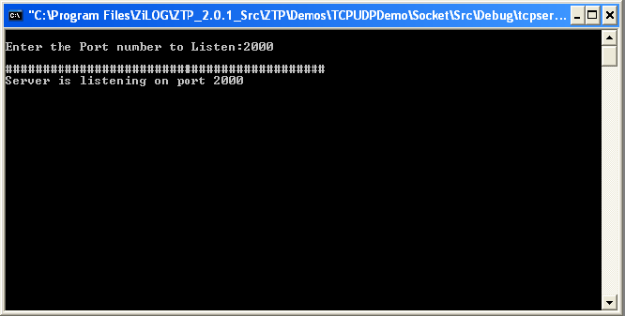

- The tcpserver application now runs on a host listening on the specified port ( For e.g. 2000 )

- Run the tcpclient application on the eZ80 side by entering the bsdtcpclient command. The user is prompted to enter server’s IP address and the port number.

- Specify the IP address and port number on the eZ80 side. The tcp client applications will communicate to the tcpserver application running on the host. By default this application sends 4000 bytes packet to the server and the same 4000 bytes packet is received from the server.

- Considering the above scenario, where the TCP Server on the host side is listening on the port number 2000, the following screen shot displays the eZ80 side data transfer with the inputs from the user as IP Address and port Number.

- A message ‘TCP CLIENT DEMO’ is displayed on the console and the user must wait till the data transfer is complete. After the data transfer is completed, the console displays messages like “Sent 4000 bytes data to the server” and “Received 4000 bytes from the server”. These messages indicate that the demo is completed successfully.

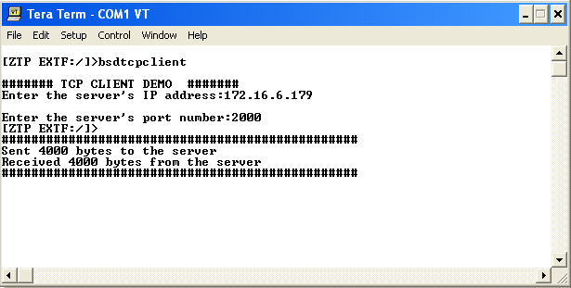

- The below Figure illustrates the output of the data transfer on the host side.

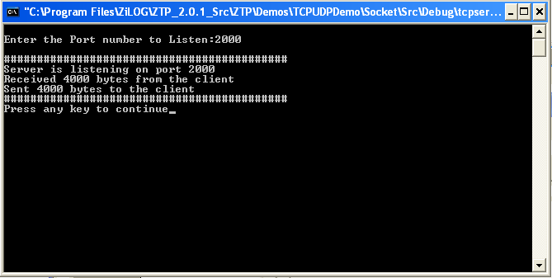

- To Execute UDP client demo repeat the above steps by executing command bsdudpclient on eZ80 side and by running the udpserver.exe on windows side.

Running the UDP Server Application

To execute an UDP server application on eZ80, perform the following steps.

- Execute the bsdudpserver command on the eZ80; the user is prompted to enter port number to listen.

- The Figure below is a screenshot of the command prompt window with the port Number specified as 2500.

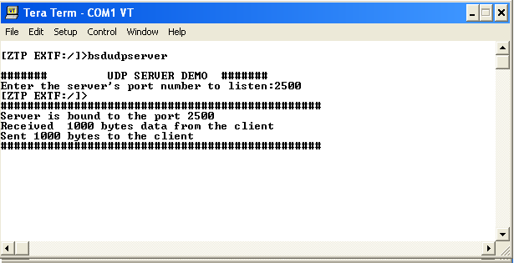

- The udp server is listening on port number 2500.

- Run the udpclient application on the host side by executing udpclient.exe. The user is prompted to enter server’s IP address and the port number.

- Specify the IP address and port number on the host side. The UDP client application on the host side sends 1000 bytes packet to the server and the same 1000 bytes packet is received from the server.

- The Figure below is a screenshot of the command prompt window with all the parameters specified from Host side.

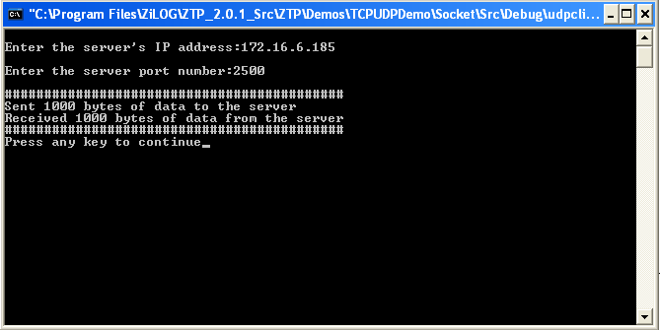

- The below Figure illustrates the output of the data transfer on the eZ80 side

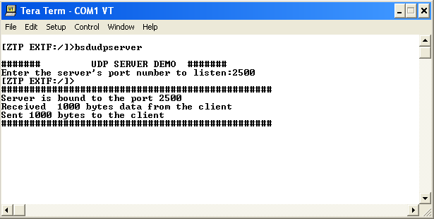

The user must wait till the data transfer is complete. After the data transfer is completed, the console displays messages like “Received 1000 bytes data from the client” and “Sent 1000 bytes to the client”. These messages indicate that the demo is completed successfully.

- To Execute TCP server demo repeat the above steps by executing command bsdtcpserver on eZ80 side and by running the tcpclient.exe on windows side.

