eZNetConfig Software package

The eZNetConfig Software package provides online configuration and remote firmware updates for servers based on the eZ80F91 product line. The eZNetConfig Software package consists of a server application on eZ80F91 and a client application that runs on windows system. eZNetConfig Software package software provides the following functionality:

- Network Scan within the subnet for eZ80F91 devices.
- Remote firmware update.
- Online configuration capability.

Theory of Operation
This software package is a demonstration of the capability and flexibility of ZTP (ZiLOG TCP/IP Software Suite ). Online configuration allows parameters of the server to be accesses and controlled remotely. The Remote firmware updates allows the firmware to be updated remotely via Ethernet without extra hardware. The Network scan lists the different eZ80F91 devices within the subnet. For Online configuration and Remote Firmware updates TCP is used and for Network Scan UDP is used.

Network Scan.
- For this IGMP should be enabled, eZ80F91 joins the Multicast group 226.2.2.2.
- Opens a UDP port 4111 and waits for commands.
- When data arrives on this UDP port it checks for the request.
- If it is a “discover” request then it sends its IP address, EMAC address and the name of the device to the system that sent the request. Any other messages on the port are ignored.

Online Configuration.
- For this Data Persistence should be enabled, the configuration settings are stored in the Flash Info page of eZ80F91 device.
- At Boot Up these configurations are read and correspondingly the values are set.
- eZ80F91 opens a TCP socket on port 4000 and listens for connection.
- After a connection is accepted on the listening socket the client is authenticated by a common shared string( password ).
- If the client is authenticated then check for the requested command.
- If the command is “QUERRY” then eZ80F91 replies with the current configuration of the system.
- For the “QUERRY” the configuration that will be sent to eZNetConfig utility is the one stored in the Flash Info page. If DHCP is enabled then the IP parameters assigned are the ones provided by the DHCP Server.
- If the command is “SETPAR” then eZ80F91 reads the configuration parameters sent along with the command. These parameters are then stored in the Flash info page and the system is rebooted for the new configuration parameters to take effect.

Remote Firmware Update.
- This is applicable only for COPY TO RAM configuration where in the CODE is flashed on to the Internal Flash memory and at runtime this CODE is copied to RAM and executed from RAM.
- When the CODE is being executed from RAM the Internal Flash can be updated with a new program which is also a COPY TO RAM configuration program.
- After a connection is accepted on the listening socket the client is authenticated by a common shared string( password ).
- If the client is authenticated then check for the requested command.
- If the command is “FIRMWA” then eZ80F91 prepares for updating the Internal Flash with new ZTP firmware.
- After the ZTP firmware is updated to the internal flash, the system will reboot for the new firmware to start execution.

Limitation of the eZNetConfig.
- For Network Scan IGMP protocol must be enabled and Data Persistence must be enabled for Remote configuration.
- Remote Firmware Update is only for COPY TO RAM configuration of ZTP on eZ80F91.
- The code should fit into the eZ80F91 internal flash only.
- During the Remote Firmware due to network problems if connection to eZ80F91 is lost or power supply is disrupted then the system cannot be recovered.
- When reading the current configuration the values that is sent to eZNetConfig utility is the one stored in the Flash Info page. So if DHCP is enabled then the IP parameters assigned to eZ80F91 may not be the same, but are the ones provided by the DHCP Server. If time server and DNS server IP address are not parameters are stored in the Info page then it is read from the commonServers structure.

Steps to Execute eZNetConfig on eZ80F91 side:

- Open the demo project eZNetConfig.zdsproj which is located at ..\ ZTP\SamplePrograms\ eZNetConfig.
- Change the system parameters to suit your network and build the project.
- Erase the Internal Flash, Flash Info page and flash the generated code to internal flash of eZ80F91 device.
- Reset the Development Board for the ZTP code to execute.

Steps to Execute eZNetConfig on host side:

- Run the WindowseZnetConfig.exe.
- Below are the screen shots of the output of the different commands.

Main Menu

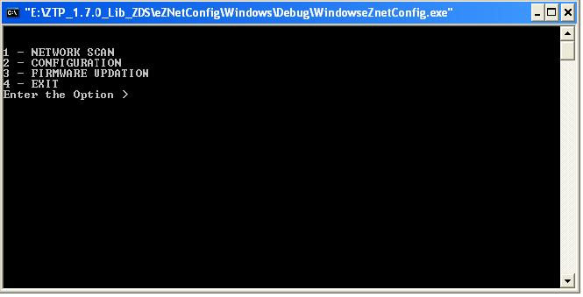

Network Scan

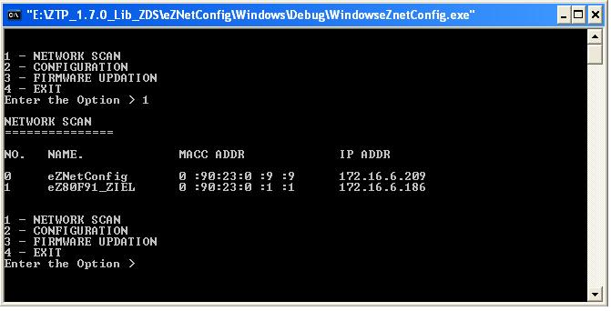

Configuration.

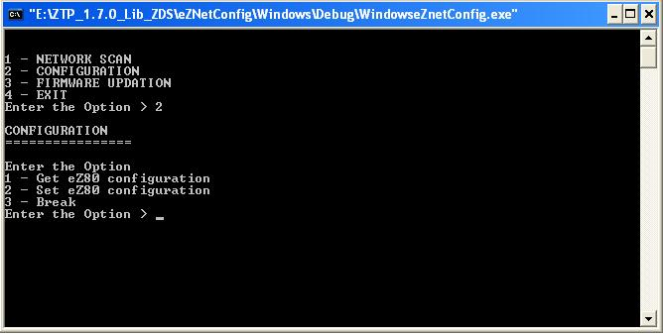

Get eZ80 configuration

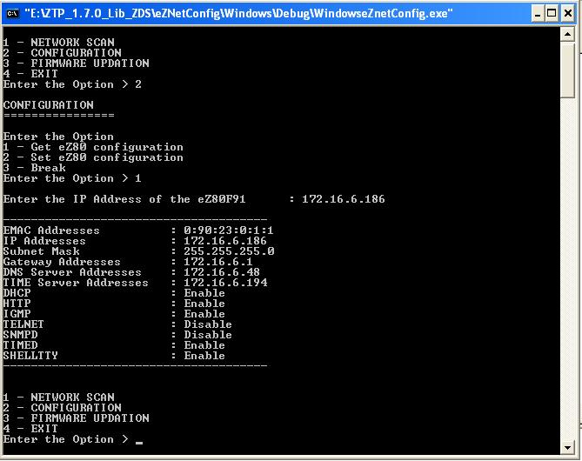

Set eZ80 configuration

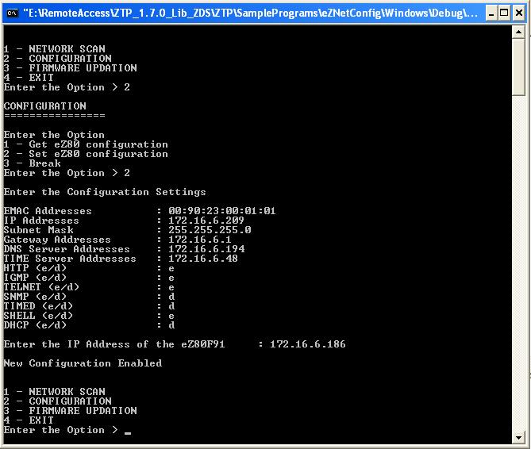

Firmware Updating

