Requirements Specification
for
MySynth – Effects Module

Prepared by Daniel Thomer
MySynth Project Group
30.01.2019
Table of Contents
Table of Contents ii
Revision History ii
1. Introduction 1
1.1 Purpose 1
1.2 Product Scope 1
1.3 References 1
2. Overall Description 2
2.1 Product Functions 2
2.2 User Classes and Characteristics 2
2.3 Operating Environment 2
3. External Interface Requirements 3
3.1 User Interfaces 3
3.2 Hardware Interfaces 3
4. System Features 4
4.1 System Feature 1 4
4.2 System Feature 2 (and so on) 4
Appendix A: Glossary 5
Appendix B: Analysis Models 5
Appendix C: To Be Determined List 5

Revision History
Name | Date | Reason For Changes | Version
Daniel Thomer | 30.01.19 | Initial revision | 1.0

Introduction

Purpose
This Specification will describe all Requirements for the Eurorack compatible MySynth Effects Module to be created during the Course ELT-23056 Embedded Systems and Electronics Productization in Spring 2019.

Product Scope

The Module to be created shall be fitable inside a working Eurorack System and provide easy to use simple effects for a modular Synthesizer. The goal of creating this product is to learn more about Embedded Systems Productization and how a Embedded System development project works.

References
- Course Moodle Page: https://moodle2.tut.fi/course/view.php?id=12395

Overall Description

Product Functions
The MySynth Effects Module will offer the following functions:
- In and Output compatible with Eurorack Specification
- Effect 1: XXX
- Effect 2: XXX

User Classes and Characteristics
<Identify the various user classes that you anticipate will use this product. User classes may be differentiated based on frequency of use, subset of product functions used, technical expertise, security or privilege levels, educational level, or experience. Describe the pertinent characteristics of each user class. Certain requirements may pertain only to certain user classes. Distinguish the most important user classes for this product from those who are less important to satisfy.>

Operating Environment
The Software and Hardware shall work within a Eurorack system as specified by Doepfer.

External Interface Requirements

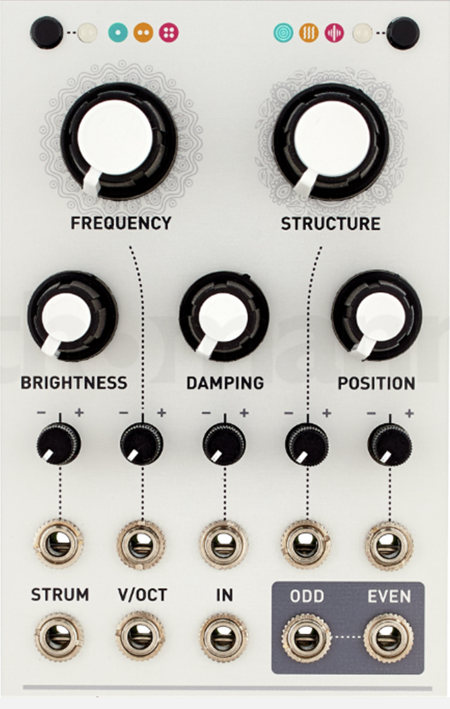
User Interfaces
The User Interface shall consist of:
- 3 Knobs to control effects
- 3 Buttons to control effects
- LEDs to indicate the functionality of the module

The User Interface should be visually similar to the picture shown on the right.

Hardware Interfaces
The module shall have one analog Input:
- Audio Input
- Voltage Range: 0V -5V
The module shall have one analog Output:
- Audio Output
- Voltage Range: 0V -5V

The Input voltage shall be transformed using a ADC to be used in Software.
After the Effects described in Chapter 4 have been applied by Software, a DAC shall be used to create the analog Output.

System Features
<This template illustrates organizing the functional requirements for the product by system features, the major services provided by the product. You may prefer to organize this section by use case, mode of operation, user class, object class, functional hierarchy, or combinations of these, whatever makes the most logical sense for your product.>

System Feature 1
<Don’t really say “System Feature 1.” State the feature name in just a few words.>
4.1.1 Description and Priority
<Provide a short description of the feature and indicate whether it is of High, Medium, or Low priority. You could also include specific priority component ratings, such as benefit, penalty, cost, and risk (each rated on a relative scale from a low of 1 to a high of 9).>
4.1.2 Stimulus/Response Sequences
<List the sequences of user actions and system responses that stimulate the behavior defined for this feature. These will correspond to the dialog elements associated with use cases.>
4.1.3 Functional Requirements
<Itemize the detailed functional requirements associated with this feature. These are the software capabilities that must be present in order for the user to carry out the services provided by the feature, or to execute the use case. Include how the product should respond to anticipated error conditions or invalid inputs. Requirements should be concise, complete, unambiguous, verifiable, and necessary. Use “TBD” as a placeholder to indicate when necessary information is not yet available.>

<Each requirement should be uniquely identified with a sequence number or a meaningful tag of some kind.>

REQ-1:
REQ-2:

System Feature 2 (and so on)
Appendix A: Glossary
<Define all the terms necessary to properly interpret the SRS, including acronyms and abbreviations. You may wish to build a separate glossary that spans multiple projects or the entire organization, and just include terms specific to a single project in each SRS.>
Appendix B: Analysis Models
<Optionally, include any pertinent analysis models, such as data flow diagrams, class diagrams, state-transition diagrams, or entity-relationship diagrams.>
Appendix C: To Be Determined List
<Collect a numbered list of the TBD (to be determined) references that remain in the SRS so they can be tracked to closure.>

