Postman.

HW_1

Создать запросы в Postman.

Protocol: http

IP: 162.55.220.72

Port: 5005

EP_1

Method: GET

EndPoint: /get_method

request url params:

name: str

age: int

response:

[

“Str”,

“Str”

]

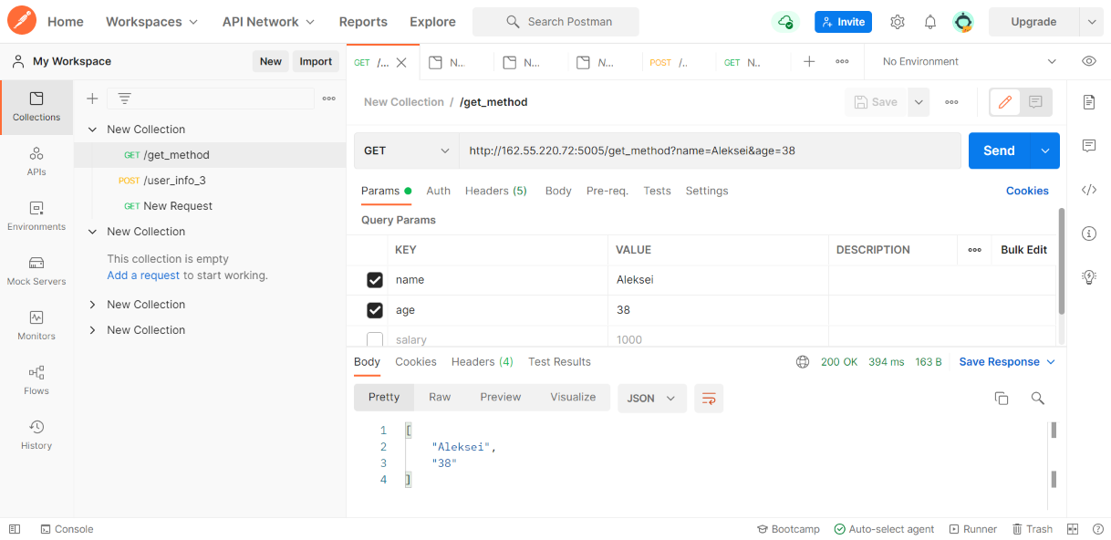

==================

EP_2

Method: POST

EndPoint: /user_info_3

request form data:

name: str

age: int

salary: int

response:

{'name': name,

'age': age,

'salary': salary,

'family': {'children': [['Alex', 24], ['Kate', 12]],

'u_salary_1_5_year': salary * 4}}

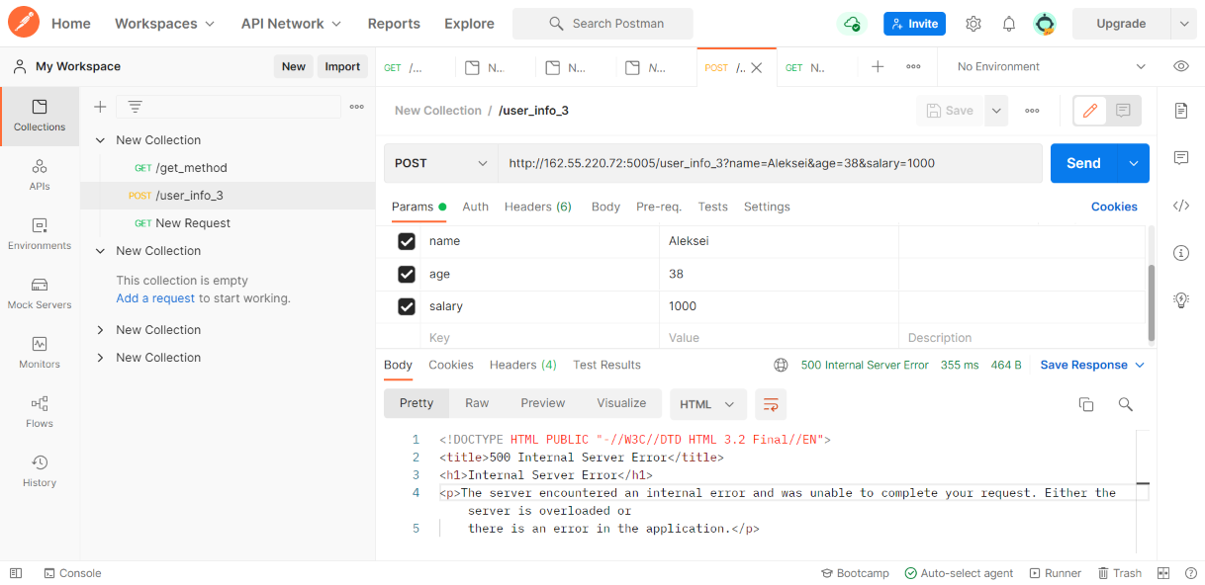

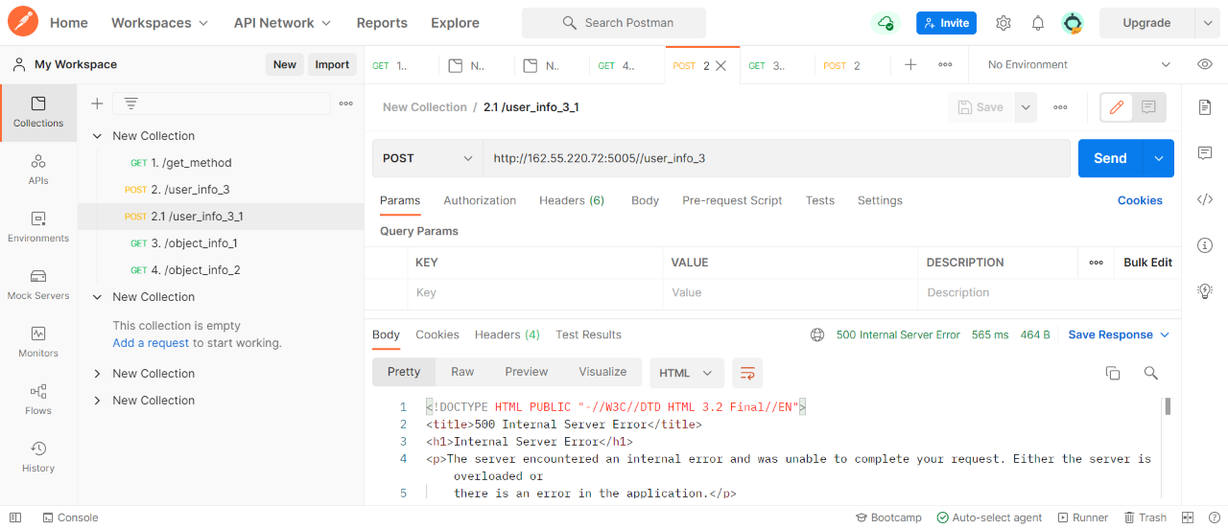

==================

EP_3

Method: GET

EndPoint: /object_info_1

request url params:

name: str

age: int

weight: int

response:

{'name': name,

'age': age,

'daily_food': weight * 0.012,

'daily_sleep': weight * 2.5}

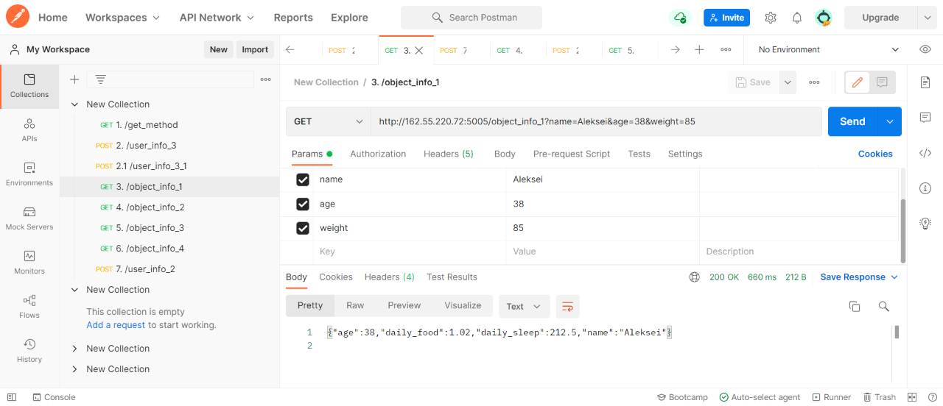

==================

EP_4

Method: GET

EndPoint: /object_info_2

request url params:

name: str

age: int

salary: int

response:

{'start_qa_salary': salary,

'qa_salary_after_6_months': salary * 2,

'qa_salary_after_12_months': salary * 2.7,

'qa_salary_after_1.5_year': salary * 3.3,

'qa_salary_after_3.5_years': salary * 3.8,

'person': {'u_name': [user_name, salary, age],

'u_age': age,

'u_salary_5_years': salary * 4.2}

}

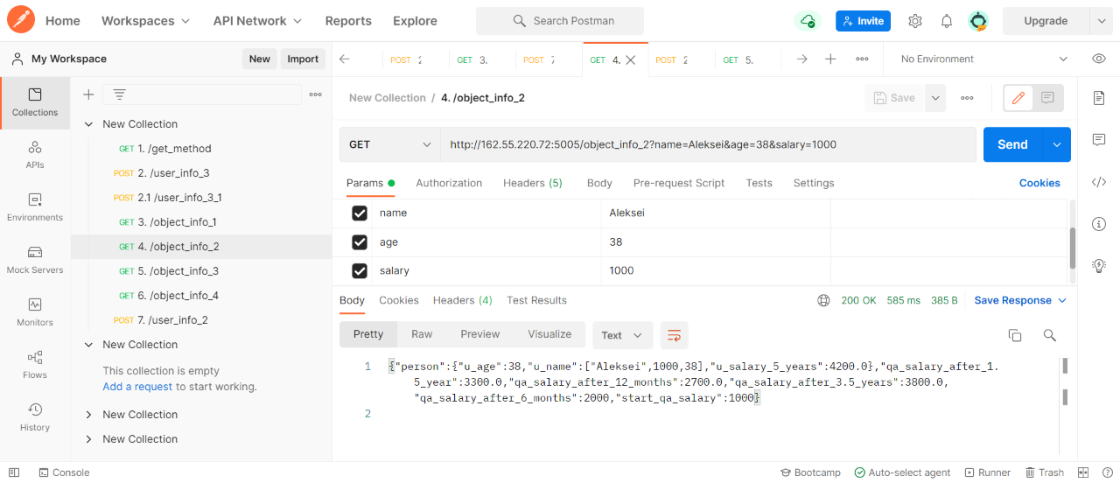

==================

EP_5

Method: GET

EndPoint: /object_info_3

request url params:

name: str

age: int

salary: int

response:

{'name': name,

'age': age,

'salary': salary,

'family': {'children': [['Alex', 24], ['Kate', 12]],

'pets': {'cat':{'name':'Sunny',

'age': 3},

'dog':{'name':'Luky',

'age': 4}},

'u_salary_1_5_year': salary * 4}

}

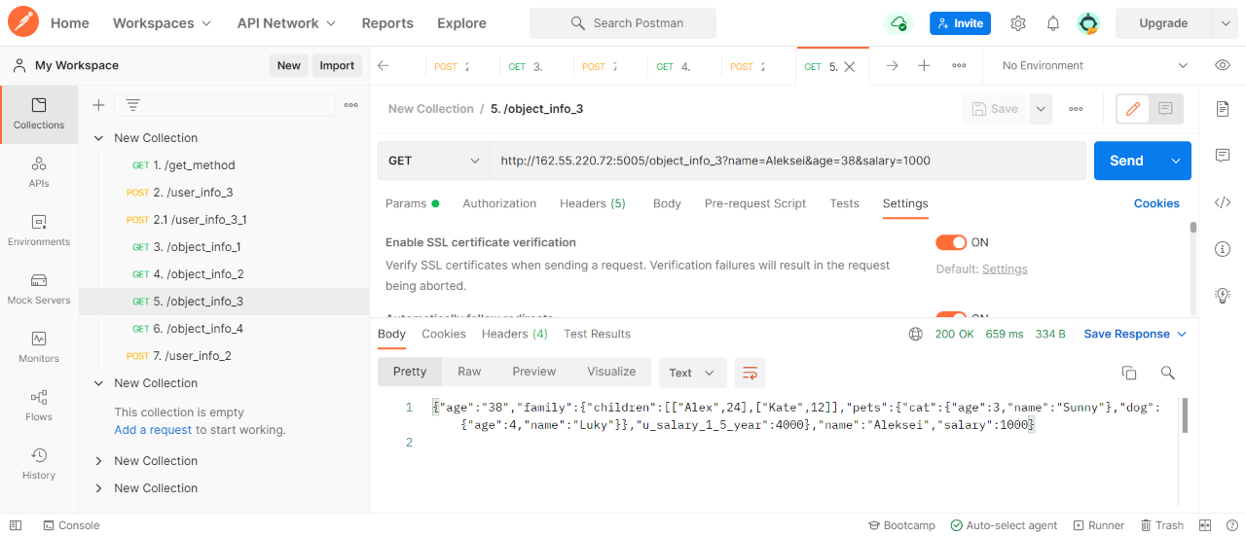

==================

EP_6

Method: GET

EndPoint: /object_info_4

request url params:

name: str

age: int

salary: int

response:

{'name': name,

'age': int(age),

'salary': [salary, str(salary * 2), str(salary * 3)]}

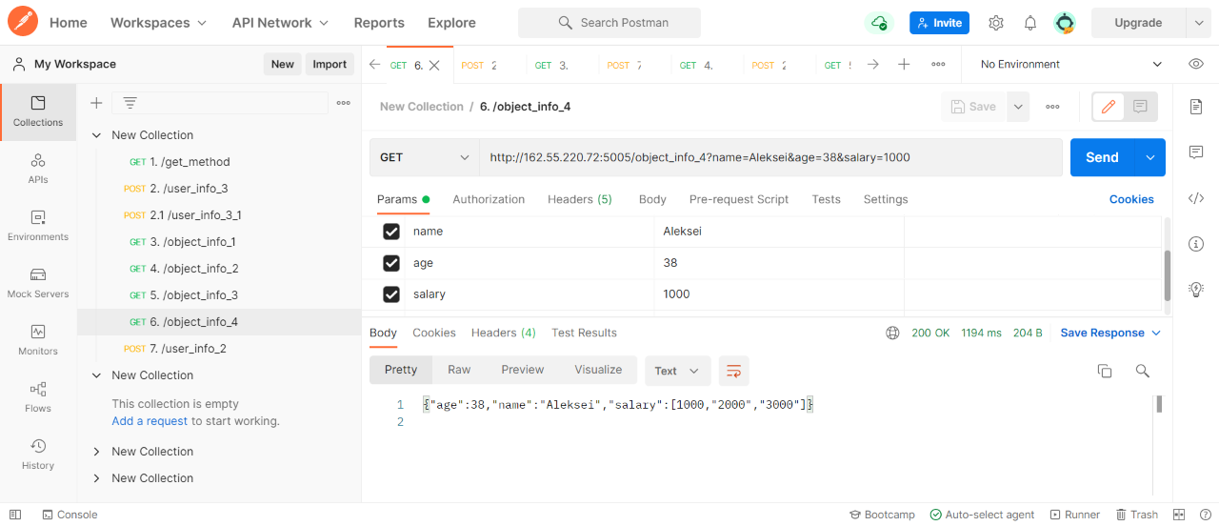

==================

EP_7

Method: POST

EndPoint: /user_info_2

request form data:

name: str

age: int

salary: int

response:

{'start_qa_salary': salary,

'qa_salary_after_6_months': salary * 2,

'qa_salary_after_12_months': salary * 2.7,

'qa_salary_after_1.5_year': salary * 3.3,

'qa_salary_after_3.5_years': salary * 3.8,

'person': {'u_name': [user_name, salary, age],

'u_age': age,

'u_salary_5_years': salary * 4.2}

}

