# Neural Networks: Representation

Q. Which of the following statements are true? Check all that apply.

√ X

A two layer (one input layer, one output layer; no hidden layer) neural network can represent the XOR function.

The activation values of the hidden units in a neural network, with the sigmoid activation function applied at every layer, are always in the range (0, 1).

Suppose you have a multi-class classification problem with three classes, trained with a 3 layer network. Let a(3)1=(hΘ(x))1 be the activation of the first output unit, and similarly a(3)2=(hΘ(x))2 and a(3)3=(hΘ(x))3. Then for any input x, it must be the case that a(3)1+a(3)2+a(3)3=1.

Any logical function over binary-valued (0 or 1) inputs x1 and x2 can be (approximately) represented using some neural network.

Q. Consider the neural network given below. Which of the following equations correctly computes the activation a1(3)? Note: g(z) is the sigmoid activation function.



√ 

Q. You have the following neural network:



You'd like to compute the activations of the hidden layer a(2)∈ℝ3. One way to do so is the following Octave code:



You want to have a vectorized implementation of this (i.e., one that does not use for loops). Which of the following implementations correctly compute a(2)? Check all that apply.

√ z = Theta1 * x; a2 = sigmoid (z);

X a2 = sigmoid (x * Theta1);

X a2 = sigmoid (Theta2 * x);

X z = sigmoid(x); a2 = sigmoid (Theta1 * z);

Q.

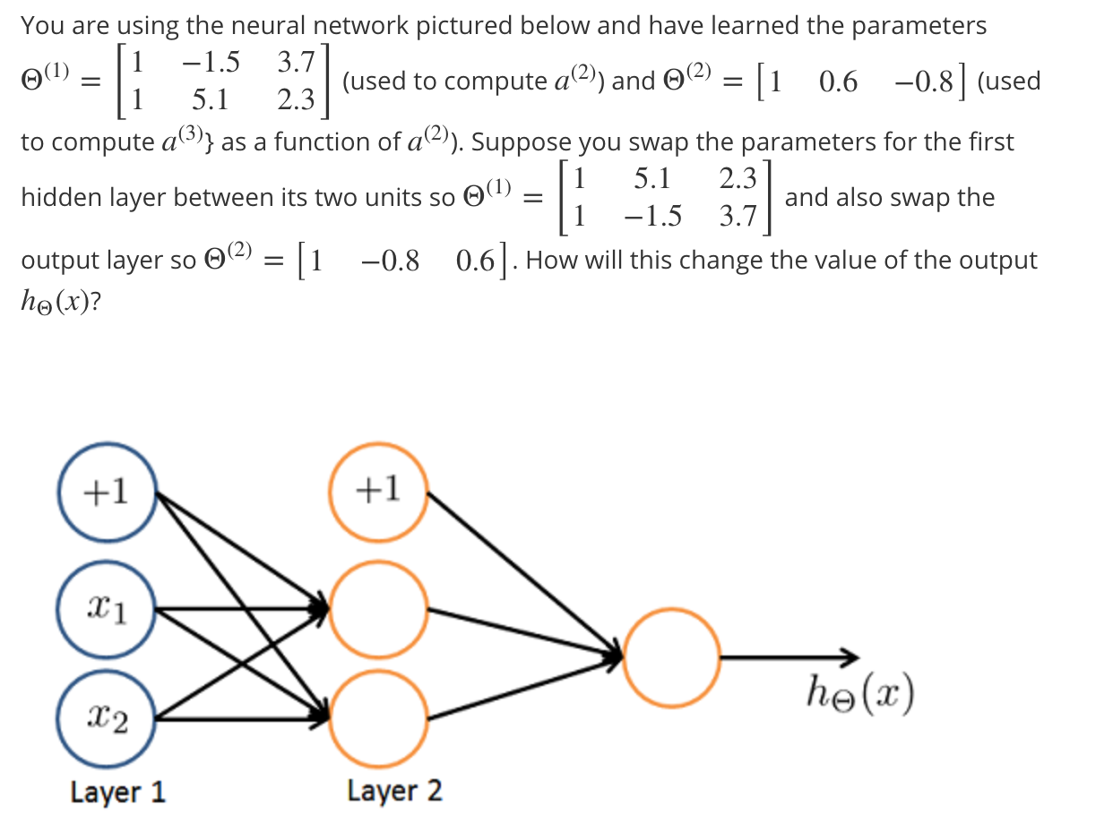

√ It will stay the same.