Autumn 2025, Homework 4 (15 points)
Q1. (7 pts)
Assume that src1 DCD 0xFF00FF00 and src2 DCD 0x00AA00AA are located consecutively in the READONLY area of memory (see the code below). Also, assume that src1 starts at address 0x00000008 and SP = 0x20000400.
- For each of the following instructions, calculate the values of registers involved. Write the values in the comment spaces of the following code as instructed. For example, “R0 =”means you need to fille out like R0 = 0x00000008; “SP = ” means you need to show the transition of SP contents like SP = 0x20000400 0x20003FC.

THUMB
StackSize EQU 0x00000400

AREA STACK, NOINIT, READWRITE, ALIGN=3
MyStackMem SPACE StackSize

AREA RESET, READONLY
EXPORT __Vectors
__Vectors
DCD MyStackMem + StackSize
DCD Reset_Handler

AREA MYDATA, DATA, READWRITE

AREA MYDCODE, CODE, READONLY
src1 DCD 0xFF00FF00
src2 DCD 0x00AA00AA

ALIGN
ENTRY
EXPORT Reset_Handler
Reset_Handler
; WHAT ARE THE CONTENTS OF EACH REGISTER BELOW? Please fill in as comments
HW4_2 LDR R0, =src1 ; R0 = 0x00000008
ADD R0, R0, #1 ; R0 = 0x00000009
LDRB R1, [R0] ; R1 = 0x000000FF
draw_mem1 PUSH {R1} ; SP = 0x20000400->0x200003FC
ADD R0, #4 ; R0 = 0x0000000D
LDRSB R2, [R0] ; R2 = 0xFFFFFFFF
draw_mem2 PUSH {R2} ; SP = 0x200003FC->0x200003F8
MOV R3, SP ; R3 = 0x200003F8
ADD R3, #4 ; R3 = 0x200003FC
LDR R4, [R3] ; R4 = 0x000000FF
SUB R4, #0x004C004C; R4 = 0xFFB400B3
draw_mem3 STRB R4, [R3] ; R3 = 0x200002FC
POP {R2} ; SP = 0x200003F8->,0x200003FC R2 = 0xFFFFFFFF
POP {R1} ; SP = 0x200003FC->,0x2000040 R1 = 0x000000FF

- Stack memory: fill out blanks upon the completion of each event: draw_mem1, draw_mem2, and draw_mem3. Each cell should store only one byte.

Address | draw_mem1 | draw_mem2 | draw_mem3
 | PUSH {R1} | PUSH {R2} | STRB R4, [R3]
0x200003F8 | - | 0xFF | 0xFF
0x200003F9 | - | 0xFF | 0xFF
0x200003FA | - | 0xFF | 0xFF
0x200003FB | - | 0xFF | 0xFF
0x200003FC | 0xFF | 0xFF | 0xFF
0x200003FD | 0x00 | 0x00 | 0x00
0x200003FE | 0x00 | 0x00 | 0x00
0x200003FF | 0x00 | 0x00 | 0x00

Q2. (8 pts) Parity-Bit Adding Program
Write a program in ARM assembly code that adds an odd parity to each ASCII character.
Important information: Even parity ensures that the total number of ‘1’ bits in a data unit, including the parity bit, is even. Odd parity, on the other hand, ensures that the total number of ‘1’ bits is odd. This question focuses on odd parity.

While you may use parity.s runnable on VisUAL (which you can find in Canvas/files/folder/code/VisUAL), your HW4-Q2 program must run on Keil uVision. Your code must also satisfy the following specifications:
- To run Keil uVision,
  - Create the HW4 folder on your Windows desktop, start uVision, choose “new uVision projection”.
  - Select this HW4 folder.
  - Use HW4 for HW4.uvproj/.uvprojx file names.
  - Choose Texas Instruments/Tiva C Series/TM4C123x Series/TM4C1233H6PM (the same platform as in lab1b).
  - Create mainhw4q2.s under Project HW4/Target 1/Source Group1/. You should not overwrite the startup_TM4C123.s file as in lab1b.
- Simply comment out line 236 (or the line close to this line number but with the same content) of startup_TM4C123.s:
236 ; BLX R0
so that startup_TM4C123.s skips calling SystemInit and directly invokes __main at line 238. (This is the only modification you need to do in startup_TM4C123.s.)
- In your mainhw4q2.s, get started with the following code snippet:

AREA MyData, DATA, READWRITE
dst SPACE 200

AREA MyCODE, DATA, READONLY
src DCB "Computing and Software Systems, University of Washington Bothell", 0

AREA |.text|, CODE, READONLY

EXPORT __main [WEAK]
ENTRY
__main
LDR R0, =src ; src address
LDR R1, =dst ; dst address
; R2 = the current ASCCI Char
; R3 = counter from 7 to 0
; R4 = #ones ; used to record the number of set bit (1)

- Use R0, R1, R2, R3, and R4 as specified in the above code snipped:
  - To read a new ASCII character from src, you should use: LDRB R2, [R0], #1
  - To write an ASCII character (with added parity or not) to dst, use: STRB R2, [R1], #1
- If you use the parity.s sample code from Canvas, make sure:
  - R0 should be R2 in HW4.
  - R1 should be R4 in HW4.
  - R2 should be R3 in HW4.
- To check if R4 is even or odd, use: LSRS R4, #1
If a carry is clear (C==0), R4 is even, in which case add a parity bit at bit 7 of R2 to satisfy the odd parity requirement. Otherwise (C==1), R4 must be odd, and thus you don’t change bit 7 of R2.
- Unlike VisUAL, a real ARM processor does not stop with END. The very last statement in mainhw4q2.s should be an infinite loop like: end_of_main B end_of_main
- Run your program, capture snapshots of src and dst memory contents, and verify if your dst memory contents got correct odd parities. The following is the key answer’s results. Don’t copy them. You need to generate those with your own program.

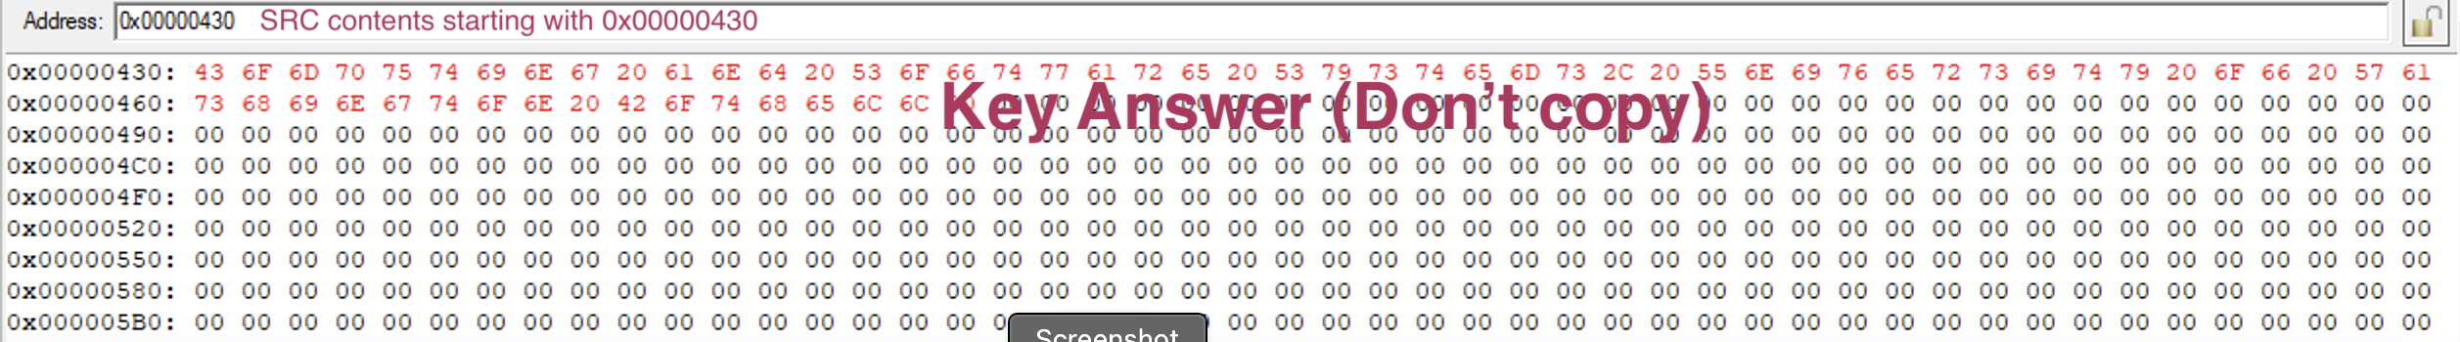
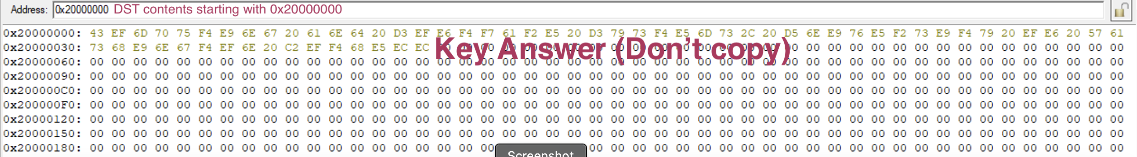

For this question, you need to submit the followings:
- The screenshots of memory view (src and dst contents) into the pdf file to support your correct results. Please include these screenshots in the same pdf file that you show your answers to Q1 and Q2.
- After the screenshots, copy the code in mainhw4q2.s into the same pdf file that you show your answers to Q1 and Q2.
- Additionally, you also need to submit the source file, mainhw4q2.s. (If no source file, you get zero point for this question)

SRC

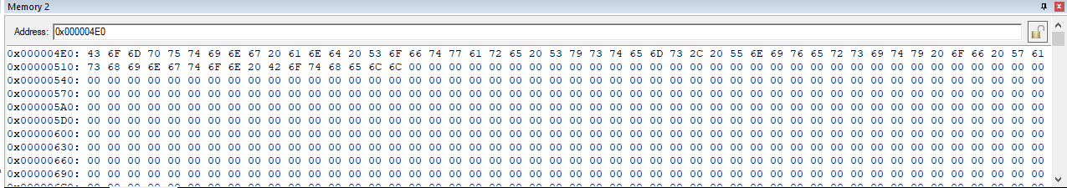

DST
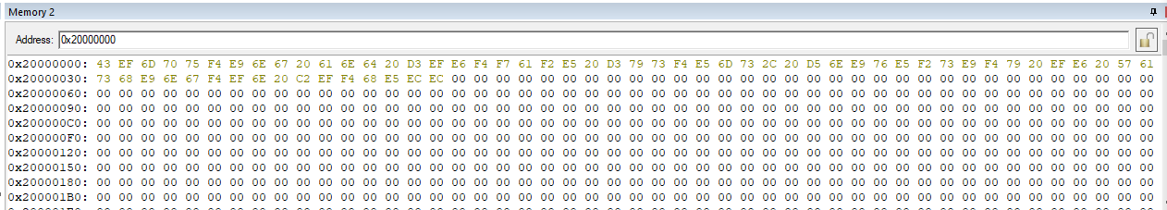

Code:

AREA MyData, DATA, READWRITE
dst SPACE 200

AREA MyCODE, DATA, READONLY
src DCB "Computing and Software Systems, University of Washington Bothell", 0

AREA |.text|, CODE, READONLY

EXPORT __main [WEAK]
ENTRY
; R2 = the current ASCCI Char
; R3 = counter from 7 to 0
; R4 = #ones ; used to record the number of set bit (1)
__main
LDR R0, =src ; src address
LDR R1, =dst ; dst address

for_loop
LDRB R2, [R0], #1 ; set the first value, update after
CMP R2, #0 ; check of R2 to see if at end of string
BEQ end_of_main ; go to end of program
MOV R3, #7 ; set the 7 counter
MOV R4, #0 ; reset counter of 1s

count_ones
CMP R3, #0 ; i = 7
BEQ continue_loop ; if i = 0, end internal loop
RORS R2, R2, #1 ; rotate right
BCS increment ; increment if its a 1
SUB R3, R3, #1 ; i--
B count_ones ; loop again

increment
ADD R4, R4, #1 ; ones++
SUB R3, R3, #1 ; i--
B count_ones ; loop again

continue_loop ; we know how many 1s there are now so find out if even or odd amount
ROR R2, R2, #25 ; make value normal
LSRS R4, #1 ; even or odd comparison
BCC odd_parity ; if even do parity math
STRB R2, [R1], #1 ; set the value in dst
B for_loop ; if even restart loop

odd_parity
ADD R2, #0x80 ; add 0b 1000 0000
STRB R2, [R1], #1 ;set the new value in dst
B for_loop ; restart the big loop
end_of_main ; end of function
B end_of_main ; repeat forever
END

