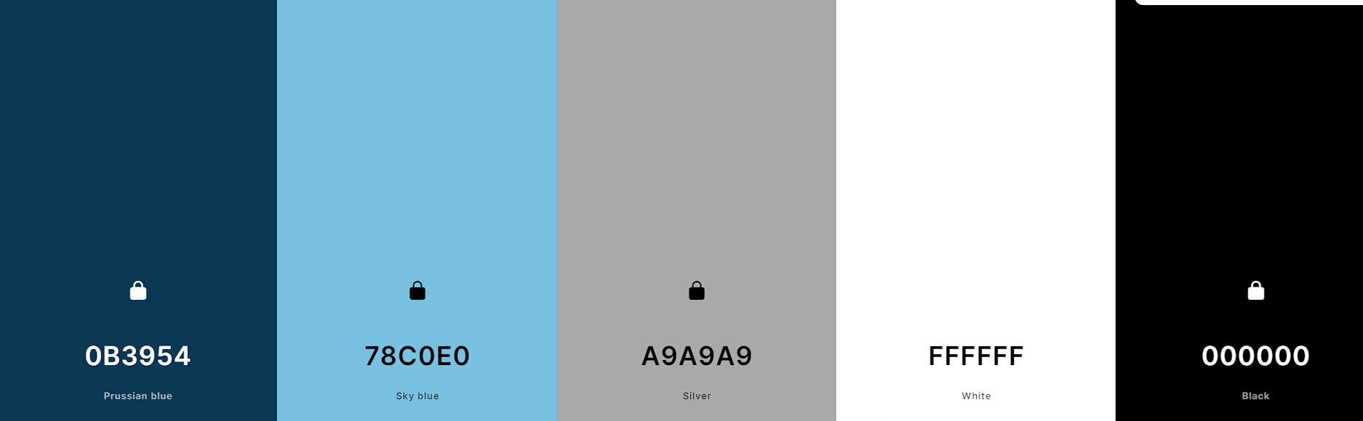

#0B3954

#78C0E0

#A9A9A9

#FFFFFF

#000000