Online Product Review Analysis
Data Mining Mini Project

Team Number: 1

24B11AI476 — Yenugupalli Alekya
24B11AI353 — Pothula Dhanalakshmi
24B11AI256 — Neelapu Bhargavi
24B11AI365 — Reddy Pranathi Ramya

Preprocessing

Before Preprocessing
The dataset used in this project is the Online Product Reviews dataset created for the purpose of this Data Mining Mini Project. The purpose of this dataset is to analyse customer review behaviour and identify patterns in product ratings, helpfulness, and sentiment using data mining techniques in both Python (Google Colab) and the WEKA tool. Before applying preprocessing techniques, the dataset contained raw and uncleaned information with several problems and inconsistencies, which could affect the accuracy and performance of machine learning models.

The dataset consisted of 500 records and 18 attributes: Reviewer Name, Country, Product, Category, Rating, Review Title, Review Text, Review Date, Date of Experience, Review Count, Helpful Votes, Total Votes, Helpfulness Score, Product Price ($), Delivery Days, Review Length, Sentiment Score, and Verified Purchase. Since the data was structured to simulate a real-world e-commerce review dataset, it required preprocessing before analysis could be performed effectively.

One of the major issues in the dataset before preprocessing was the presence of missing values across numerical columns. Columns such as Rating, Review Count, Helpful Votes, Total Votes, Helpfulness Score, Product Price ($), Delivery Days, Review Length, and Sentiment Score contained blank or null entries. These missing values can lead to incorrect predictions because most algorithms cannot handle incomplete data. Therefore, it was necessary to identify and handle these missing values before performing classification.

Another problem observed was that numerical attributes had different scales. For example, Product Price ($) ranged from $10.00 to $1500.00, while Delivery Days ranged from 1 to 14, and Sentiment Score ranged from -1.0 to +1.0. This difference in scale could give disproportionate weight to certain attributes during model training, thereby reducing classification accuracy.

The dataset also contained mixed data types. Some attributes were numerical, such as Rating, Review Count, Helpful Votes, and Sentiment Score, while others were nominal, such as Country, Product, Category, and Verified Purchase. Machine learning algorithms require a structured and consistent format, so this variation in data types needed to be handled properly before model building.

Because of all these problems, preprocessing was required to clean and transform the dataset. Data preprocessing helps to improve the quality, consistency, and reliability of the dataset. It also increases the performance and accuracy of classification algorithms such as ZeroR, Decision Tree, and Random Forest.

Therefore, before applying machine learning techniques, several preprocessing steps were performed on the dataset. These steps included handling missing values using column-specific strategies (mode for rating, median for integer columns, and mean for continuous ratio columns), and loading the cleaned dataset into WEKA for visualization and classification.

Dataset Before Preprocessing
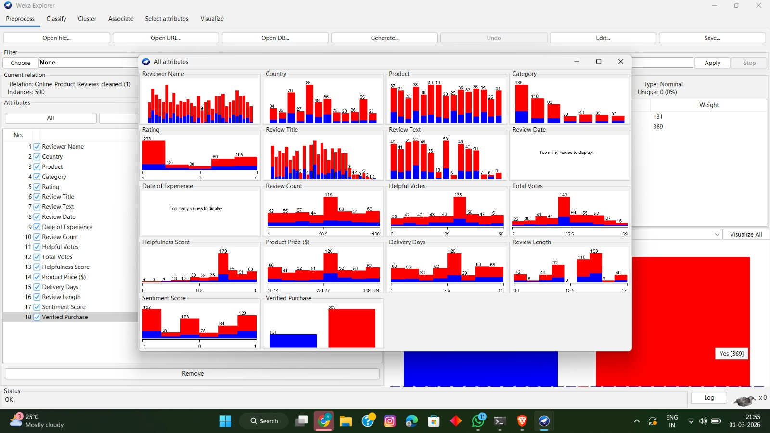
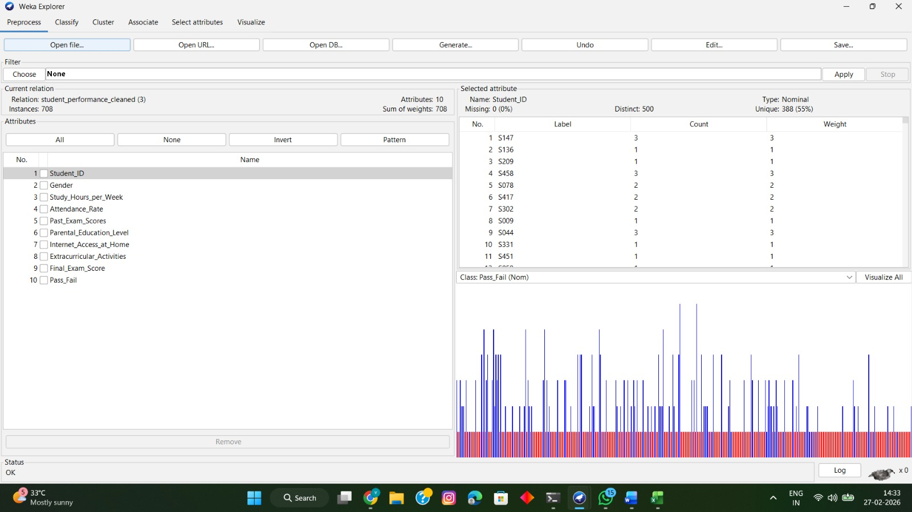
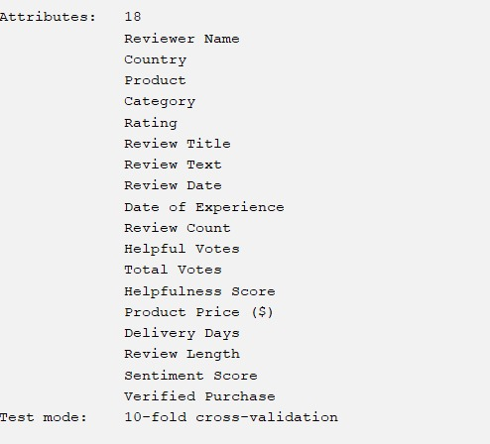

Preprocessing and Cleaning
Data preprocessing and cleaning is a crucial step in the data mining process. The quality of the results obtained from data mining techniques largely depends on the quality of the input data. Since the raw dataset collected before preprocessing contained missing values, inconsistencies, and irrelevant information, preprocessing was required to make the data suitable for analysis.

In this project, preprocessing techniques were applied using Python in Google Colab and WEKA Explorer. This process involved identifying and handling missing values and transforming data into a structured and usable format. Proper preprocessing ensures that the dataset is clean and ready for further data mining tasks such as classification, clustering, and pattern analysis.

Attributes
The Online Product Reviews dataset contains the following 18 attributes loaded into WEKA. The attribute list below was captured from WEKA's Preprocess panel after loading the cleaned CSV file.

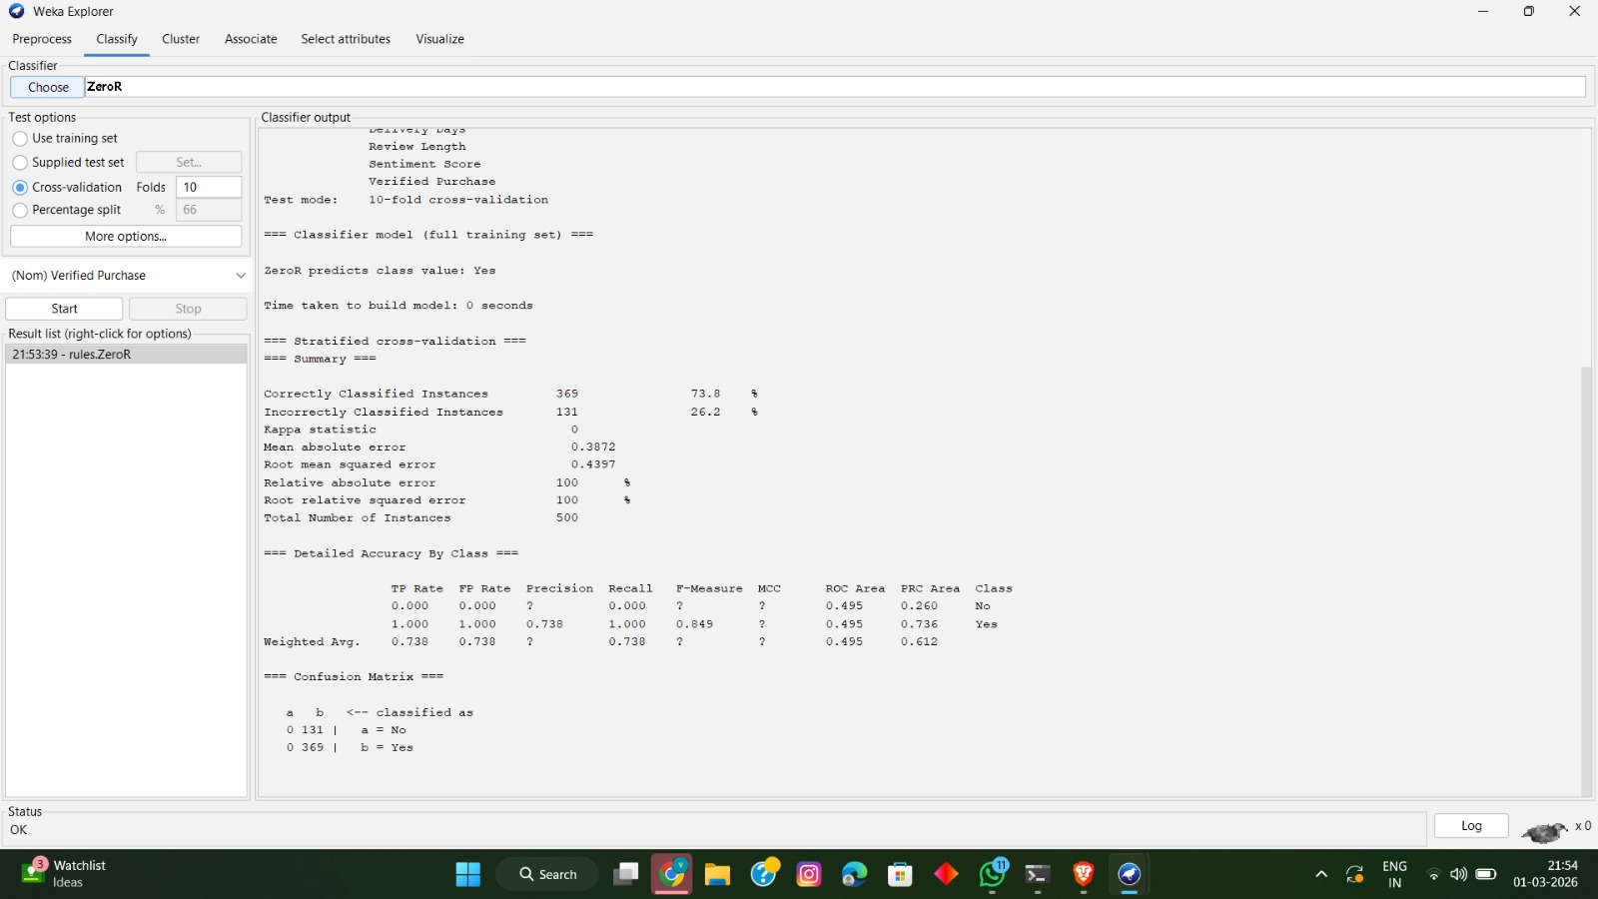

Handling Missing Values
The dataset contained missing or null values in nine numerical columns: Rating (approx. 89 missing), Review Count (77 missing), Helpful Votes (75 missing), Total Votes (82 missing), Helpfulness Score (77 missing), Product Price ($) (79 missing), Delivery Days (67 missing), Review Length (76 missing), and Sentiment Score (83 missing). In total, 705 values were missing out of 4,500 numerical entries — approximately 15.6%.

Most machine learning algorithms cannot handle missing values effectively. To overcome this issue, column-specific imputation strategies were applied using Python's Pandas library in Google Colab. This approach is more appropriate than applying a single strategy across all columns because each column has different statistical characteristics. The strategies used were as follows:

- Rating — Filled with Mode (most frequently occurring rating value, as rating is ordinal/categorical in nature)
- Review Count — Filled with Median (integer column with skewed distribution; median is robust to outliers)
- Helpful Votes — Filled with Median (count-based integer column)
- Total Votes — Filled with Median (count-based integer column)
- Helpfulness Score — Filled with Mean (ratio value between 0.0 and 1.0; mean is appropriate for symmetric distributions)
- Product Price ($) — Filled with Mean (continuous monetary value; mean captures the central price trend)
- Delivery Days — Filled with Median (integer column; median avoids the influence of extreme delivery times)
- Review Length — Filled with Median (word count integer column)
- Sentiment Score — Filled with Mean (continuous value ranging from -1.0 to +1.0 with symmetric distribution)

After applying these column-specific strategies, all 705 missing values were successfully filled, resulting in a complete dataset with zero missing values. This approach preserves the statistical integrity of each column better than a uniform strategy.

Before Cleaning (Python — Google Colab):
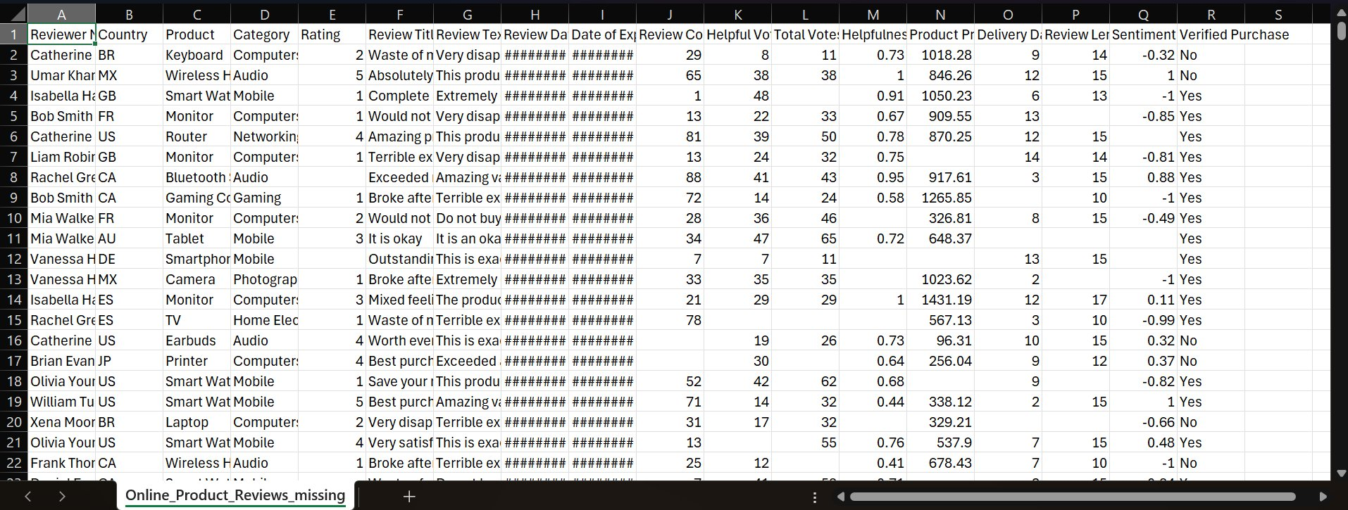

After Cleaning (Python Output):
After cleaning, all 705 missing values across 9 numerical columns were reduced to 0. The dataset now contains 500 complete records with 18 attributes and was saved as Online_Product_Reviews_cleaned.csv, ready for loading into WEKA.

Loading Cleaned Dataset in WEKA
After cleaning the dataset using Python, the cleaned CSV file (Online_Product_Reviews_cleaned.csv) was loaded into WEKA Explorer for further preprocessing, visualization, and classification. WEKA's Preprocess panel was used to examine and visualize all 18 attributes and their distributions.

WEKA Preprocess — All Attributes Visualization:


Visualization — Plot Matrix
The Visualize tab in WEKA was used to generate a scatter plot matrix of all attributes in the dataset. Each cell in the matrix represents the relationship between two attributes, coloured by the class variable Verified Purchase (blue = No, red = Yes). This visualization helps identify patterns and correlations between attributes that influence customer review and purchase behaviour.

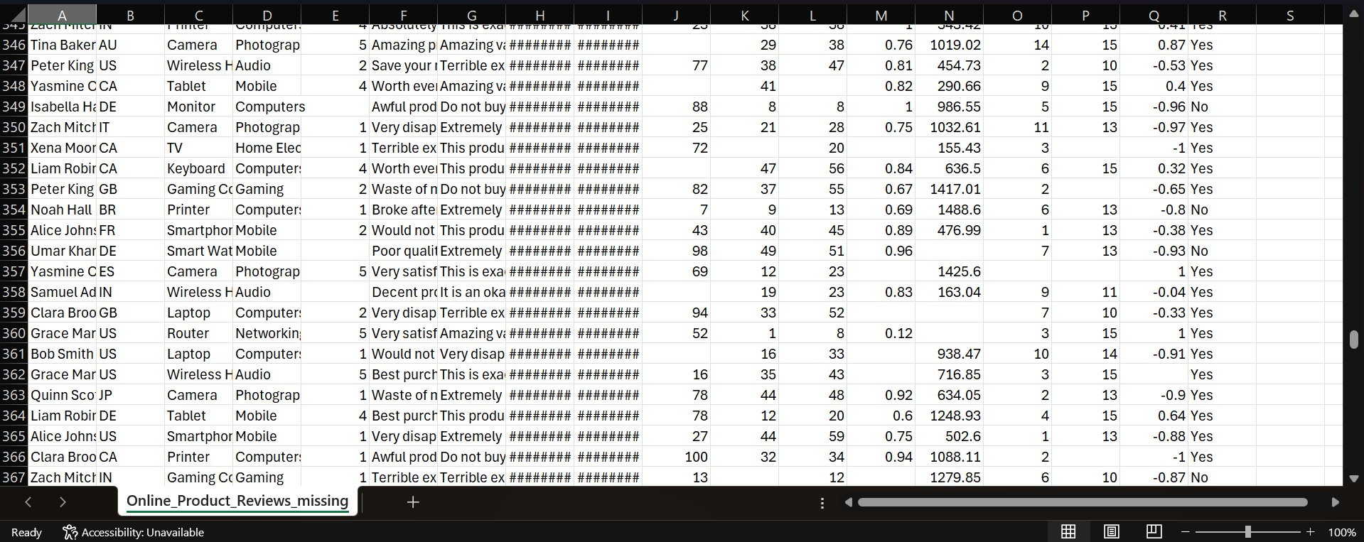

Classification Using ZeroR
To establish a baseline for classification performance, the ZeroR classifier was applied in WEKA using 10-fold cross-validation. ZeroR is the simplest classifier that predicts only the majority class for every instance. It serves as a benchmark — any useful classifier must perform better than ZeroR.

The ZeroR model predicted 'Yes' for Verified Purchase for every instance since 'Yes' was the majority class in the dataset (369 out of 500 instances, i.e. 73.8%). The results were as follows: Correctly Classified Instances: 369 (73.8%), Incorrectly Classified Instances: 131 (26.2%). The Kappa statistic was 0, indicating no agreement beyond chance. The mean absolute error was 0.3872 and root mean squared error was 0.4397, confirming this baseline model has limited discriminative power.

The confusion matrix showed that all 369 'Yes' instances were correctly classified as 'Yes', while all 131 'No' instances were incorrectly classified as 'Yes'. This baseline result confirms that a more sophisticated classification algorithm is needed to accurately predict whether a product review corresponds to a verified purchase.

ZeroR Classifier — Run Information:
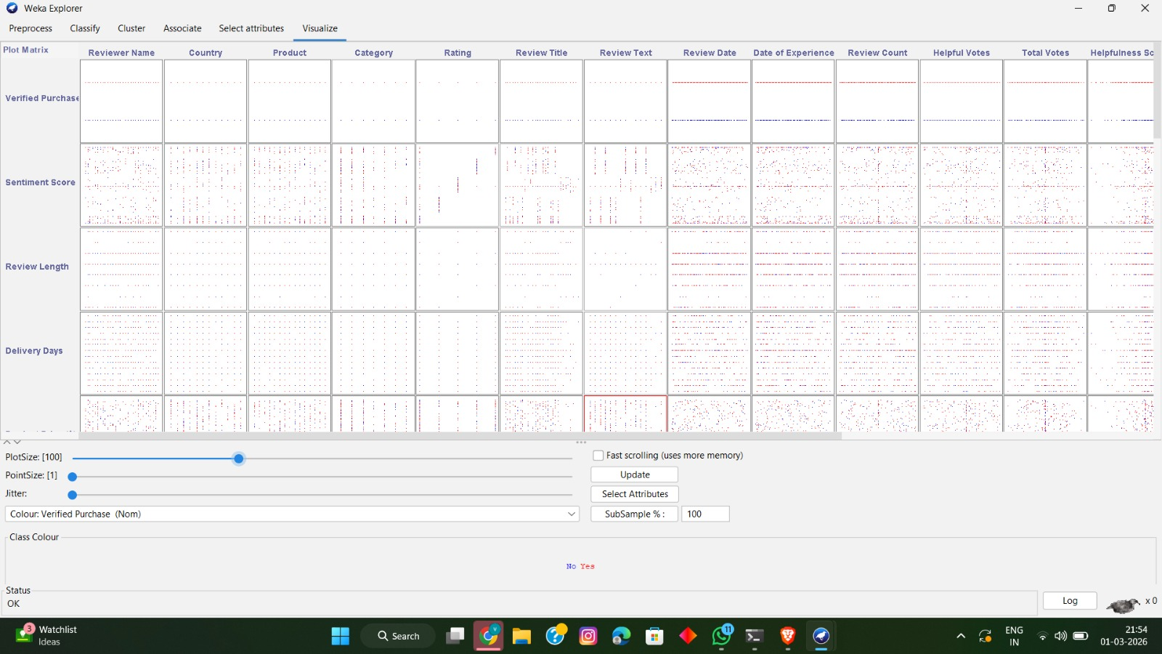

ZeroR Classifier — Summary and Confusion Matrix:
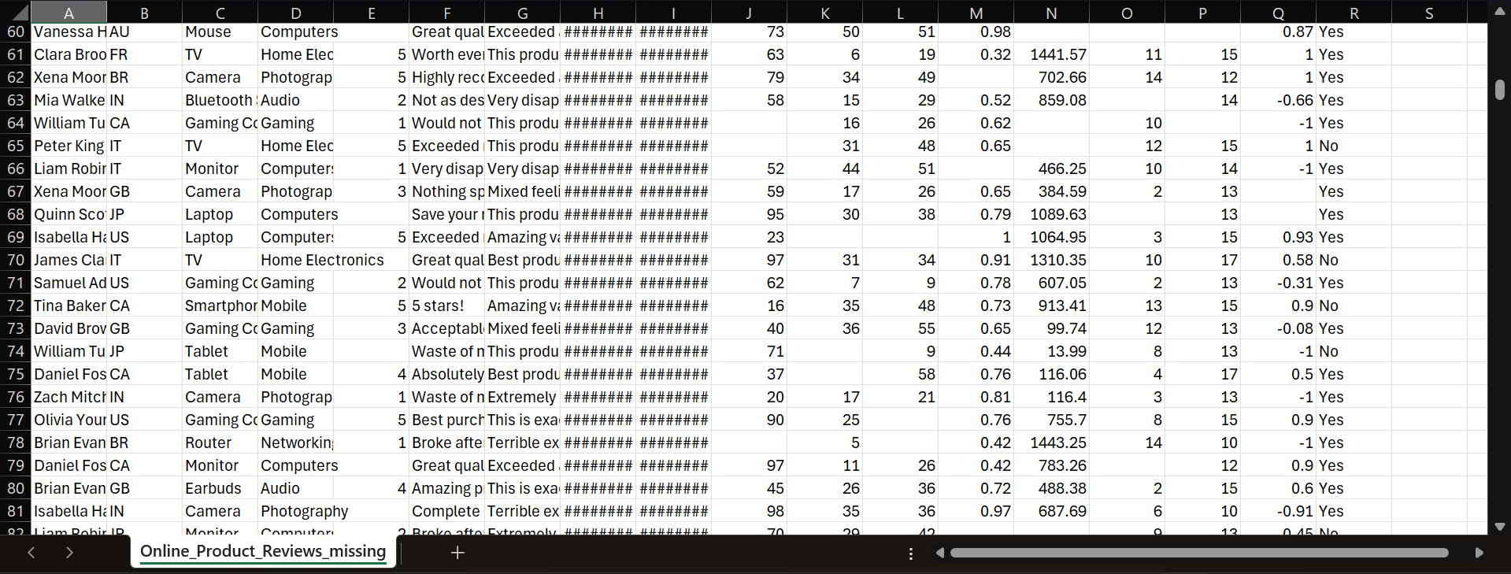

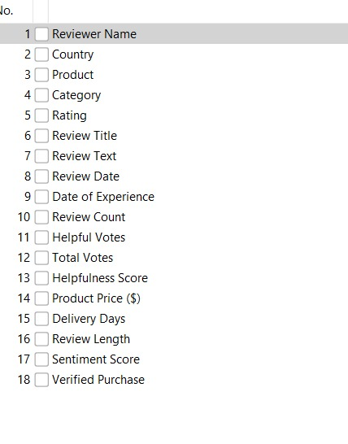

Conclusion of Preprocessing and Cleaning
After applying various preprocessing and cleaning techniques, the Online Product Reviews dataset was transformed into a clean, consistent, and reliable form. Missing values present in nine numerical columns (Rating, Review Count, Helpful Votes, Total Votes, Helpfulness Score, Product Price ($), Delivery Days, Review Length, and Sentiment Score) were successfully handled using column-specific imputation strategies. The total number of missing values was reduced from 705 to 0.

The cleaned dataset was then loaded into WEKA Explorer for visualization and classification. Attribute distributions were explored using the Preprocess panel, and scatter plot relationships were examined using the Visualize tab. A ZeroR baseline classifier was applied to establish a performance benchmark, achieving approximately 73.8% accuracy using 10-fold cross-validation.

These preprocessing steps improved the overall quality of the dataset and prepared it for effective data mining and analysis. The cleaned data is now suitable for identifying patterns, understanding customer review behaviour, and applying advanced classification algorithms such as Decision Tree and Random Forest to predict whether a product purchase was verified.

Summary
The project Online Product Review Analysis aims to understand and analyse customer review patterns and purchase behaviour using data mining techniques. A dataset of 500 product review records with 18 attributes was created to simulate a real-world e-commerce review dataset. The raw data contained approximately 705 missing values (15.6%) across 9 numerical columns.

The data was carefully preprocessed and cleaned in Python (Google Colab). Column-specific imputation strategies were applied: mode for the Rating column, median for integer-type numerical columns (Review Count, Helpful Votes, Total Votes, Delivery Days, Review Length), and mean for continuous ratio columns (Helpfulness Score, Product Price ($), Sentiment Score). After cleaning, the dataset was verified to have zero missing values and was saved as a new CSV file.

The cleaned dataset was then loaded into WEKA Explorer for further analysis. Attribute visualizations were generated to understand the distribution of each feature across all 18 columns. A scatter plot matrix was produced using the Visualize tab to examine correlations between attributes. The ZeroR baseline classifier was applied using 10-fold cross-validation, achieving 73.8% accuracy, which establishes the minimum benchmark for any further classification model.

The refined dataset provides meaningful insights into online product review patterns and serves as a reliable foundation for applying advanced classification and clustering algorithms. This project demonstrates the effective application of data mining concepts — including data cleaning, preprocessing, visualization, and baseline classification — to real-world e-commerce review data.

