Clase22oct.R

Usuario

2024-10-22

#correlation, Alejandra Elizondo Trejo  
#1847945  
#CLASE 22 OCTUBRE PARTE 1  
  
#USANDO CUARTETOS DE ANSCOMBE  
  
#CUARTETO I  
x1 <- c(10,8,13,9,11,14,6,4,12,7,5)  
y1 <- c(8.04, 6.95, 7.58, 8.81,8.33, 9.96, 7.24, 4.26, 10.84, 4.82, 5.68)  
  
mean(x1); mean(y1)

## [1] 9

## [1] 7.500909

var(x1); var(y1)

## [1] 11

## [1] 4.127269

sd(x1); sd(y1)

## [1] 3.316625

## [1] 2.031568

cor.test(x1,y1)

##   
## Pearson's product-moment correlation  
##   
## data: x1 and y1  
## t = 4.2415, df = 9, p-value = 0.00217  
## alternative hypothesis: true correlation is not equal to 0  
## 95 percent confidence interval:  
## 0.4243912 0.9506933  
## sample estimates:  
## cor   
## 0.8164205

# el coeficiente dió cor:0.8164205 y p-value: 0.002179 nos dice que es altamente   
#significativo  
  
#CUARTETO II  
x2 <- c(10, 8, 13, 9, 11, 14, 6, 4, 12, 7, 5)  
y2 <- c(9.14, 8.14, 8.74, 8.77, 9.26, 8.10, 6.13, 3.10, 9.13, 7.26, 4.74)  
  
mean(x2); mean(y2)

## [1] 9

## [1] 7.500909

var(x2); var(y2)

## [1] 11

## [1] 4.127629

sd(x2); sd(y2)

## [1] 3.316625

## [1] 2.031657

cor.test(x2,y2)

##   
## Pearson's product-moment correlation  
##   
## data: x2 and y2  
## t = 4.2386, df = 9, p-value = 0.002179  
## alternative hypothesis: true correlation is not equal to 0  
## 95 percent confidence interval:  
## 0.4239389 0.9506402  
## sample estimates:  
## cor   
## 0.8162365

# el coeficiente dió cor:0.8162365 y p-value: 0.002179 nos dice que es altamente   
#significativo  
  
#CUARTETO III  
x3 <- c(10, 8, 13, 9, 11, 14, 6, 4, 12, 7, 5)  
y3 <- c(7.46, 6.77, 12.74, 7.11, 7.81, 8.84, 6.08, 5.39, 8.15, 6.42, 5.73)  
  
mean(x3); mean(y3)

## [1] 9

## [1] 7.5

var(x3); var(y3)

## [1] 11

## [1] 4.12262

sd(x3); sd(y3)

## [1] 3.316625

## [1] 2.030424

cor.test(x3,y3)

##   
## Pearson's product-moment correlation  
##   
## data: x3 and y3  
## t = 4.2394, df = 9, p-value = 0.002176  
## alternative hypothesis: true correlation is not equal to 0  
## 95 percent confidence interval:  
## 0.4240623 0.9506547  
## sample estimates:  
## cor   
## 0.8162867

# el coeficiente dió cor:0.8162867 y p-value: 0.002176 nos dice que es altamente   
#significativo  
  
#CUARTETO IV  
x4 <- c(8, 8, 8, 8, 8, 8, 8, 19, 8, 8, 8)  
y4 <- c(6.58, 5.76, 7.71, 8.84, 8.47, 7.04, 5.25, 12.50, 5.56, 7.91, 6.89)  
  
mean(x4); mean(y4)

## [1] 9

## [1] 7.500909

var(x4); var(y4)

## [1] 11

## [1] 4.123249

sd(x4); sd(y4)

## [1] 3.316625

## [1] 2.030579

cor.test(x4,y4)

##   
## Pearson's product-moment correlation  
##   
## data: x4 and y4  
## t = 4.243, df = 9, p-value = 0.002165  
## alternative hypothesis: true correlation is not equal to 0  
## 95 percent confidence interval:  
## 0.4246394 0.9507224  
## sample estimates:  
## cor   
## 0.8165214

# el coeficiente dió cor:0.8165214 y p-value: 0.002165 nos dice que es altamente   
#significativo  
  
#una grafica que contenga 4 grafcias  
  
par(mfrow=c(2,2))  
plot(x1,y1,main="Cuarteto I")  
plot(x2,y2,main="Cuarteto II")  
plot(x3,y3,main="Cuarteto III")  
plot(x4,y4,main="Cuarteto IV")

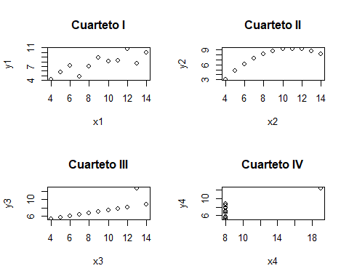

par(mfrow=c(1,1))  
  
#en ninguna de las 4 graficas hay una asociación lineal  
  
  
#Datos plántulas  
  
eba <- read.csv ("C:/Repositorios/Met_Est_2024/Clase/ebanos.csv", header = T)  
  
plot(eba$diametro, eba$altura,  
 xlab= "DBH (mm)",  
 ylab= "Altura (cm)")  
text (15,20, "r=0.82")

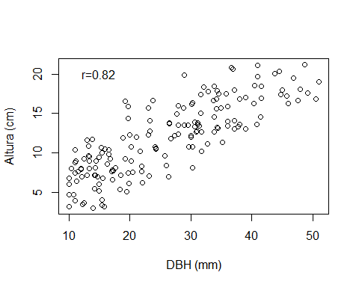

cor.test(eba$diametro, eba$altura)

##   
## Pearson's product-moment correlation  
##   
## data: eba$diametro and eba$altura  
## t = 18.354, df = 162, p-value < 2.2e-16  
## alternative hypothesis: true correlation is not equal to 0  
## 95 percent confidence interval:  
## 0.7648115 0.8659458  
## sample estimates:  
## cor   
## 0.8217467

#es positiva, con correlacion de 0.8217467 y altamente significativa p-value=2.2e-16