Series

A Series, by contrast, is a sequence of data values. If a DataFrame is a table, a Series is a list. And in fact you can create one with nothing more than a list:

Guardando la table como un cvs, quizas me sirva para el Proyecto de los pozos

Puedo acceder asi, como con los JSON

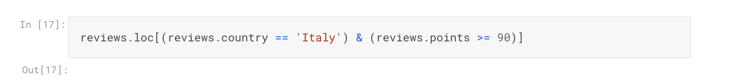

PARA OBTENER UNA ROW EN ESPECIFICO SE USA ILOC.

LOC te filtra en toda la table y le puedes colocar condicionales

ILOC[index, colum] sigue esa nomenclatura y puede crear un dataFrame

Grouping and sorting

Data Type

Para transformar el tipo de dato a otro tipo se usa

astype('float64')

Seleccionar los null

reviews[pd.isnull(reviews.country)]

replace("@kerinokeefe", "@kerino")

Renaming

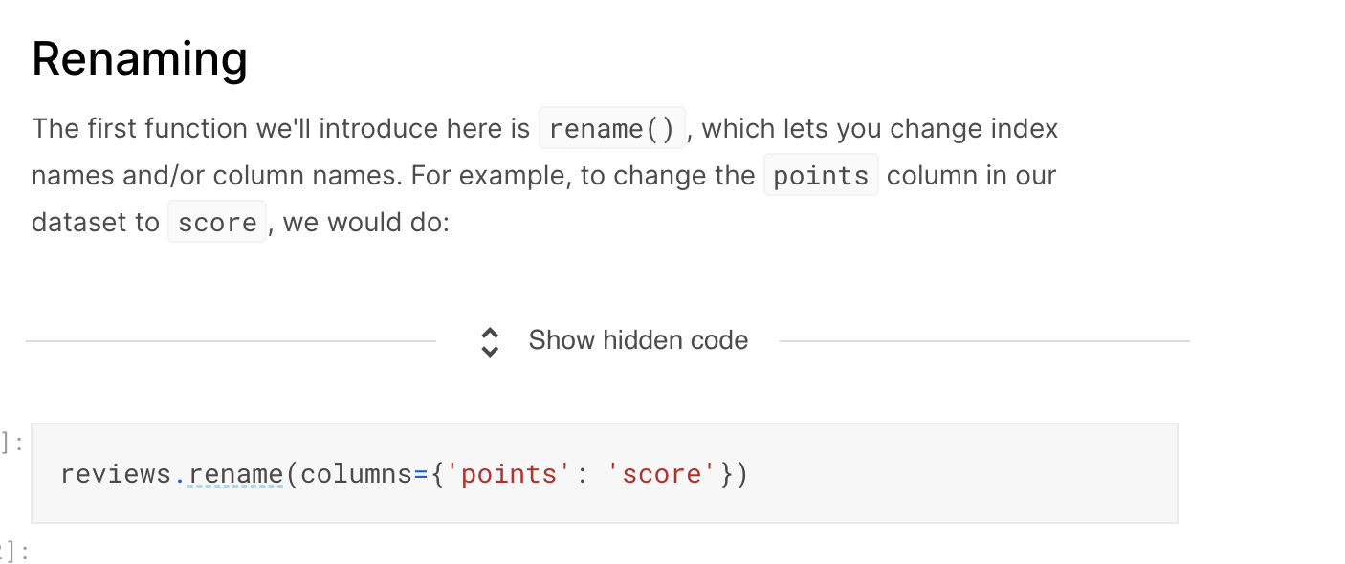

Combining