习题三

三．

**1.**

Form1.cs

using System;

using System.Collections.Generic;

using System.ComponentModel;

using System.Data;

using System.Drawing;

using System.Linq;

using System.Text;

using System.Windows.Forms;

namespace _3._1

{

public partial class Form1 : Form

{

public Form1()

{

InitializeComponent();

}

private void Form1_Load(object sender, EventArgs e)

{

}

private void label3_Click(object sender, EventArgs e)

{

}

private void button1_Click(object sender, EventArgs e)

{

int y;

y = int.Parse(textBox1.Text);

if ((y % 4 == 0 && y % 100 != 0) || (y % 400 == 0))

{

label3.Text = y + "是闰年";

}

else

{

label3.Text = y + "不是闰年";

}

}

private void button2_Click(object sender, EventArgs e)

{

Application.Exit();

}

private void textBox1_TextChanged(object sender, EventArgs e)

{

}

}

}

Program.cs

using System;

using System.Collections.Generic;

using System.Linq;

using System.Windows.Forms;

namespace _3._1

{

static class Program

{

/// <summary>

/// 应用程序的主入口点。

/// </summary>

[STAThread]

static void Main()

{

Application.EnableVisualStyles();

Application.SetCompatibleTextRenderingDefault(false);

Application.Run(new Form1());

}

}

}

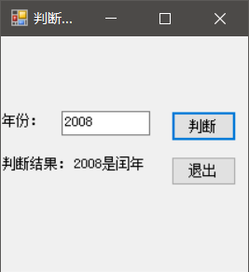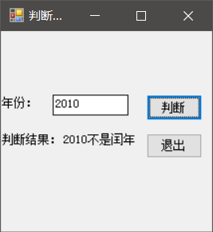

**2.**

Program.cs

using System;

using System.Collections.Generic;

using System.Linq;

using System.Text;

namespace _3._2

{

class Program

{

static void Main(string[] args)

{

int a,i,j,k;

a = int.Parse(Console.ReadLine());

for (i = ((a+1)/2); i >= 1; i--)

{

for (j = 1; j <= ((a + 1) / 2 - i); j++)

{

Console.Write(" ");

}

for (k = 1; k <= 2 * i - 1; k++)

{

Console.Write("*");

}

Console.Write("\n");

}

Console.ReadLine();

}

}

}

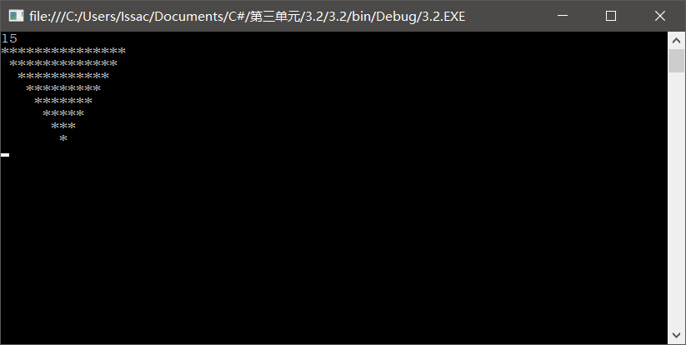

**3.**

Program.cs

using System;

using System.Collections.Generic;

using System.Linq;

using System.Text;

namespace _3._3

{

class Program

{

static void Main(string[] args)

{

double n,s,t,pi;

t = 1; pi = 0; n = 1.0; s = 1;

while (Math.Abs(t) > Math.Pow(10, -6))

{

pi = pi + t;

n = n + 2;

s = -s;

t = s/n;

}

pi = pi * 4;

Console.WriteLine("pi={0}", pi);

Console.ReadLine();

}

}

}

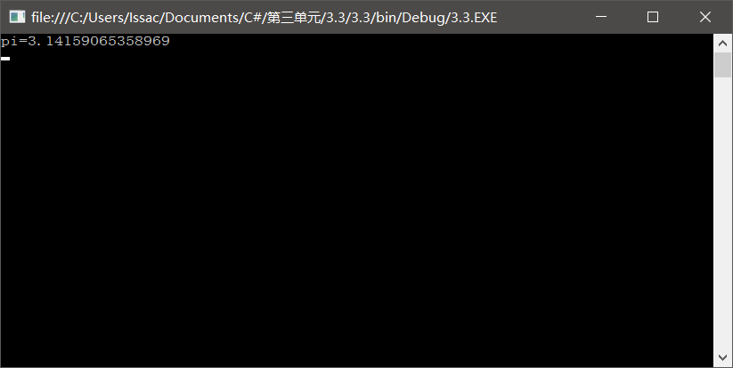

**4.**

Program.cs

using System;

using System.Collections.Generic;

using System.Linq;

using System.Text;

namespace _3._4

{

class Program

{

static void Main(string[] args)

{

double e, n, i;

e = 1;

n = 1;

for (i = 1; 1.0 / n > Math.Pow(10, -6); i++)

{

n *= i;

e = e + 1.0 / n;

}

Console.WriteLine("e={0}", e);

Console.ReadLine();

}

}

}

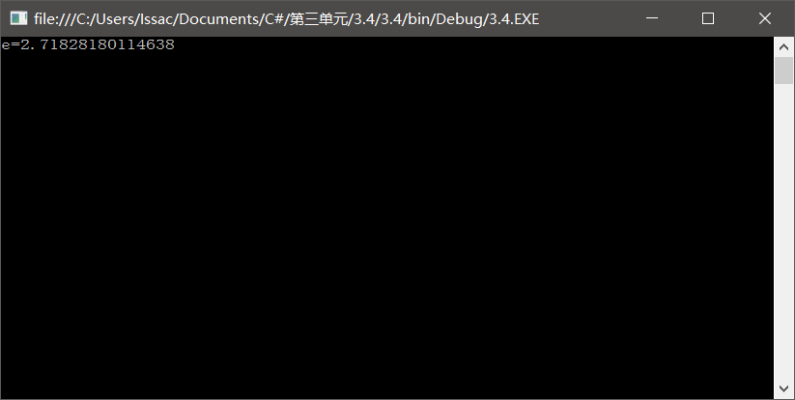

**5.**

Program.cs

using System;

using System.Collections.Generic;

using System.Linq;

using System.Text;

namespace _3._5

{

class Program

{

static void Main(string[] args)

{

int i, j, k;

for (i = 1; i <= 9; i++)

{

for (j = 0; j <= 9; j++)

{

for (k = 0; k <= 9; k++)

{

if (i!=j&&i!=k&&j!=k&&i*100+j*10+k+i+j*10+k*100==1333)

{

Console.Write("a={0},b={1},c={2}\n", i, j, k);

}

}

}

}

Console.ReadLine();

}

}

}

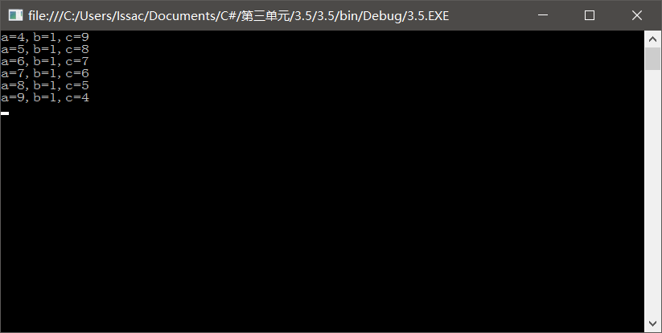

**6.**

Program.cs

using System;

using System.Collections.Generic;

using System.Linq;

using System.Text;

namespace _3._6

{

class Program

{

static void Main(string[] args)

{

int i=1, a=1;

while (i < 10)

{

a = (a + 1) * 2;

i++;

}

Console.Write("第一天共摘了{0}个桃子", a);

Console.ReadLine();

}

}

}

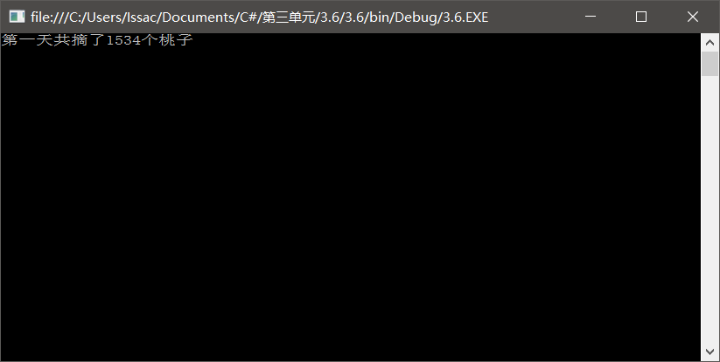

**7.**

Program.cs

using System;

using System.Collections.Generic;

using System.Linq;

using System.Text;

namespace _3._7

{

class Program

{

static void Main(string[] args)

{

int a, b, c;

for (a = 0; a <= 30; a++)

{

for (b = 0; b <= 30; b++)

{

for (c = 0; c <= 30; c++)

{

if ((a * 3 + b * 2 + c * 1 == 50) && (a + b + c == 30))

{

Console.WriteLine("男人有{0}个，女人有{1}个，孩子有{2}个",a,b,c);

}

}

}

}

Console.ReadLine();

}

}

}

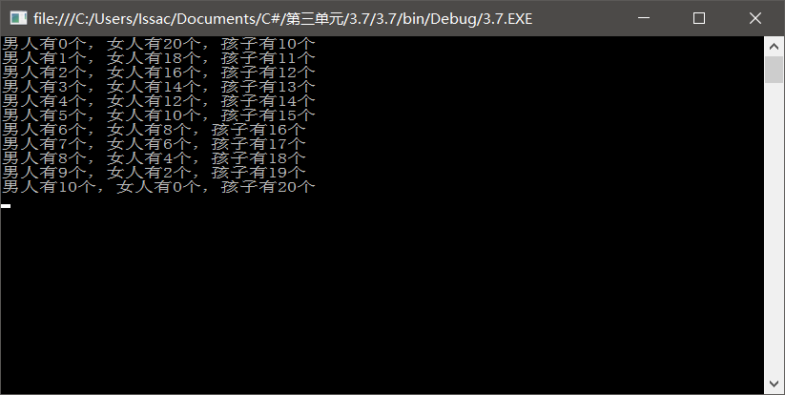

**8.**

Program.cs

using System;

using System.Collections.Generic;

using System.Linq;

using System.Text;

namespace _3._8

{

class Program

{

static void Main(string[] args)

{

double max,min,sum=0;

int i;

double[] a=new double[7];

Console.Write("请输入7个分数\n");

for (i = 0; i < 7; i++)

{

a[i] = double.Parse(Console.ReadLine());

}

max = min = a[0];

for (i = 0; i < 7; i++)

{

sum = sum + a[i];

if (max <= a[i])

{

max = a[i];

}

if (min >= a[i])

{

min = a[i];

}

}

sum = sum - (max + min);

Console.WriteLine("最高分{0},最低分{1}", max, min);

Console.WriteLine("选手平均成绩为{0}", sum/5 );

Console.ReadLine();

}

}

}

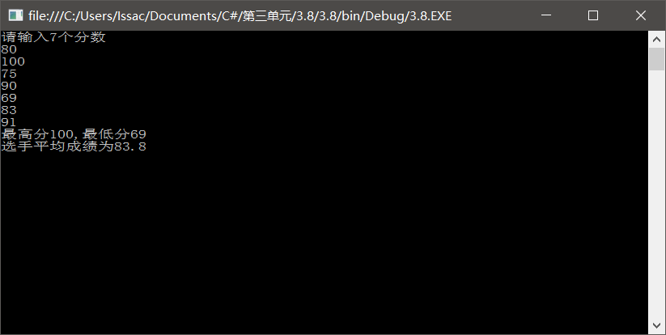

**9.**

Program.cs

using System;

using System.Collections.Generic;

using System.Linq;

using System.Text;

namespace _3._9

{

class Program

{

static void Main(string[] args)

{

int x, a, b, c;

for (x = 100; x <= 999; x++)

{

a = x / 100;

b = x % 100 / 10;

c = x % 10;

if ((a * a * a) + (b * b * b) + (c * c * c) == x)

{

Console.WriteLine(x);

}

}

Console.ReadLine();

}

}

}

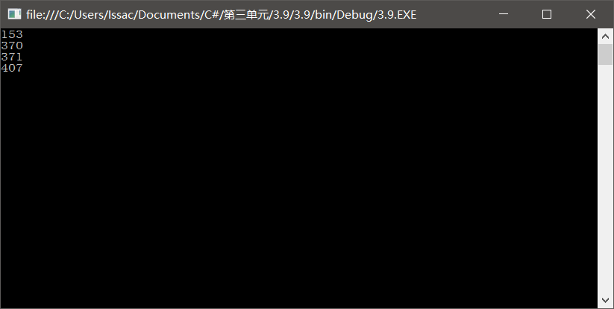

**10.**

Program.cs

using System;

using System.Collections.Generic;

using System.Linq;

using System.Text;

namespace _3._10

{

class Program

{

static void Main(string[] args)

{

int i, j, sum = 0;

for (i = 2; i <= 1000; i++)

{

sum = 0;

for (j = 1; j < i; j++)

{

if (i % j == 0)

{

sum = sum + j;

}

}

if (sum == i)

{

Console.WriteLine(i);

}

}

Console.ReadLine();

}

}

}

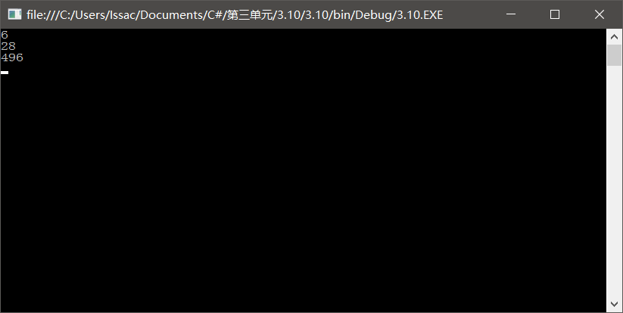

**11.**

**1)**

Program.cs

using System;

using System.Collections.Generic;

using System.Linq;

using System.Text;

namespace _3._11_1_

{

class Program

{

static void Main(string[] args)

{

int i, sum=0;

for (i = 101; i <= 500; i += 2)

{

Console.Write("{0}\n",i);

sum = sum + i;

}

Console.Write("100~500的基数总和为a{0}",sum);

Console.ReadLine();

}

}

}

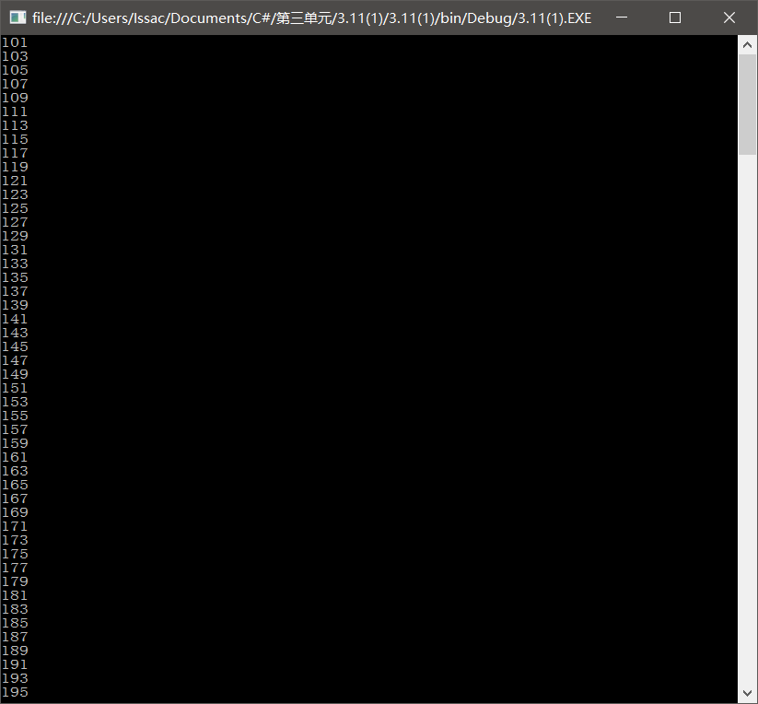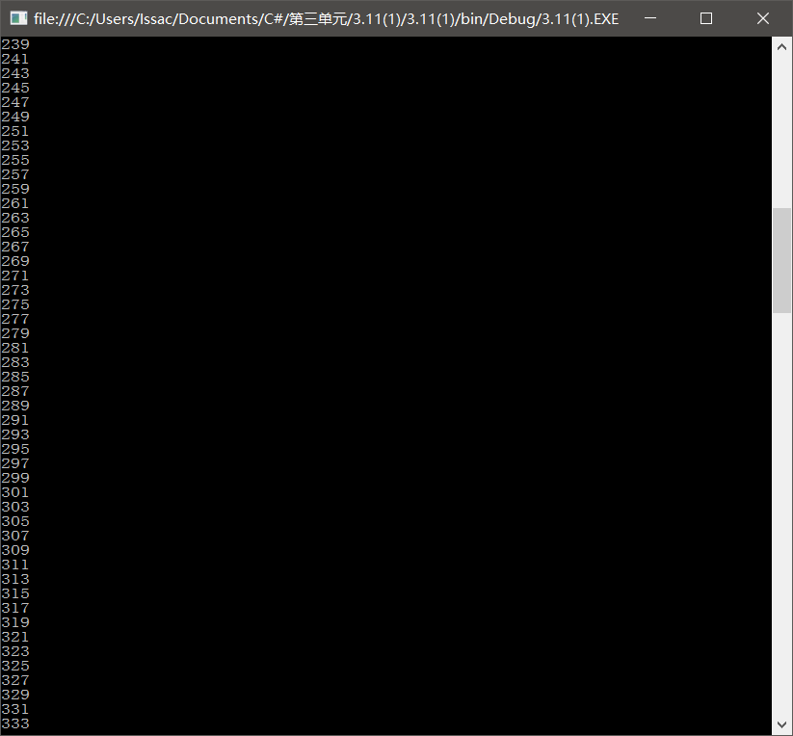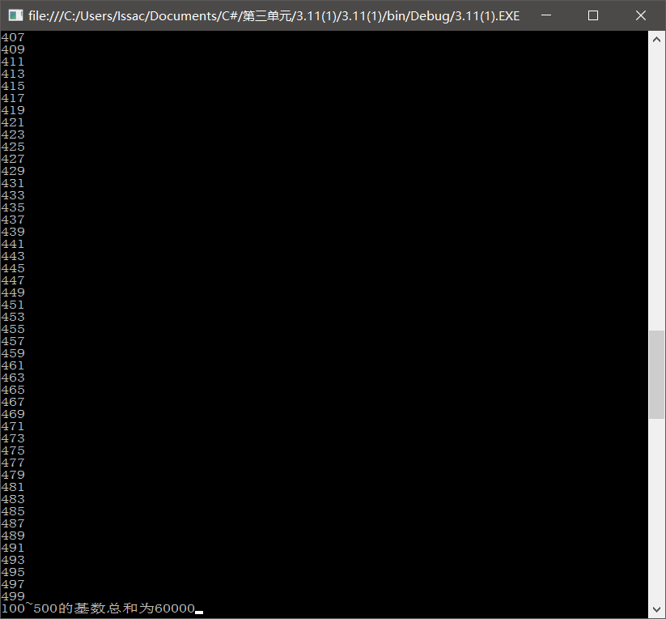

**2)**

Program.cs

using System;

using System.Collections.Generic;

using System.Linq;

using System.Text;

namespace _3._11_2_

{

class Program

{

static void Main(string[] args)

{

int i;

for (i = 100; i <= 200; i++)

{

if (i % 3 != 0)

{

Console.Write("{0}\n", i);

}

}

Console.ReadLine();

}

}

}

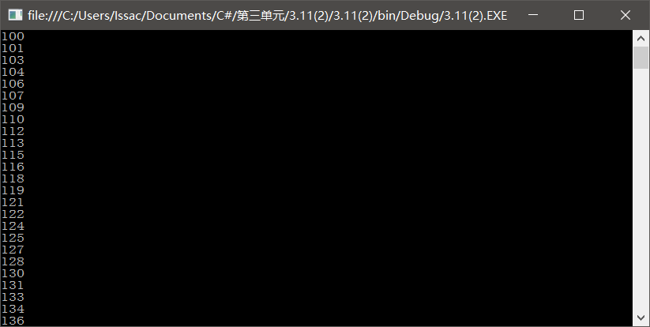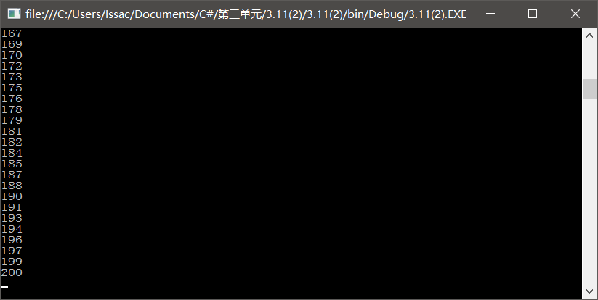

**3)**

Program.cs

using System;

using System.Collections.Generic;

using System.Linq;

using System.Text;

namespace _3._11_3_

{

class Program

{

static void Main(string[] args)

{

int i, count=0;

for (i = 1; i <= 1000; i++)

{

if ((i % 5 == 0) && (i % 7 == 0))

{

count = count + 1;

}

}

Console.Write("满足条件的数有{0}个?", count);

Console.ReadLine();

}

}

}

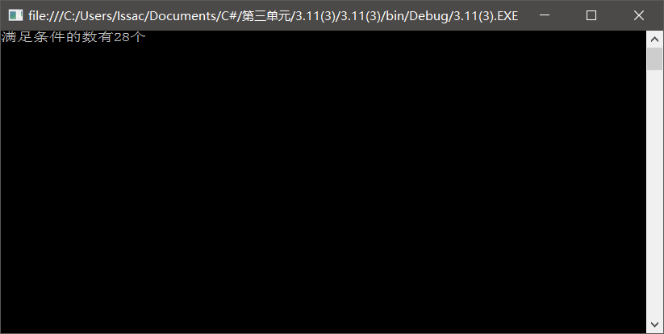

**4)**

Program.cs

using System;

using System.Collections.Generic;

using System.Linq;

using System.Text;

namespace _3._11_4_

{

class Program

{

static void Main(string[] args)

{

int i=300, count=0;

while (count<=99)

{

if ((i % 3 == 0) && (i % 5) == 0)

{

Console.Write("{0} ", i);

count += 1;

}

i = i + 1;

}

Console.ReadLine();

}

}

}

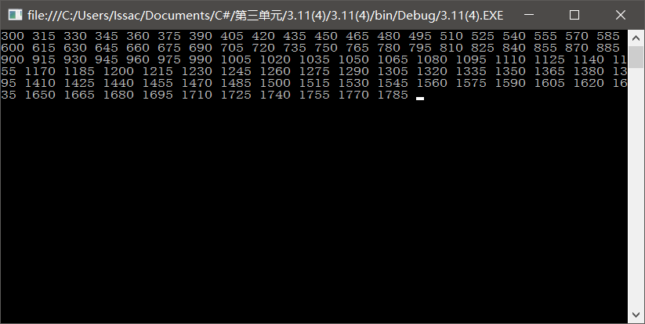

**5)**

Program.cs

using System;

using System.Collections.Generic;

using System.Linq;

using System.Text;

namespace _3._11_5_

{

class Program

{

static void Main(string[] args)

{

int i, j, k, n, sum=0;

Console.Write("请输入的值：");

n = int.Parse(Console.ReadLine());

for (i = 1; i <= n; i++)

{

k = 1;

for (j = 1; j <= i; j++)

{

k *= j;

}

sum =sum+k;

}

Console.Write("结果为a{0}", sum);

Console.ReadLine();

}

}

}

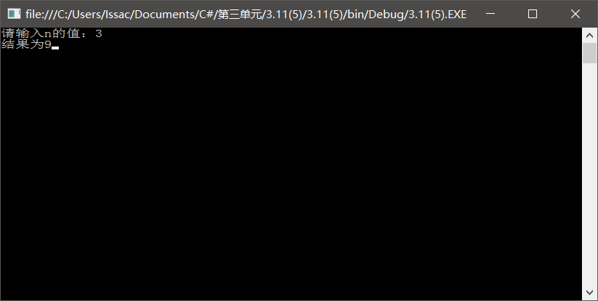

**6)**

Program.cs

using System;

using System.Collections.Generic;

using System.Linq;

using System.Text;

namespace _3._11_6_

{

class Program

{

static void Main(string[] args)

{

int i,j,count=0;

for (i = 1000; i >= 0; i--)

{

for (j = 2; j <= i - 1; j++)

{

if (i % j == 0)

{

break;

}

}

if (j >= i)

{

Console.Write("{0} ", i);

count += 1;

}

if (count == 10)

{

break;

}

}

Console.ReadLine();

}

}

}

