习题五

三

以下系统时间均为报告制作时间2017-10-31

**1.**

Form1.cs

using System;

using System.Collections.Generic;

using System.ComponentModel;

using System.Data;

using System.Drawing;

using System.Linq;

using System.Text;

using System.Windows.Forms;

namespace _5._1

{

public partial class Form1 : Form

{

public Form1()

{

InitializeComponent();

}

private void Form1_Load(object sender, EventArgs e)

{

int[] hashtable = new int[99];

int[] output = new int[99];

Random r = new Random();

for (int i = 0; i < 10; i++)

{

int num = r.Next(50, 99);

while (hashtable[num] > 0)

{

num = r.Next(50, 99);

}

output[i] = num;

hashtable[num] = 1;

label1.Text += output[i] + " ";

}

}

}

}

Program.cs

using System;

using System.Collections.Generic;

using System.Linq;

using System.Windows.Forms;

namespace _5._1

{

static class Program

{

/// <summary>

/// 应用程序的主入口点。

/// </summary>

[STAThread]

static void Main()

{

Application.EnableVisualStyles();

Application.SetCompatibleTextRenderingDefault(false);

Application.Run(new Form1());

}

}

}

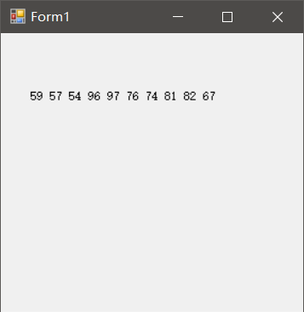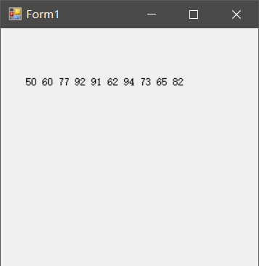

**2.**

Form1.cs

using System;

using System.Collections.Generic;

using System.ComponentModel;

using System.Data;

using System.Drawing;

using System.Linq;

using System.Text;

using System.Windows.Forms;

namespace _5._2

{

public partial class Form1 : Form

{

public Form1()

{

InitializeComponent();

}

private void textBox1_TextChanged(object sender, EventArgs e)

{

}

private void button1_Click(object sender, EventArgs e)

{

string key = textBox1.Text;

//string[] buffer = key;

int a = key.Length, a0, a1=0, a2=0, a3=0, a4=0, a5=0, a6=0, a7=0, a8=0, a9=0;

a0 = (key.Length - key.Replace("0", "").Length) / "0".Length;

a1 = (key.Length - key.Replace("1", "").Length) / "1".Length;

a2 = (key.Length - key.Replace("2", "").Length) / "2".Length;

a3 = (key.Length - key.Replace("3", "").Length) / "3".Length;

a4 = (key.Length - key.Replace("4", "").Length) / "4".Length;

a5 = (key.Length - key.Replace("5", "").Length) / "5".Length;

a6 = (key.Length - key.Replace("6", "").Length) / "6".Length;

a7 = (key.Length - key.Replace("7", "").Length) / "7".Length;

a8 = (key.Length - key.Replace("8", "").Length) / "8".Length;

a9 = (key.Length - key.Replace("9", "").Length) / "9".Length;

label2.Text = "0 1 2 3 4 5 6 7 8 9";

label3.Text = a0.ToString() + " " + a1.ToString() + " " + a2.ToString() + " " + a3.ToString() + " " + a4.ToString() + " " + a5.ToString() + " " + a6.ToString() + " " + a7.ToString() + " " + a8.ToString() + " " + a9.ToString();

}

private void label2_Click(object sender, EventArgs e)

{

}

private void Form1_Load(object sender, EventArgs e)

{

}

}

}

Program.cs

using System;

using System.Collections.Generic;

using System.Linq;

using System.Windows.Forms;

namespace _5._2

{

static class Program

{

/// <summary>

/// 应用程序的主入口点。

/// </summary>

[STAThread]

static void Main()

{

Application.EnableVisualStyles();

Application.SetCompatibleTextRenderingDefault(false);

Application.Run(new Form1());

}

}

}

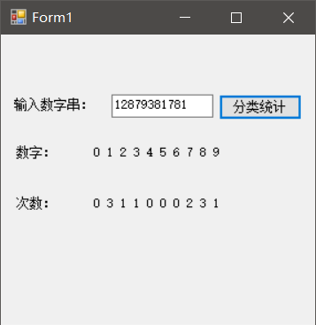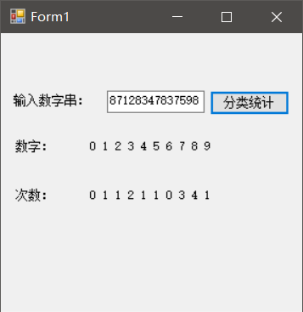

**3.**

Form1.cs

using System;

using System.Collections.Generic;

using System.ComponentModel;

using System.Data;

using System.Drawing;

using System.Linq;

using System.Text;

using System.Windows.Forms;

namespace _5._3

{

public partial class Form1 : Form

{

public Form1()

{

InitializeComponent();

}

private void textBox1_TextChanged(object sender, EventArgs e)

{

}

private void textBox2_TextChanged(object sender, EventArgs e)

{

}

private void label3_Click(object sender, EventArgs e)

{

}

private void button1_Click(object sender, EventArgs e)

{

DateTime dt1 = Convert.ToDateTime(textBox1.Text);

DateTime dt2 = Convert.ToDateTime(textBox2.Text);

TimeSpan ts1 = dt2.Subtract(dt1);

int days = ts1.Days+1;

int weekday = 0;

for (int i = 0; i <days; i++)

{

DateTime tem = dt1.Date.AddDays(i);

if (tem.DayOfWeek != System.DayOfWeek.Saturday && tem.DayOfWeek != System.DayOfWeek.Sunday)

{

weekday++;

}

}

label3.Text = "从" + dt1 + "到" + dt2 + "之间的工作日共有" + weekday.ToString() + "天";

}

}

}

Program.cs

using System;

using System.Collections.Generic;

using System.Linq;

using System.Windows.Forms;

namespace _5._3

{

static class Program

{

/// <summary>

/// 应用程序的主入口点。

/// </summary>

[STAThread]

static void Main()

{

Application.EnableVisualStyles();

Application.SetCompatibleTextRenderingDefault(false);

Application.Run(new Form1());

}

}

}

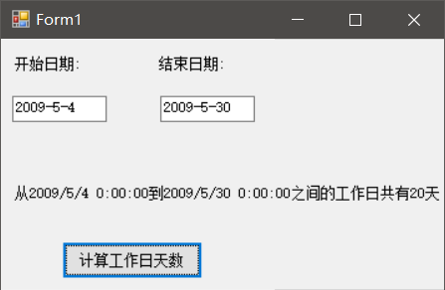

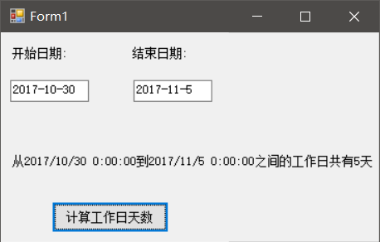

**4.**

Form1.cs

using System;

using System.Collections.Generic;

using System.ComponentModel;

using System.Data;

using System.Drawing;

using System.Linq;

using System.Text;

using System.Windows.Forms;

namespace _5._4

{

public partial class Form1 : Form

{

public Form1()

{

InitializeComponent();

}

private void textBox1_TextChanged(object sender, EventArgs e)

{

}

private void label2_Click(object sender, EventArgs e)

{

}

private void button1_Click(object sender, EventArgs e)

{

DateTime dt1 = new DateTime(2009, 2, 18, 0, 0, 0);

DateTime dt2 = Convert.ToDateTime(textBox1.Text);

TimeSpan ts1 = dt2.Subtract(dt1);

int days = ts1.Days;

int weeks = days / 7;

label2.Text = "当前日期是" + "第" + weeks.ToString() + "周";

}

}

}

Program.cs

using System;

using System.Collections.Generic;

using System.Linq;

using System.Windows.Forms;

namespace _5._4

{

static class Program

{

/// <summary>

/// 应用程序的主入口点。

/// </summary>

[STAThread]

static void Main()

{

Application.EnableVisualStyles();

Application.SetCompatibleTextRenderingDefault(false);

Application.Run(new Form1());

}

}

}

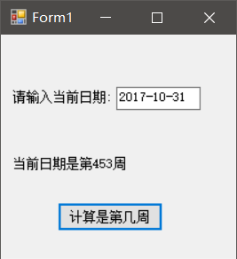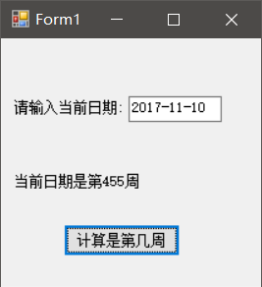

**5.**

Program.cs

using System;

using System.Collections.Generic;

using System.Linq;

using System.Text;

namespace _5._5

{

class Program

{

static void Main(string[] args)

{

DateTime dt1 = DateTime.Today;

DateTime dt2 = dt1.AddYears(1);

string dt3 = dt2.DayOfWeek.ToString();

Console.Write("明年的今天是{0}", dt3);

Console.ReadLine();

}

}

}

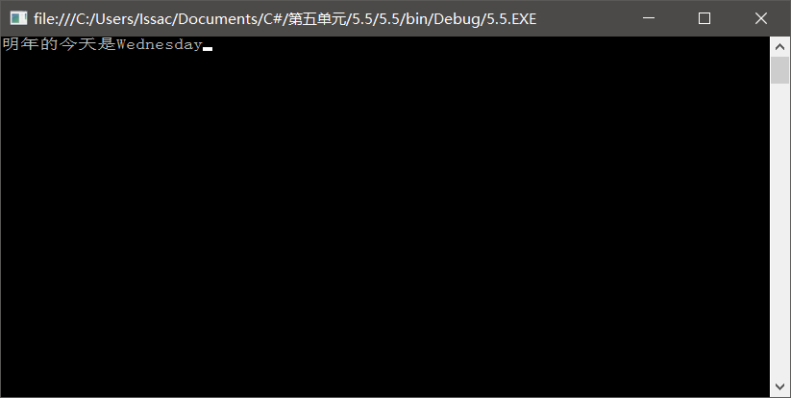

**6.**

Program.cs

using System;

using System.Collections.Generic;

using System.Linq;

using System.Text;

namespace _5._6

{

class Program

{

static void Main(string[] args)

{

DateTime dt1 = DateTime.Today;

DateTime dt2 = dt1.AddMonths(0 - (dt1.Month - 1) % 3).AddDays(1 - dt1.Day);

DateTime dt3 = dt2.AddMonths(3).AddDays(-1);

Console.Write("本季初是{0},本季末是{1}", dt2, dt3);

Console.ReadLine();

}

}

}

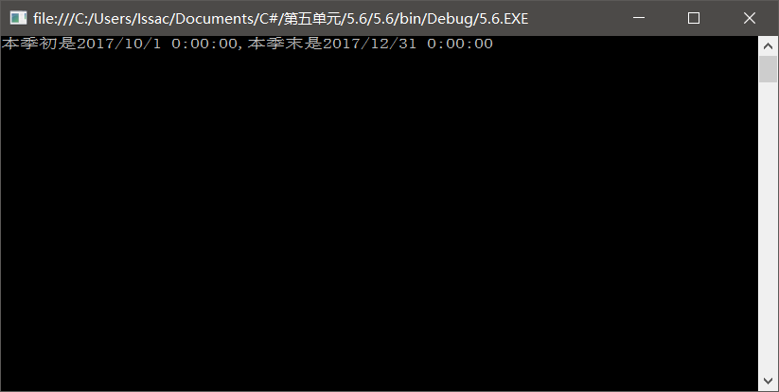

**7.**

Program.cs

using System;

using System.Collections.Generic;

using System.Linq;

using System.Text;

namespace _5._7

{

class Program

{

static void Main(string[] args)

{

DateTime dt1 = DateTime.Today;

DateTime dt2 = dt1.AddDays(1 - dt1.Day);

DateTime dt3 = dt2.AddMonths(1).AddDays(-1);

Console.Write("本月月初为a{0}，本月月末为a{1}", dt2, dt3);

Console.ReadLine();

}

}

}

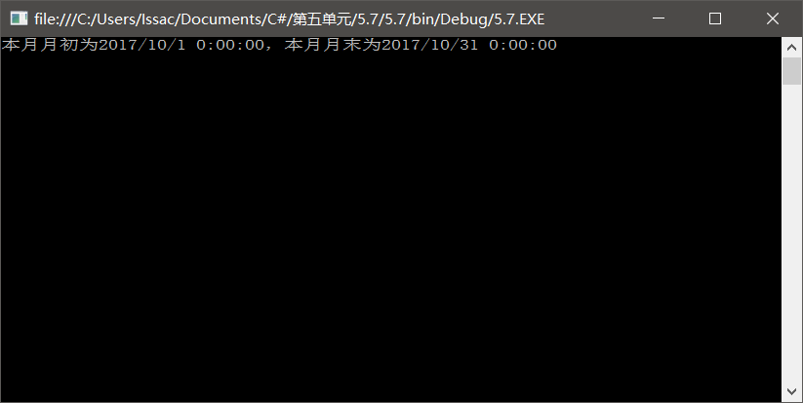

**8.**

Program.cs

using System;

using System.Collections.Generic;

using System.Linq;

using System.Text;

namespace _5._8

{

class Program

{

static void Main(string[] args)

{

DateTime dt1 = DateTime.Today;

DateTime dt2 = dt1.AddMonths(1 - dt1.Month).AddDays(1 - dt1.Day);

DateTime dt3 = dt2.AddMonths(12).AddDays(-1);

Console.Write("本年年初为a{0},本年年末为a{1}", dt2, dt3);

Console.ReadLine();

}

}

}

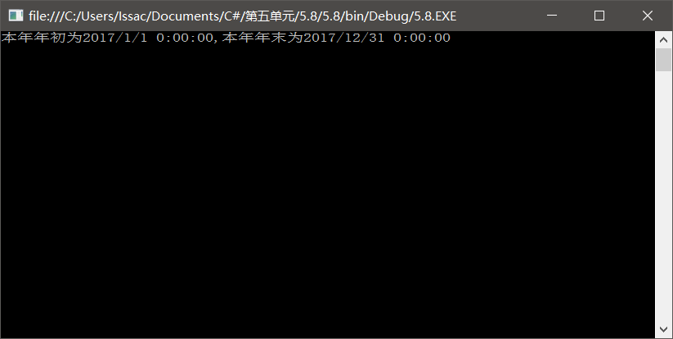

**9.**

Program.cs

using System;

using System.Collections.Generic;

using System.Linq;

using System.Text;

namespace _5._9

{

class Program

{

static void Main(string[] args)

{

DateTime dt1 = DateTime.Today;

DateTime dt2 = dt1.AddDays(1-Convert.ToInt32(dt1.DayOfWeek.ToString("d")));

DateTime dt3 = dt2.AddDays(6);

Console.Write("本周一为a{0},本周日为a{1}", dt2, dt3);

Console.ReadLine();

}

}

}

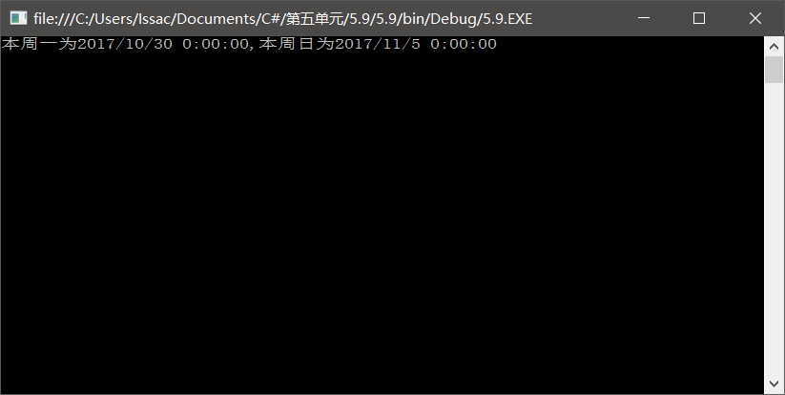

**10.**

Program.cs

using System;

using System.Collections.Generic;

using System.Linq;

using System.Text;

namespace _5._10

{

class Program

{

static void Main(string[] args)

{

DateTime dt1 = DateTime.Today;

DateTime dt2 = dt1.AddDays(1 - dt1.Day);

DateTime dt3 = dt2.AddMonths(1).AddDays(-1);

TimeSpan ts1 = dt3.Subtract(dt2);

int days = ts1.Days+1;

int weekday = 0;

for (int i = 0; i < days; i++)

{

DateTime tem = dt2.Date.AddDays(i);

if (tem.DayOfWeek != System.DayOfWeek.Saturday && tem.DayOfWeek != System.DayOfWeek.Sunday)

{

weekday++;

}

}

Console.Write("本月工作日共有{0}天",weekday);

Console.ReadLine();

}

}

}

