习题七

三

**1.**

Form1.cs

using System;

using System.Collections.Generic;

using System.ComponentModel;

using System.Data;

using System.Drawing;

using System.Linq;

using System.Text;

using System.Windows.Forms;

namespace _7._1

{

public partial class Form1 : Form

{

public Form1()

{

InitializeComponent();

}

private void textBox1_TextChanged(object sender, EventArgs e)

{

}

private void button1_Click(object sender, EventArgs e)

{

if (textBox1.Text == "")

{

textBox1.Text = "苟利国家生死以，岂因祸福避趋之。;

textBox1.Font = new Font("黑体", 20);

}

else

{

textBox1.Text = "";

}

}

private void Form1_Load(object sender, EventArgs e)

{

}

}

}

Program.cs

using System;

using System.Collections.Generic;

using System.Linq;

using System.Windows.Forms;

namespace _7._1

{

static class Program

{

/// <summary>

/// 应用程序的主入口点。

/// </summary>

[STAThread]

static void Main()

{

Application.EnableVisualStyles();

Application.SetCompatibleTextRenderingDefault(false);

Application.Run(new Form1());

}

}

}

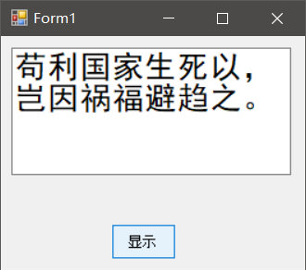

**2.**

Form1.cs

using System;

using System.Collections.Generic;

using System.ComponentModel;

using System.Data;

using System.Drawing;

using System.Linq;

using System.Text;

using System.Windows.Forms;

namespace _7._2

{

public partial class Form1 : Form

{

public Form1()

{

InitializeComponent();

}

private void listBox1_SelectedIndexChanged(object sender, EventArgs e)

{

}

private void Form1_Load(object sender, EventArgs e)

{

listBox1.MultiColumn = true;

for (int i = 0; i <= 100; i++)

{

if (i % 2 != 0)

{

listBox1.Items.Add(i.ToString());

}

}

}

}

}

Program.cs

using System;

using System.Collections.Generic;

using System.Linq;

using System.Windows.Forms;

namespace _7._2

{

static class Program

{

/// <summary>

/// 应用程序的主入口点。

/// </summary>

[STAThread]

static void Main()

{

Application.EnableVisualStyles();

Application.SetCompatibleTextRenderingDefault(false);

Application.Run(new Form1());

}

}

}

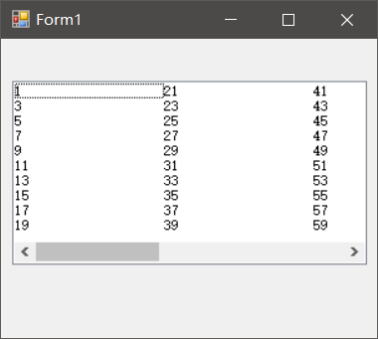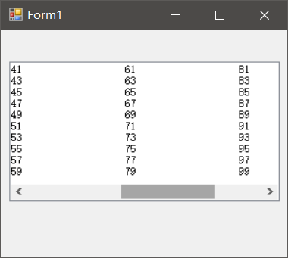

**3.**

Form1.cs

using System;

using System.Collections.Generic;

using System.ComponentModel;

using System.Data;

using System.Drawing;

using System.Linq;

using System.Text;

using System.Windows.Forms;

namespace _7._3

{

public partial class Form1 : Form

{

public Form1()

{

InitializeComponent();

}

int count = 0;

private void timer1_Tick(object sender, EventArgs e)

{

pictureBox1.Width += 125;

progressBar1.Value += 25;

count++;

if (count == 4)

{

timer1.Stop();

}

}

private void Form1_Load(object sender, EventArgs e)

{

pictureBox1.Width = 0;

timer1.Interval = 1000;

timer1.Start();

}

private void pictureBox1_Click(object sender, EventArgs e)

{

}

private void progressBar1_Click(object sender, EventArgs e)

{

}

}

}

Program.cs

using System;

using System.Collections.Generic;

using System.Linq;

using System.Windows.Forms;

namespace _7._3

{

static class Program

{

/// <summary>

/// 应用程序的主入口点。

/// </summary>

[STAThread]

static void Main()

{

Application.EnableVisualStyles();

Application.SetCompatibleTextRenderingDefault(false);

Application.Run(new Form1());

}

}

}

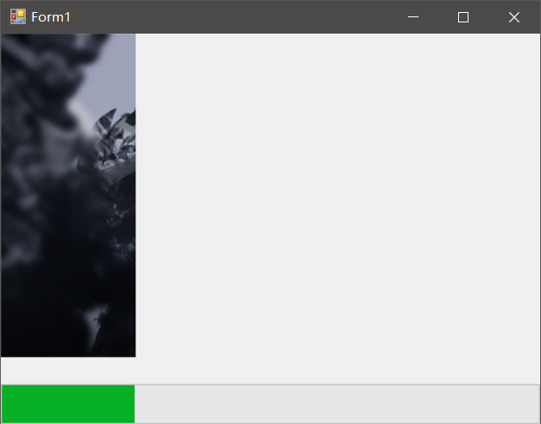

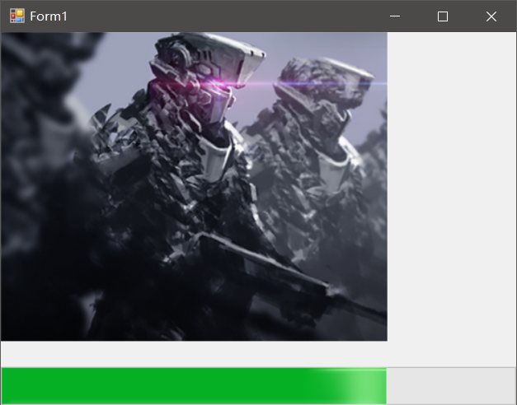

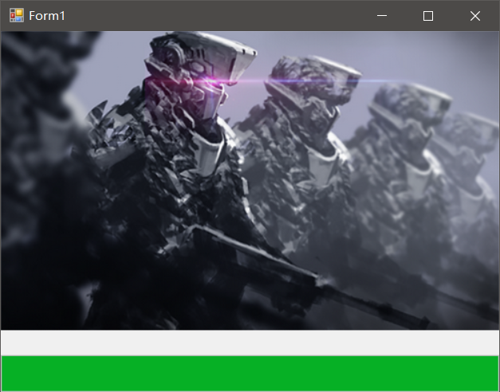

**4.**

Form1.cs

using System;

using System.Collections.Generic;

using System.ComponentModel;

using System.Data;

using System.Drawing;

using System.Linq;

using System.Text;

using System.Windows.Forms;

namespace _7._4

{

public partial class Form1 : Form

{

public Form1()

{

InitializeComponent();

}

private void textBox1_TextChanged(object sender, EventArgs e)

{

}

private void textBox2_TextChanged(object sender, EventArgs e)

{

}

private void textBox3_TextChanged(object sender, EventArgs e)

{

}

private void textBox4_TextChanged(object sender, EventArgs e)

{

}

private void textBox5_TextChanged(object sender, EventArgs e)

{

}

private void textBox6_TextChanged(object sender, EventArgs e)

{

}

private void textBox7_TextChanged(object sender, EventArgs e)

{

}

private void label1_Click(object sender, EventArgs e)

{

}

private void button1_Click(object sender, EventArgs e)

{

double[] a = new double[7];

a[0] = double.Parse(textBox1.Text);

a[1] = double.Parse(textBox2.Text);

a[2] = double.Parse(textBox3.Text);

a[3] = double.Parse(textBox4.Text);

a[4] = double.Parse(textBox5.Text);

a[5] = double.Parse(textBox6.Text);

a[6] = double.Parse(textBox7.Text);

double max, min, sum = 0;

max = min = a[0];

for (int i = 0; i < 7; i++)

{

sum = sum + a[i];

if (max < a[i])

{

max = a[i];

}

if (min > a[i])

{

min = a[i];

}

}

sum = sum - (max + min);

label1.Text = "运动员得分：" + (sum / 5).ToString();

}

}

}

Program.cs

using System;

using System.Collections.Generic;

using System.Linq;

using System.Windows.Forms;

namespace _7._4

{

static class Program

{

/// <summary>

/// 应用程序的主入口点。

/// </summary>

[STAThread]

static void Main()

{

Application.EnableVisualStyles();

Application.SetCompatibleTextRenderingDefault(false);

Application.Run(new Form1());

}

}

}

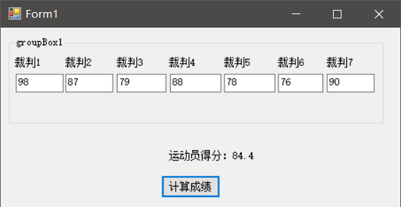

**5.**

Form1.cs

using System;

using System.Collections.Generic;

using System.ComponentModel;

using System.Data;

using System.Drawing;

using System.Linq;

using System.Text;

using System.Windows.Forms;

namespace _7._5

{

public partial class Form1 : Form

{

public Form1()

{

InitializeComponent();

}

private void label1_Click(object sender, EventArgs e)

{

}

int i = 9;

private void Form1_Load(object sender, EventArgs e)

{

label1.Text = "学无止境";

int x = (this.Width - label1.Width) / 2;

int y = (this.Height-SystemInformation.CaptionHeight - label1.Height) / 2;

Point mypoint = new Point(x, y);

label1.Location = mypoint;

timer1.Interval = 100;

timer1.Start();

timer2.Interval = 100;

timer2.Stop();

this.KeyPreview = true;

}

private void timer1_Tick(object sender, EventArgs e)

{

label1.Font = new Font("",i);

i++;

int x = (this.Width - label1.Width) / 2;

int y = (this.Height - SystemInformation.CaptionHeight - label1.Height) / 2;

Point mypoint = new Point(x, y);

label1.Location = mypoint;

if (label1.Width > this.Width)

{

timer1.Stop();

timer2.Start();

}

}

private void timer2_Tick(object sender, EventArgs e)

{

label1.Font = new Font("", i);

i--;

int x = (this.Width - label1.Width) / 2;

int y = (this.Height - SystemInformation.CaptionHeight - label1.Height) / 2;

Point mypoint = new Point(x, y);

label1.Location = mypoint;

if (label1.Width <= ((this.Width) / 10))

{

timer2.Stop();

timer1.Start();

}

}

private void Form1_KeyPress_1(object sender, KeyPressEventArgs e)

{

this.Close();

}

}

}

Program.cs

using System;

using System.Collections.Generic;

using System.Linq;

using System.Windows.Forms;

namespace _7._5

{

static class Program

{

/// <summary>

/// 应用程序的主入口点。

/// </summary>

[STAThread]

static void Main()

{

Application.EnableVisualStyles();

Application.SetCompatibleTextRenderingDefault(false);

Application.Run(new Form1());

}

}

}

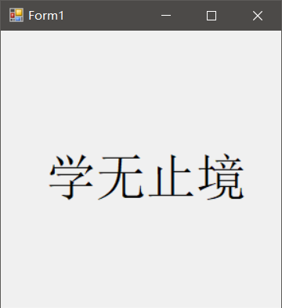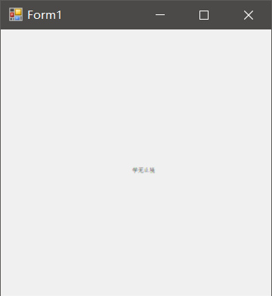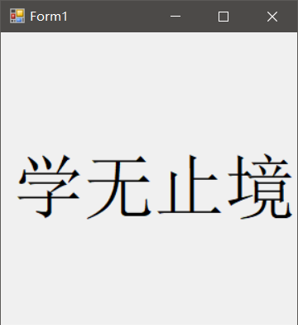

**7.**

Form1.cs

using System;

using System.Collections.Generic;

using System.ComponentModel;

using System.Data;

using System.Drawing;

using System.Linq;

using System.Text;

using System.Windows.Forms;

namespace _7._6

{

public partial class Form1 : Form

{

public Form1()

{

InitializeComponent();

}

private void listBox1_SelectedIndexChanged(object sender, EventArgs e)

{

}

private void listBox2_SelectedIndexChanged(object sender, EventArgs e)

{

}

private void button1_Click(object sender, EventArgs e)

{

if (listBox1.Items.Count == 0)

return;

if (listBox1.SelectedItem == null)

return;

listBox2.Items.Add(listBox1.SelectedItem);

listBox1.Items.Remove(listBox1.SelectedItem);

listBox1.Sorted = true;

listBox2.Sorted = true;

}

private void button2_Click(object sender, EventArgs e)

{

if (listBox1.Items.Count == 0)

return;

for (int i = 0; i < listBox1.Items.Count; i++)

{

listBox2.Items.Add(listBox1.Items[i]);

}

for (int j = 0; j < listBox2.Items.Count; j++)

{

listBox1.Items.Remove(listBox2.Items[j]);

}

listBox1.Sorted = true;

listBox2.Sorted = true;

}

private void button3_Click(object sender, EventArgs e)

{

if (listBox2.Items.Count == 0)

return;

if (listBox2.SelectedItem == null)

return;

listBox1.Items.Add(listBox2.SelectedItem);

listBox2.Items.Remove(listBox2.SelectedItem);

}

private void button4_Click(object sender, EventArgs e)

{

if (listBox2.Items.Count == 0)

return;

for (int i = 0; i < listBox2.Items.Count; i++)

{

listBox1.Items.Add(listBox2.Items[i]);

}

for (int j = 0; j < listBox1.Items.Count; j++)

{

listBox2.Items.Remove(listBox1.Items[j]);

}

listBox1.Sorted = true;

listBox2.Sorted = true;

}

private void Form1_Load(object sender, EventArgs e)

{

//listBox1.Sorted = true;

//listBox2.Sorted = true;

}

}

}

Program.cs

using System;

using System.Collections.Generic;

using System.Linq;

using System.Windows.Forms;

namespace _7._6

{

static class Program

{

/// <summary>

/// 应用程序的主入口点。

/// </summary>

[STAThread]

static void Main()

{

Application.EnableVisualStyles();

Application.SetCompatibleTextRenderingDefault(false);

Application.Run(new Form1());

}

}

}

