习题十

三

**7.**

Form1.cs

using System;

using System.Collections.Generic;

using System.ComponentModel;

using System.Data;

using System.Drawing;

using System.Linq;

using System.Text;

using System.Windows.Forms;

namespace _10._7

{

public partial class Form1 : Form

{

public Form1()

{

InitializeComponent();

}

Graphics gMouse;

Point ptStart, ptMove, p1, p2;

Pen pen1 = new Pen(Color.Black);

private void pictureBox1_MouseDown(object sender, MouseEventArgs e)

{

gMouse = pictureBox1.CreateGraphics();

ptStart.X = e.X;

ptStart.Y = e.Y;

p1.X = e.X;

p1.Y = e.Y;

pictureBox1.Cursor = Cursors.Cross;

}

private void pictureBox1_MouseMove(object sender, MouseEventArgs e)

{

if (e.Button == MouseButtons.Left)

{

ptMove.X = e.X;

ptMove.Y = e.Y;

gMouse.DrawLine(pen1, ptStart, ptMove);

ptStart = ptMove;

}

}

private void pictureBox1_MouseUp(object sender, MouseEventArgs e)

{

pictureBox1.Cursor = Cursors.Default;

p2.X = e.X;

p2.Y = e.Y;

gMouse.DrawLine(pen1, p1, p2);

}

private void Form1_Load(object sender, EventArgs e)

{

}

}

}

Program.cs

using System;

using System.Collections.Generic;

using System.Linq;

using System.Windows.Forms;

namespace _10._7

{

static class Program

{

/// <summary>

/// 应用程序的主入口点。

/// </summary>

[STAThread]

static void Main()

{

Application.EnableVisualStyles();

Application.SetCompatibleTextRenderingDefault(false);

Application.Run(new Form1());

}

}

}

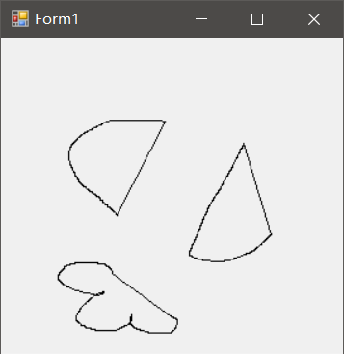

**8.**

Form1.cs

using System;

using System.Collections.Generic;

using System.ComponentModel;

using System.Data;

using System.Drawing;

using System.Linq;

using System.Text;

using System.Windows.Forms;

namespace _10._8

{

public partial class Form1 : Form

{

public Form1()

{

InitializeComponent();

}

private void textBox1_TextChanged(object sender, EventArgs e)

{

}

private void textBox2_TextChanged(object sender, EventArgs e)

{

}

private void button1_Click(object sender, EventArgs e)

{

string[] lines = textBox1.Text.Split(new string[] { "\r\n" },StringSplitOptions.None);

string[] province = new string[lines.Length];

float[] student = new float[lines.Length];

float a = 0;

float b = 0;

Graphics g = pictureBox1.CreateGraphics();

Rectangle rect = new Rectangle(50, 10, 180, 180);

Rectangle r = new Rectangle(10, 20, 10, 10);

Point p = new Point(20, 20);

float start = 0;

Random rnd = new Random();

SolidBrush brush2 = new SolidBrush(Color.Black);

for (int i = 0; i < lines.Length; i++)

{

string[] lines1 = lines[i].Split(new string[] { " " }, StringSplitOptions.None);

student[i] = float.Parse(lines1[1]);

province[i] = lines1[0];

a += student[i];

}

b = 360 / a;

for (int i = 0; i < lines.Length; i++)

{

Color cc = Color.FromArgb(rnd.Next(256), rnd.Next(256), rnd.Next(256));

SolidBrush brush1 = new SolidBrush(cc);

float sweep = student[i] * b;

g.FillPie(brush1, rect, start, sweep);

g.FillRectangle(brush1, r);

g.DrawString(province[i], this.Font, brush2, p);

start += sweep;

r.Y += 15;

p.Y += 15;

}

}

private void pictureBox1_Click(object sender, EventArgs e)

{

}

private void button2_Click(object sender, EventArgs e)

{

Application.Exit();

}

}

}

Program.cs

using System;

using System.Collections.Generic;

using System.Linq;

using System.Windows.Forms;

namespace _10._8

{

static class Program

{

/// <summary>

/// 应用程序的主入口点。

/// </summary>

[STAThread]

static void Main()

{

Application.EnableVisualStyles();

Application.SetCompatibleTextRenderingDefault(false);

Application.Run(new Form1());

}

}

}

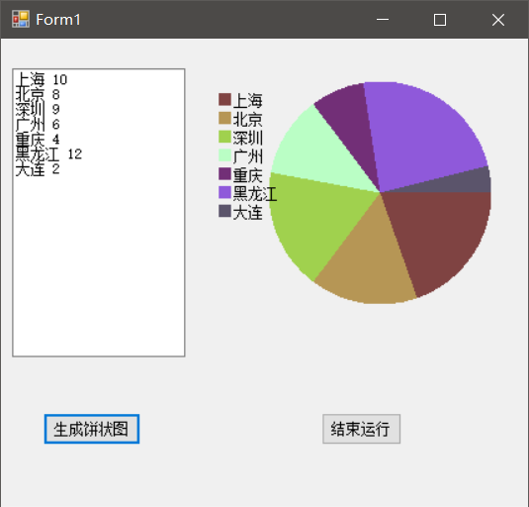

**10.**

Form1.cs

using System;

using System.Collections.Generic;

using System.ComponentModel;

using System.Data;

using System.Drawing;

using System.Linq;

using System.Text;

using System.Windows.Forms;

namespace _10._10

{

public partial class Form1 : Form

{

public Form1()

{

InitializeComponent();

}

Bitmap bmp;

private void pictureBox1_Click(object sender, EventArgs e)

{

DateTime dt1 = System.DateTime.Now;

Graphics g = Graphics.FromImage(bmp);

for (int w = 0; w < bmp.Width; w++)

{

for (int h = 0; h < bmp.Height; h++)

{

Color color = bmp.GetPixel(w, h);

byte gray = (byte)((color.R * 229 + color.G * 587 + color.B * 114) / 1000);

bmp.SetPixel(w, h, Color.FromArgb(gray, gray, gray));

}

}

g.DrawImage(bmp, 0, 0);

pictureBox1.Image = bmp;

g.Dispose();

DateTime dt2 = System.DateTime.Now;

TimeSpan ts1 = dt2.Subtract(dt1);

MessageBox.Show("运行时间为" + ts1, "提示", MessageBoxButtons.OK, MessageBoxIcon.Asterisk);

}

private void Form1_Load(object sender, EventArgs e)

{

bmp = new Bitmap(pictureBox1.ImageLocation);

}

}

}

Program.cs

using System;

using System.Collections.Generic;

using System.Linq;

using System.Windows.Forms;

namespace _10._10

{

static class Program

{

/// <summary>

/// 应用程序的主入口点。

/// </summary>

[STAThread]

static void Main()

{

Application.EnableVisualStyles();

Application.SetCompatibleTextRenderingDefault(false);

Application.Run(new Form1());

}

}

}

