习题九

三

**4.**

Form1.cs

using System;

using System.Collections.Generic;

using System.ComponentModel;

using System.Data;

using System.Drawing;

using System.Linq;

using System.Text;

using System.Windows.Forms;

using System.IO;

namespace _9._4

{

public partial class Form1 : Form

{

public Form1()

{

InitializeComponent();

}

private void button1_Click(object sender, EventArgs e)

{

if (openFileDialog1.ShowDialog() == DialogResult.OK)

{

textBox1.Text = openFileDialog1.FileName;

}

}

private void button2_Click(object sender, EventArgs e)

{

FileStream fs = new FileStream(textBox1.Text, FileMode.Open);

richTextBox1.Text = " ";

byte[] arr = new byte[30];

while (fs.Read(arr, 0, arr.Length) > 0)

{

for (int i = 0; i < arr.Length; i++)

{

richTextBox1.Text += (char)arr[i];

}

}

}

private void textBox1_TextChanged(object sender, EventArgs e)

{

}

private void richTextBox1_TextChanged(object sender, EventArgs e)

{

}

private void openFileDialog1_FileOk(object sender, CancelEventArgs e)

{

}

private void Form1_Load(object sender, EventArgs e)

{

openFileDialog1.Filter = "文本文件|*.txt";

}

}

}

Program.cs

using System;

using System.Collections.Generic;

using System.Linq;

using System.Windows.Forms;

namespace _9._4

{

static class Program

{

/// <summary>

/// 应用程序的主入口点。

/// </summary>

[STAThread]

static void Main()

{

Application.EnableVisualStyles();

Application.SetCompatibleTextRenderingDefault(false);

Application.Run(new Form1());

}

}

}

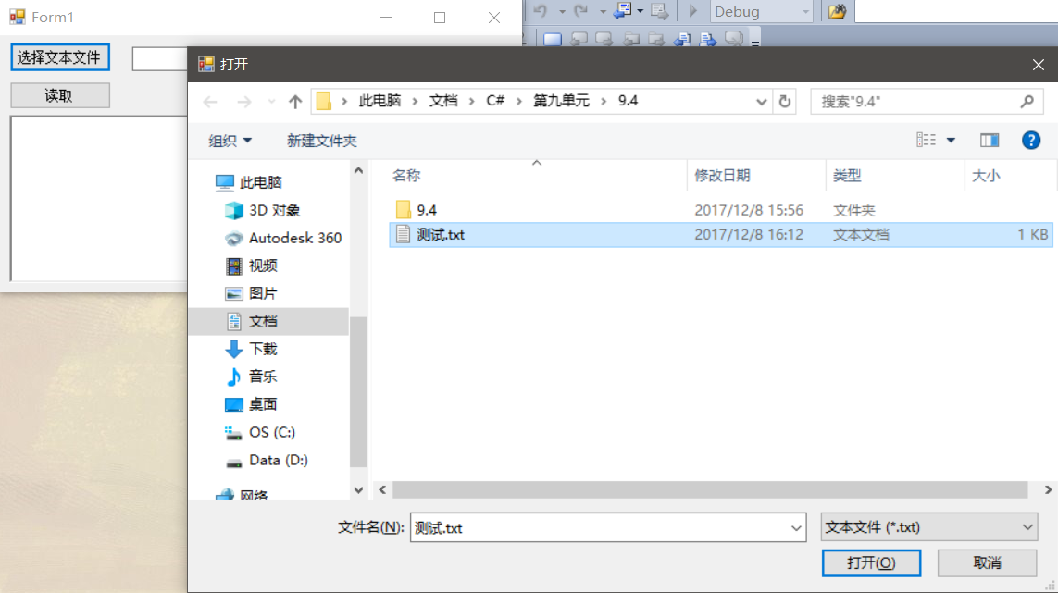

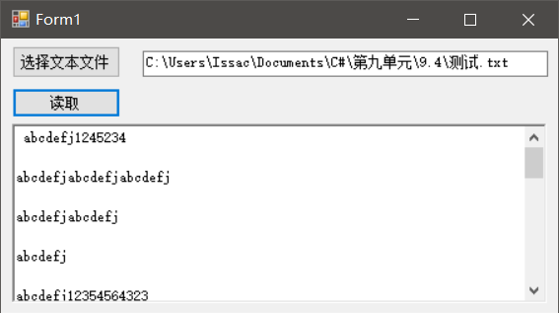

**5.**

Form1.cs

using System;

using System.Collections.Generic;

using System.ComponentModel;

using System.Data;

using System.Drawing;

using System.Linq;

using System.Text;

using System.Windows.Forms;

using System.IO;

namespace _9._5

{

public partial class Form1 : Form

{

public Form1()

{

InitializeComponent();

}

private void Form1_Load(object sender, EventArgs e)

{

openFileDialog1.Filter = "bmp图片文件|*.bmp";

}

private void button1_Click(object sender, EventArgs e)

{

if (openFileDialog1.ShowDialog() == DialogResult.OK)

{

pictureBox1.ImageLocation = openFileDialog1.FileName;

//Bitmap bmp = new Bitmap(@openFileDialog1.FileName);

FileStream fs = new FileStream(@openFileDialog1.FileName, FileMode.Open);

BinaryReader br = new BinaryReader(fs);

byte[] bmpfile = br.ReadBytes((int)fs.Length);

fs.Close();

string result = string.Empty;

for (int i = 0; i < bmpfile.Length; i++)

{

result += " "+Convert.ToString(bmpfile[i], 16);

}

richTextBox1.Text = result;

}

}

private void pictureBox1_Click(object sender, EventArgs e)

{

}

private void richTextBox1_TextChanged(object sender, EventArgs e)

{

}

private void openFileDialog1_FileOk(object sender, CancelEventArgs e)

{

}

}

}

Program.cs

using System;

using System.Collections.Generic;

using System.Linq;

using System.Windows.Forms;

namespace _9._5

{

static class Program

{

/// <summary>

/// 应用程序的主入口点。

/// </summary>

[STAThread]

static void Main()

{

Application.EnableVisualStyles();

Application.SetCompatibleTextRenderingDefault(false);

Application.Run(new Form1());

}

}

}

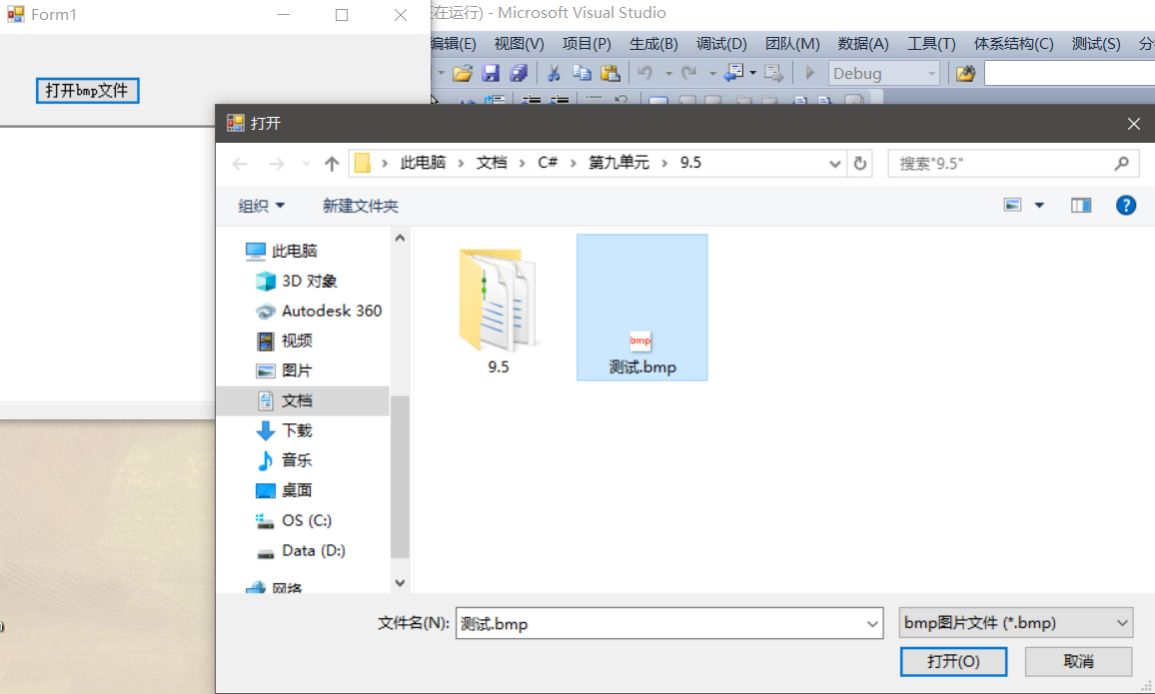

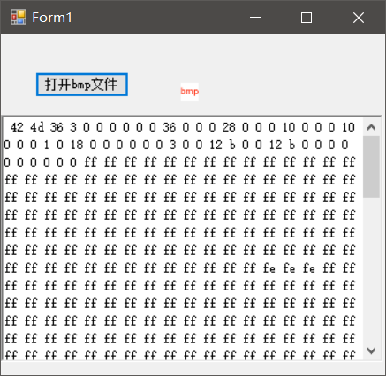

**6.**

From1.cs

using System;

using System.Collections.Generic;

using System.ComponentModel;

using System.Data;

using System.Drawing;

using System.Linq;

using System.Text;

using System.Windows.Forms;

using System.IO;

namespace _9._6

{

public partial class Form1 : Form

{

public Form1()

{

InitializeComponent();

}

private void textBox2_TextChanged(object sender, EventArgs e)

{

}

private void button2_Click(object sender, EventArgs e)

{

DirectoryInfo source = new DirectoryInfo(textBox1.Text);

DirectoryInfo destination = new DirectoryInfo(textBox2.Text);

if (!destination.Exists)

destination.Create();

foreach (FileInfo f in source.GetFiles())

{

if (f.Extension == ".doc")

{

f.CopyTo(destination.FullName + "\\" + f.Name, true);

}

}

label2.Text = "复制成功！";

}

private void textBox1_TextChanged(object sender, EventArgs e)

{

}

private void button1_Click(object sender, EventArgs e)

{

if (folderBrowserDialog1.ShowDialog() == DialogResult.OK)

{

textBox1.Text = folderBrowserDialog1.SelectedPath;

}

}

private void Form1_Load(object sender, EventArgs e)

{

}

private void folderBrowserDialog1_HelpRequest(object sender, EventArgs e)

{

}

private void label2_Click(object sender, EventArgs e)

{

}

}

}

Program.cs

using System;

using System.Collections.Generic;

using System.Linq;

using System.Windows.Forms;

namespace _9._6

{

static class Program

{

/// <summary>

/// 应用程序的主入口点。

/// </summary>

[STAThread]

static void Main()

{

Application.EnableVisualStyles();

Application.SetCompatibleTextRenderingDefault(false);

Application.Run(new Form1());

}

}

}

