习题四

三

**1.**

Form1.cs

using System;

using System.Collections.Generic;

using System.ComponentModel;

using System.Data;

using System.Drawing;

using System.Linq;

using System.Text;

using System.Windows.Forms;

namespace _4._1

{

public partial class Form1 : Form

{

public Form1()

{

InitializeComponent();

}

private void textBox1_TextChanged(object sender, EventArgs e)

{

}

private void textBox2_TextChanged(object sender, EventArgs e)

{

}

private void button1_Click(object sender, EventArgs e)

{

int a, b, x, y, c, k;

a = int.Parse(textBox1.Text);

b = int.Parse(textBox2.Text);

x = a;

y = b;

while (a % b != 0)

{

c = a % b;

a = b;

b = c;

}

k = (x * y) / b;

label1.Text="最大公约数为a"+b+"，"+"最小公倍数为a"+k;

}

private void label1_Click(object sender, EventArgs e)

{

}

}

}

Program.cs

using System;

using System.Collections.Generic;

using System.Linq;

using System.Windows.Forms;

namespace _4._1

{

static class Program

{

/// <summary>

/// 应用程序的主入口点。

/// </summary>

[STAThread]

static void Main()

{

Application.EnableVisualStyles();

Application.SetCompatibleTextRenderingDefault(false);

Application.Run(new Form1());

}

}

}

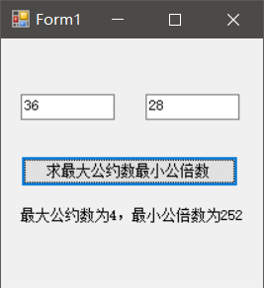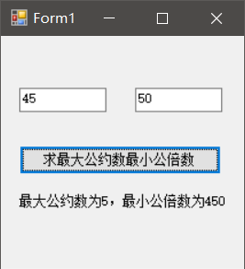

**2.**

Form1.cs

using System;

using System.Collections.Generic;

using System.ComponentModel;

using System.Data;

using System.Drawing;

using System.Linq;

using System.Text;

using System.Windows.Forms;

namespace _4._2

{

public partial class Form1 : Form

{

public Form1()

{

InitializeComponent();

}

private void textBox1_TextChanged(object sender, EventArgs e)

{

}

private void button1_Click(object sender, EventArgs e)

{

int i,n;

label2.Text = "计算结果：\n";

n=int.Parse(textBox1.Text);

for (i=1; i <= n; i++)

{

label2.Text += fib(i) + "\n";

}

}

private void label2_Click(object sender, EventArgs e)

{

}

public int fib(int num)

{

if (num>=0&&num<=1)

{

return 1;

}

else

{

return num = fib(num - 1) + fib(num - 2);

}

}

private void Form1_Load(object sender, EventArgs e)

{

}

}

}

Program.cs

using System;

using System.Collections.Generic;

using System.Linq;

using System.Windows.Forms;

namespace _4._2

{

static class Program

{

/// <summary>

/// 应用程序的主入口点。

/// </summary>

[STAThread]

static void Main()

{

Application.EnableVisualStyles();

Application.SetCompatibleTextRenderingDefault(false);

Application.Run(new Form1());

}

}

}

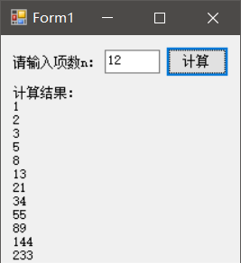

**3.**

Rectangle.cs

using System;

using System.Collections.Generic;

using System.Linq;

using System.Text;

namespace _4._3

{

class Rectangle

{

public double length;

public double width;

public double s(double a, double b)

{

return a * b;

}

public double l(double x, double y)

{

return (x + y) * 2;

}

}

}

Form1.cs

using System;

using System.Collections.Generic;

using System.ComponentModel;

using System.Data;

using System.Drawing;

using System.Linq;

using System.Text;

using System.Windows.Forms;

namespace _4._3

{

public partial class Form1 : Form

{

public Form1()

{

InitializeComponent();

}

private void textBox1_TextChanged(object sender, EventArgs e)

{

}

private void textBox2_TextChanged(object sender, EventArgs e)

{

}

private void button1_Click(object sender, EventArgs e)

{

Rectangle rectangle1 = new Rectangle();

rectangle1.length = double.Parse(textBox1.Text);

rectangle1.width = double.Parse(textBox2.Text);

label3.Text = "矩形的面积是：" + rectangle1.s(rectangle1.length,rectangle1.width);

label4.Text = "矩形的周长是：" + rectangle1.l(rectangle1.length,rectangle1.width);

}

private void label3_Click(object sender, EventArgs e)

{

}

private void label4_Click(object sender, EventArgs e)

{

}

}

}

Program.cs

using System;

using System.Collections.Generic;

using System.Linq;

using System.Windows.Forms;

namespace _4._3

{

static class Program

{

/// <summary>

/// 应用程序的主入口点。

/// </summary>

[STAThread]

static void Main()

{

Application.EnableVisualStyles();

Application.SetCompatibleTextRenderingDefault(false);

Application.Run(new Form1());

}

}

}

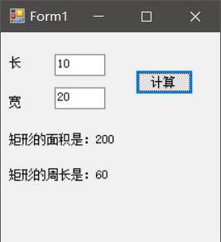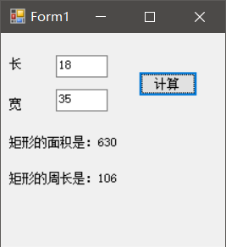

**4.**

Ball.cs

using System;

using System.Collections.Generic;

using System.Linq;

using System.Text;

namespace _4._4

{

class Ball

{

public double r;

public double pi=3.14;

public double x = 4.0 / 3.0 ;

public double s(double a)

{

return 4 * pi * a * a;

}

public double v(double b)

{

return x * pi * b * b * b;

}

}

}

Form1.cs

using System;

using System.Collections.Generic;

using System.ComponentModel;

using System.Data;

using System.Drawing;

using System.Linq;

using System.Text;

using System.Windows.Forms;

namespace _4._4

{

public partial class Form1 : Form

{

public Form1()

{

InitializeComponent();

}

private void textBox1_TextChanged(object sender, EventArgs e)

{

}

private void button1_Click(object sender, EventArgs e)

{

Ball ball1 = new Ball();

ball1.r = double.Parse(textBox1.Text);

label4.Text = "球体的表面积为：+ ball1.s(ball1.r);

label5.Text = "球体的体积为： + ball1.v(ball1.r);

}

private void label4_Click(object sender, EventArgs e)

{

}

private void label5_Click(object sender, EventArgs e)

{

}

}

}

Program.cs

using System;

using System.Collections.Generic;

using System.Linq;

using System.Windows.Forms;

namespace _4._4

{

static class Program

{

/// <summary>

/// 应用程序的主入口点。

/// </summary>

[STAThread]

static void Main()

{

Application.EnableVisualStyles();

Application.SetCompatibleTextRenderingDefault(false);

Application.Run(new Form1());

}

}

}

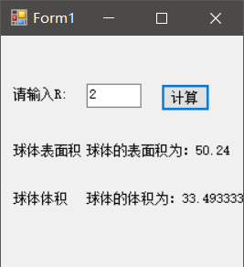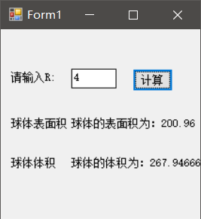

**5.**

Operation.cs

using System;

using System.Collections.Generic;

using System.Linq;

using System.Text;

namespace _4._5

{

class Operation

{

public double a;

public double b;

public double plus(double x, double y)

{

return x + y;

}

public double sub(double x, double y)

{

return x - y;

}

public double mul(double x, double y)

{

return x * y;

}

public double div(double x, double y)

{

return x / y;

}

}

}

Form1.cs

using System;

using System.Collections.Generic;

using System.ComponentModel;

using System.Data;

using System.Drawing;

using System.Linq;

using System.Text;

using System.Windows.Forms;

namespace _4._5

{

public partial class Form1 : Form

{

public Form1()

{

InitializeComponent();

}

private void textBox1_TextChanged(object sender, EventArgs e)

{

}

private void textBox2_TextChanged(object sender, EventArgs e)

{

}

private void comboBox1_SelectedIndexChanged(object sender, EventArgs e)

{

}

private void button1_Click(object sender, EventArgs e)

{

Operation ope1 = new Operation();

ope1.a = double.Parse(textBox1.Text);

ope1.b = double.Parse(textBox2.Text);

if (comboBox1.Text == "加法")

{

label3.Text = "相加结果为：" + ope1.plus(ope1.a, ope1.b);

}

else if (comboBox1.Text == "减法")

{

label3.Text = "相减结果为：" + ope1.sub(ope1.a, ope1.b);

}

else if (comboBox1.Text == "乘法")

{

label3.Text = "相乘结果为：" + ope1.mul(ope1.a, ope1.b);

}

else if (comboBox1.Text == "除法")

{

label3.Text = "相除结果为：" + ope1.div(ope1.a, ope1.b);

}

}

private void label3_Click(object sender, EventArgs e)

{

}

}

}

Program.cs

using System;

using System.Collections.Generic;

using System.Linq;

using System.Windows.Forms;

namespace _4._5

{

static class Program

{

/// <summary>

/// 应用程序的主入口点。

/// </summary>

[STAThread]

static void Main()

{

Application.EnableVisualStyles();

Application.SetCompatibleTextRenderingDefault(false);

Application.Run(new Form1());

}

}

}

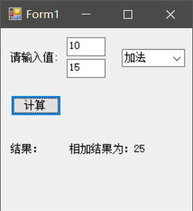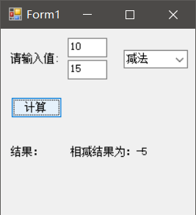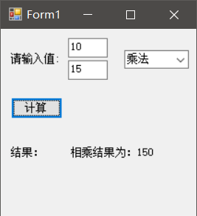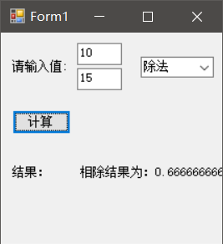

**6.**

Student.cs

using System;

using System.Collections.Generic;

using System.Linq;

using System.Text;

namespace _4._6

{

class Student

{

public string sname;

public int snumber;

public int cscore;

public int mscore;

public int escore;

}

}

Form1.cs

using System;

using System.Collections.Generic;

using System.ComponentModel;

using System.Data;

using System.Drawing;

using System.Linq;

using System.Text;

using System.Windows.Forms;

namespace _4._6

{

public partial class Form1 : Form

{

public Form1()

{

InitializeComponent();

}

private void textBox1_TextChanged(object sender, EventArgs e)

{

}

private void textBox2_TextChanged(object sender, EventArgs e)

{

}

private void textBox3_TextChanged(object sender, EventArgs e)

{

}

private void textBox4_TextChanged(object sender, EventArgs e)

{

}

private void textBox5_TextChanged(object sender, EventArgs e)

{

}

private void button1_Click(object sender, EventArgs e)

{

Student student1 = new Student();

student1.sname = "赵六";

student1.snumber = 14396;

student1.cscore = int.Parse(textBox3.Text);

student1.mscore = int.Parse(textBox4.Text);

student1.escore = int.Parse(textBox5.Text);

label6.Text = "学生姓名：" + student1.sname + "," + "学号：" + student1.snumber + "," + "语文成绩：" + student1.cscore + "," + "数学成绩：" + student1.mscore + "," + "英语成绩：" + student1.escore;

}

private void label6_Click(object sender, EventArgs e)

{

}

private void Form1_Load(object sender, EventArgs e)

{

}

}

}

Program.cs

using System;

using System.Collections.Generic;

using System.Linq;

using System.Windows.Forms;

namespace _4._6

{

static class Program

{

/// <summary>

/// 应用程序的主入口点。

/// </summary>

[STAThread]

static void Main()

{

Application.EnableVisualStyles();

Application.SetCompatibleTextRenderingDefault(false);

Application.Run(new Form1());

}

}

}

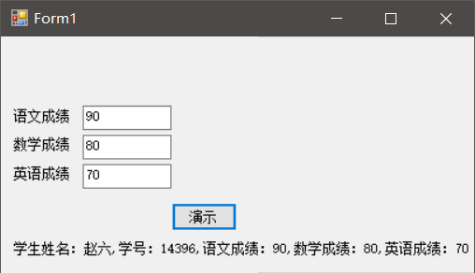

**7.**

Max.cs

using System;

using System.Collections.Generic;

using System.Linq;

using System.Text;

namespace _4._7

{

class Max

{

public long a;

public long b;

public long choose(long x, long y)

{

if (x > y)

{

return x;

}

else

{

return y;

}

}

}

}

Form.cs

using System;

using System.Collections.Generic;

using System.ComponentModel;

using System.Data;

using System.Drawing;

using System.Linq;

using System.Text;

using System.Windows.Forms;

namespace _4._7

{

public partial class Form1 : Form

{

public Form1()

{

InitializeComponent();

}

private void textBox1_TextChanged(object sender, EventArgs e)

{

}

private void textBox2_TextChanged(object sender, EventArgs e)

{

}

private void button1_Click(object sender, EventArgs e)

{

Max coop1 = new Max();

coop1.a = int.Parse(textBox1.Text);

coop1.b = int.Parse(textBox2.Text);

label2.Text = "较大的数是：" + coop1.choose(coop1.a, coop1.b);

}

private void label2_Click(object sender, EventArgs e)

{

}

private void Form1_Load(object sender, EventArgs e)

{

}

}

}

Program.cs

using System;

using System.Collections.Generic;

using System.Linq;

using System.Windows.Forms;

namespace _4._7

{

static class Program

{

/// <summary>

/// 应用程序的主入口点。

/// </summary>

[STAThread]

static void Main()

{

Application.EnableVisualStyles();

Application.SetCompatibleTextRenderingDefault(false);

Application.Run(new Form1());

}

}

}

