习题六

三

**1.**

Program.cs

using System;

using System.Collections.Generic;

using System.Linq;

using System.Text;

namespace _6._1

{

class Program

{

static void Main(string[] args)

{

string num = Console.ReadLine();

char[] a = num.ToCharArray();

int x = a.Length;

char[] b = new char[x];

Array.Copy(a, 0, b, 0, x);

Array.Reverse(a);

int y = 0;

for (int i = 0; i < x; i++)

{

if (a[i] != b[i])

{

y = 1;

break;

}

}

if (y == 0)

{

Console.Write("这是回文数");

}

if (y == 1)

{

Console.Write("这不是回文数");

}

Console.ReadLine();

}

}

}

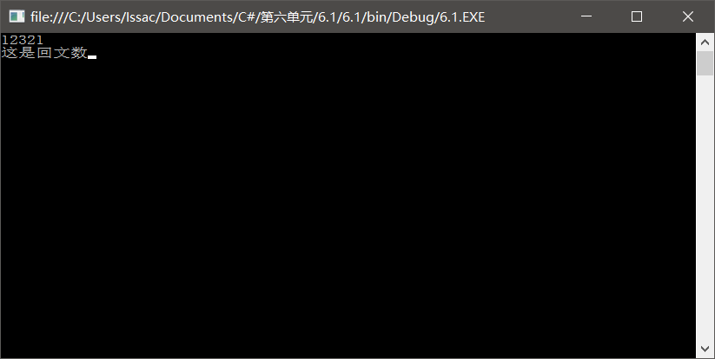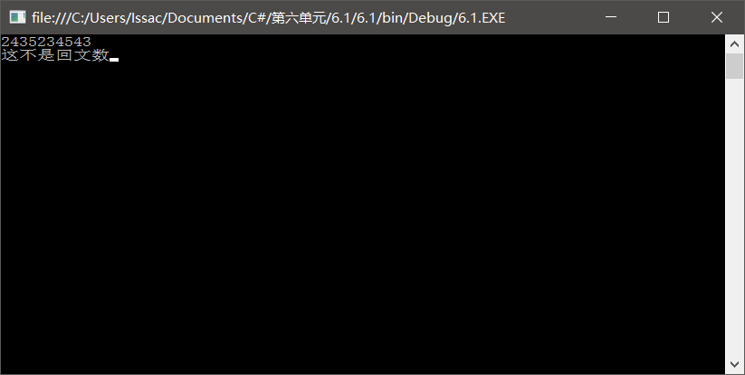

**2.**

Form1.cs

using System;

using System.Collections.Generic;

using System.ComponentModel;

using System.Data;

using System.Drawing;

using System.Linq;

using System.Text;

using System.Windows.Forms;

namespace _6._2

{

public partial class Form1 : Form

{

public Form1()

{

InitializeComponent();

}

private void Form1_Load(object sender, EventArgs e)

{

Random r = new Random();

int m = r.Next(0, 10);

int n = r.Next(0, 10);

int i,j;

int[,] arr = new int[m, n];

int[,] brr = new int[n, m];

for ( i = 0; i < m; i++)

{

for ( j = 0; j < n; j++)

{

arr[i, j] = r.Next(10, 100);

brr[j, m-i-1] = arr[i, j];

label1.Text += arr[i, j] + " ";

}

label1.Text += "\n";

}

for (i = 0; i < n; i++)

{

for (j = 0; j < m; j++)

{

label2.Text += brr[i, j] + " ";

}

label2.Text += "\n";

}

}

}

}

Program.cs

using System;

using System.Collections.Generic;

using System.Linq;

using System.Windows.Forms;

namespace _6._2

{

static class Program

{

/// <summary>

/// 应用程序的主入口点。

/// </summary>

[STAThread]

static void Main()

{

Application.EnableVisualStyles();

Application.SetCompatibleTextRenderingDefault(false);

Application.Run(new Form1());

}

}

}

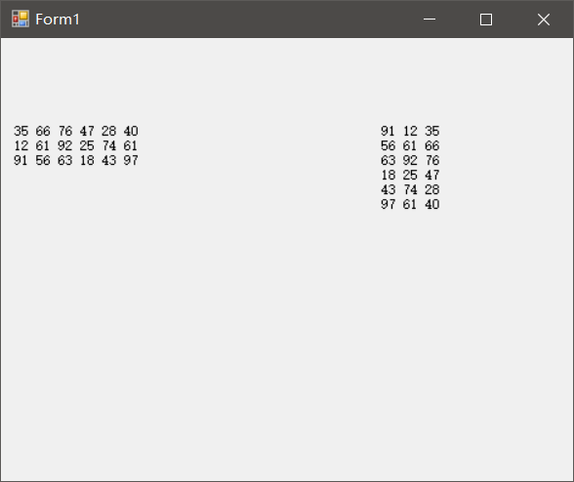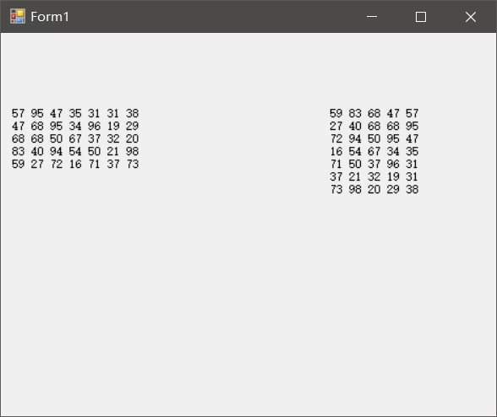

**3.**

Program.cs

using System;

using System.Collections.Generic;

using System.Linq;

using System.Text;

namespace _6._3

{

class Program

{

static void Main(string[] args)

{

int[] arr = new int[10];

int max = 0;

int p=0;

Random r = new Random();

for (int i = 0; i < 10; i++)

{

arr[i] = r.Next(10, 100);

Console.Write("{0} ",arr[i]);

}

max = arr[0];

for (int i = 0; i < 10; i++)

{

if (max < arr[i])

{

max = arr[i];

p=i;

}

}

Console.Write("最大值为{0},位于数组的{1}个单元的位置", max, p+1);

Console.ReadLine();

}

}

}

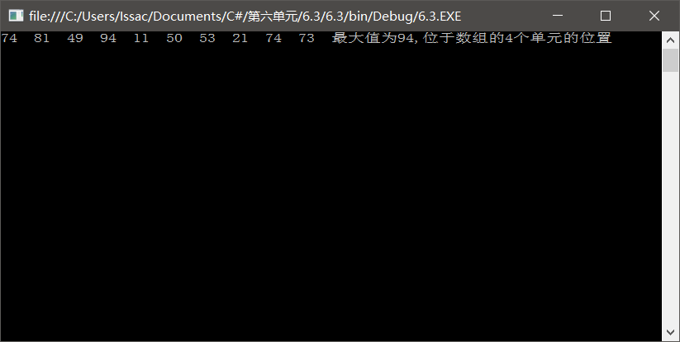

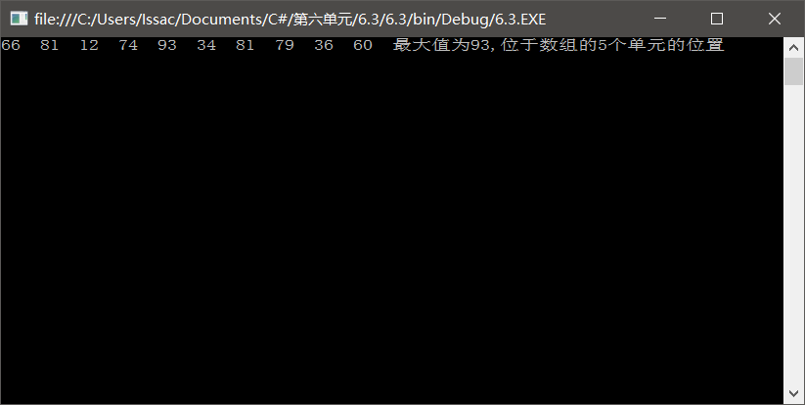

**4.**

Program.cs

using System;

using System.Collections.Generic;

using System.Linq;

using System.Text;

namespace _6._4

{

class Program

{

static void Main(string[] args)

{

int[] arr = new int[20];

int[] brr = new int[20];

int sum = 0, min = 0, p=0;

double a;

Random r = new Random();

for (int i = 0; i < 20; i++)

{

arr[i] = r.Next(10, 99);

sum = sum + arr[i];

Console.Write("{0} ", arr[i]);

}

a = sum / 20;

Console.WriteLine("数组平均值为{0}", a);

for (int i = 0; i < 20; i++)

{

brr[i] = System.Math.Abs((int)a-arr[i]);

//Console.Write("{0} ", brr[i]);

}

min = brr[0];

for (int i = 0; i < 20; i++)

{

if (min > brr[i])

{

min = brr[i];

p = i;

}

}

Console.WriteLine("最接近平均值的数为{0}", arr[p]);

Console.ReadLine();

}

}

}

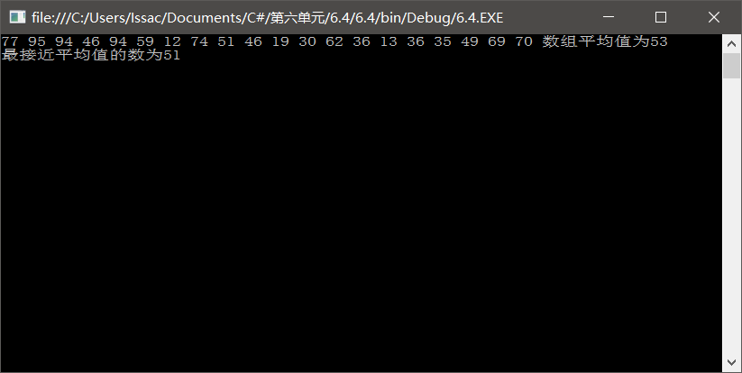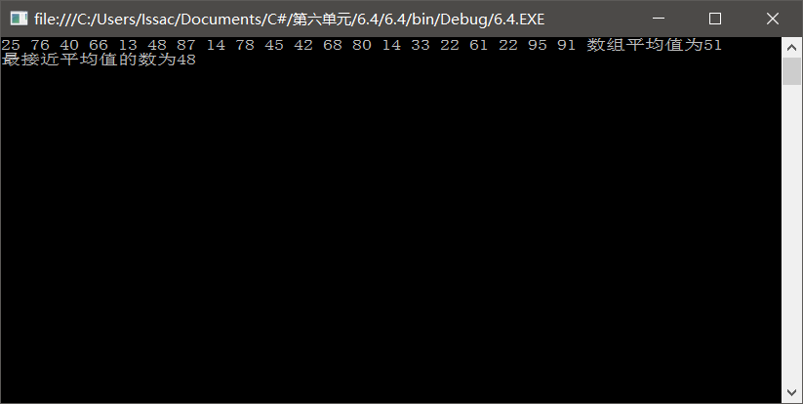

**5.**

Form1.cs

using System;

using System.Collections.Generic;

using System.ComponentModel;

using System.Data;

using System.Drawing;

using System.Linq;

using System.Text;

using System.Windows.Forms;

namespace _6._5

{

public partial class Form1 : Form

{

public Form1()

{

InitializeComponent();

}

private void textBox1_TextChanged(object sender, EventArgs e)

{

}

private void label1_Click(object sender, EventArgs e)

{

}

private void button1_Click(object sender, EventArgs e)

{

int[] a = new int[26];

string s = textBox1.Text.ToUpper();

for (int i = 0; i < s.Length; i++)

{

int s1 = char.Parse(s.Substring(i, 1)) - 'A';

if (s1 >= 0 && s1 <= 25)

{

a[s1]++;

}

}

int max = a[0];

int p = 0;

for (int i = 0; i < 25; i++)

{

if (max < a[i])

{

max = a[i];

p = i;

}

}

char c = Convert.ToChar('A' + p);

label1.Text = "出现次数最多的字母是" + c + " " + "总共出现了" + max + "次";

}

private void Form1_Load(object sender, EventArgs e)

{

}

}

}

Program.cs

using System;

using System.Collections.Generic;

using System.Linq;

using System.Windows.Forms;

namespace _6._5

{

static class Program

{

/// <summary>

/// 应用程序的主入口点。

/// </summary>

[STAThread]

static void Main()

{

Application.EnableVisualStyles();

Application.SetCompatibleTextRenderingDefault(false);

Application.Run(new Form1());

}

}

}

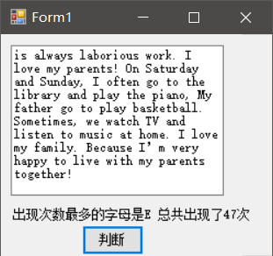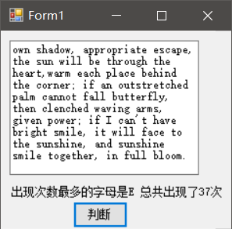

**6.**

Form1.cs

using System;

using System.Collections.Generic;

using System.ComponentModel;

using System.Data;

using System.Drawing;

using System.Linq;

using System.Text;

using System.Windows.Forms;

namespace _6._6

{

public partial class Form1 : Form

{

public Form1()

{

InitializeComponent();

}

private void textBox1_TextChanged(object sender, EventArgs e)

{

}

private void textBox2_TextChanged(object sender, EventArgs e)

{

}

private void textBox3_TextChanged(object sender, EventArgs e)

{

}

private void button1_Click(object sender, EventArgs e)

{

int n, m;

n = int.Parse(textBox1.Text);

m = int.Parse(textBox2.Text);

List<int> list = new List<int>();

for (int i = 1; i <= n; i++)

{

list.Add(i);

}

int a = 0;

do

{

a = ((a + m) % list.Count == 0 ? list.Count : (a + m) % list.Count);

label5.Text += list[a - 1].ToString() + " ";

list.RemoveAt(a - 1);

a--;

}

while (list.Count > 1);

{

textBox3.Text = list[0].ToString();

}

}

private void button2_Click(object sender, EventArgs e)

{

textBox1.Clear();

textBox2.Clear();

textBox3.Clear();

}

private void button3_Click(object sender, EventArgs e)

{

Application.Exit();

}

private void label4_Click(object sender, EventArgs e)

{

}

private void label5_Click(object sender, EventArgs e)

{

}

private void Form1_Load(object sender, EventArgs e)

{

}

}

}

using System;

using System.Collections.Generic;

using System.Linq;

using System.Windows.Forms;

namespace _6._6

{

static class Program

{

/// <summary>

/// 应用程序的主入口点。

/// </summary>

[STAThread]

static void Main()

{

Application.EnableVisualStyles();

Application.SetCompatibleTextRenderingDefault(false);

Application.Run(new Form1());

}

}

}

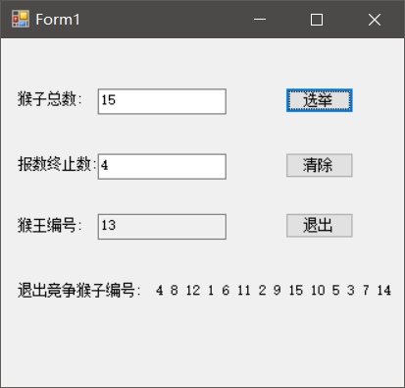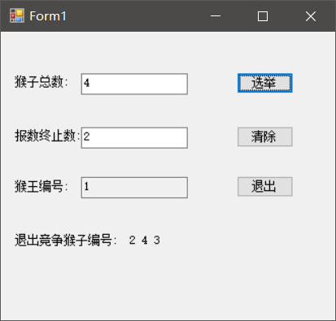

**7.**

Form1.cs

using System;

using System.Collections.Generic;

using System.ComponentModel;

using System.Data;

using System.Drawing;

using System.Linq;

using System.Text;

using System.Windows.Forms;

namespace _6._7

{

public partial class Form1 : Form

{

public Form1()

{

InitializeComponent();

}

private void Form1_Load(object sender, EventArgs e)

{

int[] a = new int[1000000];

Random r = new Random();

for (int i = 0; i < 1000000; i++)

{

a[i] = r.Next(1000, 10000);

}

DateTime d1 = System.DateTime.Now;

Array.Sort(a);

DateTime d2 = System.DateTime.Now;

TimeSpan ts1 = d2.Subtract(d1);

label1.Text = "程序的开始时间是:" + d1.ToString() + "," + "程序的结束时间是:" + d2.ToString() + "," + "运行时间为:" + ts1.ToString();

}

private void label1_Click(object sender, EventArgs e)

{

}

}

}

Program.cs

using System;

using System.Collections.Generic;

using System.Linq;

using System.Windows.Forms;

namespace _6._7

{

static class Program

{

/// <summary>

/// 应用程序的主入口点。

/// </summary>

[STAThread]

static void Main()

{

Application.EnableVisualStyles();

Application.SetCompatibleTextRenderingDefault(false);

Application.Run(new Form1());

}

}

}

