习题八

三

**1.**

Form1.cs

using System;

using System.Collections.Generic;

using System.ComponentModel;

using System.Data;

using System.Drawing;

using System.Linq;

using System.Text;

using System.Windows.Forms;

namespace _8._1

{

public partial class Form1 : Form

{

public Form1()

{

InitializeComponent();

}

private void 打开ToolStripMenuItem_Click(object sender, EventArgs e)

{

DialogResult myresult = openFileDialog1.ShowDialog();

if (myresult == DialogResult.OK)

{

//pictureBox1.Image = Image.FromFile(openFileDialog1.FileName);

pictureBox1.ImageLocation = openFileDialog1.FileName;

toolStripStatusLabel1.Text= openFileDialog1.FileName;

}

}

private void openFileDialog1_FileOk(object sender, CancelEventArgs e)

{

}

private void pictureBox1_Click(object sender, EventArgs e)

{

}

private void Form1_Load(object sender, EventArgs e)

{

openFileDialog1.Filter = "图片文件|*.jpg;*.gif;*.png";

}

private void statusStrip1_ItemClicked(object sender, ToolStripItemClickedEventArgs e)

{

}

private void toolStripStatusLabel1_Click(object sender, EventArgs e)

{

}

}

}

Program.cs

using System;

using System.Collections.Generic;

using System.Linq;

using System.Windows.Forms;

namespace _8._1

{

static class Program

{

/// <summary>

/// 应用程序的主入口点。

/// </summary>

[STAThread]

static void Main()

{

Application.EnableVisualStyles();

Application.SetCompatibleTextRenderingDefault(false);

Application.Run(new Form1());

}

}

}

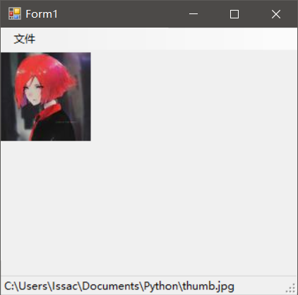

**2. 3.**

Form1.cs

using System;

using System.Collections.Generic;

using System.ComponentModel;

using System.Data;

using System.Drawing;

using System.Linq;

using System.Text;

using System.Windows.Forms;

namespace _8._2

{

public partial class Form1 : Form

{

public Form1()

{

InitializeComponent();

}

public int count = 1;

private void Form1_Load(object sender, EventArgs e)

{

openFileDialog1.Multiselect = true;

openFileDialog1.Filter = "文本文件|*.txt|富文本文件|*.RichText";

}

private void 结束程序ToolStripMenuItem_Click(object sender, EventArgs e)

{

Application.Exit();

}

private void richTextBox1_TextChanged(object sender, EventArgs e)

{

}

private void toolStripStatusLabel1_Click(object sender, EventArgs e)

{

}

private void 打开文件ToolStripMenuItem_Click(object sender, EventArgs e)

{

DialogResult myresult=openFileDialog1.ShowDialog();

if(myresult==DialogResult.OK)

{

for(int i=0;i<openFileDialog1.FileNames.Length;i++)

{

richTextBox1.Text+="第"+count+++"个文件t:\n"+System.IO.File.ReadAllText(openFileDialog1.FileNames[i],Encoding.Default)+"\n";

toolStripStatusLabel1.Text = openFileDialog1.FileNames[i];

}

}

}

private void openFileDialog1_FileOk(object sender, CancelEventArgs e)

{

}

}

}

using System;

using System.Collections.Generic;

using System.Linq;

using System.Windows.Forms;

namespace _8._2

{

static class Program

{

/// <summary>

/// 应用程序的主入口点。

/// </summary>

[STAThread]

static void Main()

{

Application.EnableVisualStyles();

Application.SetCompatibleTextRenderingDefault(false);

Application.Run(new Form1());

}

}

}

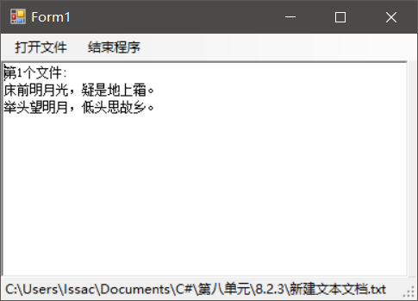

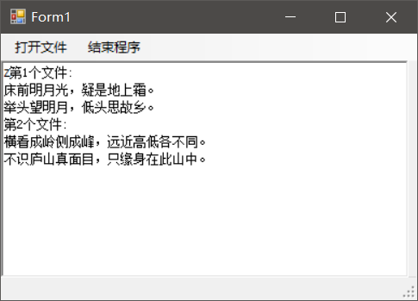

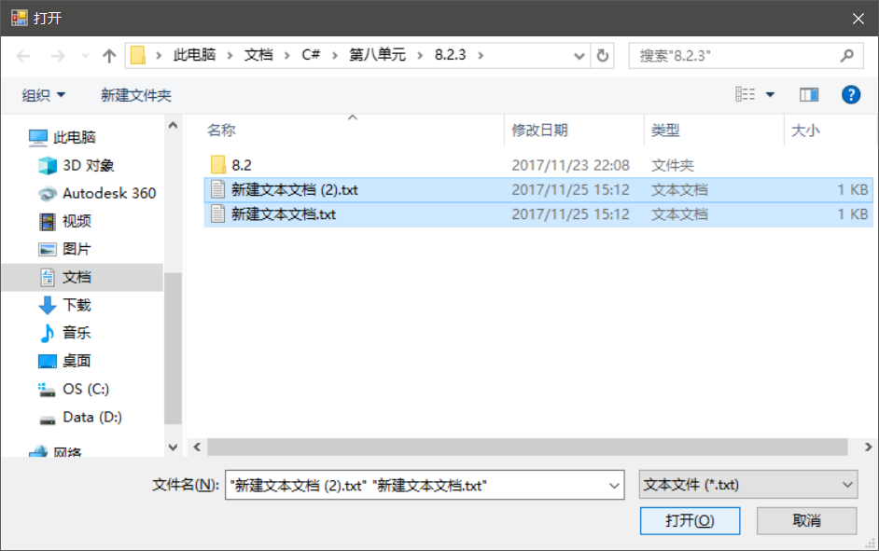

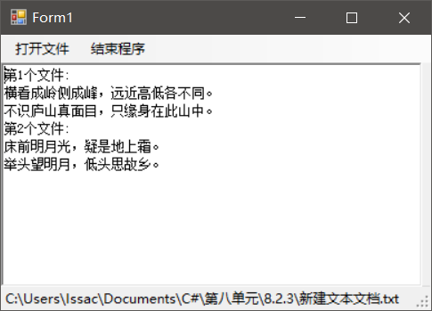

**4.**

Form1.cs

using System;

using System.Collections.Generic;

using System.ComponentModel;

using System.Data;

using System.Drawing;

using System.Linq;

using System.Text;

using System.Windows.Forms;

namespace _8._4

{

public partial class Form1 : Form

{

public Form1()

{

InitializeComponent();

}

public string[] txt = { "欢", "迎", "使", "用", "我", "设", "计", "的", "小", "程", "序" };

public int a = 0;

private void Form1_Load(object sender, EventArgs e)

{

timer1.Interval = 200;

timer2.Interval = 1000;

timer1.Start();

}

private void toolStripStatusLabel1_Click(object sender, EventArgs e)

{

}

private void timer1_Tick(object sender, EventArgs e)

{

toolStripStatusLabel1.Text += txt[a];

a++;

if (a == 11)

{

timer1.Stop();

timer2.Start();

}

}

private void timer2_Tick(object sender, EventArgs e)

{

a = 0;

toolStripStatusLabel1.Text = "";

timer1.Start();

timer2.Stop();

}

}

}

Progarm.cs

using System;

using System.Collections.Generic;

using System.Linq;

using System.Windows.Forms;

namespace _8._4

{

static class Program

{

/// <summary>

/// 应用程序的主入口点。

/// </summary>

[STAThread]

static void Main()

{

Application.EnableVisualStyles();

Application.SetCompatibleTextRenderingDefault(false);

Application.Run(new Form1());

}

}

}

