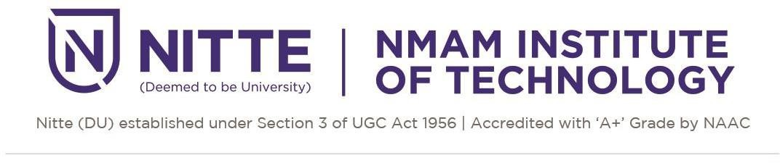

Department of Artificial Intelligence and Data Science

Project Proposal for the mini project in Fundamentals of Machine learning lab

Topic or area of the project: | ML Application in Healthcare
Tentative title: | Drug-Food interaction risk assessment and awareness system
Group member details: | NNM24AD005- Alen Agnel Chettiar  NNM24AD012-Arshith  NNM24AD034-Lakshya B  NNM24AD054-Shetty Shravya Vittal
Abstract
Drug–food interactions pose significant risks in oncology treatment, where interactions can impact therapy outcomes and patient well-being. This project will focus on developing a Drug–Food Interaction Risk Assessment and Awareness System specifically for cancer medications. The system will use machine learning to analyze interaction patterns between oncology drugs and food components. It will categorize interactions into risk levels such as critical, moderate, or neutral and provide reasoning for each assessment. The proposed system will support personalized interaction assessment and provide meaningful insights based on learned patterns from interaction data. The expected outcome is to improve awareness of potential drug–food interaction risks among patients, caregivers, and healthcare professionals. This project will contribute toward improving informed decision-making during cancer treatment by providing an assistive and educational tool focused on oncology drug–food interaction awareness.
Problem Statement
Drug–food interactions can influence medication outcomes, yet awareness of such interactions among patients and caregivers remains limited. In cancer treatment, managing drug–food interactions is particularly important due to the complexity of oncology therapies. Patients undergoing cancer treatment often follow specific dietary habits that may unintentionally interact with prescribed medications. However, drug–food interaction information related to cancer therapy is not always clearly understood or easily applied during routine treatment and dietary planning. Existing interaction checkers primarily use rule-based algorithms to determine drug–food interaction outcomes. This can make it challenging for patients, caregivers, and healthcare providers to identify and understand potential interaction risks during cancer treatment. Due to the critical nature of cancer therapies and the potential impact of drug–food interactions, this problem needs to be addressed.
Objectives
- To acquire and prepare publicly available oncology drug–food interaction data for structured analysis and risk assessment.
- To design a ML Model that categorizes drug–food combinations into defined risk levels to improve awareness of life-critical interactions in cancer therapy.
- To create an assistive awareness model that consolidates drug–food interaction knowledge into a single accessible platform for cancer patients ,caregivers and also for educational and research purposes.
Expected outcome
- A functional model capable of demonstrating interaction risk assessment in a simple, interpretable, and user-friendly format for patients, caretakers.
- Improved awareness and understanding of food-related risks associated with cancer medications among users and researchers.
- Accurate risk assessment of drug-food combinations related to oncology medications, enabling early identification of potentially harmful interactions.
- Improved accessibility of drug–food interaction awareness for general patients, including those who may not have easy access to specialized medical interaction resources or technical data.

