Alen Joseph

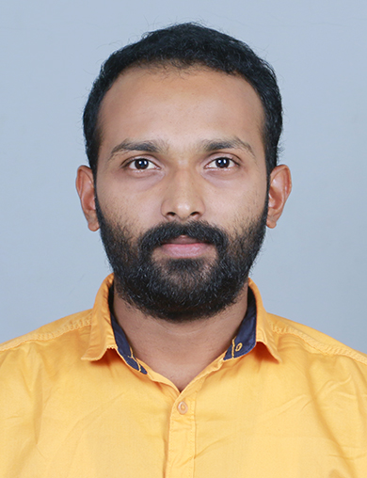

# PROFILE

Self-motivated and enthusiastic fresher seeking for an opportunity to work in a challenging environment to prove my skills and utilize my knowledge in the growth of the organization

# EDUCATION

**10th**- 2012 (90%)

# EXPERTISE

**Manual Testing SQL**

**12th**- 2012-14 (70%)

## BSc Mathematics

2014-17 (66%)

## MCA

### 2017-21

#### Phone

+918075252736

#### Email

[alenmj163@gmail.com](mailto:dev.rahul1741@gmail.com)

##### Mozhiparambil House

P.O Chevoor, Thrissur, Kerala, 680027

# ACADEMIC PROJECTS

TravelAmigo App

TravelAmigo is a web based application which one can perform all operations related to traveling. The project is developed by using PHP and SQL.

Functionality Testing Integration Testing System Testing Acceptance Testing Smoke Testing

Unit Testing Exploratory Testing Regression Testing Perfomance Testing Globalization Testing

Compactability Testing Usability Testing

Agile Method

# STRENGTH

Best in Time management Good in Leadership

# LANGUAGES

**English** - Working proficiency

**Malayalam** - Native proficiency

# INTERESTS

Good understanding of RDBMS concepts like constraints, Normalization, Tables etc.

Excellent knowledge of writing SQL Queries.

Good understanding of SQL concepts like grouping, sub-queries etc.

Solid understand of SQL Joins.

Good Knowledge of DDL, DML and TCL.

##### Travel Movies & Songs Cricket