

**Tribhuvan University**

**Faculty of Humanities and Social Sciences**

Social Media and Social Networking Site **‘MitraPark’**

**A PROJECT PROPOSAL**

Submitted to

**Department of Computer Application**

**Ratna Rajyalaxmi Campus,**

Pradarshanimarga, Kathmandu

*In partial fulfillment of the requirements for the Bachelor in Computer Application*

Submitted by

Alen Pariyar ( 6-2-40-4-2021 )

Anjali Thapa ( 6-2-40-6-2021 )

January, 2023

Under the supervision of

**Kriti Nemkul**

**Table of Contents**

**1.** **Introduction** 1

**2.** **Problem Statement** 2

**3.** **Objectives** 2

**4. Methodology** 3

a. Requirement Identification 3

i. Study of Existing System 3

ii. Requirement Collection 4

b. Feasibility Study 5

i. Technical 5

ii. Operational 6

iii. Economic 6

c. High Level System Design 8

i. System Flowchart 8

**5. Gantt Chart** 9

**6. Expected Outcome** 10

**7. References 11**

# **Introduction**

Presenting MitraPark, a social media and social networking platform crafted to facilitate genuine connections and seamless communication between users. MitraPark goes beyond conventional social media sites, providing a comprehensive suite of features that empower users to create personal accounts, discover friends (Mitras), and engage in a spectrum of social interactions. Whether it's sending and receiving friend requests, exchanging messages, posting updates, or expressing sentiments through likes and comments, MitraPark offers a dynamic space for users to cultivate meaningful relationships.

MitraPark stands out as a user-centric platform committed to user privacy and security, ensuring a safe and enjoyable environment for authentic self-expression. The platform's user-friendly interface and easy navigation cater to a diverse audience, making it the ideal choice for individuals seeking a vibrant and interactive online community. This isn't just another social media site; MitraPark is a digital platform where users can share experiences, celebrate milestones, and foster connections with both familiar faces and new acquaintances.

In a world where not all social media platforms cater to the varied needs of users, MitraPark addresses this gap by providing a space where individuals can forge connections beyond the constraints of mainstream platforms. MitraPark extends its reach to include even those individuals who prefer not to register on popular social media websites, ensuring a diverse and inclusive community. [1]

# **Problem Statement**

In response to persistent challenges within the current social media landscape, MitraPark emerges as a novel solution addressing crucial issues such as compromised user privacy, the prioritization of quantity over quality connections, and the prevalence of cyberbullying. Existing platforms often compromise user data for targeted advertising, fostering shallow connections and overwhelming users with irrelevant content. MitraPark stands out by prioritizing user privacy and fostering genuine connections, aiming to create a secure and authentic social networking experience. Moreover, it seeks to rectify the lack of inclusivity in mainstream platforms by providing a dedicated space for personalized and authentic interactions, ensuring that diverse voices, often overlooked in the existing ecosystem, have a platform to connect effectively. In a rapidly evolving digital landscape, MitraPark aims to redefine social media by addressing these shortcomings and offering users a more inclusive and positive online experience. [1]

# **Objectives**

The objective for developing MitraPark is to create a dynamic and user-centric social media platform that addresses the shortcomings of existing systems and fulfills the following key objectives:

* To develop a web-based social media system that provides platform for users to connect with other users,
* To provide users the features to post, message and interact with each other

# **4. Methodology**

## **a. Requirement Identification**

### **i. Study of Existing System**

In the requirement identification phase for MitraPark, drawing insights from Facebook.com is crucial. Facebook, as a pioneer in social media, provides valuable lessons in creating user-friendly profiles, seamless connectivity, and a versatile content-sharing environment. The efficient messaging system, robust privacy features, and real-time notifications contribute to a comprehensive social experience. Lessons from Facebook's content algorithm and business pages inform MitraPark's goal of fostering genuine connections, empowering local businesses, and implementing transparent and user-centric features. [2]

Similarly, Instagram.com, known for its visual-centric approach, offers unique perspectives for MitraPark's development. Insights from Instagram's emphasis on visual storytelling, Stories feature, and direct messaging provide inspiration for creating a vibrant and engaging platform. MitraPark aims to incorporate simplicity, a focus on user-generated content, and streamlined interfaces, taking cues from Instagram's success in shaping digital culture through visual expression. [3]

Likewise, Twitter.com, with its emphasis on succinct and real-time communication, offers key lessons for MitraPark's requirement identification. Twitter's character-limited tweets, hashtag categorization, and dynamic feed for real-time updates influence MitraPark's goal of facilitating quick and direct interactions. Learning from Twitter's impact on breaking news and global trends, MitraPark aims to implement features that encourage concise expression, community engagement, and immediate information dissemination. [4]

By assimilating lessons from these prominent platforms, MitraPark strives to combine the best elements from existing platforms to create a unique and user-centric social media experience.

### **ii. Requirement Collection**

Functional Requirements

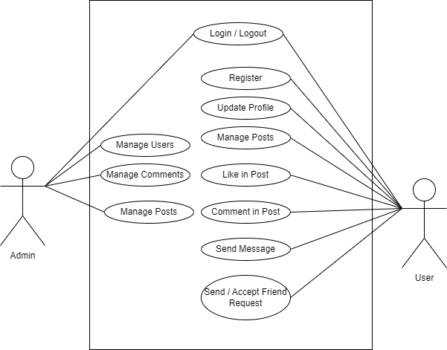

Figure 1 : Use-case diagram for ‘MitraPark’

**User Module:**

* User shall be able to Register into the system
* User shall be able to Login / Logout into the system
* User shall be able to manage posts
* User shall be able to send messages
* User shall be able to like in post
* User shall be able to comment in post
* User shall be able to update profile
* User shall be able to send and receive friend request

**Admin Module**

* Admin shall be able to Login / Logout
* Admin shall be able to manage users
* Admin shall be able to manage posts
* Admin shall be able to manage comments

## **b. Feasibility Study**

The analysis of feasibility has concluded that the project is feasible with respect to time and cost. The technology used to develop are almost Open Source, therefore less cost for implementation and maintenance will be involved.

1. **Technical**

The system can be implemented in various technologies which are presently available as well as in all technologies which will be implemented in future.

* Hardware Requirement

Processor: 800MHz Intel Pentium III or equivalent or new

Disk space: 50MB or more

RAM: 128MB or more

* Software Requirement

Operating System: Windows (7 or more)

Web Browser: IE 10 or above, Mozilla FF and above or Google Chrome

XAMPP, MySQL

* Technology: HTML, CSS, JavaScript, PHP, MySQL [5]

1. **Operational**

Operational feasibility is all about how well the system solves problem and takes advantage of identified opportunities during scope definition of the system.

* The MitraPark project is operationally feasible, ensuring its practicality and effectiveness in the social media landscape.
* Through a thorough examination of the current mode of operation, the project ensures that it aligns seamlessly with existing processes, providing enhanced throughput and response times.
* The proposed system of MitraPark is designed to genuinely benefit individuals, offering improvements to current work practices and procedures within the social networking realm.
* Operational feasibility is further confirmed through an analysis of resource utilization, including people, time, and the flow of forms, ensuring that MitraPark makes optimal use of available resources for a streamlined user experience.

1. **Economic**

This aims to determine the positive economic benefits to the organization that the proposed system will provide. The system is economically feasible to be implemented because it is a web-based application.

* The system is cost effective.
* The system benefits outweigh costs.

## **c. High Level System Design**

## **i. System Flowchart**

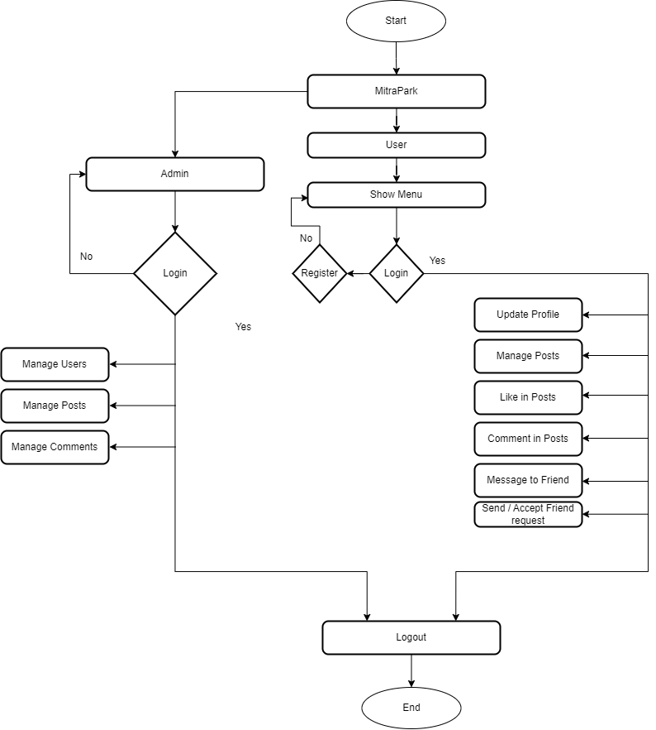

**Figure 1 : System Flowchart of MitraPark**

# 

# **5. Gantt Chart**

|  |  |  |  |  |  |  |  |  |  |  |  |  |
| --- | --- | --- | --- | --- | --- | --- | --- | --- | --- | --- | --- | --- |
| MitraPark | | | | | | | | | | | | |
| Months | Poush 2080 | | | | Magh 2080 | | | | Falgun 2080 | | | |
| Week | 1 | 2 | 3 | 4 | 1 | 2 | 3 | 4 | 1 | 2 | 3 | 4 |
| Planning |  |  |  |  |  |  |  |  |  |  |  |  |
| Analysis |  |  |  |  |  |  |  |  |  |  |  |  |
| Design |  |  |  |  |  |  |  |  |  |  |  |  |
| Coding |  |  |  |  |  |  |  |  |  |  |  |  |
| Testing |  |  |  |  |  |  |  |  |  |  |  |  |
| Documentation |  |  |  |  |  |  |  |  |  |  |  |  |

The system is planned to initialize from the fourth week of Poush, 2080. The planning phase will extend until the end of Poush. Starting from the first week of Magh, the project will proceed with requirement gathering and analysis. Data modeling will be the main focus during this phase, covering topics such as entities, attributes, key attributes, cardinality, and the overall process of the system. This understanding will be developed throughout the planning phase.

Following data modeling, the focus will shift to process modeling by creating Data Flow Diagrams (DFDs) and their levels. Moving into the design phase, the Graphical User Interface (GUI) will be designed, beginning in the third week of Magh. In the later stages of the design phase, the database for the system will be created, and the design of both the front end and back end will be completed by the end of the Magh .

Immediately after the design phase, the coding of the system will commence from the first week of Falgun. This coding phase is expected to take one month for completion. Simultaneously, testing of code and integrated components will be conducted from the first week of Falgun, continuing until the last week of Falgun. Due to the critical nature of documentation for this system, it will commence from the beginning of the project initiation, i.e., from the fourth week of Poush. However, the preparation of a standardized documentation will only begin after the final testing of the system has been concluded.

# **6. Expected Outcome**

After the completion of the project we expect the subsequent outputs which can minimize the issues likewise as solve the prevailing problem.

**Authentic Connections**: Aims to foster genuine and meaningful connections among users, moving beyond superficial interactions commonly found on other social media platforms.

**Enhanced User Privacy**: Prioritizes user privacy by implementing robust measures to protect personal information, giving users more control over their data and interactions.

**Inclusive Social Space**: The platform is designed to be inclusive, catering to a diverse range of users and voices. MitraPark encourages participation from various backgrounds and perspectives.

# **7. References**

|  |  |
| --- | --- |
| [1] | S. M. Musa, "Social Networking," April 2009. [Online]. Available: https://www.researchgate.net/publication/333695257_Social_Networking. |
| [2] | Meta, "Facebook," [Online]. Available: https://www.facebook.com. |
| [3] | Meta, "Instagram," [Online]. Available: https://www.instagram.com. |
| [4] | Twitter, "X (twitter)," [Online]. Available: https://twitter.com. |
| [5] | P. D. a. H. Deitel, Internet & WorldWideWeb How To Program, Pearson Education, Inc, 2008. |