建表
- --用户信息表
- drop table if exists homework.user_info;
- create table homework.user_info
- (
- user_id INT primary key,
- phone_number VARCHAR(11),
- user_name VARCHAR(5),
- ID_Number VARCHAR(18),
- Register_time DATE,
- pet_name VARCHAR(12),
- sex VARCHAR(2),
- age int,
- email VARCHAR(12)
- );
- -- Add comments to the table
- comment on table homework.user_info
- is '用户信息表';
- -- Add comments to the columns
- comment on column homework.user_info.user_id
- is '用户id';
- comment on column homework.user_info.phone_number
- is '手机号码';
- comment on column homework.user_info.user_name
- is '用户姓名';
- comment on column homework.user_info.ID_Number
- is '身份证号码';
- comment on column homework.user_info.Register_time
- is '注册时间';
- comment on column homework.user_info.pet_name
- is '用户昵称';
- comment on column homework.user_info.sex
- is '用户性别';
- comment on column homework.user_info.AGE
- is '用户年龄';
- comment on column homework.user_info.email
- is '邮箱地址';

- --用户地址表
- drop table if exists homework.user_address;
- create table homework.user_address
- (
- user_id int primary key,
- provience VARCHAR(5),
- city VARCHAR(5),
- county VARCHAR(5),
- specific_address VARCHAR(10)
- );
- -- Add comments to the table
- comment on table homework.user_address
- is '用户地址表';
- -- Add comments to the columns
- comment on column homework.user_address.user_id
- is '用户id';
- comment on column homework.user_address.provience
- is '省份';
- comment on column homework.user_address.city
- is '市';
- comment on column homework.user_address.county
- is '县';
- comment on column homework.user_address.specific_address
- is '具体地址';

- --用户登陆表
- drop table if exists homework.login;
- create table homework.login
- (
- user_id INT primary key ,
- phone_number VARCHAR(11),
- passwords VARCHAR(10)
- );
- -- Add comments to the table
- comment on table homework.login
- is '用户登陆表';
- -- Add comments to the columns
- comment on column homework.login.user_id
- is '用户id';
- comment on column homework.login.phone_number
- is '用户账号';
- comment on column homework.login.passwords
- is '用户密码';

- --用户购物车表
- drop table if exists homework.shopping_cart;
- create table homework.shopping_cart
- (
- user_id INT ,
- sku_id INT ,
- numbers INT,
- total_price INT
- );
- -- Add comments to the table
- comment on table homework.shopping_cart
- is '用户购物车表';
- -- Add comments to the columns
- comment on column homework.shopping_cart.user_id
- is '用户id';
- comment on column homework.shopping_cart.sku_id
- is '商品id';
- comment on column homework.shopping_cart.numbers
- is '商品数量';
- comment on column homework.shopping_cart.total_price
- is '总价格';

- --订单表
- drop table if exists homework.orders;
- create table homework.orders
- (
- id INT primary key,
- user_id INT ,
- sku_id INT ,
- numbers INT,
- total_prices INT,
- order_month_time INT
- );
- -- Add comments to the table
- comment on table homework.orders
- is '订单信息表';
- comment on column homework.orders.id
- is '订单id';
- comment on column homework.orders.user_id
- is '用户id';
- comment on column homework.orders.sku_id
- IS '商品id';
- comment on column homework.orders.numbers
- IS '商品数量';
- comment on column homework.orders.total_prices
- IS '总价格';
- comment on column homework.orders.order_month_time
- IS '创建订单时间';

- --销售额总表
- DROP TABLE IF EXISTS homework.sales;
- CREATE TABLE homework.sales
- (
- sex varchar(2),
- months int,
- city varchar(4),
- category varchar(4),
- pro_sum int
- );
- -- Add comments to the table
- comment on table homework.sales
- is '销售信息总表';
- comment on column homework.sales.sex
- IS '性别';
- comment on column homework.sales.months
- IS '月份';
- comment on column homework.sales.city
- IS '城市';
- comment on column homework.sales.category
- IS '商品类别';
- comment on column homework.sales.pro_sum
- IS '销售总额';

- --按城市分类的销售表
- DROP TABLE IF EXISTS homework.sale_city;
- CREATE TABLE homework.sale_city
- (
- city VARCHAR(4),
- months int,
- pro_sum int
- );
- -- Add comments to the table
- comment on table homework.sale_city
- is '城市商品销售总表';
- comment on column homework.sale_city.city
- IS '城市';
- comment on column homework.sale_city.months
- IS '月份';
- comment on column homework.sale_city.pro_sum
- IS '总额';

- --按性别分类的销售表
- DROP TABLE IF EXISTS homework.sale_sex;
- CREATE TABLE homework.sale_sex
- (
- sex VARCHAR(2),
- months int,
- pro_sum int
- );
- -- Add comments to the table
- comment on table homework.sale_sex
- is '按性别分类商品销售总表';
- comment on column homework.sale_sex.sex
- IS '性别';
- comment on column homework.sale_sex.months
- IS '月份';
- comment on column homework.sale_sex.pro_sum
- IS '销售总额';

- --按商品类别分的销售总额表
- DROP TABLE IF EXISTS homework.sale_cate;
- CREATE TABLE homework.sale_cate
- (
- category VARCHAR(4),
- months int,
- pro_sum int
- );
- -- Add comments to the table
- comment on table homework.sale_cate
- is '按商品类别商品销售总表';
- comment on column homework.sale_cate.category
- IS '商品类别';
- comment on column homework.sale_cate.months
- IS '月份';
- comment on column homework.sale_cate.pro_sum
- IS '销售总额';

- --商家信息
- DROP TABLE IF EXISTS homework.seller_info;
- CREATE TABLE homework.seller_info
- (
- seller_id INT PRIMARY KEY,
- name VARCHAR(5),
- account VARCHAR(10),
- passwords VARCHAR(10)
- );
- -- Add comments to the table
- comment on table homework.seller_info
- is '卖家信息表';
- comment on column homework.seller_info.seller_id
- IS '卖家id';
- comment on column homework.seller_info.passwords
- IS '密码';
- comment on column homework.seller_info.account
- IS '账户';

- --商品种类表
- DROP TABLE IF EXISTS homework.product_cate;
- CREATE TABLE homework.product_cate
- (
- spu_id int PRIMARY KEY,
- product_name VARCHAR(5),
- category VARCHAR(4)
- );
- -- Add comments to the table
- comment on table homework.product_cate
- is '商品种类表';
- comment on column homework.product_cate.spu_id
- IS 'id';
- comment on column homework.product_cate.product_name
- IS '商品名称';
- comment on column homework.product_cate.category
- IS '商品类别';

- --卖家商品信息表
- DROP TABLE IF EXISTS homework.seller_pro;
- CREATE TABLE homework.seller_pro
- (
- sku_id int PRIMARY KEY,
- spu_id int ,
- seller_id int ,
- numbers int,
- prices int
- );
- -- Add comments to the table
- comment on table homework.seller_pro
- IS '卖家商品信息表';
- comment on column homework.seller_pro.sku_id
- IS '商品id';
- comment on column homework.seller_pro.spu_id
- IS '商品类别id';
- comment on column homework.seller_pro.seller_id
- IS '商家id';
- comment on column homework.seller_pro.numbers
- IS '库存量';
- comment on column homework.seller_pro.prices
- IS '价格';

- drop table if exists homework.users_allinfo;
- create table homework.users_allinfo
- (
- months int,
- users_new_register int,
- users_registered int
- );
- -- Add comments to the table
- comment on table homework.users_allinfo
- is '用户信息统计表';
- -- Add comments to the columns
- comment on column homework.users_allinfo.months
- is '月份';
- comment on column homework.users_allinfo.users_new_register
- is '新增注册人数';
- comment on column homework.users_allinfo.users_registered
- is '用户总数';

二、业务系统物理模型

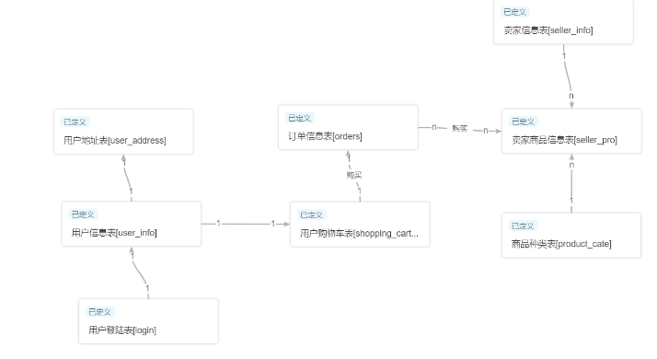

三、数据仓库物理模型
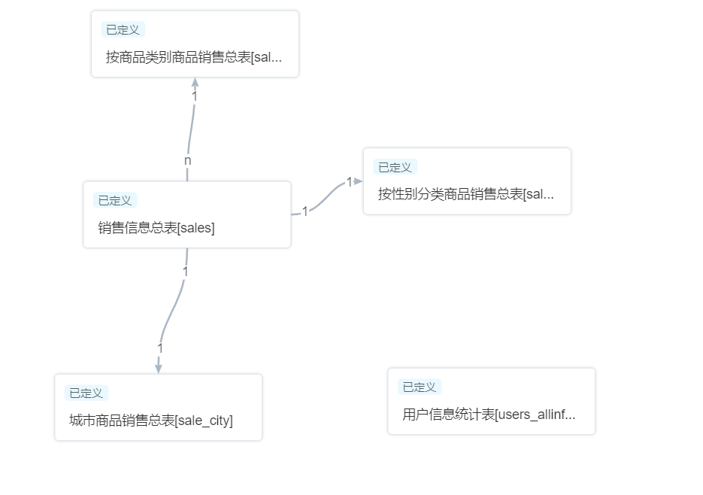

四、质量管理
添加规则
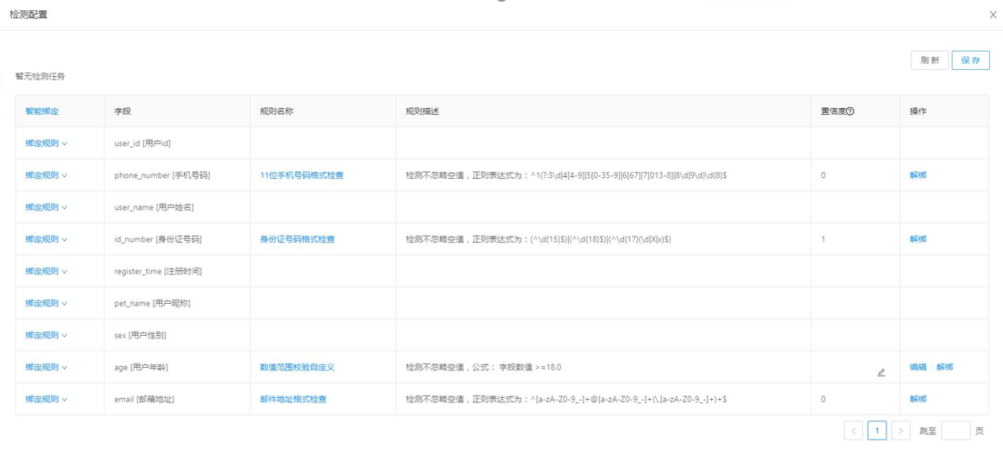
查看检测报告

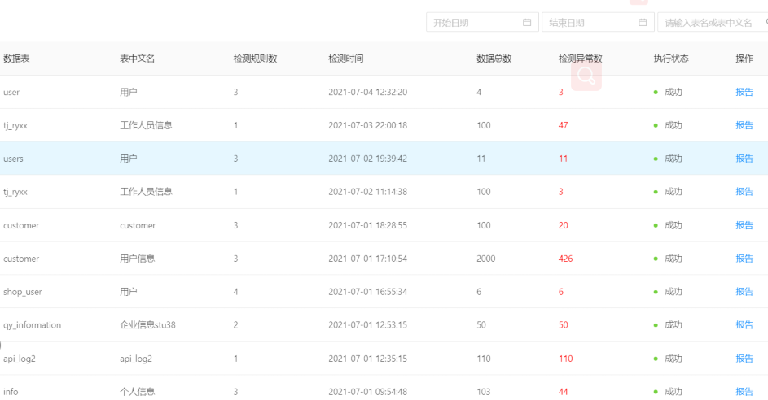

四、SQL查询
- --按月查看总体销售额
- select months, sum(pro_sum)
- from homework.sales
- group by months;

- --按月查看新增注册人数
- select months,users_new_register
- from homework.users_allinfo
- order by months;

- --按月查看城市销售额
- select months,city,pro_sum
- from homework.sale_city;

- --按月查看城市、商品类别的销售额
- select homework.sale_city.months,city,category, homework.sale_city.pro_sum
- from homework.sale_city,homework.sale_cate
- where homework.sale_city.months = homework.sale_cate.months;

- --按月查看性别、商品类别的销售额
- select homework.sale_sex.months,sex,category,homework.sale_sex.pro_sum
- from homework.sale_sex,homework.sale_cate
- where homework.sale_sex.months = homework.sale_cate.months;

