**WHY IT’S IMPORTANT TO AIR CONDITION THE ROOMS:**

Optimizing the microclimate in the premises is aimed at ensuring maximum comfort by adjusting the air level, temperature, flow direction, cleanliness, and other parameters. This affects the well-being, mood, and even health of the people present. The use of ventilation systems and air conditioners allows you to create optimal conditions for living or working.

To ensure the effective operation of ventilation and air conditioning systems, it is necessary to choose equipment that corresponds to the parameters and power. At the same time, it is important to consider the following factors:

* the area of the room in square meters and its volume in cubic meters.
* heat supply sources and their location.
* zoning and purpose of each segment.
* ceiling height and maximum width of the room or zone.
* availability of stationary ventilation hoods and channels.
* the level of wall and ceiling insulation against moisture, noise, and cold.
* climatic conditions of the region, such as sudden changes in temperature, harsh winters, high humidity, periods of drought, etc.

It is also important to consider the orientation of the southern and front facades of the building, the construction scheme and the location of other elements of household systems. The low efficiency of double-glazed windows, the quality of doors, and the flow of people during a certain period also matter. These details determine the optimal option of the air conditioning system, the power of the units, and their effective placement inside the room.

Residential and commercial air conditioning systems are simply designed devices that can efficiently heat, cool, clean, and direct air according to user preferences. They can be used both periodically and daily with automatic settings. You can always adjust the air temperature using the remote control.

**PROS AND CONS:**

The benefit of using an air conditioning system is undeniable: it provides comfort both in the heat and in the cold, improves the quality of the air, and makes it fresher and more useful. Using an air conditioner in the house has several advantages:

* Indoor temperature control without the need to open windows, which is more hygienic and safer.
* Protection against insects in spring and summer, especially against mosquitoes, flies, gnats, and bugs, ensuring a high level of hygiene and cleanliness of the premises.
* Absence of harmful effects on children, pets, and people with weak immunity, but on the contrary, creating comfortable conditions for their stay.
* The availability of programs for simple and convenient use of the "Auto mode" function, which allows even the elderly, teenagers, and children to control the air conditioner.
* Quick elimination of unpleasant odors arising during cooking, from the vital activity of domestic animals, after using household chemicals, disinfectants, insecticides, and others.

Of course, when using an air conditioner in the house, there is also a drawback - the air can be overdried, which negatively affects the condition of the mucous membranes and respiratory tract and can aggravate chronic diseases. However, this problem can be quickly solved by using a humidifier, which allows you to increase the level of humidity and fill it with aromas using essential oils, essences, and other additives.

**HOME AIR CONDITIONER. FEATURES OF FUNCTIONALITY:**

Multi-conditioning systems of premises allow to combination of all internal units and create an individual microclimate in each room separately, which is relevant for both residential and commercial facilities. Therefore, the selection of indoor units of the air conditioning system with different capabilities is a key aspect:

*Kitchen*: It is recommended to use powerful air conditioners with several filters that effectively remove unpleasant odors, heavy metals, and other pollutants. These filters must be changed every 3 months.

*Bedroom*: The indoor unit must be equipped with a night mode for continuous quiet operation and maintenance of optimal air temperature. It is also important to have fine air purification using a multi-filter, carbon, or plasma device.

*Children's room*: It is recommended to install several filters, antibacterial, with silver and carbon, as well as multifunctional for different levels of filtration. It is also important that the indoor unit has a heating function and that the filters are changed more often.

*Living room*: The choice of the unit depends on the volume of the room, the number of windows, heating devices, and other factors. For example, if the room burns or uses scented candles, you should choose a powerful unit.

Before purchasing an air conditioner, you should consult with specialists to make the optimal choice considering the configuration, price, special installation conditions, and other factors. Our team of qualified workers will help you in this to ensure maximum comfort for you and your loved ones.

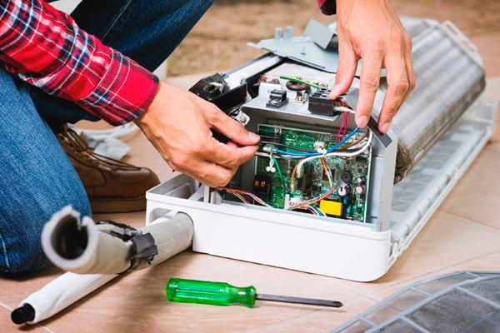

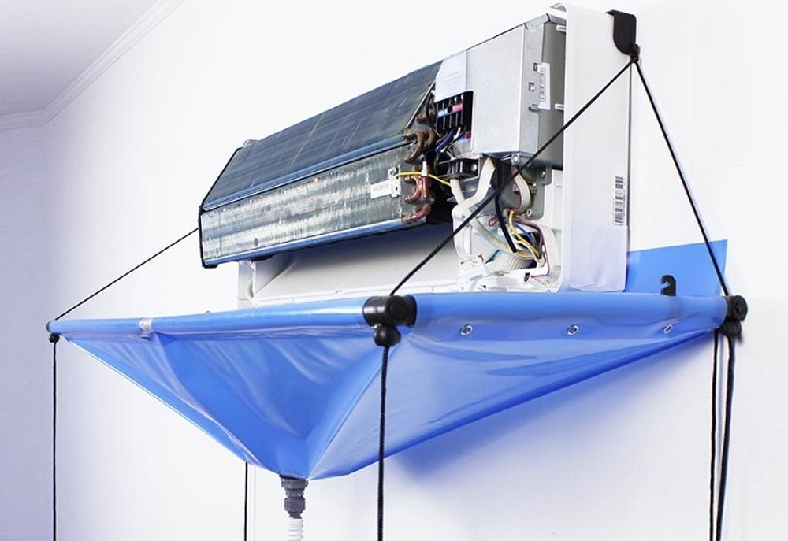

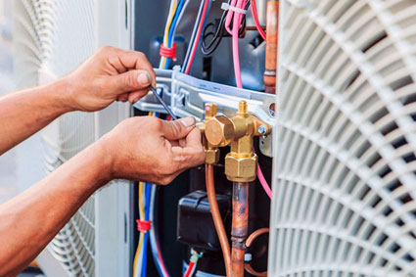

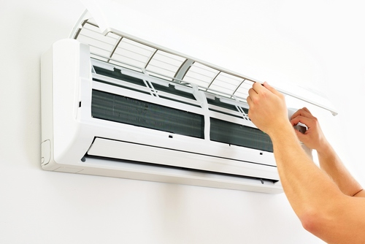

**OUR SERVICES:**

1. **FIRE DUMPER INSTALLATION**

The main purpose of fire dampers is to prevent the spread of flames through the fire barrier. They will be mounted close to the walls or floor depending on the specific circumstances and are part of the barrier they protect. The reaction of fire valves occurs when the temperature rises to a set value, after which the damper is automatically closed.

In the context of preventing the spread of fire, smoke, and toxic gases in buildings, fire dampers are critical. They play a key role in ensuring security. It is important that these dampers are properly installed and regularly maintained, as failure or incomplete functionality can have catastrophic consequences. If the damper does not work or only partially works, it can be a matter of life and death.

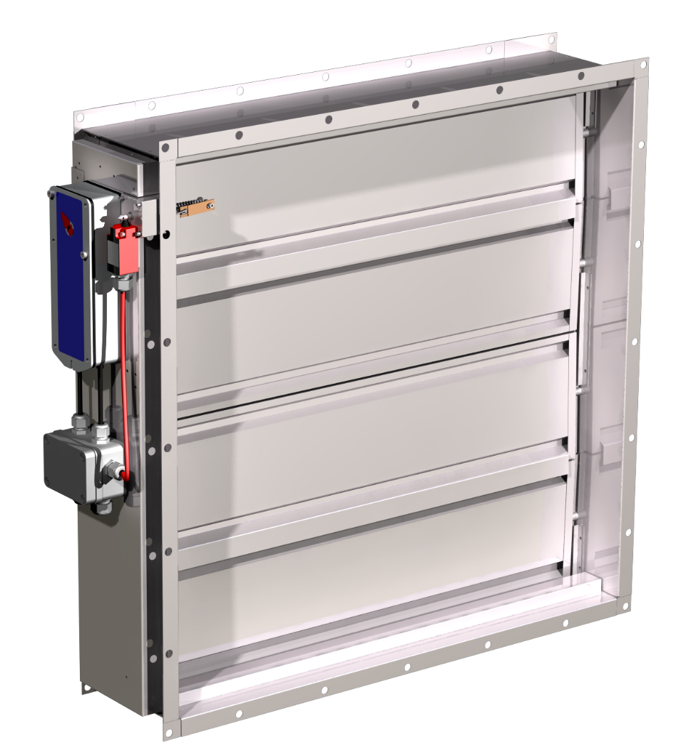

1. **HEAT PUMP INSTALLATION**

Heat pumps are an energy-efficient and environmentally friendly way of heating a low-carbon home. They are suitable for almost all types of buildings and can significantly reduce energy costs, depending on the heating system they replace.

The heat pump works as follows:

* It collects thermal energy from a colder zone, usually outside the building.
* Increases the temperature of this energy.
* Transfers heat inside the house.

Although a heat pump uses electricity to operate, it generates much more heat than it consumes electricity. This makes heat pumps more efficient in terms of energy savings than traditional gas or oil boilers. In addition, they emit significantly less carbon than other heating systems.

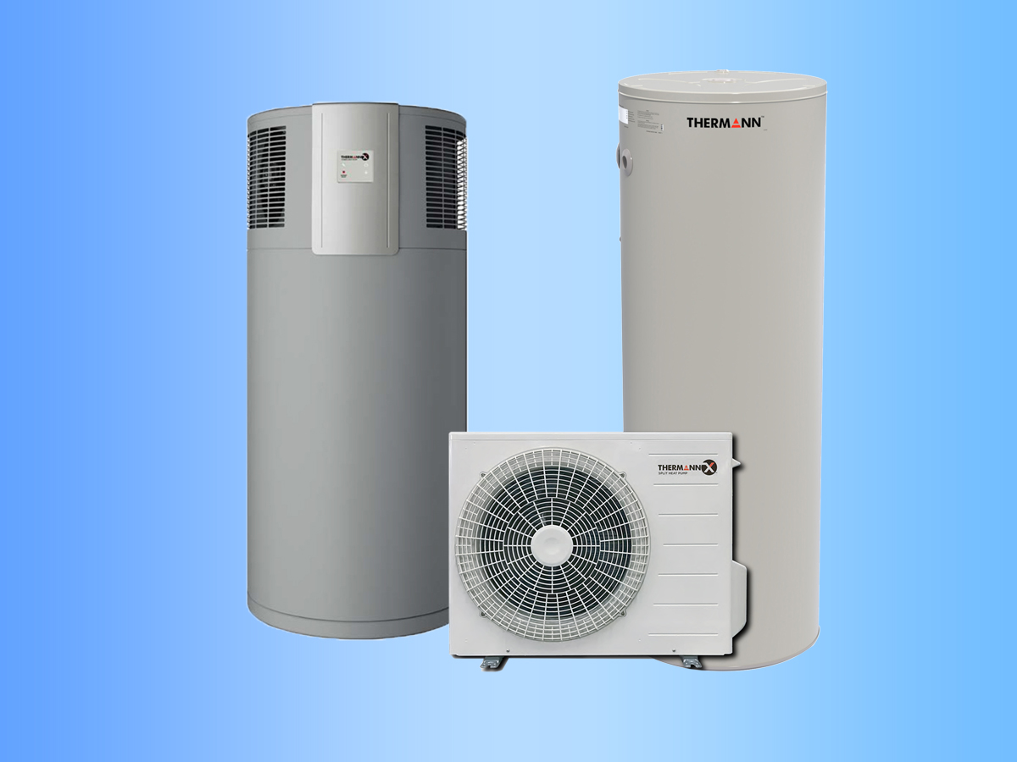

1. **CONDITIONERS INSTALLATION**

Our mission is to provide your home with state-of-the-art heating and cooling solutions that meet your needs most efficiently and practically. We offer high-quality installations at affordable prices and our standards and quality are second to none. From the initial site inspection to installation, you'll be confident in your air conditioning investment because you can rest assured that your home is in good hands.

Our residential air conditioning systems have a wide range of applications to suit your design and offer the most cost-effective and practical solutions for heating and cooling your home.

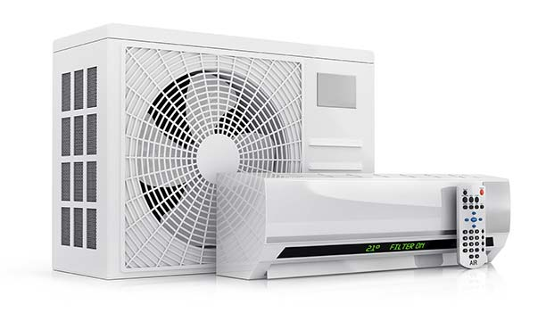

1. **CONDITIONERS REFILLING**

The process of air conditioning regasification involves removing the old gaseous refrigerant from your air conditioning system and replacing it with new refrigerant so that your air conditioner can cool the room efficiently again.

This should be the first thing you look at if your air conditioning system is not working properly and is not producing as cold air as expected. The procedure usually takes a specialist no more than an hour.

While there are other possible reasons why your air conditioner may stop cooling the air properly, a reputable mechanic will be able to advise if the problem is the result of something other than the need for regassing.

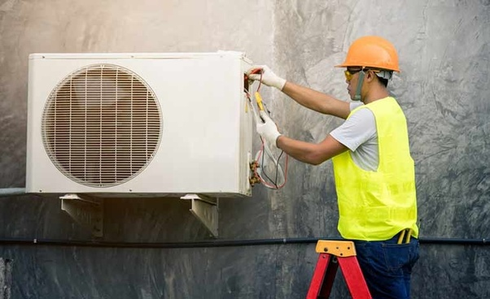

1. **PREVENTION**

Air conditioning problems usually occur at the onset of warm weather, especially in the spring months when the air conditioner begins to be used again. Spring is a great time to consider the following tips because by the time you've done them all, consistently warm weather will likely be here. Air conditioning units are complex pieces of equipment that depend on various elements to function properly. If one zone is damaged or not working, it can cause many other zones to fail.

Follow these tips to prevent AC troubles and protect your device.

* *SCHEDULE REGULAR MAINTENANCE*

It is important to have your air conditioner regularly serviced every year. This includes important technical checks aimed at detecting possible problems with the electrical supply. This will prevent potential problems in the future and keep your equipment running efficiently. Do not forget to invite a qualified specialist for this task.

* *KEEP THE OUTSIDE AREA AROUND THE DEVICE CLEAR*

Keep the area around your device free of any debris or obstructions. It is important to clean the area regularly, removing grass, branches, and leaves from previous seasons. Failure to do so can cause debris and dirt to accumulate inside your equipment, which can affect its performance or even cause it to fail.

* *CLEAN THE INDOOR UNIT*

The same goes for the interior of your heating or air conditioning system. Dirt can accumulate on the inside just as easily as it can on the outside. Also, it is important to avoid storing items too close to the indoor unit. If there are too many objects around, it can make it difficult for a specialist to access for inspection in the event of a breakdown of the air conditioner.

* *CHECK/CHANGE FILTERS MONTHLY*

Dirty air filters are one of the main causes of air conditioner malfunctions. But the good news is that this problem can be completely avoided. A dirty filter prevents the free flow of air, forcing your device to work harder to provide the necessary cooling. Overloading the system can cause serious damage, so it's important to check the air filter regularly and replace it as needed during the summer months. Most standard 1-inch filters are recommended to be inspected monthly and replaced every 1-3 months, depending on operating conditions.

* *CHECK FOR WATER LEAKS*

Along with checking the filter, you can quickly inspect your furnace or air handler for signs of water leaks. If you notice any leaks around your system, contact a qualified technician immediately to fix the problem. Leaks can cause serious problems and require immediate repair.

* *KEEP VENTS OPEN AND UNBLOCKED*

Covering vents is not a good idea and won't save you money. On the contrary, it can disrupt the operation of the air conditioning system. Your air conditioner is designed to operate at a certain pressure in your home. Covering the vents makes the device harder to operate and puts more stress on the device, which can cause it to shut down due to overload. If you're covering vents to try to direct more air into some rooms and less into others, consider using a variable speed system that can distribute the air more evenly throughout the room. You can also consider a zoned system to segment your home but be aware that these systems can be problematic if installed incorrectly.

* *KEEP CALM WITH YOUR AIR CONDITIONER*

If you help your air conditioner by keeping the vents open and avoiding too long periods of active cooling, you'll enjoy a unit that runs longer and more efficiently. Also, turning on ceiling fans and intelligently setting up the cooling system, especially during periods of the greatest heat, will help ensure comfortable conditions and reduce the load on the air conditioner.

* *MONITOR THE HEAT IN YOUR HOME*

Indeed, you can help your air conditioner by doing a few simple tasks to prevent your home from heating up. For example, avoid closing the curtains to avoid excess heat coming through the windows, and be sensible about using heat-generating appliances, including the oven and stove, only in the evening when it's cool. These simple steps will help reduce the heat load on your air conditioner and provide more comfortable conditions in your home.

* *KNOW WHEN TO REPLACE YOUR DEVICE*

If you know how old your air conditioner is, you can be prepared to replace it when the time comes. Older air conditioners have a higher risk of failure because they have already passed a certain period of service. It should also be noted that the service life of air conditioners may vary depending on the region of residence. For example, on average in Utah, air conditioners last about 13-15 years. Replacing your air conditioner on time can save you money on future repairs in the long run.

* *CALL IF YOU KNOW THERE IS A PROBLEM*

If you have problems with your air conditioner, contact our team of experts! We are always ready to help you solve any problems and repair the breakdown of the air conditioner or other air conditioning problems.

By following these tips, you will enjoy the operation of the air conditioner throughout the summer season. For more information on Master Builders VS LTD services, call our team on 07525459552 and speak to our specialist today.



1. **RELATED SERVICES**

|  |  |  |
| --- | --- | --- |
| **№** | **TYPE OF WORKS** | **PRICE** |
| 1 | Master's visit for consultation and costing (within the city) | £ 75.00 |
| 2 | Out of town (£/km) | £ 0.75/km |
| 3 | Dismantling (installation) of the external unit of the air conditioner in an accessible place | £ 150.00 |
| 4 | Dismantling (installation) of the internal unit of the air conditioner in an accessible place | £ 150.00 |
| 5 | Refilling the air conditioner with freon | £ 150.00 |
| 6 | Fastening the internal unit to the metal | £ 75.00 |
| 7 | Fastening the external unit to the metal | £ 75.00 |
| 8 | Installation of the air conditioner on the finished main line (without materials) | £ 300.00 |
| 9 | Complete dismantling of the air conditioner in an accessible place | £ 225.00 |
| 10 | The overhang of the indoor unit in an accessible place (without materials) | £ 150.00 |
| 11 | The overhang of the outdoor unit in an accessible place (without materials) | £ 150.00 |
| 12 | Punching additional holes (when installing the air conditioner), per pc | £ 75.00 |
| 13 | Laying a box 25*25 under an electric wire (for 1 m) with materials | £ 30.00 |
| 14 | Laying a box 60*60 under the freon main (for 1 m) with materials | £ 40.00 |
| 15 | Works on connecting the air conditioner at a height of more than 3 m (ladder) | £ 150.00 |
| 16 | Works on connecting the air conditioner from the car tower | £ 225.00 |
| 17 | Plastering of walls when installing air conditioning (brick, gas block, mineral wool) | £ 300.00 |
| 18 | Plastering of walls when installing air conditioning (concrete) | £ 400.00 |
| 19 | Complete air conditioner disassembly and service | £ 300.00 |
| 20 | Additional hole | £ 75.00 |

