1. SELECT COUNT (*) FROM Customers
WHERE Country = 'Germany'
Result: 11

2. SELECT COUNT (*) FROM Customers
WHERE CustomerName LIKE '%e'
Result: 14

3. INSERT INTO Customers (CustomerID, CustomerName, ContactName, Address, City, PostalCode, Country)
VALUES (92, 'Alyona Romascheva', 'Alyona Romashcheva', 'Baumana 3\2', 'Novosibirsk', 630046, 'Russia')

SELECT * FROM Customers WHERE CustomerID = 92

4. UPDATE Customers SET CustomerName = 'Maria Romascheva'
WHERE CustomerID = 92

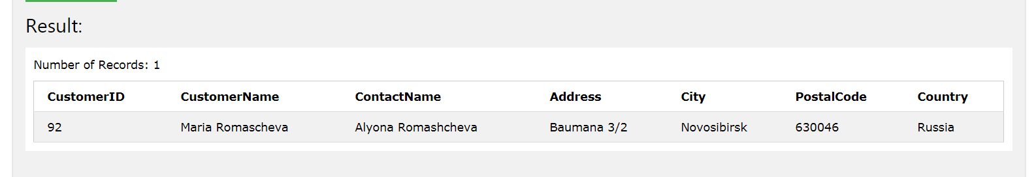

5. DELETE FROM Customers
WHERE City = 'Nantes'

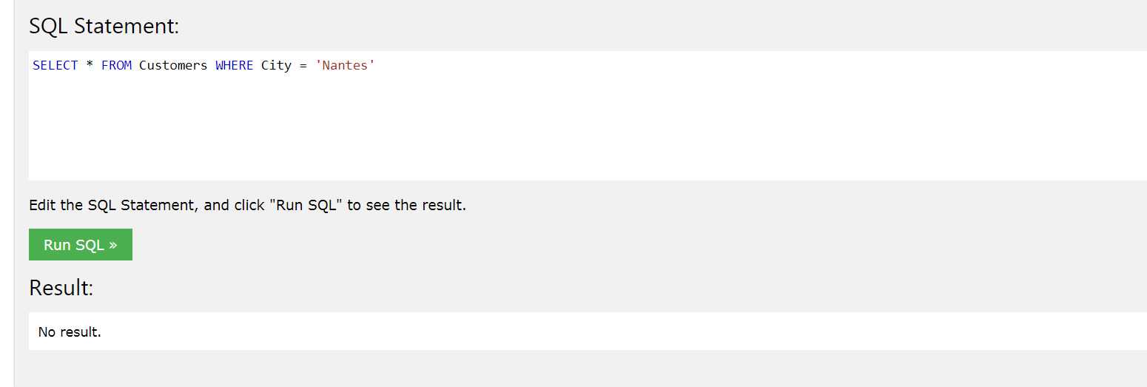

6. SELECT Orders.OrderID, Orders.EmployeeID FROM Orders
INNER JOIN Employees ON Orders.EmployeeID = Employees.EmployeeID WHERE Employees.FirstName='Steven';

