A1-20171-SQL-DBS301
DUE DATE: Nothing will be accepted after this date. It will get a zero
Due BEFORE MIDNIGHT on the FRIDAY of WEEK 6

PLAGIARISM
When you submit an assignment, you are saying that the submission is your own work and as such you wish to be given credit for the work.

Occasionally, especially when working on a design problem or writing programs (but never on exams or tests!), it may be necessary to ask someone for a small amount of help. You are permitted to do so, provided you meet the following two conditions.

1 You acknowledge the help on the work you hand in, including explaining the work or portion of the work done or assisted by another person.

2 You understand the work that you hand in, so that you could explain the reasoning behind the parts of the work done for you or assisted by another.

Any other assistance by another person constitutes a violation called plagiarism and will be treated as such.

When 2 or more of you work together as a group, only one assignment should be submitted with all the members’ names on it at the time of submission. If two submissions exist, that are essentially the same, then both submissions cannot possibly make the claim that the work is "solely their own". This is a serious matter and is considered plagiarism. It is recorded in accordance with College policy and may result in a penalty such as expulsion from the College. Please do not put yourself in this position. Plagiarism is very easy to detect.
Anyone not in this list cannot be added to the group later
Names Student ID(s) Section A, B or C

Alena Mitrakhovich 115 297 152 A
Bonnie Hung 117 400 150 C
Alexei Bonilla 121 784 151 A
Xin Li 024 629 156 A
Yeonwoo Park 120 415 153 A
Paolo Chang 127 430 155 A

The above acknowledges you understand.

INSTRUCTION:

1 Rename this WORD file A1-xxxxx where xxxxx is replaced with your email account name, not the whole email. If you are in a group pick one of them.

2 When finished email this back to me and CC everyone in your group as proof it was sent.

3 The following tables are used for this assignment. You will be given a script to load.

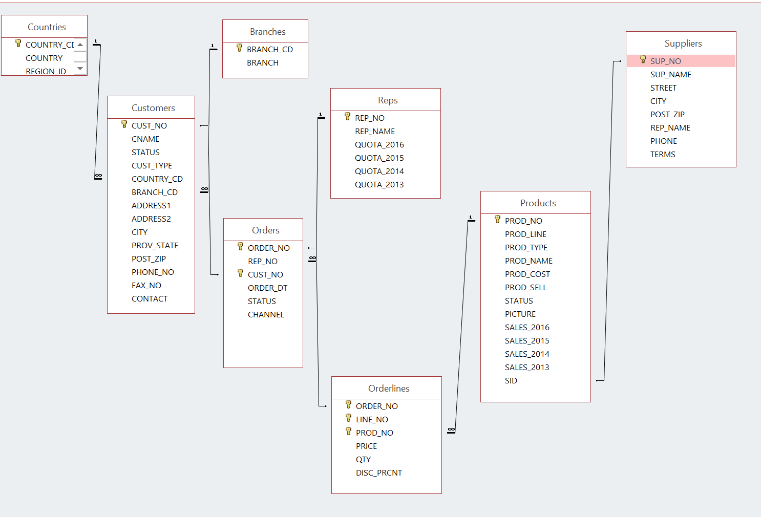

NOTE:
If any output goes on for more than 100 lines, only cut and paste the first 100 or so. I don’t want to get this word document too big.

1. Display the customer number, customer name and country code for all the customers that are in SPAIN. The country code for Spain is SPA. Please note that you are given SPA, or spa or SpA to use and not Spain.
SQL:

SELECT CUST_NO, CNAME, COUNTRY_CD
FROM CUSTOMERS
WHERE UPPER(COUNTRY_CD) = UPPER('Spa');

OUTPUT:

CUST_NO CNAME COUN
---------- ------------------------------ ----
1019 Supremax Montagna 5 SPA
1035 Ultra Sports 1 SPA
1095 Supremax Montagna 1 SPA
1096 Supremax Montagna 2 SPA
1097 Supremax Montagna 3 SPA
1098 GO Outlet Madrid SPA

6 rows selected

2. How many orders have the product number 40302?
SQL

SELECT COUNT(DISTINCT ORDER_NO) AS “Number of Orders for 40302”
FROM ORDERLINES
WHERE PROD_NO = 40302;

OUTPUT:

Number of Orders for 40302
---------------------------------------
22

3. List the customer number, customer name and order number for customers that ordered product 40302. Put result in customer number order.
SQL:

SELECT C.CUST_NO, C.CNAME, O.ORDER_NO
FROM CUSTOMERS C INNER JOIN ORDERS O
ON C.CUST_NO = O.CUST_NO
INNER JOIN ORDERLINES OL
ON O.ORDER_NO = OL.ORDER_NO
WHERE OL.PROD_NO = 40302
ORDER BY C.CUST_NO;

OUTPUT:

CUST_NO CNAME ORDER_NO
---------- ------------------------------ ----------
1001 GO Outlet Montreal 67
1005 GO Outlet Boston 153
1019 Supremax Montagna 5 78
1036 Ultra Sports 2 11
1039 Vacation Central 1 65
1041 Vacation Central 3 33
1045 Mountain Madness 3 16
1051 Sportwaren G.m.b.H. 1 139
1062 123 Fitness PTE Ltd 38
1066 Wilderness Wonderment Ltd 164
1069 Andes Camping Supplies 3 157

CUST_NO CNAME ORDER_NO
---------- ------------------------------ ----------
1071 Lookout Below Ltd 37
1078 Act'N'Up Fitness 4 44
1083 Over the Top Cycles 1 77
1095 Supremax Montagna 1 205
1102 Pro Form Supplies 4 28
1121 GO Outlet Manchester 15
1127 Fresh Air Co 1 135
1129 Fresh Air Co 3 101
1130 Fresh Air Lte 4 120
1139 Fredies Sport Whse 1 194
1148 Juan's Sports 2 2

22 rows selected

4 Display the customer number for Ultra Sports 5.
SQL:

SELECT CUST_NO
FROM CUSTOMERS
WHERE UPPER(CNAME) = 'ULTRA SPORTS 5';

OUTPUT:
CUST_NO
----------
1002

5. Display all orders for United Kingdom. The word entered is United Kingdom and not UK. Show only cities that start with L.
Display the customer number, customer name, order number, product name, the total dollars for that line. Give that last column the name of TOTAL.
Put the output into customer number order from highest to lowest and display only order numbers less than 75
SQL:

SELECT O.CUST_NO, M.CNAME, OL.ORDER_NO, P.PROD_NAME, OL.PRICE * OL.QTY AS TOTAL
FROM COUNTRIES C
JOIN CUSTOMERS M
ON C.COUNTRY_ID = M.COUNTRY_CD
JOIN ORDERS O
ON M.CUST_NO = O.CUST_NO
JOIN ORDERLINES OL
ON O.ORDER_NO = OL.ORDER_NO
JOIN PRODUCTS P
ON OL.PROD_NO = P.PROD_NO
WHERE M.CITY LIKE 'L%'
AND OL.ORDER_NO < 75
AND UPPER(C.COUNTRY_NAME) = UPPER('United Kingdom')
ORDER BY O.CUST_NO DESC;

OUTPUT:

CUST_NO CNAME ORDER_NO PROD_NAME TOTAL
---------- ------------------------------ ---------- ------------------------------ ----------
1120 GO Outlet London 61 Star Lite 5610
1120 GO Outlet London 49 Pocket Water Filter 3780
1120 GO Outlet London 29 MoonGlow 2064
1120 GO Outlet London 49 Day Tripper 14
1120 GO Outlet London 49 Pack n' Hike 262
1120 GO Outlet London 49 GO Cookset 1512
1120 GO Outlet London 29 GO Cookset 1512
1120 GO Outlet London 61 GO Camp Kettle 1533
1120 GO Outlet London 49 GO Headband 320
1120 GO Outlet London 61 GO Wristband 384
1120 GO Outlet London 29 GO Wristband 640

CUST_NO CNAME ORDER_NO PROD_NAME TOTAL
---------- ------------------------------ ---------- ------------------------------ ----------
1120 GO Outlet London 29 Pocket U.V. Alerter 558
1120 GO Outlet London 49 RiverKind Shampoo 558
1120 GO Outlet London 29 RiverKind Detergent 1806
1120 GO Outlet London 61 Pro-Lite Water Filter 165
1120 GO Outlet London 61 Pocket Water Filter 8370
1120 GO Outlet London 61 MoonGlow 1677

17 rows selected

6. Display a count of how many different country codes there are
SQL:
SELECT COUNT(DISTINCT(COUNTRY_CD))
FROM CUSTOMERS;

OUTPUT:

COUNT(DISTINCT(COUNTRY_CD))
---------------------------------------
14

7. **Find the total dollar value for all orders from London**. Each row will show customer name, order number and total dollars for the order. Sort by order number
SQL:

SELECT c.CNAME, o.ORDER_NO, SUM(r.PRICE * r.QTY)
FROM CUSTOMERS c, ORDERS o, ORDERLINES r
WHERE (c.CUST_NO = o.CUST_NO and o.ORDER_NO = r.ORDER_NO)
AND UPPER(CITY) = UPPER('London')
GROUP BY o.ORDER_NO, c.CNAME
ORDER BY ORDER_NO;

OUTPUT:

CNAME ORDER_NO SUM(R.PRICE*R.QTY)
------------------------------ ---------- ---------------------------------------
GO Outlet London 29 6580
GO Outlet London 49 6446
GO Outlet London 61 17739
GO Outlet London 107 28466
Trees to Seas Ltd 122 5056
Trees to Seas Ltd 170 5728

6 rows selected

Going back to the same tables you have used for labs that came from demobld10g

8. 8 Display the (a) employee number, (b) full employee name, (c) job and (d) hire date.
- Limit the display to all employees hired in May, June, July, August or Dec
- The most recently hired employees are displayed first.
- Exclude people hired in 1992 to 1996
- Full name should be in the form à Lastname, Firstname -- with an alias called Full Name.
- Hire date should point to the last day in May, June, July, August or December of that year (NOT to the exact hire date)
- The format is in the form of May 31st of 1997 –better if there is no big gap between month and 31st
- The hire date column should be called Start Date.
NOTE: Do NOT use a LIKE operator.
You should display ONE row per output line by limiting the width of the Full Name to 25 characters.
SQL:

SELECT EMPLOYEE_ID, SUBSTR(LAST_NAME || ', ' || FIRST_NAME, 1 , 25) as "Full Name", JOB_ID, TO_CHAR((LAST_DAY(HIRE_DATE)), 'FMMonth ddth "of "yyyy') as "Start Date"
FROM EMPLOYEES
WHERE TO_CHAR(HIRE_DATE, 'YYYY') NOT IN(1992, 1993, 1994,1995, 1996)
AND TO_CHAR(HIRE_DATE, 'MM') IN (05, 06, 07, 08, 12) --May or November OR May, June, July, August, December?
ORDER BY HIRE_DATE DESC;

OUTPUT:

EMPLOYEE_ID Full Name JOB_ID Start Date
----------- ------------------------- ---------- -------------------------------------------------
178 Grant, Kimberely SA_REP May 31st of 1999
144 Vargas, Peter ST_CLERK July 31st of 1998
202 Fay, Pat MK_REP August 31st of 1997
104 Ernst, Bruce IT_PROG May 31st of 1991
100 King, Steven AD_PRES June 30th of 1987

9. List the employee number, full name, job and the modified salary for all employees
- whose monthly earning (without the increase) is outside the range $6,000 – $11,000
- and who are employed as a Vice Presidents or Managers (President is not counted here).
- You should use Wild Card characters for this.
- the modified salary for a VP will be 30% higher
- and managers a 20% salary increase.
- Sort the output by the top salaries (before this increase).
Heading will be: → Employees with Increased Pay
The output lines should look like this sample line:
Employee 101 named Neena Kochhar with Job ID of AD_VP will have a new salary of $22100
SQL:

SELECT 'Employee ' || EMPLOYEE_ID || ' named '|| FIRST_NAME || ' ' || LAST_NAME
|| ' with Job ID of ' || JOB_ID || ' will have a new salary of $' ||
CASE WHEN JOB_ID LIKE '%VP' THEN (SALARY * 1.3)
WHEN JOB_ID LIKE '%MAN' THEN (SALARY * 1.2)
WHEN JOB_ID LIKE '%MGR' THEN (SALARY * 1.2)
END
AS "Employees with Increased Pay"
FROM EMPLOYEES
WHERE SALARY NOT BETWEEN 6000 AND 11000
AND REGEXP_LIKE(JOB_ID, '\_(VP|MGR|MAN)$');

OUTPUT:

Employees with Increased Pay
----------------------------------------------------------------------------------------------------------------------------------------------------------------------------------------------------
Employee 101 named Neena Kochhar with Job ID of AD_VP will have a new salary of $22100
Employee 102 named Lex De Haan with Job ID of AD_VP will have a new salary of $22100
Employee 124 named Kevin Mourgos with Job ID of ST_MAN will have a new salary of $6960
Employee 201 named Michael Hartstein with Job ID of MK_MAN will have a new salary of $15600
Employee 205 named Shelley Higgins with Job ID of AC_MGR will have a new salary of $14400

10. Display last_name, job id and salary for all employees who earn more than all lowest paid employees per department that are in locations outside the US.
Exclude President and Vice Presidents from this query.
Sort the output by job id ascending.
If a JOIN is needed you must use a “newer” method (USING/JOIN)
SQL:

SELECT LAST_NAME, JOB_ID, SALARY
FROM EMPLOYEES
JOIN DEPARTMENTS
USING (DEPARTMENT_ID)
JOIN LOCATIONS
USING (LOCATION_ID)
WHERE SALARY > (SELECT MIN(SALARY) FROM EMPLOYEES)
AND COUNTRY_ID != 'US'
AND (UPPER(JOB_ID) NOT LIKE '%PRES'
AND UPPER(JOB_ID) NOT LIKE '%VP')
ORDER BY JOB_ID;

OUTPUT:

LAST_NAME JOB_ID SALARY
------------------------- ---------- ----------
Hartstein MK_MAN 13000
Fay MK_REP 6000
Zlotkey SA_MAN 10500
Abel SA_REP 11000
Taylor SA_REP 8600

11. Who are the employees (show last_name, salary and job) who work either in IT , ACCOUNTING or MARKETING department and earn more than the worst paid person in the SHIPPING department.
Sort the output by the last name alphabetically.
You need to use ONLY the Subquery method (NO joins allowed).
SQL:

SELECT LAST_NAME, SALARY, JOB_ID
FROM EMPLOYEES
WHERE DEPARTMENT_ID = ANY
(SELECT DEPARTMENT_ID
FROM DEPARTMENTS
WHERE UPPER(DEPARTMENT_NAME) IN ('IT', 'ACCOUNTING', 'MARKETING'))
AND SALARY > (SELECT MIN(SALARY)
FROM EMPLOYEES
WHERE DEPARTMENT_ID = (SELECT DEPARTMENT_ID
FROM DEPARTMENTS
WHERE UPPER(DEPARTMENT_NAME) = ('SHIPPING')))
ORDER BY LAST_NAME;

OUTPUT:

LAST_NAME SALARY JOB_ID
------------------------- ---------- ----------
Ernst 6000 IT_PROG
Fay 6000 MK_REP
Gietz 8300 AC_ACCOUNT
Hartstein 13000 MK_MAN
Higgins 12000 AC_MGR
Hunold 9000 IT_PROG
Lorentz 4200 IT_PROG

7 rows selected

12. Display Department_id, Job_id and the Lowest salary for this combination but only if that Lowest Pay falls in the range $6000 - $18000.
Exclude people who
(a) work as some kind of Representative job from this query and
(b) departments IT and SALES
Sort the output according to the Department_id and then by Job_id.
You MUST NOT use the Subquery method.
SQL:

SELECT DEPARTMENT_ID, JOB_ID, MIN(SALARY)
FROM EMPLOYEES INNER JOIN DEPARTMENTS USING (DEPARTMENT_ID)
WHERE SALARY BETWEEN 6000 AND 18000
AND JOB_ID NOT LIKE '%REP'
AND UPPER(DEPARTMENT_NAME) NOT IN ('IT', 'SALES')
GROUP BY DEPARTMENT_ID, JOB_ID
ORDER BY DEPARTMENT_ID, JOB_ID;

OUTPUT:

DEPARTMENT_ID JOB_ID MIN(SALARY)
------------- ---------- ---------------------------------------
20 MK_MAN 13000
90 AD_VP 17000
110 AC_ACCOUNT 8300
110 AC_MGR 12000

