PART I – COOKIES
Storing and displaying cookies in two methods
Keeping track of the number of visits to the page
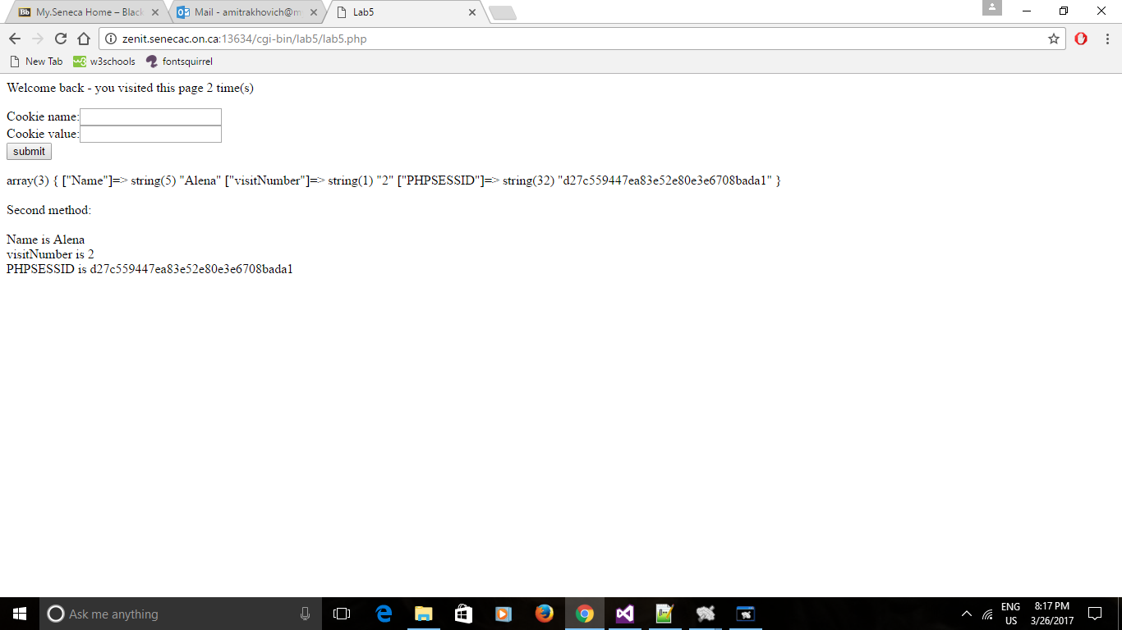
More cookies added and displayed
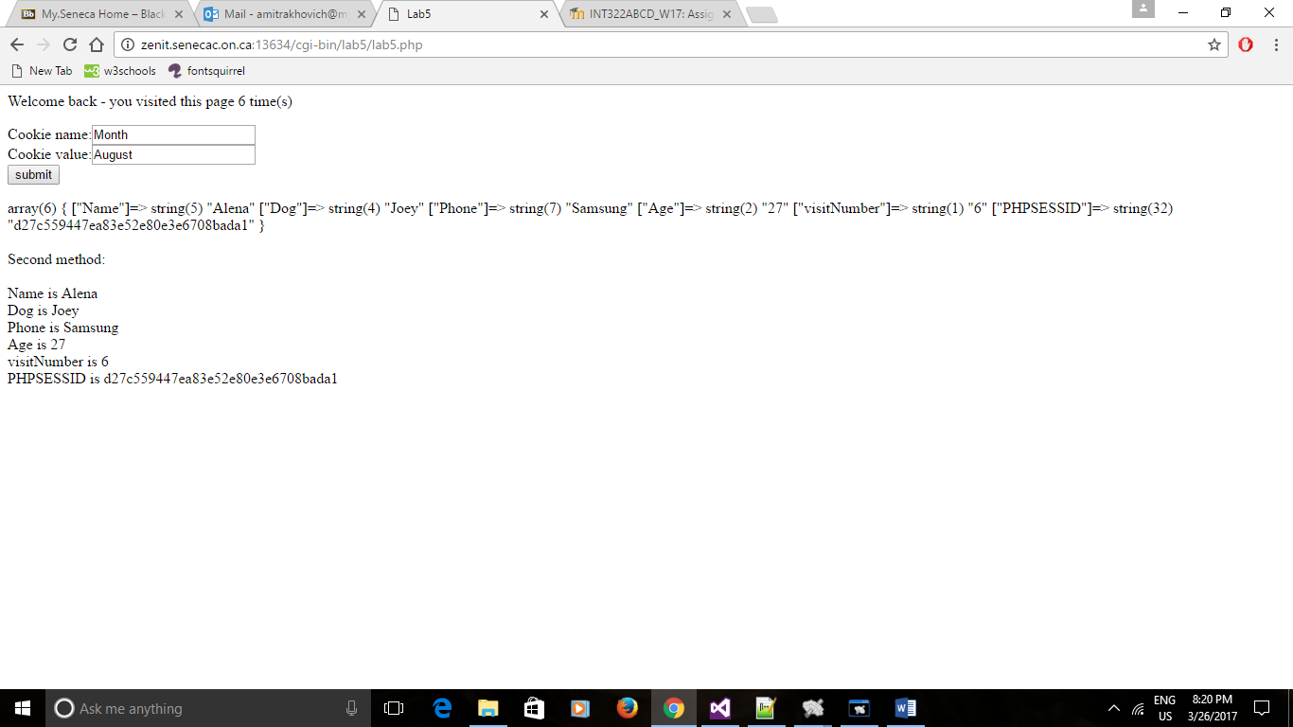
PART II and III – SESSIONS AND EMAIL
Form to input username(e-mail) and password to log in
Link to ‘forgot my password’ to have a password hint e-mailed to user
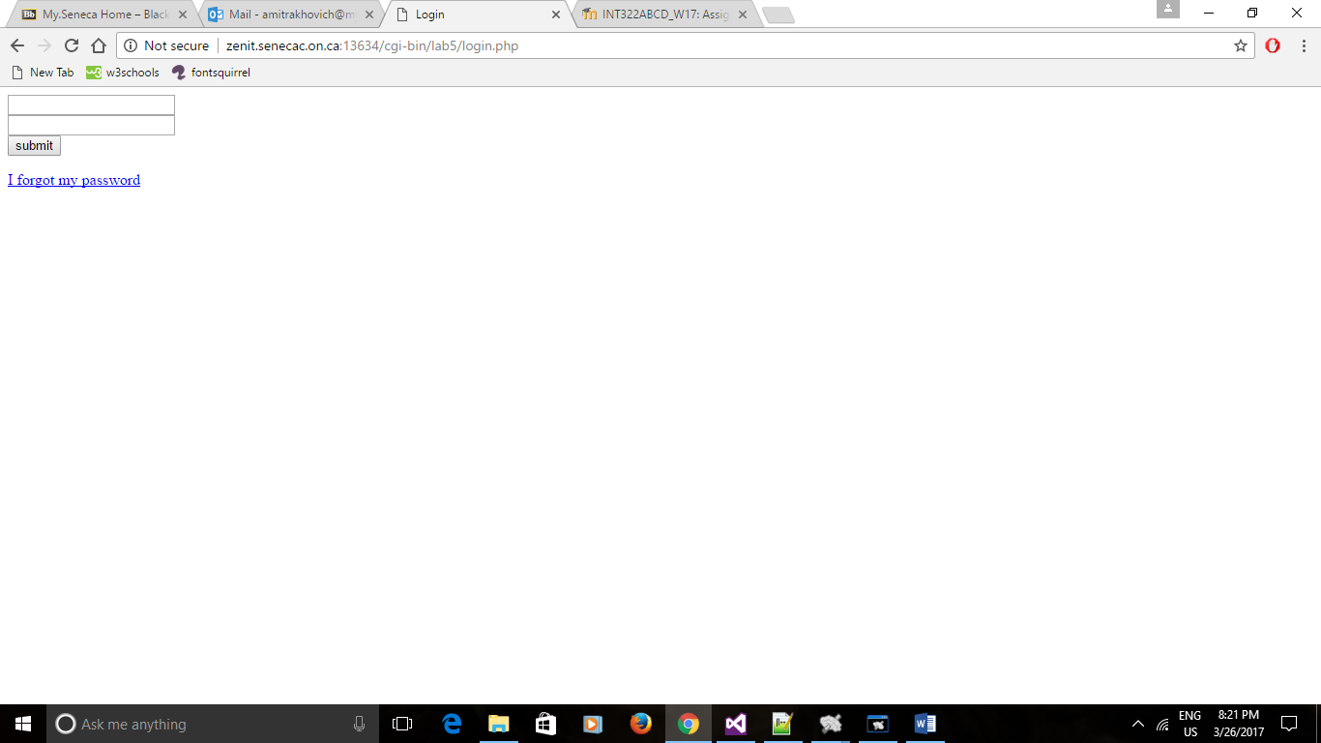
Information stored in the users table
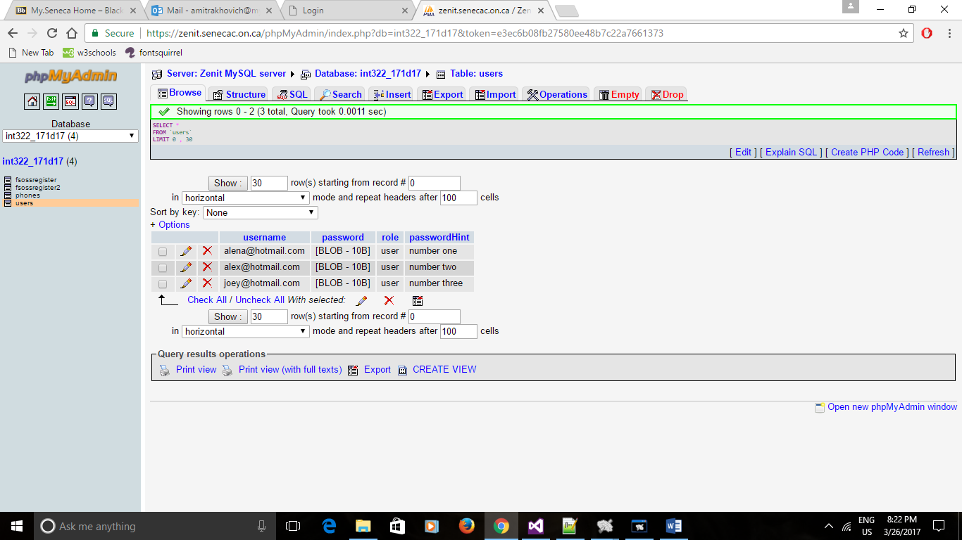
Entering valid data
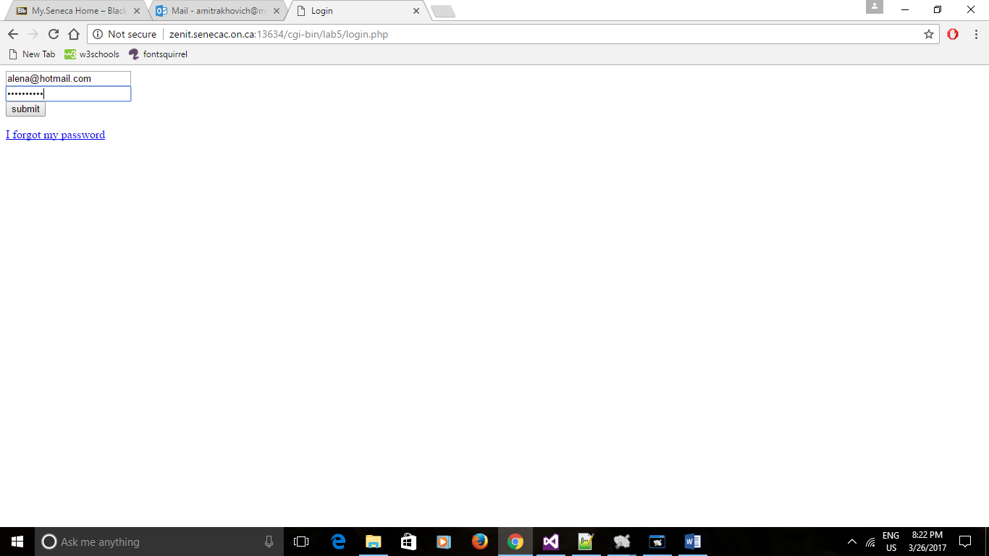
When valid data is entered, this is displayed:
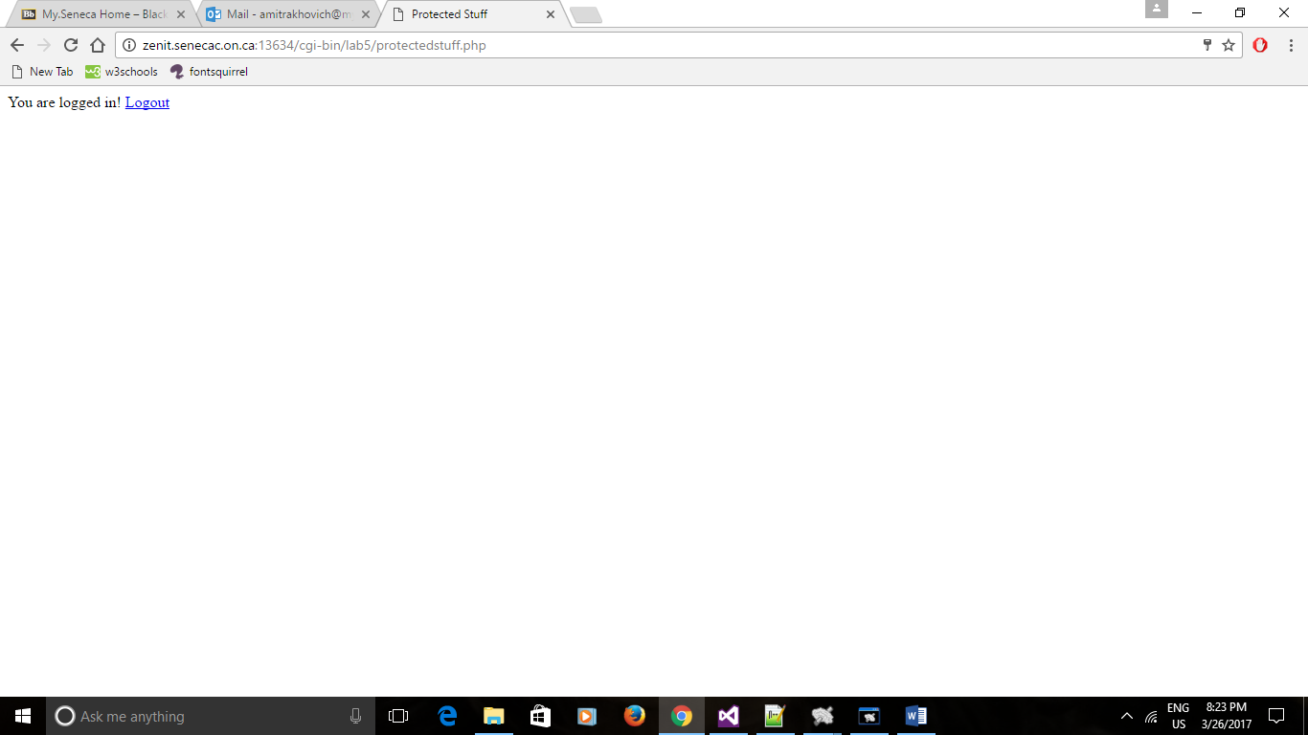

When invalid password is entered with a valid email (both have to match in the database):
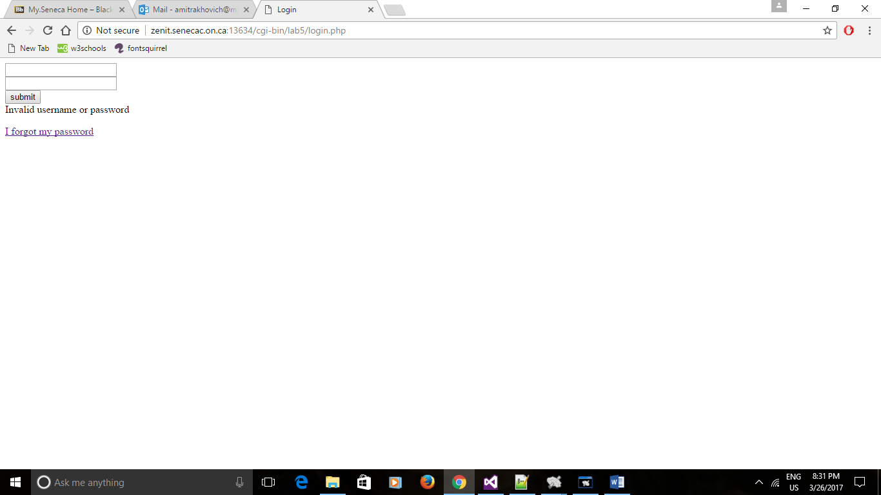

When ‘forgot my password’ is clicked, this is displayed for user to enter an email address to receive via email a password hint stored under their profile:
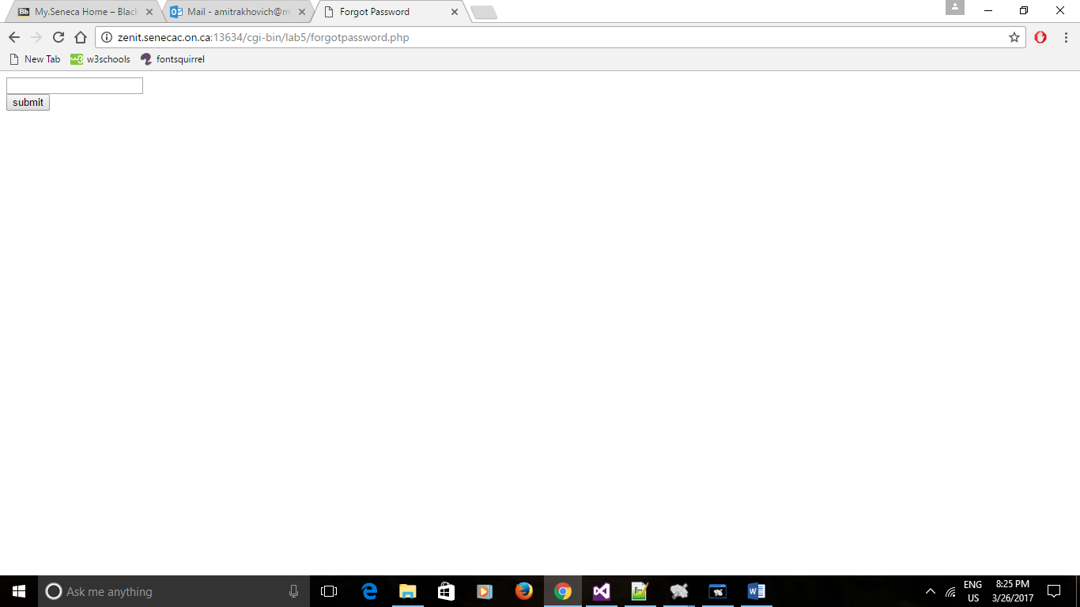
When a matching email address is entered, e-mail is sent successfully and message is displayed:
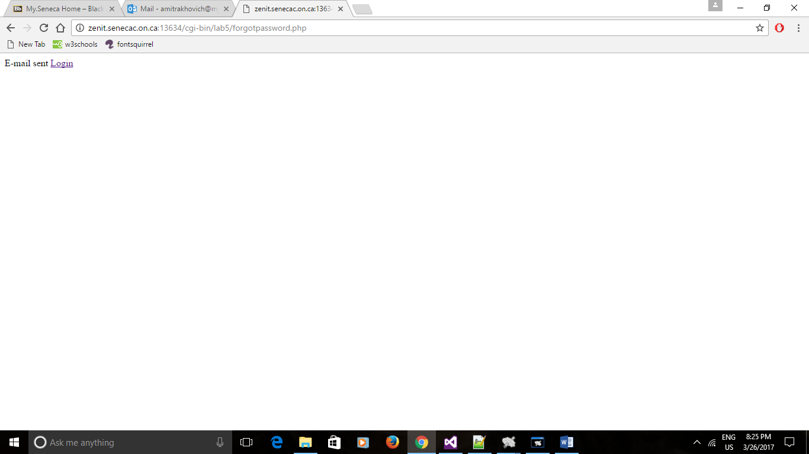
Current session username is stored and displayed after logging in:
