INT322 Lab 6
Alena Mitrakhovich
115 297 152
- Testing the DB_link class to do several queries and to call/use the display function
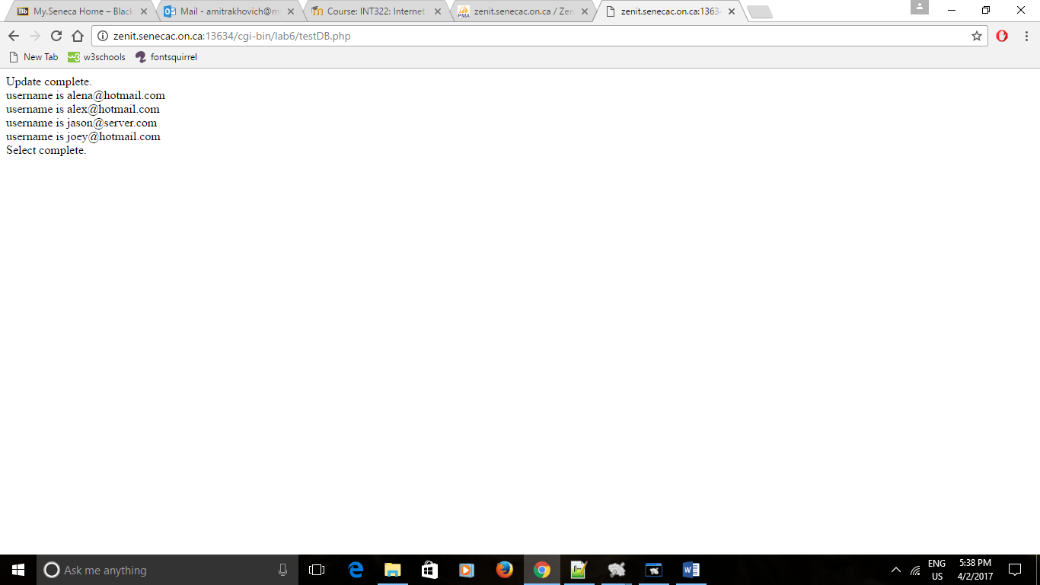

- Updated information in the dabatase to show query worked
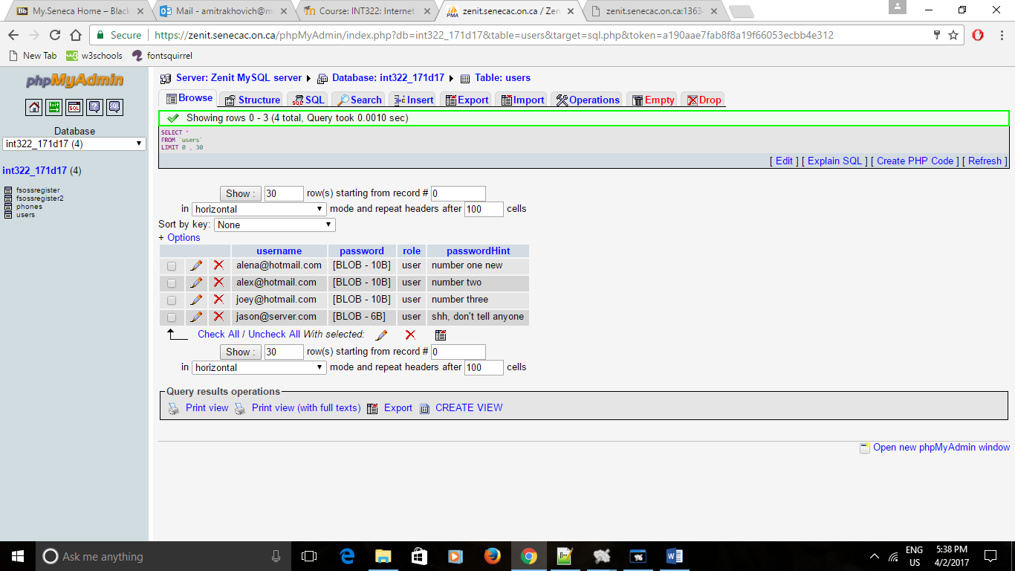
- Testing Menu class
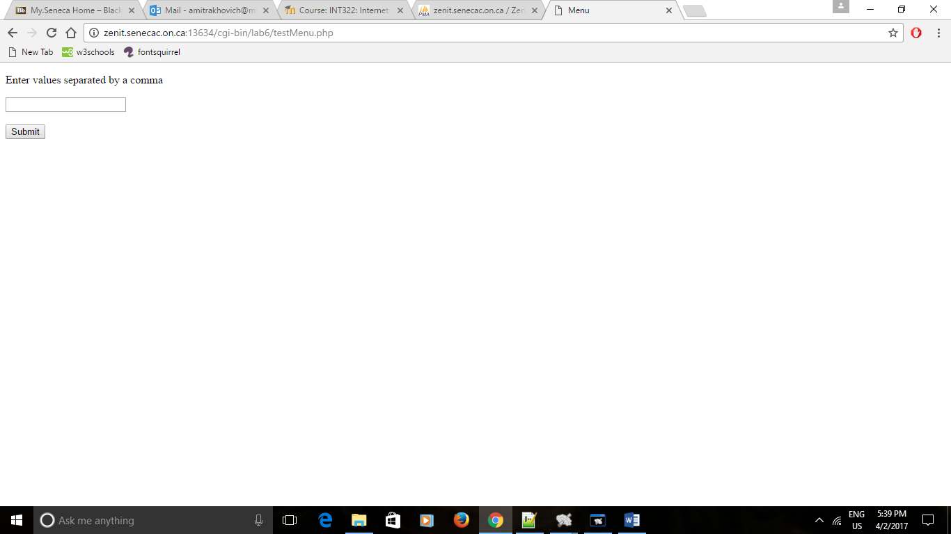

- Picking information for a menu
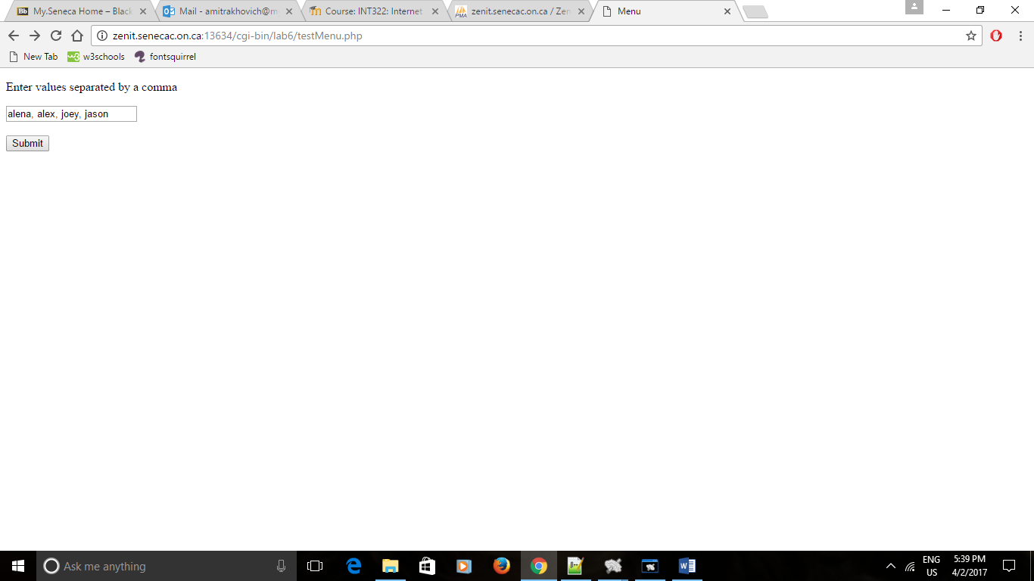
- Menu is displayed
