Based off of multiple factors in the data received, there is reason to believe that Big Mountain is undercharging their ticket prices.

To explain this further, it must be stated that each state and region where ski resorts are located have their own features and pricing. Competitors were chosen based off of a comparison of pricing scaled by those features in conjunction with statewide population and acreage data, and it was determined that all resorts in the data frame had reasonable points of comparison.

The biggest 4 features associated with ticket price happen to be the vertical drop, amount of fast-quads, runs, and snow-making, as you can see by the histogram created from an random forest regression model supported by an initial linear analysis.

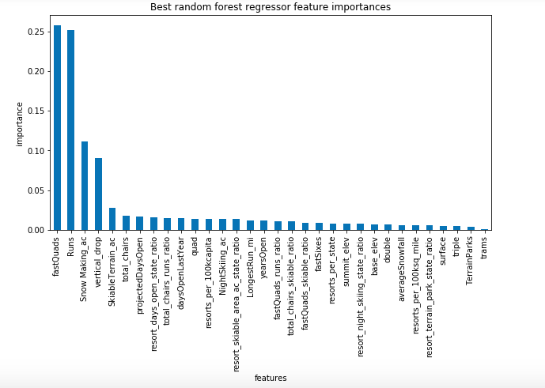

Big Mountain comparatively fares rather well against its competitors in this way, as you can see from these next graphs created, where the red line shows Big Mountain's place compared to the other resorts. From these, it is clear that Big Mountain is on the higher end of having fast quads, total number of chairs, number of runs, and area covered by snow-makers. Its longest run is also longer than a large amount of resorts as well.

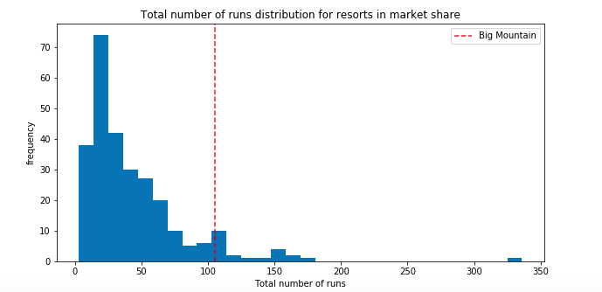

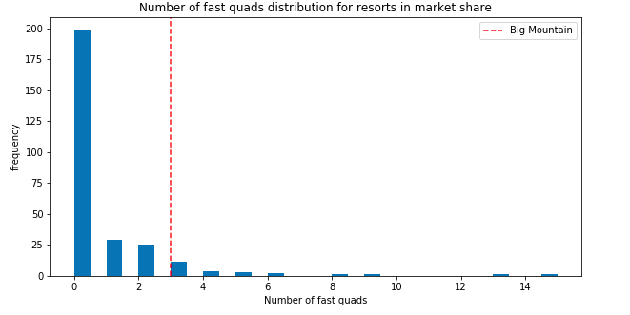

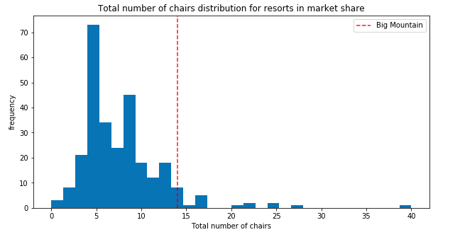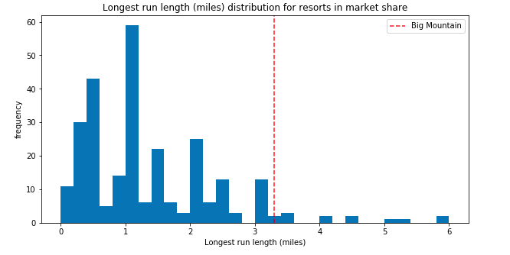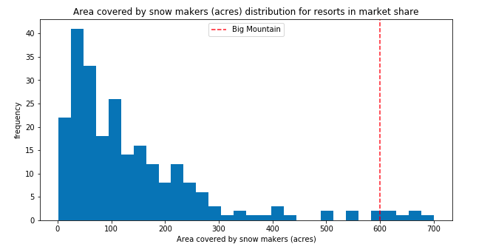

Big Mountain has been charging a price of $81.00 for an adult skiing ticket, and based off of a machine learning model we created from the data, that price could be much higher. According to that model, prices could go up by at least $2.83 accounting for errors but could go up to $94.22.

This model is limited in terms of not knowing all the details of what goes into each resort's pricing strategy, as well as operational costs and other limitations. In keeping that in mind, there are a couple of proposed scenarios to increase revenue aside from merely increasing the ticket price.

According to our modeling, if Big Mountain adds another chairlift, they could increase their prices by $8.46. With the average amount of tickets being sold a year, that revenue would lead to about $14,811,594.

If there is less expendable income and the company is looking to primarily cut costs, closing some of the least-used runs is a possibility as shown by the graphs using the model. As shown, ticket prices stay the same if 3-5 runs are closed, and this pattern continues for closing 6-8.

If one wanted to go about just increasing the price alone there are a few more pieces of information that could help inform the best strategy of increase. If we were able to get data on how many repeat-skiers Big Mountain has a year, that would influence the best way to go about increasing the prices: as in whether the increase should be introduced in one-fell swoop or in tiers over time. This change is small enough that it wouldn’t be incredibly noticeable, especially if it was done in a staggering yearly increase.