## page break

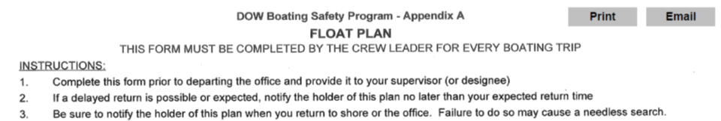

# Crew Info

Crew Leader: Alene Onion……..Crew Members: self

Departure Date,Time,Location: 2020-05-13 06:00:00, Tech Park

# Trip Information

|  |  |  |  |
| --- | --- | --- | --- |
| Lake | Y_Coordinate | X_Coordinate | Return |
| 0403ROC0155_Rockville Lake | 42.30818 | -78.14973 | 2020-05-13 12:33:00 |

|  |  |  |  |
| --- | --- | --- | --- |
| Lake | Y_Coordinate | X_Coordinate | Return |
| 0402GOD0017_Godfrey Pond | 43.02853 | -78.11157 | 2020-05-13 16:27:00 |

# Boat and Vehicle Information

|  |  |  |
| --- | --- | --- |
| Boat.Type | Manufacturer | Size.Length.Color |
| canoe/kayak | we-no-nah | 15’, 8’ |

|  |  |
| --- | --- |
| Boat.Owner | Vehicle.Description |
| DOW | Dodge Ram Silver (4109) |

# On Board Communication and Safety Equipment (in addition to PDFs)

Cell Phone Numbers: (314)910-2334

Comments: will radio on lake/off lake

Float plan holder 1: Karen Woodfield, (518)366-7249

Float plan holder 2: Karen Stainbrook, (518) 428 2252

Hotel Information: none

# *******IF BOATERS ARE OVERDUE, SEE INSTRUCTIONS Below*******

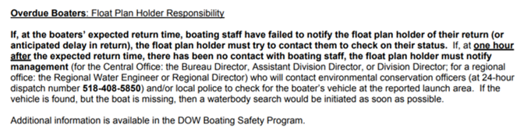 ## page break



# Crew Info

Crew Leader: Stephanie June……..Crew Members: self

Departure Date,Time,Location: 2020-05-13 06:00:00, Tech Park

# Trip Information

|  |  |  |  |
| --- | --- | --- | --- |
| Lake | Y_Coordinate | X_Coordinate | Return |
| 0403ROC0155_Rockville Lake | 42.30818 | -78.14973 | 2020-05-13 12:33:00 |

|  |  |  |  |
| --- | --- | --- | --- |
| Lake | Y_Coordinate | X_Coordinate | Return |
| 0402GOD0017_Godfrey Pond | 43.02853 | -78.11157 | 2020-05-13 16:27:00 |

# Boat and Vehicle Information

|  |  |  |
| --- | --- | --- |
| Boat.Type | Manufacturer | Size.Length.Color |
| canoe/kayak | we-no-nah | 15’, 8’ |

|  |  |
| --- | --- |
| Boat.Owner | Vehicle.Description |
| DOW | Blue Steel Streams Truck |

# On Board Communication and Safety Equipment (in addition to PDFs)

Cell Phone Numbers: (518)209-4096

Comments: will radio on lake/off lake

Float plan holder 1: Karen Woodfield, (518)366-7249

Float plan holder 2: Karen Stainbrook, (518) 428 2252

Hotel Information: none

# *******IF BOATERS ARE OVERDUE, SEE INSTRUCTIONS Below*******

