## page break

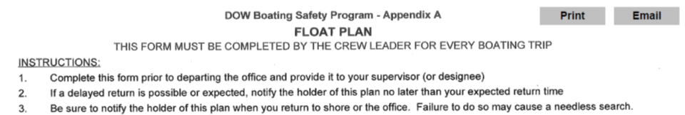

# Crew Info

Crew Leader: Stephanie June……..Crew Members: Alene Onion, Alexa Blunck

Departure Date,Time,Location: 2019-06-11 06:59:59, Central Office

# Trip Information

|  |  |  |  |
| --- | --- | --- | --- |
| Lake | Y_Coordinate | X_Coordinate | Return |
| 1702BRY1106_Bryam Lake Reservoir | 41.1728 | -73.69329 | 2019-06-11 13:13:59 |

|  |  |  |  |
| --- | --- | --- | --- |
| Lake | Y_Coordinate | X_Coordinate | Return |
| 1702SHE1087_Sheldrake Lake | 41.95204 | -73.77392 | 2019-06-11 11:25:59 |

|  |  |  |  |
| --- | --- | --- | --- |
| Lake | Y_Coordinate | X_Coordinate | Return |
| 1702OAK0107_Oakland Lake | 40.75927 | -73.75849 | 2019-06-11 11:24:59 |

# Boat and Vehicle Information

|  |  |  |
| --- | --- | --- |
| Boat.Type | Manufacturer | Size.Length.Color |
| canoe | sportspal | 15 foot, aluminum |

|  |  |
| --- | --- |
| Boat.Owner | Vehicle.Description |
| DOW | Dodge Ram Silver (4109) |

# On Board Communication and Safety Equipment (in addition to PDFs)

Cell Phone Numbers: (518)209-4096

Marine Radio: -, Distress Flag: -, Distress Light: -, Smoke/Dye Signals: -, Flares: -, Horn: -, Signal Mirror: -, Fire Extinguisher(s): -

Comments: Will use Spot 2 when off lake

Float plan holder 1: Karen Woodfield, (518)366-7249

Float plan holder 2: Alexander Smith, (518)867-2865

Hotel Information: hotel - holiday inn express, 2050 Express Dr S, Hauppauge, NY 11788

# *******IF BOATERS ARE OVERDUE, SEE INSTRUCTIONS Below*******

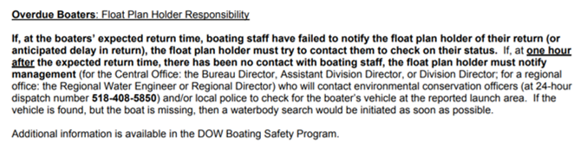

## page break



# Crew Info

Crew Leader: Stephanie June……..Crew Members: Callan Green, Alexa Blunck

Departure Date,Time,Location: 2019-06-12 06:59:59, Central Office

# Trip Information

|  |  |  |  |
| --- | --- | --- | --- |
| Lake | Y_Coordinate | X_Coordinate | Return |
| 1701GRE0885_Great Patchogue Lake | 40.76778 | -73.02008 | 2019-06-12 09:37:59 |

|  |  |  |  |
| --- | --- | --- | --- |
| Lake | Y_Coordinate | X_Coordinate | Return |
| 1701LOW0855_Lower Lake | 40.8346 | -72.91775 | 2019-06-12 11:18:59 |

# Boat and Vehicle Information

|  |  |  |
| --- | --- | --- |
| Boat.Type | Manufacturer | Size.Length.Color |
| canoe | sportspal | 15 foot, aluminum |

|  |  |
| --- | --- |
| Boat.Owner | Vehicle.Description |
| DOW | Dodge Ram Silver (4109) |

# On Board Communication and Safety Equipment (in addition to PDFs)

Cell Phone Numbers: (518)209-4096

Marine Radio: -, Distress Flag: -, Distress Light: -, Smoke/Dye Signals: -, Flares: -, Horn: -, Signal Mirror: -, Fire Extinguisher(s): -

Comments: Will use Spot 2 when off lake

Float plan holder 1: Karen Woodfield, (518)366-7249

Float plan holder 2: Alexander Smith, (518)867-2865

Hotel Information: NA

# *******IF BOATERS ARE OVERDUE, SEE INSTRUCTIONS Below*******



## page break



# Crew Info

Crew Leader: Matt Kraft……..Crew Members: Jesse Keltz, Callan Green

Departure Date,Time,Location: 2019-06-11 06:59:59, Central Office

# Trip Information

|  |  |  |  |
| --- | --- | --- | --- |
| Lake | Y_Coordinate | X_Coordinate | Return |
| 1701PEC0555_Peconic Lake | 40.91344 | -72.71529 | 2019-06-11 15:51:59 |

|  |  |  |  |
| --- | --- | --- | --- |
| Lake | Y_Coordinate | X_Coordinate | Return |
| 1701LAU0496_Laurel Lake | 40.97875 | -72.5572 | 2019-06-11 11:21:59 |

# Boat and Vehicle Information

|  |  |  |
| --- | --- | --- |
| Boat.Type | Manufacturer | Size.Length.Color |
| canoe | we-no-nah | 16 foot, green |

|  |  |
| --- | --- |
| Boat.Owner | Vehicle.Description |
| DOW | Dodge Ram Silver (4110) |

# On Board Communication and Safety Equipment (in addition to PDFs)

Cell Phone Numbers: (716)997-2645

Marine Radio: -, Distress Flag: -, Distress Light: -, Smoke/Dye Signals: -, Flares: -, Horn: -, Signal Mirror: -, Fire Extinguisher(s): -

Comments: Will use Spot 1 when off lake

Float plan holder 1: Karen Woodfield, (518)366-7249

Float plan holder 2: Alexander Smith, (518)867-2865

Hotel Information: hotel - holiday inn express, 2050 Express Dr S, Hauppauge, NY 11788

# *******IF BOATERS ARE OVERDUE, SEE INSTRUCTIONS Below*******



## page break



# Crew Info

Crew Leader: Matt Kraft……..Crew Members: Jesse Keltz, Alene Onion

Departure Date,Time,Location: 2019-06-12 06:59:59, Central Office

# Trip Information

|  |  |  |  |
| --- | --- | --- | --- |
| Lake | Y_Coordinate | X_Coordinate | Return |
| 1701MAR0495_Maratooka Lake | 40.9933 | -72.52386 | 2019-06-12 10:37:59 |

|  |  |  |  |
| --- | --- | --- | --- |
| Lake | Y_Coordinate | X_Coordinate | Return |
| 1701MAR0495_Maratooka Lake bathymetry | NA | NA | 2019-06-12 09:16:59 |

# Boat and Vehicle Information

|  |  |  |
| --- | --- | --- |
| Boat.Type | Manufacturer | Size.Length.Color |
| canoe | we-no-nah | 16 foot, green |

|  |  |
| --- | --- |
| Boat.Owner | Vehicle.Description |
| DOW | Dodge Ram Silver (4110) |

# On Board Communication and Safety Equipment (in addition to PDFs)

Cell Phone Numbers: (716)997-2645

Marine Radio: -, Distress Flag: -, Distress Light: -, Smoke/Dye Signals: -, Flares: -, Horn: -, Signal Mirror: -, Fire Extinguisher(s): -

Comments: Will use Spot 1 when off lake

Float plan holder 1: Karen Woodfield, (518)366-7249

Float plan holder 2: Alexander Smith, (518)867-2865

Hotel Information: NA

# *******IF BOATERS ARE OVERDUE, SEE INSTRUCTIONS Below*******

