## page break

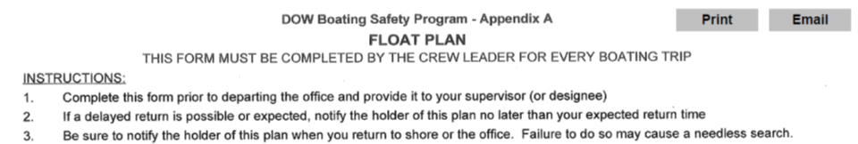

# Crew Info

Crew Leader: Jesse Keltz……..Crew Members: Carrie Buetow

Departure Date,Time,Location: 2019-06-17 06:00:00, Region 4

# Trip Information

|  |  |  |  |
| --- | --- | --- | --- |
| Lake | Y_Coordinate | X_Coordinate | Return |
| 0601YOU0408_Youngs Lake | 42.84414 | -74.92091 | 2019-06-17 10:16:00 |

|  |  |  |  |
| --- | --- | --- | --- |
| Lake | Y_Coordinate | X_Coordinate | Return |
| 0601GOE0378_Goey Pond | 42.62579 | -74.97406 | 2019-06-17 12:46:00 |

|  |  |  |  |
| --- | --- | --- | --- |
| Lake | Y_Coordinate | X_Coordinate | Return |
| 0601GIL0287_Gilbert Lake | 42.57874 | -75.12655 | 2019-06-17 15:12:00 |

# Boat and Vehicle Information

|  |  |  |
| --- | --- | --- |
| Boat.Type | Manufacturer | Size.Length.Color |
| canoe | we-no-nah | 16 foot, green |

|  |  |
| --- | --- |
| Boat.Owner | Vehicle.Description |
| DOW | Dodge Ram Silver (4110) |

# On Board Communication and Safety Equipment (in addition to PDFs)

Cell Phone Numbers: (914)960-0033

Marine Radio: -, Distress Flag: -, Distress Light: -, Smoke/Dye Signals: -, Flares: -, Horn: -, Signal Mirror: -, Fire Extinguisher(s): -

Comments: Will use Spot 1 when off lake

Float plan holder 1: Karen Woodfield, (518)366-7249

Float plan holder 2: Alexander Smith, (518)867-2865

Hotel Information: Holiday Inn Express - 141 Courtyard Dr, Oneonta, NY 13820,Â (607) 684-2000

# *******IF BOATERS ARE OVERDUE, SEE INSTRUCTIONS Below*******

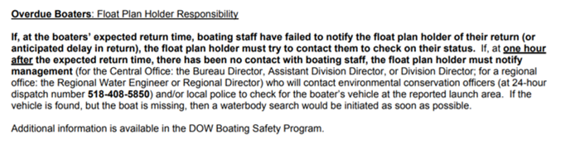

## page break



# Crew Info

Crew Leader: Jesse Keltz……..Crew Members: Carrie Buetow

Departure Date,Time,Location: 2019-06-18 06:59:59, Holiday Inn Express - 141 Courtyard Dr, Oneonta, NY 13820,Â (607) 684-2000

# Trip Information

|  |  |  |  |
| --- | --- | --- | --- |
| Lake | Y_Coordinate | X_Coordinate | Return |
| 0601ESI0262_East Sidney Lake | 42.32997 | -75.22639 | 2019-06-18 09:21:59 |

|  |  |  |  |
| --- | --- | --- | --- |
| Lake | Y_Coordinate | X_Coordinate | Return |
| 0602ROU0082_Round Pond | 42.3996 | -75.8392 | 2019-06-18 12:10:59 |

|  |  |  |  |
| --- | --- | --- | --- |
| Lake | Y_Coordinate | X_Coordinate | Return |
| 0602LLY5637_Lower Little York Lake | 42.69205 | -76.16388 | 2019-06-18 14:53:59 |

# Boat and Vehicle Information

|  |  |  |
| --- | --- | --- |
| Boat.Type | Manufacturer | Size.Length.Color |
| canoe | we-no-nah | 16 foot, green |

|  |  |
| --- | --- |
| Boat.Owner | Vehicle.Description |
| DOW | Dodge Ram Silver (4110) |

# On Board Communication and Safety Equipment (in addition to PDFs)

Cell Phone Numbers: (914)960-0033

Marine Radio: -, Distress Flag: -, Distress Light: -, Smoke/Dye Signals: -, Flares: -, Horn: -, Signal Mirror: -, Fire Extinguisher(s): -

Comments: Will use Spot 1 when off lake

Float plan holder 1: Karen Woodfield, (518)366-7249

Float plan holder 2: Alexander Smith, (518)867-2865

Hotel Information: Holiday Inn Express - 4.5 Locust Ave, Cortland, NY 13045,Â (607) 299-0099

# *******IF BOATERS ARE OVERDUE, SEE INSTRUCTIONS Below*******



## page break



# Crew Info

Crew Leader: Jesse Keltz……..Crew Members: Carrie Buetow

Departure Date,Time,Location: 2019-06-19 06:59:59, Holiday Inn Express - 4.5 Locust Ave, Cortland, NY 13045,Â (607) 299-0099

# Trip Information

|  |  |  |  |
| --- | --- | --- | --- |
| Lake | Y_Coordinate | X_Coordinate | Return |
| Round Bathymetry | NA | NA | 2019-06-19 09:51:59 |