## page break

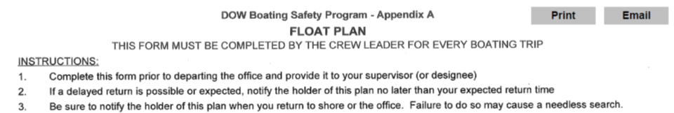

# Crew Info

Crew Leader: Rebecca Gorney……..Crew Members: AJ Smith

Departure Date,Time,Location: 2019-10-02 08:00:00, Central Office

# Trip Information

|  |  |  |  |
| --- | --- | --- | --- |
| Lake | Y_Coordinate | X_Coordinate | Return |
| 1301WAS0302_Washington Park Lake_site A1 | 42.655630000000002 | -73.771766999999997 | 2019-10-02 09:30:00 |
| Lake | Y_Coordinate | X_Coordinate | Return |
| 1301WAS0302_Washington Park Lake_site A2 | 42.655616000000002 | -73.771879999999996 | 2019-10-02 10:30:00 |
| Lake | Y_Coordinate | X_Coordinate | Return |
| 1301WAS0302_Washington Park Lake_site A3 | 42.655659 | -73.771816000000001 | 2019-10-02 11:30:00 |

# Boat and Vehicle Information

|  |  |  |
| --- | --- | --- |
| Boat.Type | Manufacturer | Size.Length.Color |
| canoe | we-no-nah | 16 foot, green |
| Boat.Owner | Vehicle.Description |
| DOW | Dodge Ram Silver (4110) |

# On Board Communication and Safety Equipment (in addition to PDFs)

Cell Phone Numbers: NA

Marine Radio: -, Distress Flag: -, Distress Light: -, Smoke/Dye Signals: -, Flares: -, Horn: -, Signal Mirror: -, Fire Extinguisher(s): -

Comments: Will use Spot 1 when off lake

Float plan holder 1: Karen Woodfield, (518)366-7249

Float plan holder 2: Karen Stainbrook, (518) 428 2252

Hotel Information: none

# *******IF BOATERS ARE OVERDUE, SEE INSTRUCTIONS Below*******

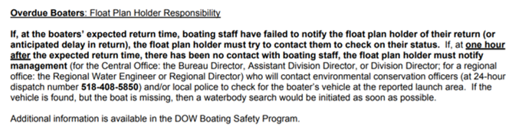

## page break



# Crew Info

Crew Leader: Andrea Conine……..Crew Members: Matt Kraft

Departure Date,Time,Location: 2019-10-02 08:00:00, Central Office

# Trip Information

|  |  |  |  |
| --- | --- | --- | --- |
| Lake | Y_Coordinate | X_Coordinate | Return |
| 1301WAS0302_Washington Park Lake_site B | 42.656689 | -73.772948 | 2019-10-02 09:30:00 |
| Lake | Y_Coordinate | X_Coordinate | Return |
| 1301WAS0302_Washington Park Lake_site C | 42.657865000000001 | -73.773639000000003 | 2019-10-02 10:30:00 |
| Lake | Y_Coordinate | X_Coordinate | Return |
| 1301WAS0302_Washington Park Lake_site D | 42.658805000000001 | -73.774809000000005 | 2019-10-02 11:30:00 |

# Boat and Vehicle Information

|  |  |  |
| --- | --- | --- |
| Boat.Type | Manufacturer | Size.Length.Color |
| canoe | we-no-nah | 15 foot, aluminum |
| Boat.Owner | Vehicle.Description |
| DOW | Dodge Ram Silver (4109) |

# On Board Communication and Safety Equipment (in addition to PDFs)

Cell Phone Numbers: NA

Marine Radio: -, Distress Flag: -, Distress Light: -, Smoke/Dye Signals: -, Flares: -, Horn: -, Signal Mirror: -, Fire Extinguisher(s): -

Comments: Will use Spot 2 when off lake

Float plan holder 1: Karen Woodfield, (518)366-7249

Float plan holder 2: Karen Stainbrook, (518) 428 2252

Hotel Information: none

# *******IF BOATERS ARE OVERDUE, SEE INSTRUCTIONS Below*******

