## page break

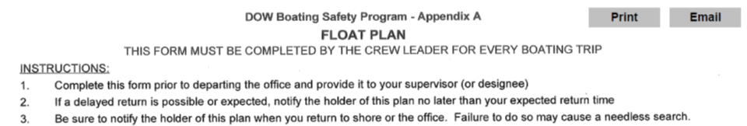

# Crew Info

Crew Leader: Jesse Keltz……..Crew Members: Alene Onion

Departure Date,Time,Location: 2019-09-24 06:00:00, Central Office

# Trip Information

|  |  |  |  |
| --- | --- | --- | --- |
| Lake | Y_Coordinate | X_Coordinate | Return |
| 1003KUS0055_Lake Kushaqua | 44.521039999999999 | -74.113200000000006 | 2019-09-24 13:24:00 |
| Lake | Y_Coordinate | X_Coordinate | Return |
| 1003FRA5095_Franklin Falls Pond | 44.415480000000002 | -73.998310000000004 | 2019-09-24 16:37:00 |

# Boat and Vehicle Information

|  |  |  |
| --- | --- | --- |
| Boat.Type | Manufacturer | Size.Length.Color |
| motor boat | Kishbaugh | 17 foot, white |
| Boat.Owner | Vehicle.Description |
| DOW | Dodge Ram Silver (4110) |

# On Board Communication and Safety Equipment (in addition to PDFs)

Cell Phone Numbers: (914)960-0033

Marine Radio: -, Distress Flag: -, Distress Light: -, Smoke/Dye Signals: -, Flares: X, Horn: X, Signal Mirror: -, Fire Extinguisher(s): X

Comments: Will use Spot 1 when off lake

Float plan holder 1: Karen Woodfield, (518)366-7249

Float plan holder 2: Karen Stainbrook, (518) 428 2252

Hotel Information: hotel - crown paza 101 Olympic Dr, Lake Placid, NY 12946

# *******IF BOATERS ARE OVERDUE, SEE INSTRUCTIONS Below*******

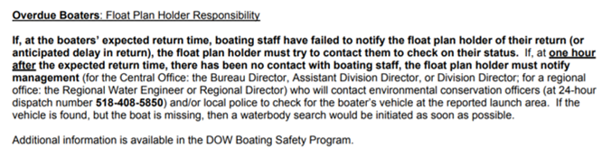

## page break



# Crew Info

Crew Leader: Jesse Keltz……..Crew Members: Alene Onion

Departure Date,Time,Location: 2019-09-25 06:30:00, hotel - crown paza 101 Olympic Dr, Lake Placid, NY 12946

# Trip Information

|  |  |  |  |
| --- | --- | --- | --- |
| Lake | Y_Coordinate | X_Coordinate | Return |
| 1003ROL0168_Rollins Pond | 44.311990000000002 | -74.414869999999993 | 2019-09-25 09:08:00 |
| Lake | Y_Coordinate | X_Coordinate | Return |
| 1003COL0106_Lake Colby | 44.345889999999997 | -74.14819 | 2019-09-25 12:09:00 |
| Lake | Y_Coordinate | X_Coordinate | Return |
| 1003LSA0104_Lower Saranac Lake | 44.314590000000003 | -74.178970000000007 | 2019-09-25 15:13:00 |

# Boat and Vehicle Information

|  |  |  |
| --- | --- | --- |
| Boat.Type | Manufacturer | Size.Length.Color |
| motor boat | Kishbaugh | 17 foot, white |
| Boat.Owner | Vehicle.Description |
| DOW | Dodge Ram Silver (4110) |

# On Board Communication and Safety Equipment (in addition to PDFs)

Cell Phone Numbers: (914)960-0033

Marine Radio: -, Distress Flag: -, Distress Light: -, Smoke/Dye Signals: -, Flares: X, Horn: X, Signal Mirror: -, Fire Extinguisher(s): X

Comments: Will use Spot 1 when off lake

Float plan holder 1: Karen Woodfield, (518)366-7249

Float plan holder 2: Karen Stainbrook, (518) 428 2252

Hotel Information: hotel - crown paza 101 Olympic Dr, Lake Placid, NY 12946

# *******IF BOATERS ARE OVERDUE, SEE INSTRUCTIONS Below*******



## page break



# Crew Info

Crew Leader: Jesse Keltz……..Crew Members: Matt Kraft

Departure Date,Time,Location: 2019-09-26 06:30:00, hotel - crown paza 101 Olympic Dr, Lake Placid, NY 12946

# Trip Information

|  |  |  |  |
| --- | --- | --- | --- |
| Lake | Y_Coordinate | X_Coordinate | Return |
| 1003ROL0168_Rollins Pond bathymetry | NA | NA | 2019-09-26 13:08:00 |

# Boat and Vehicle Information

|  |  |  |
| --- | --- | --- |
| Boat.Type | Manufacturer | Size.Length.Color |
| motor boat | Kishbaugh | 17 foot, white |
| Boat.Owner | Vehicle.Description |
| DOW | Dodge Ram Silver (4110) |

# On Board Communication and Safety Equipment (in addition to PDFs)

Cell Phone Numbers: (914)960-0033

Marine Radio: -, Distress Flag: -, Distress Light: -, Smoke/Dye Signals: -, Flares: X, Horn: X, Signal Mirror: -, Fire Extinguisher(s): X

Comments: Will use Spot 1 when off lake

Float plan holder 1: Karen Woodfield, (518)366-7249

Float plan holder 2: Karen Stainbrook, (518) 428 2252

Hotel Information: none

# *******IF BOATERS ARE OVERDUE, SEE INSTRUCTIONS Below*******



## page break



# Crew Info

Crew Leader: Matt Kraft……..Crew Members: Charlie Stoll

Departure Date,Time,Location: 2019-09-24 06:00:00, Central Office

# Trip Information

|  |  |  |  |
| --- | --- | --- | --- |
| Lake | Y_Coordinate | X_Coordinate | Return |
| 0902BAR0262_Barnum Pond | 44.46058 | -74.257760000000005 | 2019-09-24 10:48:00 |
| Lake | Y_Coordinate | X_Coordinate | Return |
| 1003CLE0199_Lake Clear | 44.369199999999999 | -74.252300000000005 | 2019-09-24 13:00:00 |
| Lake | Y_Coordinate | X_Coordinate | Return |
| 1003MOO0083_Moose Pond | 44.375329999999998 | -74.061310000000006 | 2019-09-24 15:23:00 |

# Boat and Vehicle Information

|  |  |  |
| --- | --- | --- |
| Boat.Type | Manufacturer | Size.Length.Color |
| canoe | we-no-nah | 15 foot, aluminum |
| Boat.Owner | Vehicle.Description |
| DOW | Dodge Ram Silver (4109) |

# On Board Communication and Safety Equipment (in addition to PDFs)

Cell Phone Numbers: (716)997-2645

Marine Radio: -, Distress Flag: -, Distress Light: -, Smoke/Dye Signals: -, Flares: -, Horn: -, Signal Mirror: -, Fire Extinguisher(s): -

Comments: Will use Spot 2 when off lake

Float plan holder 1: Karen Woodfield, (518)366-7249

Float plan holder 2: Karen Stainbrook, (518) 428 2252

Hotel Information: hotel - crown paza 101 Olympic Dr, Lake Placid, NY 12946

# *******IF BOATERS ARE OVERDUE, SEE INSTRUCTIONS Below*******



## page break



# Crew Info

Crew Leader: Matt Kraft……..Crew Members: Charlie Stoll

Departure Date,Time,Location: 2019-09-25 06:30:00, hotel - crown paza 101 Olympic Dr, Lake Placid, NY 12946

# Trip Information

|  |  |  |  |
| --- | --- | --- | --- |
| Lake | Y_Coordinate | X_Coordinate | Return |
| 1004LCA0270_Lower Cascade Lake | 44.227424999999997 | -73.872573000000003 | 2019-09-25 08:51:00 |
| Lake | Y_Coordinate | X_Coordinate | Return |
| 1004UCA0271_Upper Cascade Lake | 44.223816999999997 | -73.879097000000002 | 2019-09-25 11:21:00 |
| Lake | Y_Coordinate | X_Coordinate | Return |
| 1005BAR0338_Bartlett Pond | 44.105600000000003 | -73.511780000000002 | 2019-09-25 14:32:00 |

# Boat and Vehicle Information

|  |  |  |
| --- | --- | --- |
| Boat.Type | Manufacturer | Size.Length.Color |
| canoe | we-no-nah | 15 foot, aluminum |
| Boat.Owner | Vehicle.Description |
| DOW | Dodge Ram Silver (4109) |

# On Board Communication and Safety Equipment (in addition to PDFs)

Cell Phone Numbers: (716)997-2645

Marine Radio: -, Distress Flag: -, Distress Light: -, Smoke/Dye Signals: -, Flares: -, Horn: -, Signal Mirror: -, Fire Extinguisher(s): -

Comments: Will use Spot 2 when off lake

Float plan holder 1: Karen Woodfield, (518)366-7249

Float plan holder 2: Karen Stainbrook, (518) 428 2252

Hotel Information: none

# *******IF BOATERS ARE OVERDUE, SEE INSTRUCTIONS Below*******

