## page break

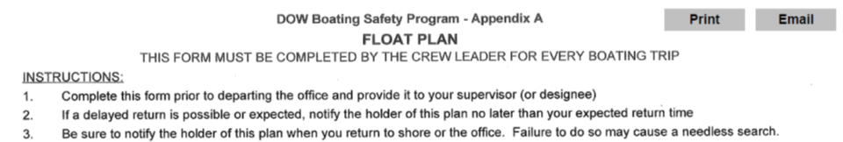

# Crew Info

Crew Leader: Alene Onion……..Crew Members: Jeff Lojpsberger, Keleigh Reynolds

Departure Date,Time,Location: 2019-10-02 06:30:00, Holiday Inn Express - 5860 Carmenica Dr, Cicero, NY 13039

# Trip Information

|  |  |  |  |
| --- | --- | --- | --- |
| Lake | Y_Coordinate | X_Coordinate | Return |
| 0703ONE0026_Oneida Lake Three Mile Bay | 43.221110000000003 | -76.044439999999994 | 2019-10-02 08:40:00 |
| Lake | Y_Coordinate | X_Coordinate | Return |
| 0703ONE0026_Oneida Lake Shackelton Point | 43.18083 | -75.926389999999998 | 2019-10-02 11:03:00 |
| Lake | Y_Coordinate | X_Coordinate | Return |
| Canaseraga Creek_ | NA | NA | 2019-10-02 12:03:00 |
| Lake | Y_Coordinate | X_Coordinate | Return |
| 0703ONE0026_Oneida Lake Buoy 109 | 43.186109999999999 | -75.770830000000004 | 2019-10-02 14:17:00 |

# Boat and Vehicle Information

|  |  |  |
| --- | --- | --- |
| Boat.Type | Manufacturer | Size.Length.Color |
| motor boat | Triumph | 20 foot, white |
| Boat.Owner | Vehicle.Description |
| DOW | Blue Steel |

# On Board Communication and Safety Equipment (in addition to PDFs)

Cell Phone Numbers: (314)910-2334

Marine Radio: -, Distress Flag: -, Distress Light: -, Smoke/Dye Signals: -, Flares: X, Horn: X, Signal Mirror: -, Fire Extinguisher(s): X

Comments: Will text when off the water

Float plan holder 1: Karen Woodfield, (518)366-7249

Float plan holder 2: Karen Stainbrook, (518) 428 2252

Hotel Information: none

# *******IF BOATERS ARE OVERDUE, SEE INSTRUCTIONS Below*******

