TEAM 2 TRADING
EMA Strategy v5.13
Complete User Guide — QQQ Automated Signal Engine
No programming knowledge required

11  Entry Patterns | 2  Daily Trade Cap | 2-Min  Chart Timeframe | QQQ  Asset

Institutional EMA methodology · Automated signal generation · Webhook-ready JSON alerts

01 What This Strategy Does
An automated signal engine for QQQ built on proven EMA methodology

This is an automated signal engine for QQQ (Invesco QQQ Trust) built on the Team2Trading EMA playbook. It continuously monitors a 2-minute chart and fires a precise buy or short-sell signal the moment a high-probability setup forms — then manages the trade automatically.
Half the position is trimmed at a defined first target to lock in profit. The remaining 'runner' is trailed using the EMA13 dynamic exit or held to a second fixed target. A hard stop loss is always active from entry.
KEY PRINCIPLE
You do not need to watch the chart. When a signal fires, TradingView sends a
JSON alert directly to your webhook or broker automation — fully hands-free.

02 How a Trade Gets Taken
All five gates must open simultaneously — if any is closed, no trade fires

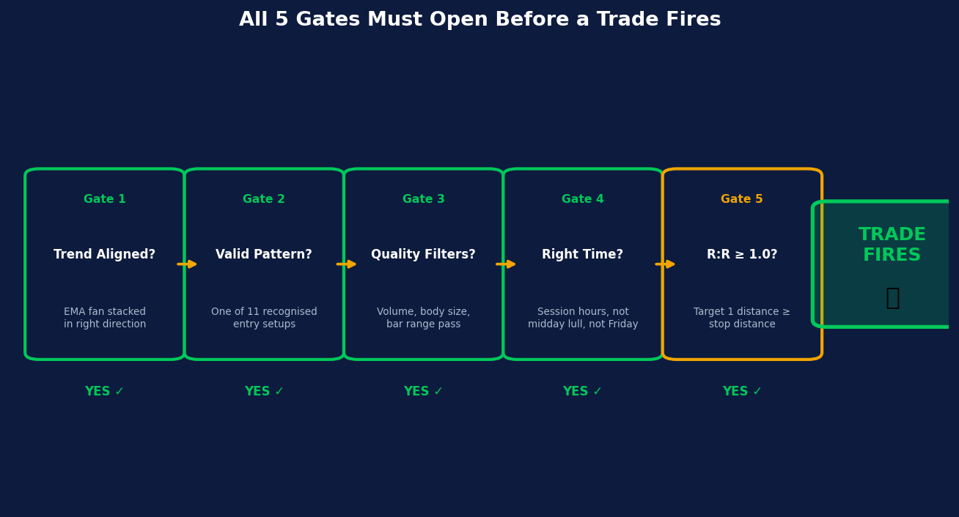
Figure 1 — All five decision gates must pass before a trade signal fires
Gate | Question | What It Checks
Gate 1 | Trend Aligned? | EMA 13 > 48 > 200 (bull) or 13 < 48 < 200 (bear)
Gate 2 | Valid Pattern? | One of 11 recognised entry setups (pullback, breakout, flag…)
Gate 3 | Quality Filters? | Volume, bar range, and candle body strength all pass
Gate 4 | Right Time? | Within session hours — not midday lull, not Friday
Gate 5 | R:R ≥ minimum? | Target 1 distance ≥ stop distance (default 1:1 minimum)

03 Key Concepts Explained
The building blocks — understand these and everything else follows

The EMA Fan — Your Trend Compass
Three Exponential Moving Averages (EMAs) define the market regime. When they stack in order — Fast above Medium above Slow — the market is in a healthy uptrend and long entries are allowed. When reversed, shorts are permitted.
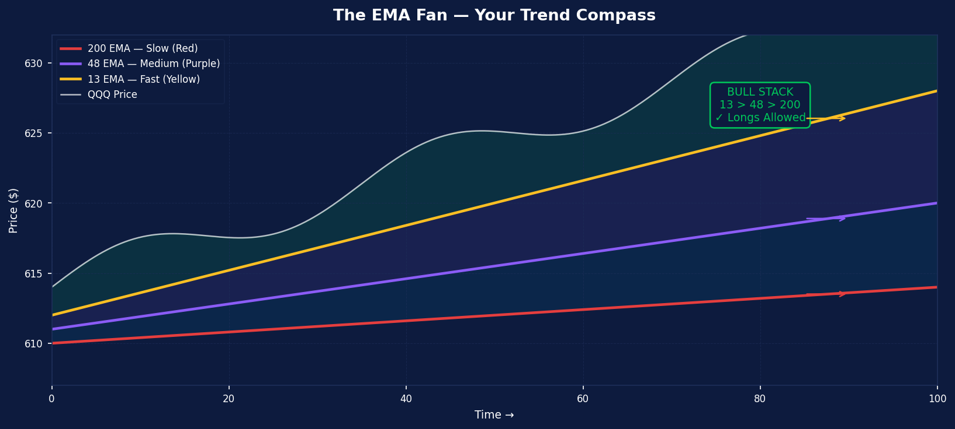
Figure 2 — EMA Fan showing Bull Stack alignment. Green background = longs allowed.
EMA | Colour on Chart | Role
Fast EMA (13) | Yellow line | Short-term momentum. Price bounces off or gets rejected by this line.
Medium EMA (48) | Purple line | Intermediate trend filter. Used as a rejection level for shorts.
Slow EMA (200) | Red line | Big-picture market regime. Must be rising for longs to fire.

Key Price Levels
Four horizontal lines are plotted automatically every day. These are widely watched by institutional traders and act as natural support and resistance zones.
Level | Example Value | Significance
PDH — Prior Day High | $626.74 (example) | A close above = buyers are in control
PDL — Prior Day Low | $608.11 (example) | A close below = sellers are in control
PMH — Pre-Market High | $621.70 (example) | Highest price from 4:00 AM – 9:29 AM ET
PML — Pre-Market Low | $618.45 (example) | Lowest price from 4:00 AM – 9:29 AM ET

ATR — The Volatility Ruler
Average True Range (ATR) measures how much QQQ moves per 2-minute bar on average. The strategy uses ATR to dynamically size stops and targets so they automatically adjust when the market is quiet or volatile. Think of it as a yardstick that stretches or shrinks with the market.

04 All Input Settings — Plain English
A complete reference for every configurable parameter

EMA Settings
Setting | Default | What It Does
Fast EMA | 13 | Period for the yellow EMA. Controls the speed of the short-term trend line. Do not change unless you understand EMA crossover systems.
Medium EMA | 48 | Period for the purple EMA. Used for trend bias and as a rejection level for shorts.
Slow EMA | 200 | Period for the red EMA. Defines the big-picture market regime.

Entry Settings
Setting | Default | What It Does
EMA Pullback Proximity (%) | 0.5% | How close price must get to EMA13 to count as a 'touch'. Lower = tighter touch required.
EMA Pullback Entry (Long) | ON | Buy when price pulls back to EMA13 in a bull stack and bounces.
PDH Breakout Entry (Long) | ON | Buy when price closes above yesterday's high for the first time today.
PMH Breakout Entry (Long) | ON | Buy when price closes above the pre-market session high.
Flag Break Entry (Long/Short) | ON | Enter on a tight consolidation breakout or breakdown.
Break & Retest (Long/Short) | ON | Enter on a pullback that retests a recently broken level.
PDL Breakdown Entry (Short) | ON | Short when price closes below yesterday's low.
EMA13 Rejection (Short) | ON | Short when price is rejected by EMA13 from below.
EMA48 Rejection (Short) | ON | Short when price is rejected by EMA48 from below.
Gap-Down Open Short | ON | Short at session open if QQQ gaps below PDL by > 0.5× ATR.

Risk Management
Setting | Default | What It Does
Stop Loss (ATR x) | 1.0× | Stop placed this many ATR units from entry. At ATR $0.63, stop = $0.63 below entry.
Target 1 (ATR x) | 2.0× | First profit target for EMA entries. Half position closes here.
Target 2 (ATR x) | 3.5× | Second profit target. Runner exits here unless EMA dynamic exit fires first.
Trim % at Target 1 | 50% | Percentage of position closed at Target 1. Remaining is the 'runner'.
EMA13 Dynamic Exit | ON | After T1, if runner crosses EMA13 in the wrong direction → exit immediately.
Min Stop Floor % (EMA) | 0.30% | Stop can never be less than 0.30% of price for EMA entries. Prevents absurdly tight stops.
Min Stop Floor % (Breakout) | 0.20% | Same floor for PDH/PDL breakout entries. Slightly looser.
Min Reward/Risk to T1 | 1.0× | Trade only fires if T1 distance ≥ stop distance. Raise to 1.5× or 2.0× for better setups only.
Max Consecutive Losses | 3 | After 3 losses in a row, stop trading for the rest of the day.

Fibonacci TP (Structural Entries)
Setting | Default | What It Does
Use Fib for Breakout TPs | ON | PDH/PMH breakout longs and PDL/Gap-Down shorts use Fib extension levels instead of ATR.
Fib T1 Level | 0.786 | First target: 78.6% of the pre-market range projected above PMH. Institutional level.
Fib T2 Level | 1.0 | Second target: 100% extension — full measured move.
Trailing Stop for T2 | ON | Once Fib T1 is hit, the runner trails price by 1× ATR offset instead of a fixed T2.

Filters
Setting | Default | What It Does
Min Volume (x 20-MA) | 1.5× | EMA entries require 1.5× average volume. Strong participation needed.
Min Volume for PMH Break | 1.0× | PMH reclaims often happen on quieter volume — softer threshold.
Max Entries Per Day | 2 | After 2 trades, no more signals for the rest of the day.
Min Candle Body % | 50% | Body must be ≥ 50% of range. Filters doji/spinning tops.
Min Bar Size % — EMA | 0.05% | EMA signal bar must be at least 0.05% of price wide (~$0.31 on $620).
Min Bar Size % — Structural | 0.03% | Breakout bars need only 0.03% (~$0.19). They compress at key levels.
Require Full Bear Stack | ON | Shorts require EMA13 < EMA48 < EMA200 (all falling).

Trading Window
Setting | Default | What It Does
Enable Session Filter | ON | Only signals during 9:30 AM – 3:30 PM ET regular session.
EOD No-Entry Window | 60 min | No new entries after 2:30 PM ET. Force-close at 3:30 PM ET.
EMA Rejection Blackout | 60 min | EMA rejection shorts blocked in first 60 min (before 10:30 AM).
Long Entry Wait | 10 min | All longs wait 10 minutes after the open.
Block Friday Entries | ON | No trades on Fridays. Backtest showed 0% win rate from 11 Friday entries.
Restrict Midday Trades | ON | Most longs blocked 11:00 AM – 1:15 PM unless strong trend + structural context.

05 Entry Types — When the Script Buys or Shorts
11 distinct patterns across long and short directions

LONG Entries (Buys)

1. EMA13 Pullback
In a bull trend, price pulls back to the 13 EMA on a red candle, then the next bar bounces green and closes back above EMA13. The EMA acts as a springboard.
Requirements: Full bull stack · Prior bar red & touched EMA13 · Current bar green · Close > EMA13 · Volume > 1.5× average · Body > 50%

2. PDH Breakout
The first bar of the day to close above yesterday's high. Signals that buyers have decisively broken through a major resistance level.
Requirements: EMA13 > EMA48 (intraday momentum) · Close > PDH, prior close ≤ PDH · Green bar, body > 50% · Volume > average

3. PMH Breakout
The first regular-session bar to close above the pre-market high. A powerful recovery setup — reclaiming PMH after a gap-down often marks the start of a strong intraday reversal.
Requirements: EMA13 rising · Close > PMH, prior close ≤ PMH · Green bar · Volume > 1.0× average (softer — recovery days are calmer)

4. Flag Break
Price consolidates tightly for 5 bars (a flag) then breaks out above the top of that range. The consolidation shows sellers have given up.
Requirements: Full bull stack · Flag range < 1.5× ATR · Closes above 5-bar high · Green bar, body > 50% · Volume > 1.5× average

5. Break & Retest
After PDH or PMH breaks, price pulls back to retest that level from above within 30 bars — a second-chance entry at the broken resistance (now acting as support).
Requirements: Full bull stack · Level broke 1–30 bars ago · Low touches level (within 0.5 ATR) · Green close above level · Volume > 1.0× average

SHORT Entries (Sells)

6. EMA13 Rejection
During a downtrend, price rallies up to touch EMA13 from below (green bar), then is rejected back down with a red bar closing below EMA13. The EMA acts as a ceiling.
Requirements: Full bear stack · Prior green bar touched EMA13 · Red bar below EMA13 · EMA13 falling · Volume > 1.5× average · Not in first 60 min

7. EMA48 Rejection
Same concept but price bounces all the way up to EMA48 — a deeper retracement showing a stronger resistance level is holding.
Requirements: Full bear stack · Prior green bar touched EMA48 · Red bar below EMA48 · EMA48 falling · Not in first 60 min

8. PDL Breakdown
The first bar to close below yesterday's low — a bearish structural break that attracts momentum sellers and stops out longs.
Requirements: Bear stack · Close < PDL, prior close ≥ PDL · Red bar · Volume > average

9. Flag Break (Short)
5-bar tight consolidation followed by a breakdown below the flag low. The failure to push higher tells sellers to take over.
Requirements: Bear stack · Flag range < 1.5× ATR · Closes below 5-bar low · Red bar, body > 50%

10. Break & Retest (Short)
After PDL or PML breaks, price bounces back up to retest the level from below — a short at the broken support now acting as resistance.
Requirements: Bear stack · Level broke 1–30 bars ago · High touches level · Red close below level · Volume > 1.0× average

11. Gap-Down Open Short
QQQ opens below PDL by more than 0.5× ATR on a macro shock. No EMA alignment required — the gap itself is the directional signal.
Requirements: Session first bar · Open < PDL − (0.5 × ATR) · Red bar · Not Friday

06 Sample Trade Scenarios
Five real-world examples with annotated chart diagrams

Scenario A — EMA13 Pullback (Long)
QQQ is in a clear bull stack (EMA13 > EMA48 > EMA200, all rising). Price pulls back from $622 and touches the yellow EMA13 on a red candle at 9:48 AM. The very next 2-minute bar opens at $619.90, bounces strongly green, and closes above EMA13. The signal fires.
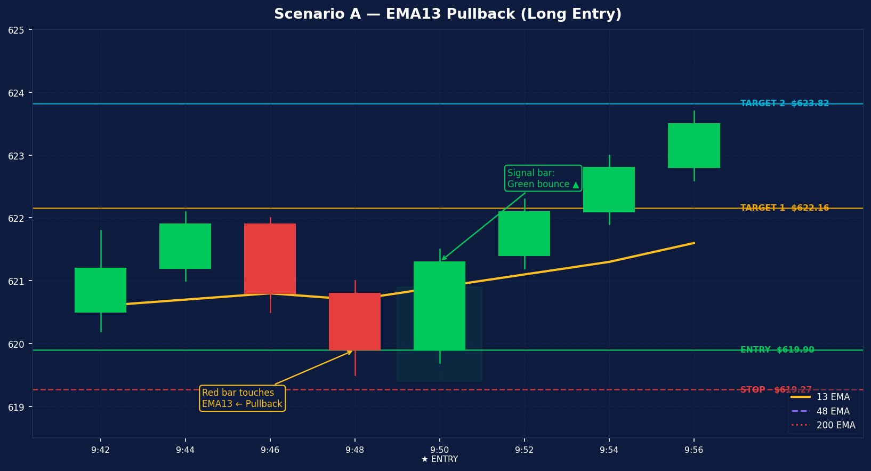
Figure 3 — EMA13 Pullback. Red touch bar followed by green bounce entry. ATR-based stops and targets calculated automatically.
TRADE MATH (ATR = $0.63)
Entry: $619.90 (next bar open after signal)
Stop: $619.27 (entry − 1.0 × ATR)
Target 1: $621.16 (entry + 2.0 × ATR) → close 50%
Target 2: $622.11 (entry + 3.5 × ATR) → trail via EMA13 exit
R:R to T1: 2.0:1

Scenario B — PDH Breakout (Long) with Fibonacci Targets
QQQ has been climbing all morning. At 10:39 AM a strong green bar closes decisively above PDH ($626.74). The pre-market range (PMH $621.70 − PML $618.45 = $3.25) is measured and projected above PMH for Fibonacci targets. The trailing stop activates automatically when price reaches Fib T1.
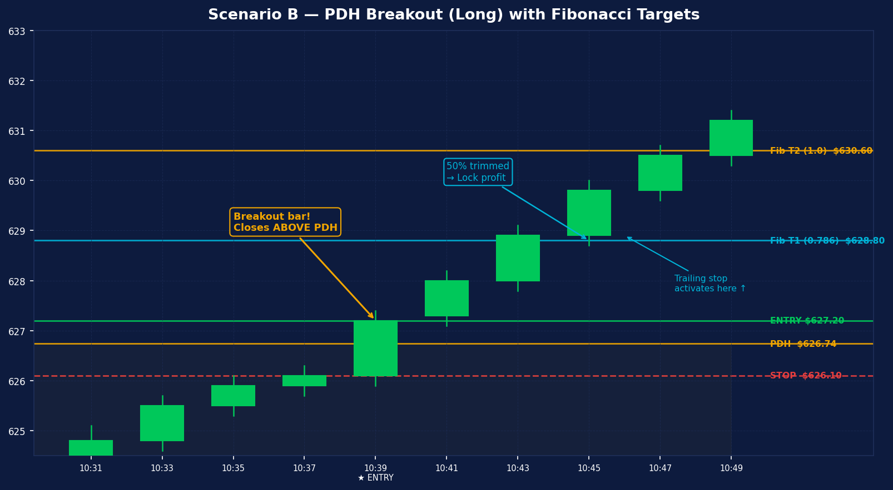
Figure 4 — PDH Breakout. Fibonacci extension targets replace ATR levels. Trailing stop activates at Fib T1 and follows the runner higher.
TRADE MATH (PM Range = $3.25)
Entry: $626.80 (next bar open above PDH)
Stop: $626.17 (entry − 1.0 × ATR $0.63)
Fib T1: $628.26 (PMH + 0.786 × $3.25) → close 50%
Fib T2: $629.20+ (runner trails 1× ATR below price from T1)
On strong trend days the runner can capture 2–3× the PM range

Scenario C — EMA13 Rejection (Short)
QQQ is in a downtrend (full bear stack). Price bounces up to test EMA13 at $614.50 on a green candle. The next bar opens, fails to push through the EMA, and closes red below EMA13. The rejection signal fires.
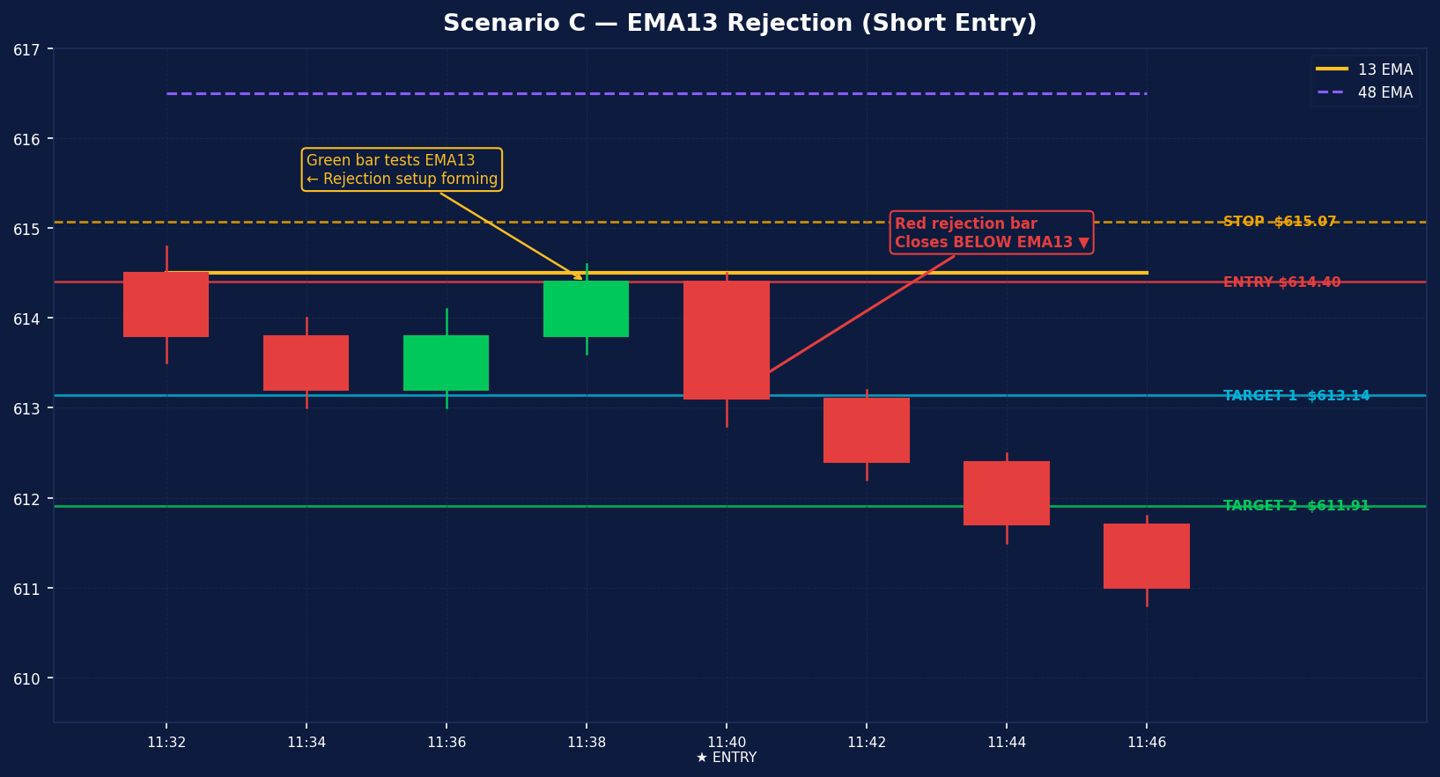
Figure 5 — EMA13 Rejection Short. Green bar tests EMA13 from below, followed by red rejection bar. Short fired at next open.
TRADE MATH (ATR = $0.63)
Entry: $614.40 (next bar open after rejection)
Stop: $615.03 (entry + 1.0 × ATR)
Target 1: $613.14 (entry − 2.0 × ATR) → close 50%
Target 2: $611.99 (entry − 3.5 × ATR) → trail via EMA13 exit
Note: EMA rejection shorts BLOCKED in first 60 min after open

Scenario D — Flag Break (Long)
After a strong opening move (the 'pole'), QQQ consolidates tightly for 5 bars between $620.30 and $621.00 — a range of only $0.70 vs ATR of $0.63 × 1.5 = $0.95. The flag is tight enough. At 10:36 AM a green bar closes above the flag high. Entry fires.
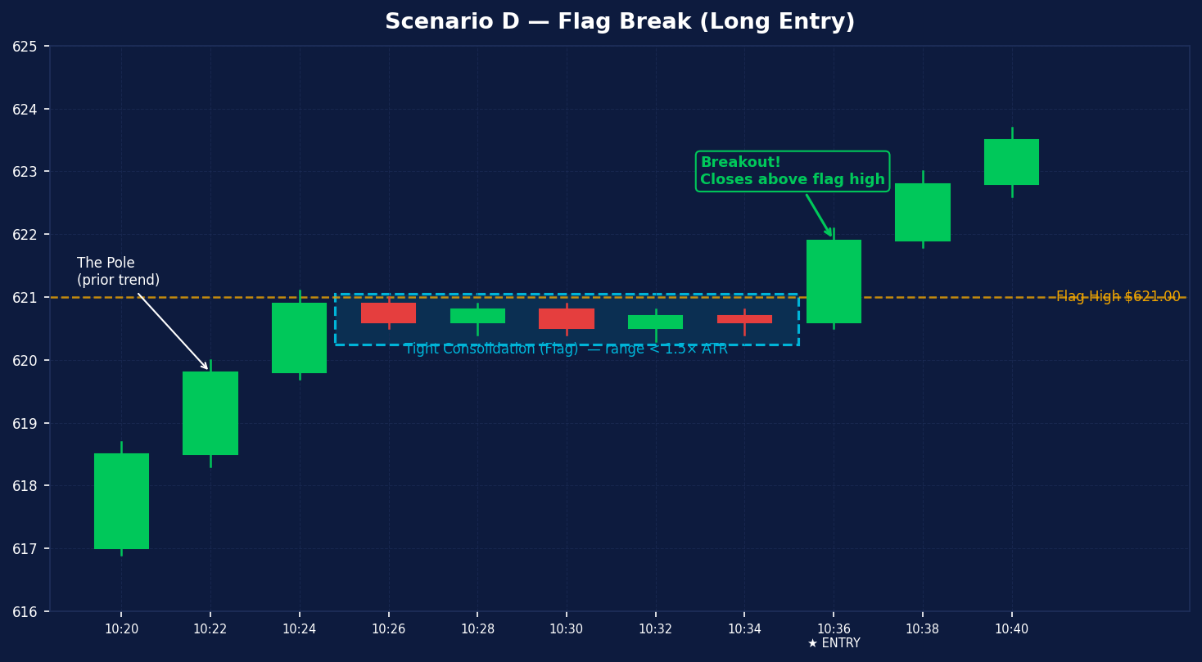
Figure 6 — Flag Break (Long). Tight 5-bar consolidation followed by breakout above the flag high on strong volume.

Scenario E — Gap-Down Open Short
Macro shock overnight. QQQ opens at $605.00, more than $1.00 below PDL ($608.11). The gap is 1.6× ATR — well above the 0.5× minimum. The opening bar is red with a strong body. The gap-down short fires immediately on the first bar. No EMA alignment required.
TRADE MATH (PD Range = $18.63, ATR = $0.63)
Entry: $605.00 (session open price)
Stop: $605.63 (entry + 1.0 × ATR)
Fib T1: PDL − (PD Range × 0.786) → close 50%
Fib T2: PDL − (PD Range × 1.0) → runner trails
This setup requires no EMA crossover — the gap IS the signal

07 How Trades Are Managed After Entry
Position trimming, dynamic exits, and end-of-day force-close

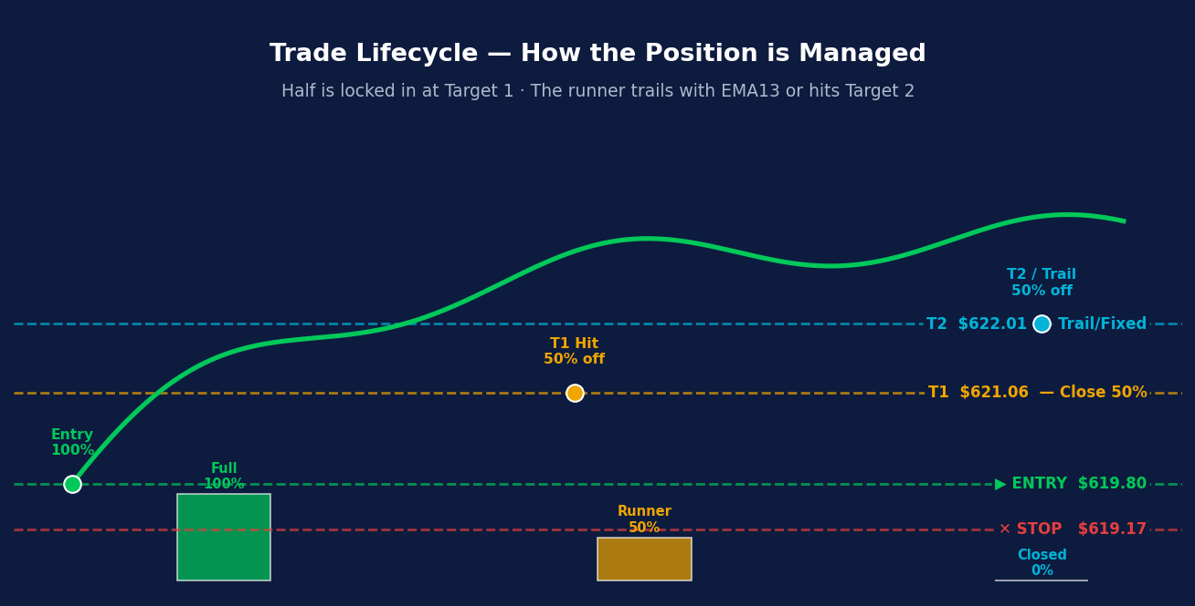
Figure 7 — Trade lifecycle. 50% trimmed at T1, runner held via trailing EMA exit or fixed T2. Force-close at 3:30 PM ET.

Exit Priority Order
The strategy checks exits in this order every bar:
Priority | Exit Type | Description
1 — Highest | Stop Loss | Always active. Closes 100% of remaining position immediately.
2 | Target 1 | Fixed level (ATR or Fib). Closes 50%. Locks in partial profit.
3 | EMA13 Dynamic Exit | Runner crosses EMA13 wrong way → exit immediately. Protects profits.
4 | Thesis Break | EMA13 crosses EMA48 (trend reversal). Exit all. Premise is gone.
5 | Target 2 / Trail | Final exit for the runner — fixed T2 or trailing stop.
6 — Lowest | EOD Force-Close | 3:30 PM ET: all positions closed. No overnight holds, ever.

08 The Trading Window
Time-based gates that protect against historically poor trading periods

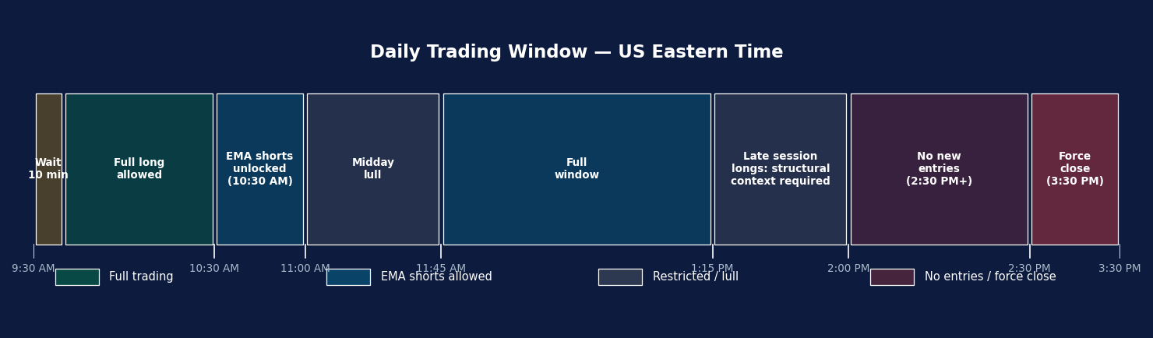
Figure 8 — Daily trading window. Coloured segments show when each entry type is active throughout the US session.
Time (ET) | What Happens
9:30 AM | Session opens. First 10 min: no long entries (wait for direction).
9:30–10:30 AM | EMA rejection shorts blocked (high volatility, poor win rate in backtest).
10:30 AM | All entry types active. Full session underway.
11:00 AM–1:15 PM | Midday lull. Most longs blocked unless strong trend + above PDH/PMH.
1:15 PM | Full entry window resumes.
2:00 PM+ | Late longs: must be above a structural level (PDH or PMH).
2:30 PM | No new entries for any setup. Existing positions manage normally.
3:30 PM | Session close — all positions force-closed regardless of P&L.
Friday | ALL entries blocked (0% backtest win rate from 11 Friday entries).

09 Troubleshooting — Why Didn't a Trade Fire?
Use this checklist when a setup looks right but no signal appeared

Blocker | How to Spot It | What to Do
EMA stack not aligned | Info table shows NEUTRAL or wrong direction | Wait for trend confirmation
Price inside PM Range | Between PML and PMH (no-trade zone) | Wait for price to break PMH or PML
Volume too low | Bar volume < 1.5× 20-bar average | EMA entries need strong volume. Wait for conviction bar.
Bar too small | Range < 0.05% (EMA) or 0.03% (structural) | Signal bar was a micro-move. Next bigger bar will fire.
Doji / spinning top | Body < 50% of range | The bar showed indecision. Wait for decisive close.
EMA rejection blackout | Short before 10:30 AM ET | EMA rejection shorts only after 10:30 AM.
Midday lull | 11:00 AM – 1:15 PM ET | Longs blocked unless price is above PDH or PMH.
Late session block | After 2:30 PM ET | No new entries. Hold existing positions only.
Friday filter | Day is Friday | All entries blocked on Fridays.
Daily trade cap hit | Already 2 trades today | Increase Max Entries Per Day in settings if desired.
Circuit breaker | 3 consecutive losses today | Strategy paused for rest of day to protect capital.
Poor reward:risk | T1 < 1.0× stop distance | Price is too far from the level. Trade geometry fails.
EMA warmup | Info table shows WARMING… | Strategy needs 220+ bars of history. Wait for READY ✓.

10 Setting Up Alerts & Webhook Integration
Connect the strategy to your broker automation — step by step

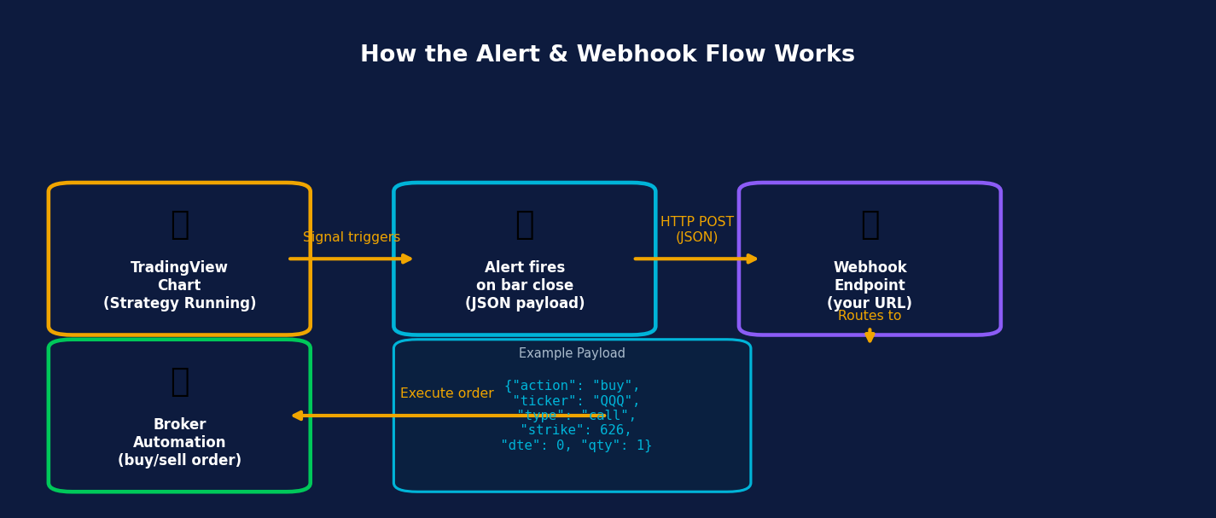
Figure 9 — Alert flow from TradingView chart → JSON payload → webhook → broker.
The strategy sends JSON messages automatically on every trade event. One TradingView alert rule captures all three event types — you do not need a separate alert for entries and exits.

The Three JSON Payloads
Event | JSON Payload
Long entry (buy call) | {"action":"buy","ticker":"QQQ","type":"call","strike":626,"dte":0,"qty":1}
Short entry (buy put) | {"action":"buy","ticker":"QQQ","type":"put","strike":612,"dte":0,"qty":1}
Any exit (T1/T2/stop/EOD) | {"action":"sell","ticker":"QQQ"}

The strike price is automatically set to the rounded close price at signal time. dte: 0 means 0-day-to-expiry (0DTE) options. The sell payload covers T1 trim, T2/trail exit, stop loss, EMA dynamic exit, thesis break, and EOD force-close.

Step-by-Step Alert Setup in TradingView

Step 1 — Open the Alert Dialog
Click the alarm clock icon in the top toolbar (or press Alt+A / Option+A on Mac). Click "+ Add Alert".

Step 2 — Set the Condition
Line 1: Select "Team2Trading EMA Strategy v5.13"
Line 2: Select "Any alert() function call"
→ This single selection captures ALL trade events (entries + exits) in one rule.

Step 3 — Set Trigger Frequency
Under Options / Trigger, select: "Once Per Bar Close"
→ Ensures the alert only fires when a 2-minute bar officially closes, matching the strategy's bar-close evaluation logic.

Step 4 — Enter Your Webhook URL
Enable "Webhook URL" in the Notifications section.
Paste your endpoint URL:
https://your-broker-or-automation.com/webhook/tradingview
→ Works with Alpaca, IBKR bridges, Make, n8n, Zapier, or your own server.

Step 5 — Set the Message Field
In the Message box, enter exactly:
{{strategy.order.alert_message}}
→ This TradingView placeholder inserts whichever JSON payload the script defined for the event that just fired. Do not add any other text.

Step 6 — Name and Save
Alert Name: Team2Trading QQQ Strategy
Expiration: Open-ended (no expiry)
Click "Create".

Important Notes
- TradingView must be open or running as a web app for alerts to fire. Premium plan enables server-side alerts (no browser needed).
- 2-minute timeframe only The strategy is calibrated for 2-min bars. Changing the timeframe breaks signal logic.
- One alert rule is enough {{strategy.order.alert_message}} forwards whichever JSON the script sends. All scenarios are covered.
- Paper trade first Run in TradingView Paper Trading mode for at least 2 weeks before connecting live capital.

REF Quick Reference Card
Tear-out summary — print and keep at your desk

TREND CHECK (top-right table on chart)
BULL STACK ▲ → Longs allowed
BEAR STACK ▼ → Shorts allowed
INTRADAY ▼ → Weak shorts only (EMA / flag)
NEUTRAL ─ → No trades
DAILY LIMITS
Max trades per day: 2
Circuit breaker: 3 consecutive losses → stop for day
TRADING HOURS (ET)
Open: 9:30 AM (10-min wait for longs)
EMA shorts start: 10:30 AM
Midday lull: 11:00 AM – 1:15 PM (longs restricted)
Last entry: 2:30 PM
Force-close: 3:30 PM
Fridays: NO TRADES
EXIT RULES
T1: 50% off at fixed level (ATR or Fib extension)
Runner: trails via EMA13 cross or fixed T2
Stop: always active from bar of entry
EOD: force-close at session end — no overnight holds
ALERT MESSAGE FIELD
{{strategy.order.alert_message}}

Team2Trading EMA Strategy v5.13 · QQQ Automated Signal Engine · Guide v1.0 · 2-minute chart

