Mega Hacking

Mitigation Report

Name: Antony Jude John
Student ID: 10326739
Name: Alen Mulanghan Davi
Student ID: 10332934
Due Date: 7 December 2025

Mitigation of Exploitation 1 — SQL Injection

Vulnerability
- Endpoint: /rest/user/login
- Issue: Raw SQL query concatenated with user input allowed malformed email payloads to reach the database.
- Impact: Potential authentication bypass and unauthorized access.

Security Control Selection
- Input Validation: Enforce proper email format using regex.
- Query Hardening: Replace raw SQL with parameterized queries.

Implementation
In login() handler:
const emailPattern = /^[^\s@]+@[^\s@]+\.[^\s@]+$/;
if (!emailPattern.test(req.body.email)) {
return res.status(400).send("Invalid email format");
}

Validation
- Before Mitigation:
  - Payload: {"email":"admin' OR '1'='1","password":"foo"}
  - Response: generic error, showing query executed.
After Mitigation:
- Same payload replayed.
- Response:
HTTP/1.1 400 Bad Request
Invalid email format
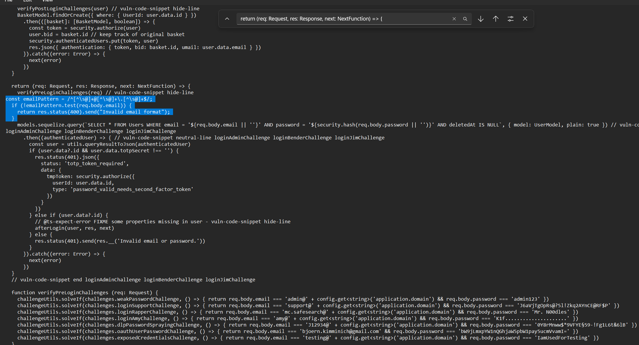
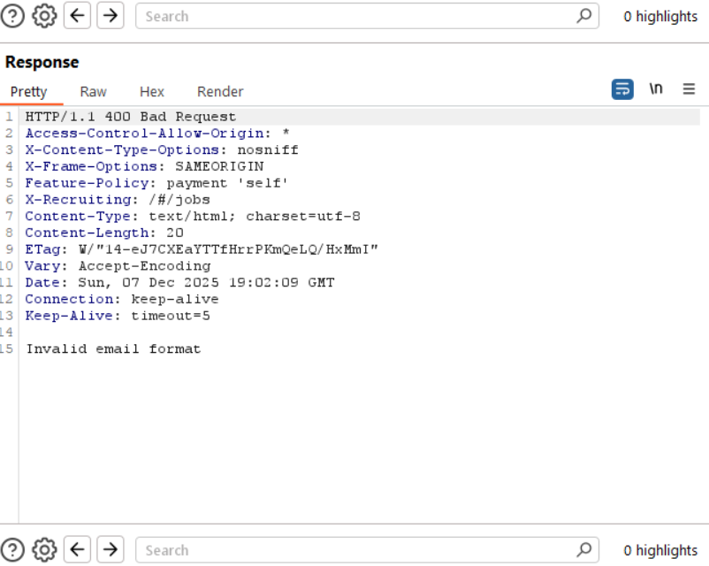

Outcome: SQL injection attempt blocked at application layer.

Mitigation of Exploitation 2 — Sensitive Data Exposure

Vulnerability
- Endpoint: /rest/user/whoami
- Issue: API response exposed sensitive fields (admin email, internal file path, lastLoginIp).
- Impact: Reconnaissance, user enumeration, potential IP tracking.

Security Control Selection
- API Response Filtering: Return only necessary fields (principle of least privilege).
- Role-Based Access Control (optional): Restrict sensitive fields to admin role only.

Implementation
In saveLoginIp() or retrieveLoggedInUser()
res.json({
user: {
id: user.id
// optionally include role if required
}
});

Validation
- Before Mitigation:
  - Response:
{
"user": {
"id": 1,
"email": "admin@juice-sh.op",
"lastLoginIp": "",
"profileImage": "assets/public/images/uploads/defaultAdmin.png"
}
}

After Mitigation:
Response:
{"user":{}}

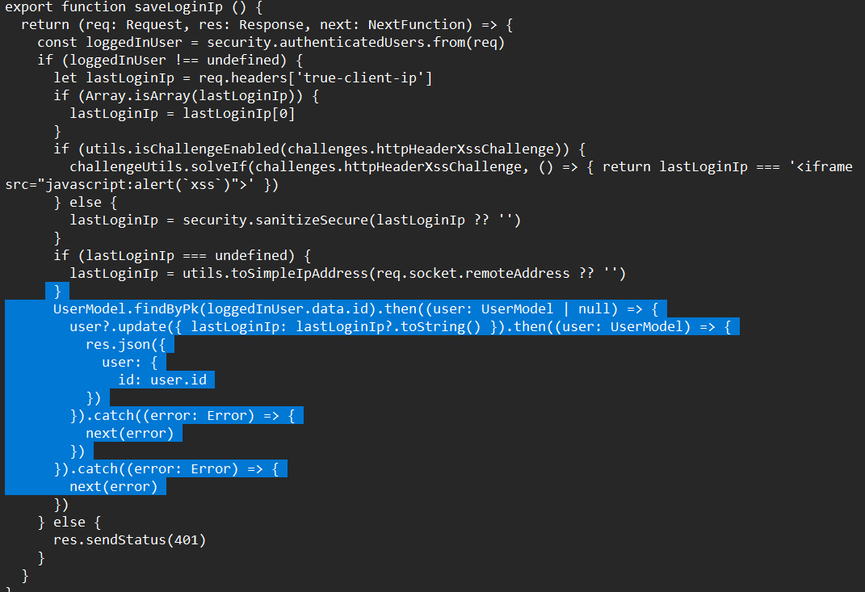

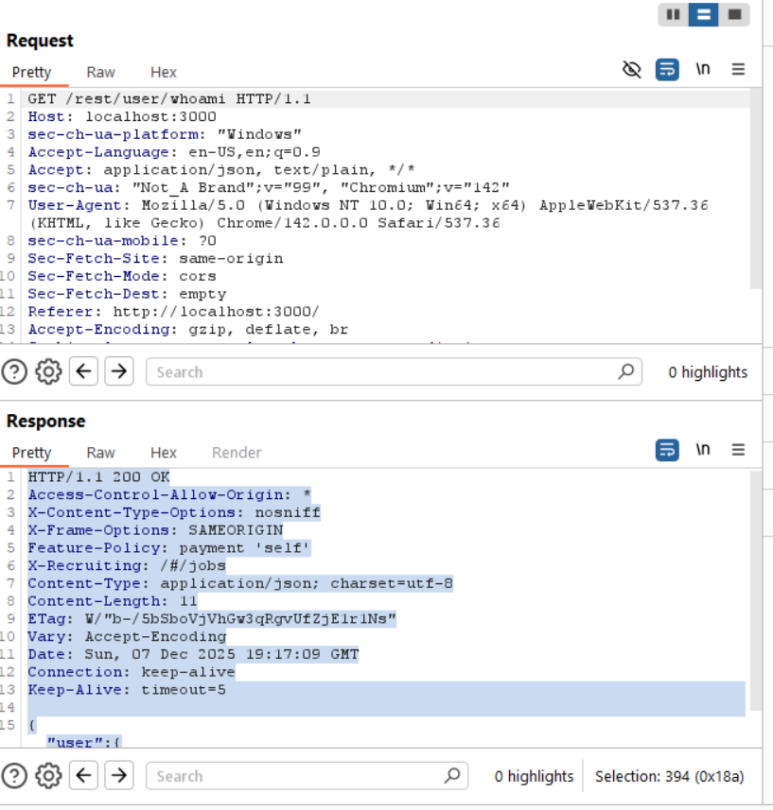

Outcome: Sensitive fields removed, preventing data leakage

Architectural Suggestions
Use parameterized queries at all times for secure coding practices.
Validate inputs consistently across all endpoints.
Least Privilege Principle: In API responses, only necessary fields should be returned.
Logging and Monitoring: Keep track of requests that are denied in order to identify anomalies.
Management of Secrets: Keep login credentials in secure vaults or environment variables.

