**Checking customer availability :**

**Uses array.split method then searches the customers data base for first and last name:**

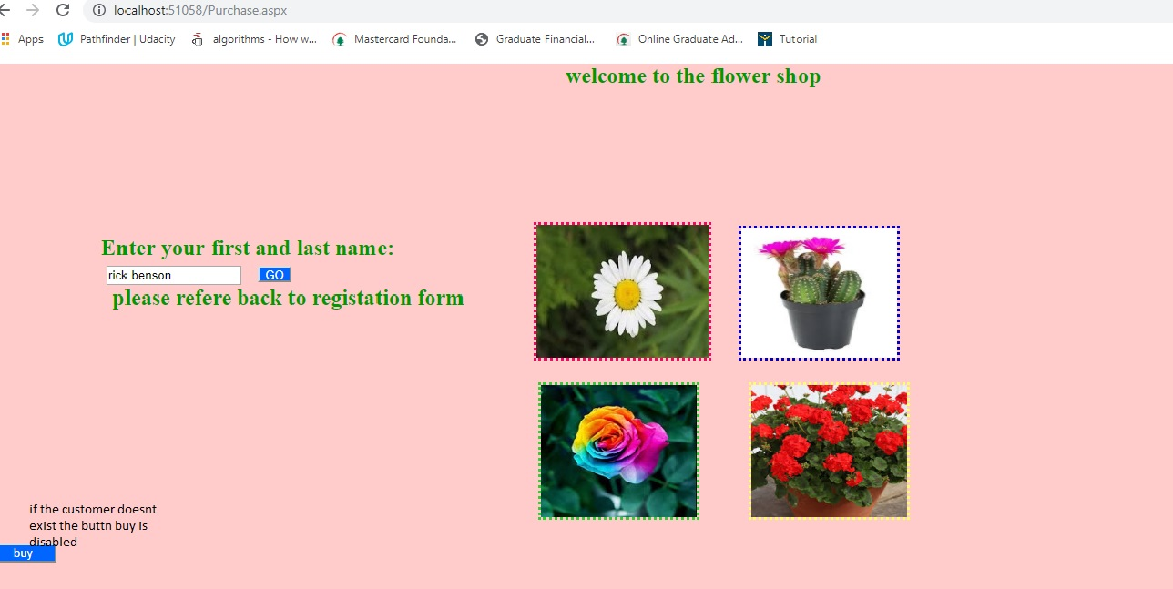

The buy button is disabled .

User enters his registered name again the button is enabled : a welcome message is shown :

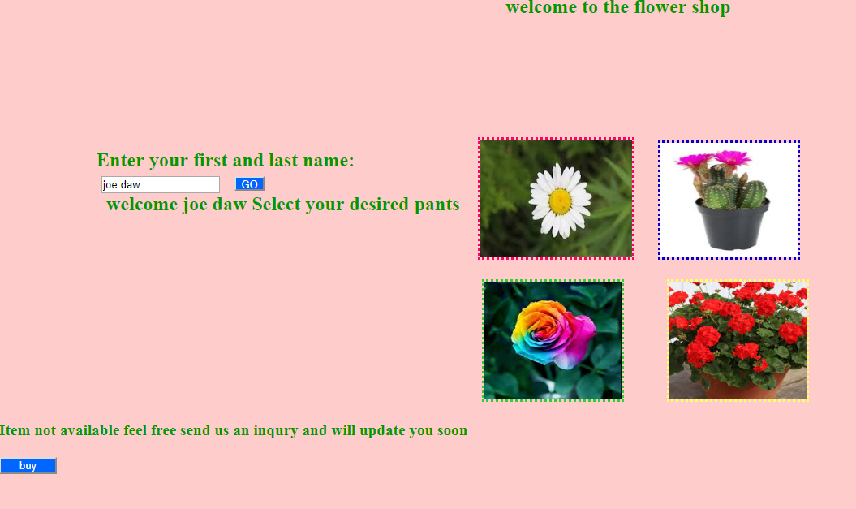

The image buttons search the product database for item , and returns message .

Finally the buy button lets the customer know of the items he selected :

